Patient logging is an essential aspect of clinical education, providing a detailed record of your interactions with patients. This guide outlines how to log patient encounters using the Exxat Prism system. It covers how to access coursework, select placements, add new logs, and run reports to ensure you are meeting patient log program requirements. The guide also explains how to handle logs that require your attention after your school or experiential supervisor reviews them. Additionally, this guide provides solutions to common issues you may face when logging patient encounters.
In this document you will learn how to:
1. Add Patient Logs
2. Send them for Experiential Supervisor Review
3. Resubmit ‘Needs Attention’ Patient Logs
4. Run Reports on Patient Logs
5. Troubleshoot, if you have Trouble Adding Logs

How to Add a Patient Log from the Coursework Section:
- Navigate to the coursework section by,

- Clicking on the Coursework Section from your Dashboard.

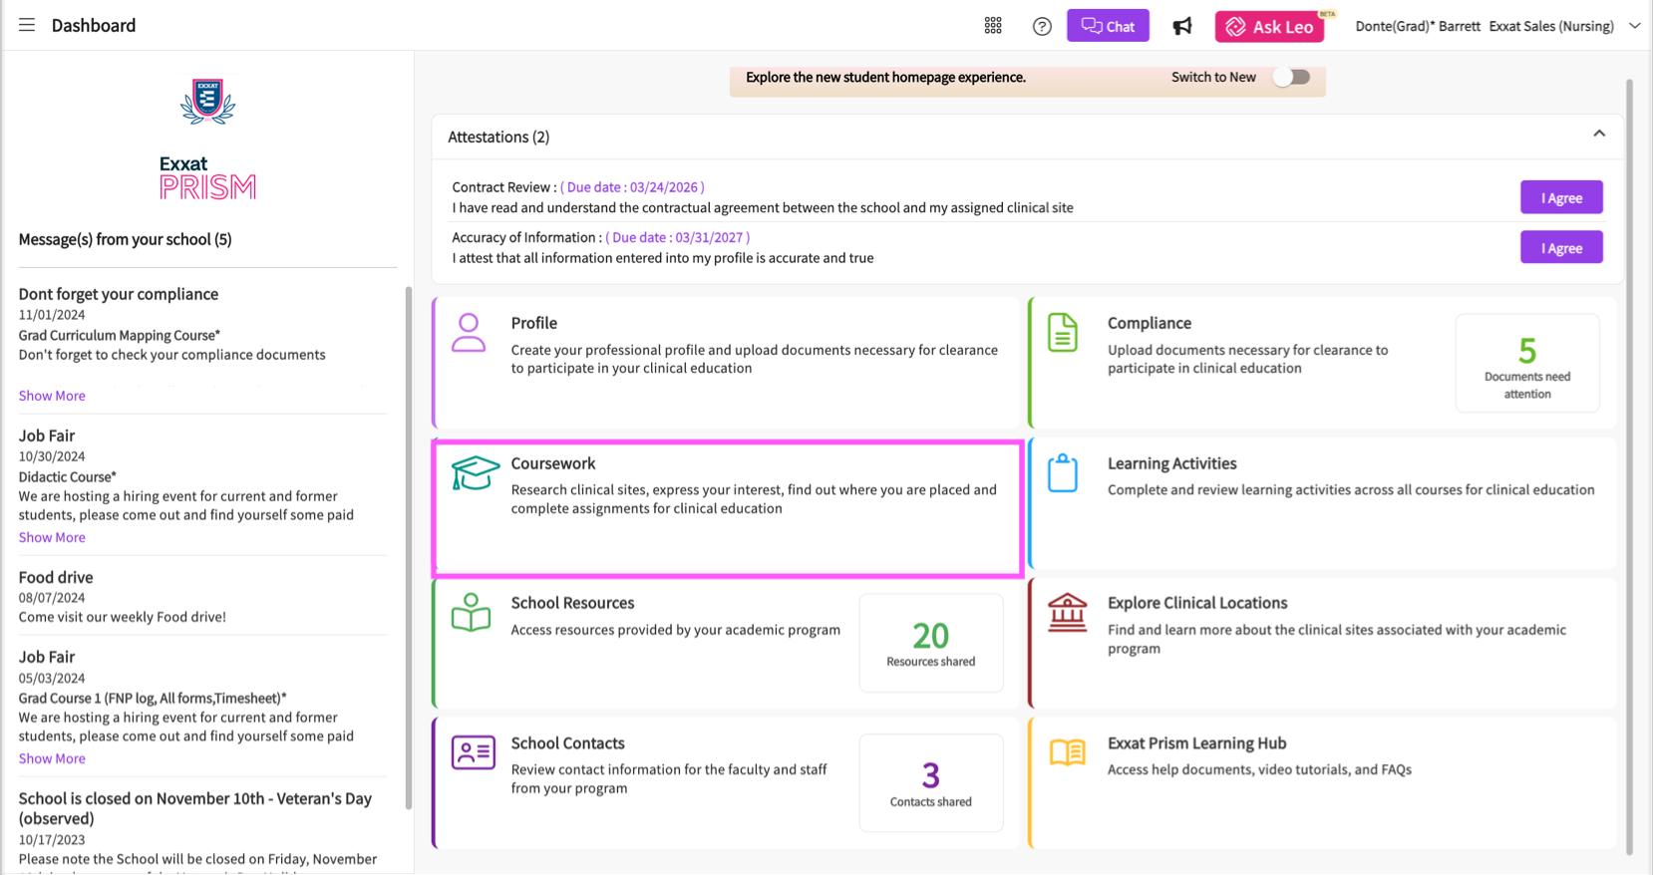

Or

- Clicking on the Left Hand Hamburger Menu and selecting the Coursework Option.
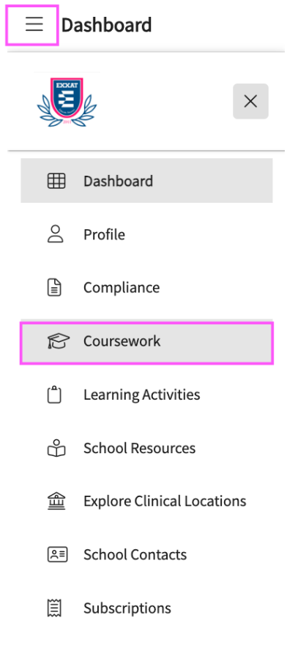

Or

- Clicking on the View all Coursework Option from the New Student Dashboard.

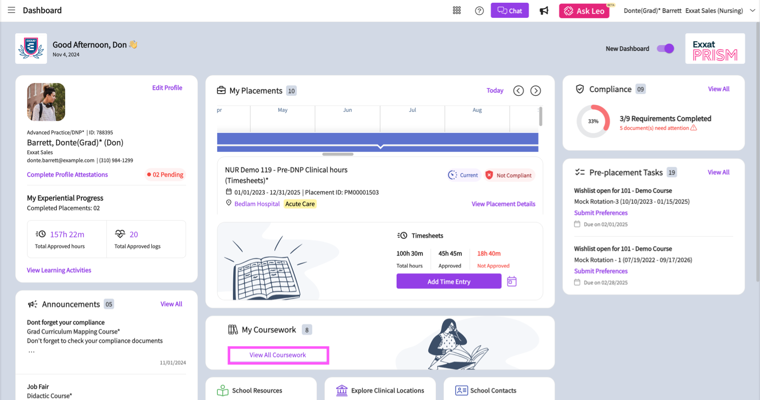
- The system will display all the courses you are registered for.

- If you wish to see the courses that require placement, click on the Require Placement tab.

- If you wish to see the didactic courses, you can click on the Do Not Require Placement tab.

- The page will always list any current placements at the very top, followed by upcoming placements, followed by courses in which you have not yet been placed and completed placements are found at the bottom.

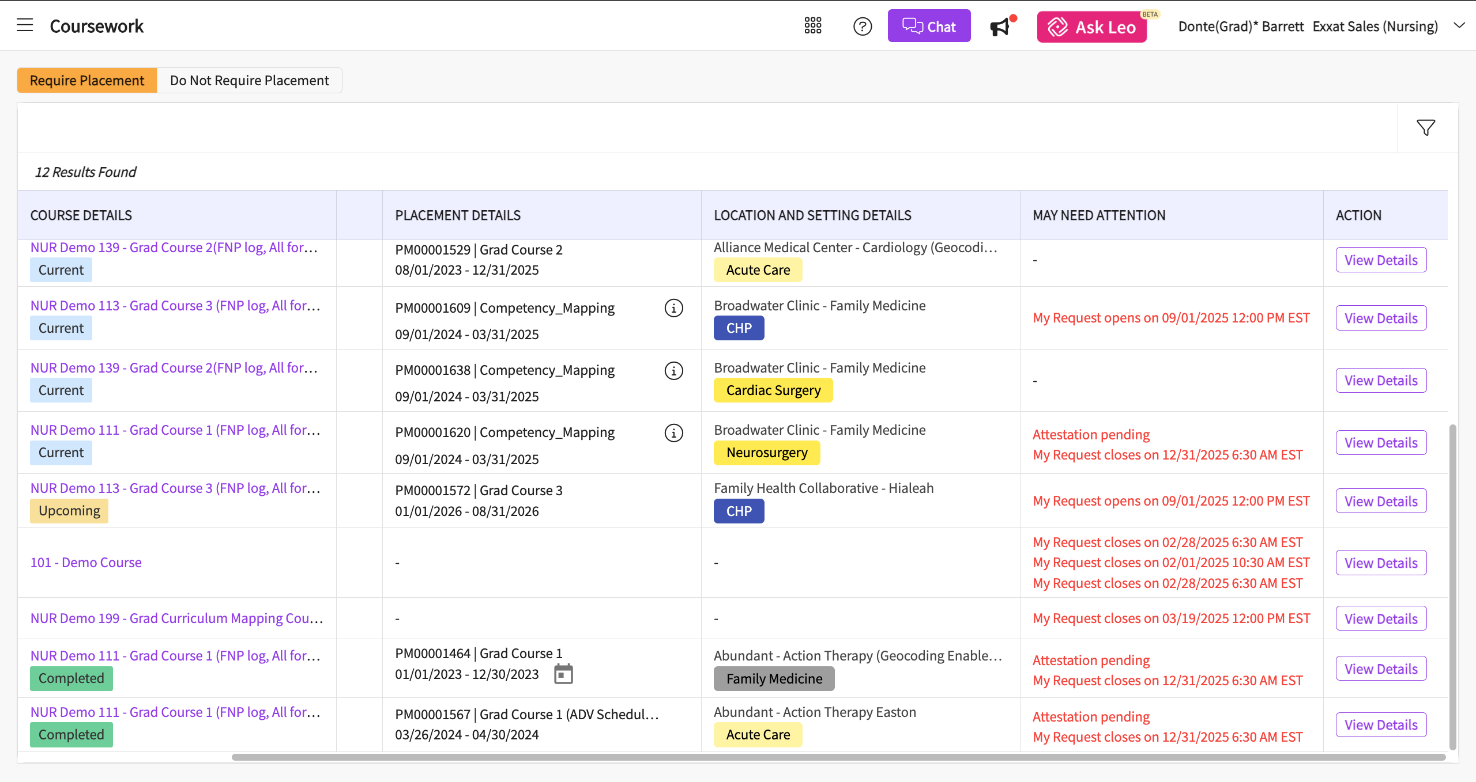
- Select the placement you would like to add a patient log for by clicking on the View Details button.
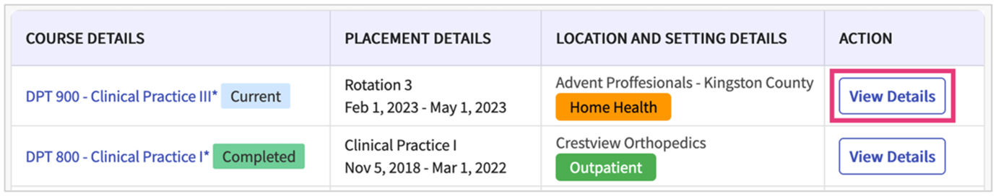
- Scroll down the page to the Patient Logs section. The system will show you a count of your total logs, as well as any logs that need your attention, are in progress, and the average number of logs entered per day.
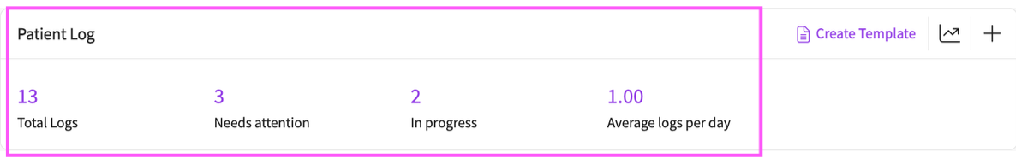
- If most of your patient encounters have the same details, you can use patient log templates to quickly fill out common information in your patient logs.

  - To add a new patient log template, click on the create template hyperlink.

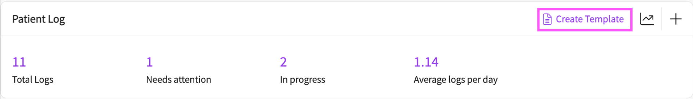
  - Then click on the add new template button to add a new template.

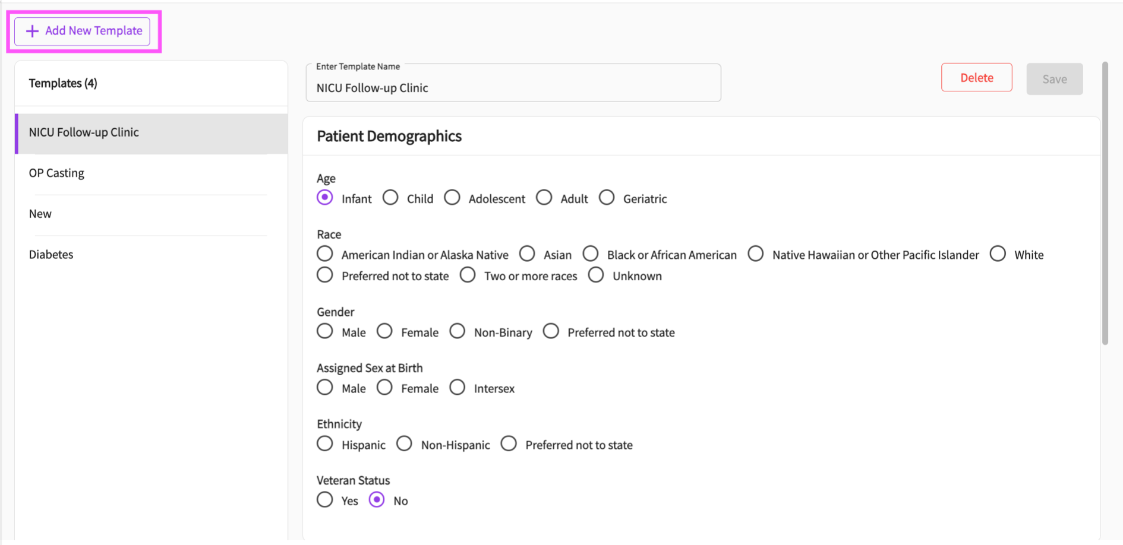
  - You will then need to provide the template with a name and make selections on the template indicating the common information.

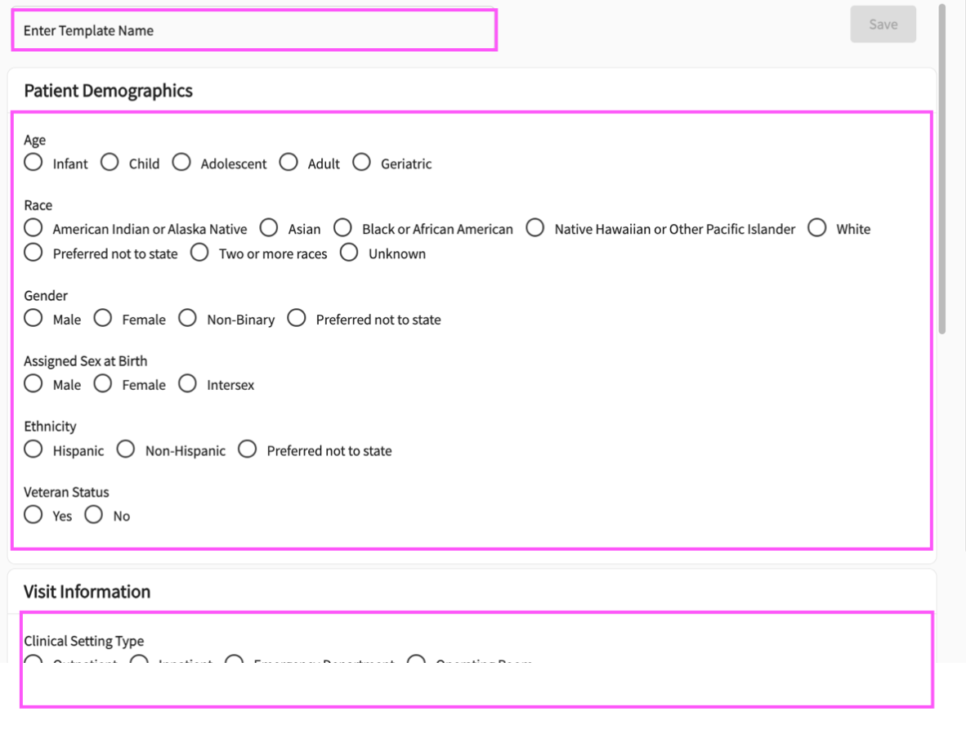
  - Once you are finished, click on the save button to save the template.

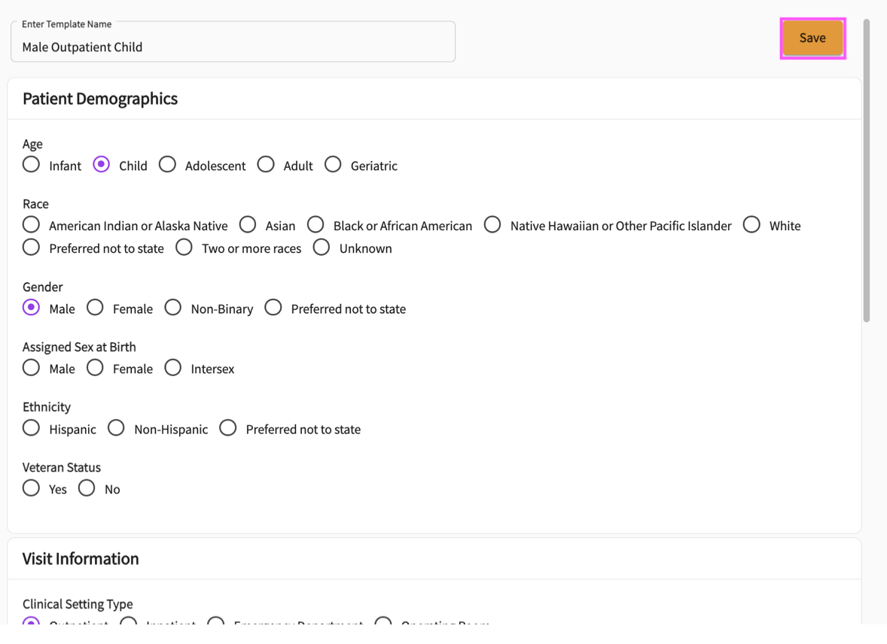

  - The new template will then appear in the template list on the left-hand side of the page. You can make changes to a previously added template by selecting the template, making your desired changes, and clicking on the save button. You can also delete a template by clicking on the delete hyperlink.

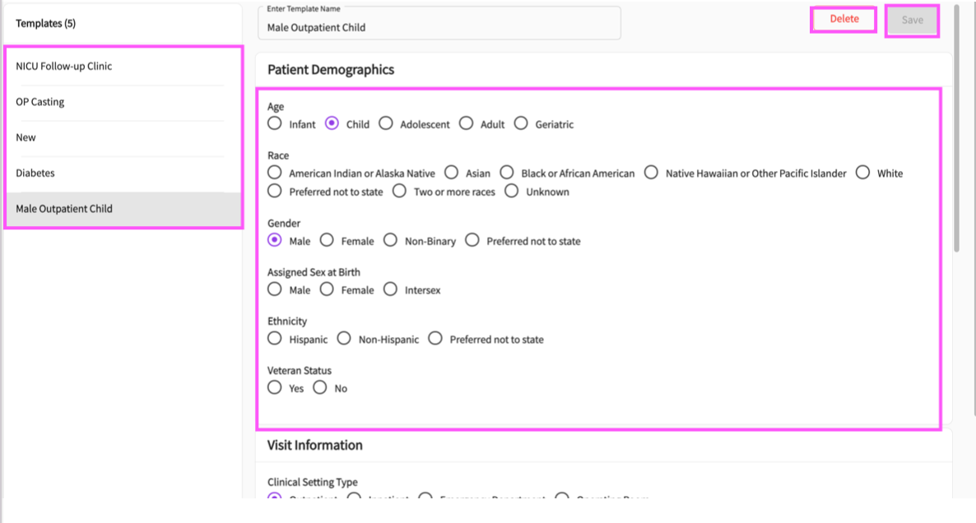
- To add a new patient log, click on the + icon.

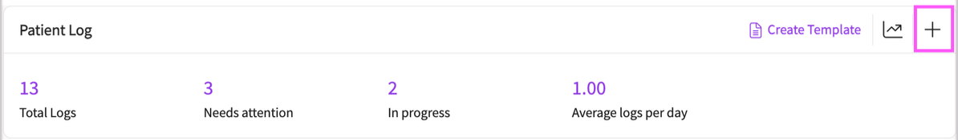
- This will open a drawer with the patient log you will complete.

- Your patient log may look like the example below, however you may have different sections to fill depending on your program:
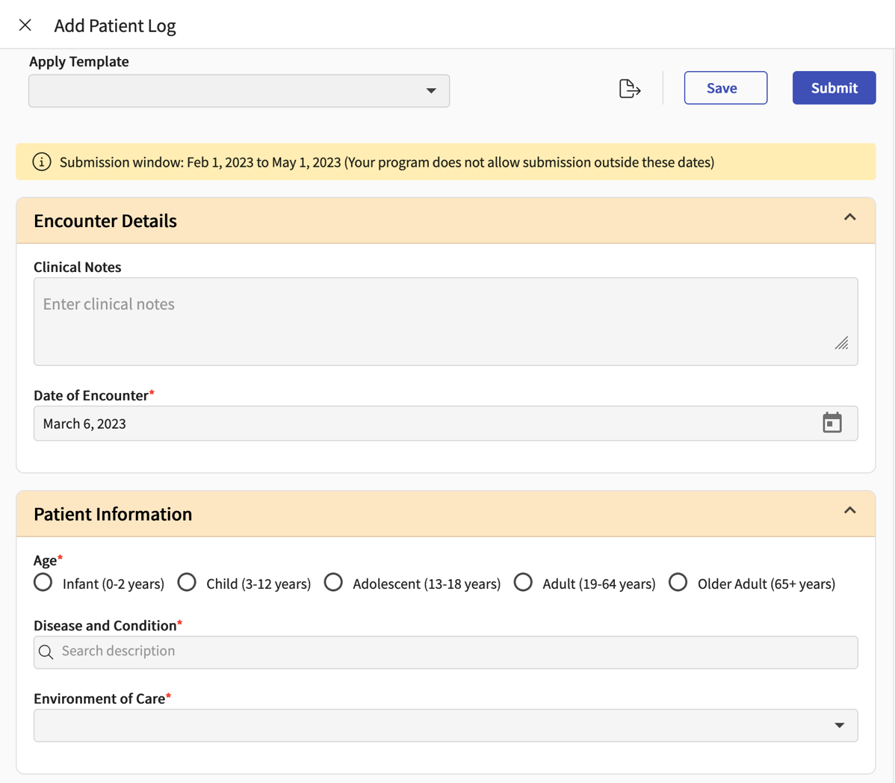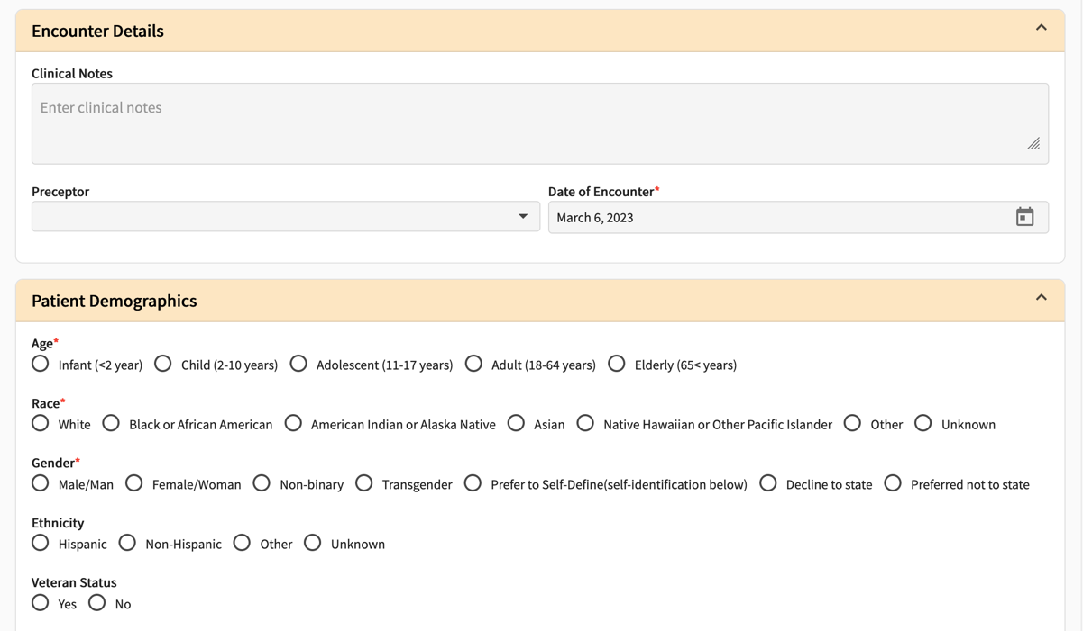
- To apply a template to the patient log entry, click on the Apply Template dropdown and select a template the common information will then be applied to your patient log.

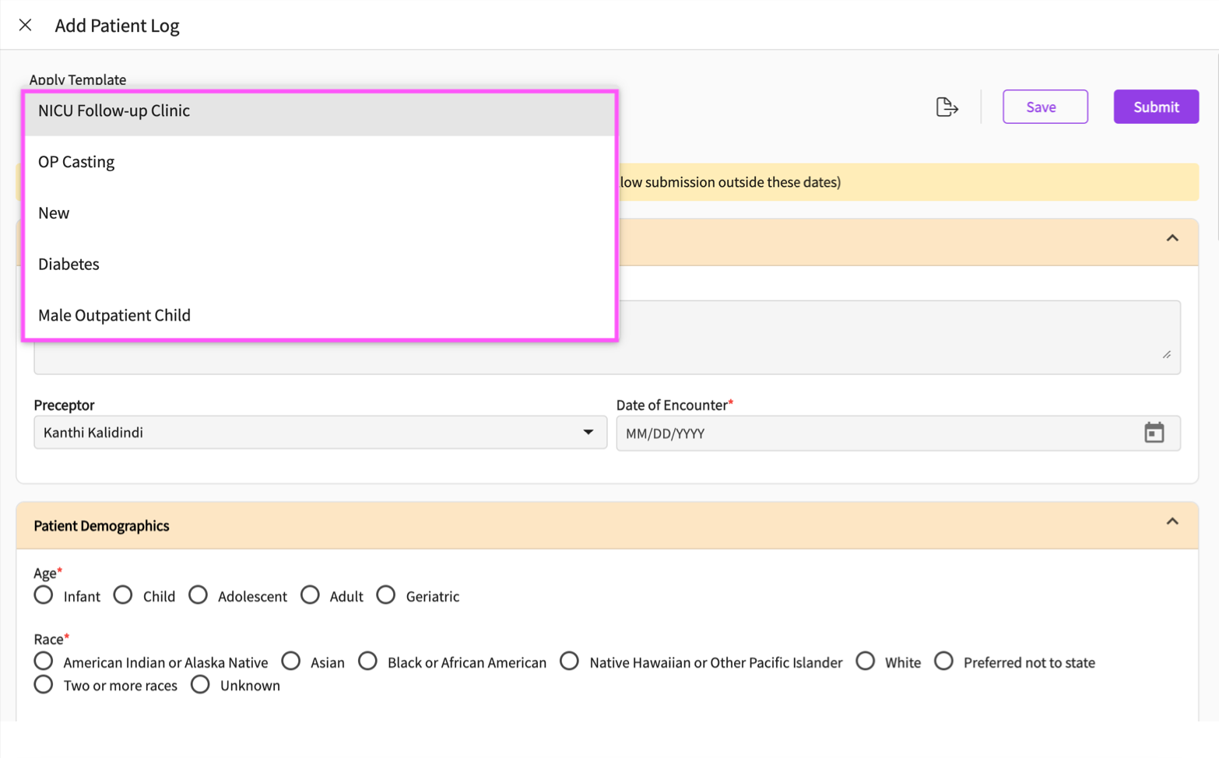

- If your patient log allows you to link an experiential supervisor, you will need to click on the experiential supervisor dropdown to assign this patient log an experiential supervisor.
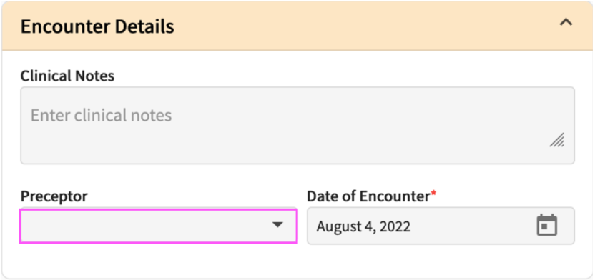
- The system will show you any experiential supervisors associated with your placement. Please select an experiential supervisor.
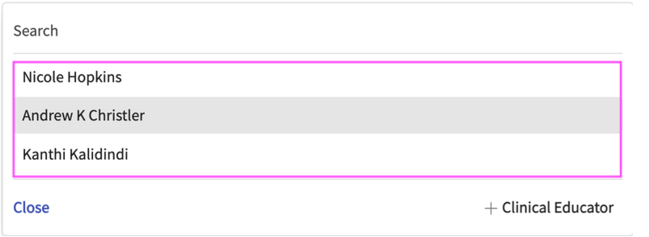
- You may have the option to add any new experiential supervisor. To add a new experiential supervisor, click on the add experiential supervisor button. Please note that when you add an experiential supervisor, this new experiential supervisor will be assigned to your placement in this course.

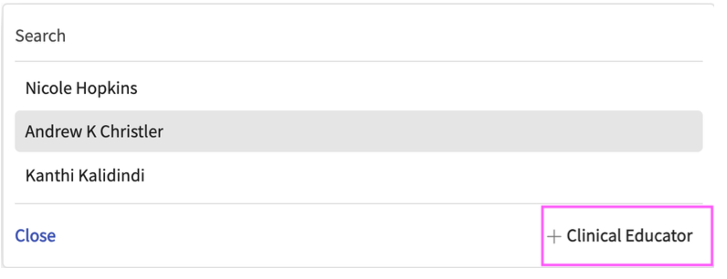

- You will then need to fill out the experiential supervisors information and click on the save button. The new experiential supervisor will then be assigned to this patient log and placement.
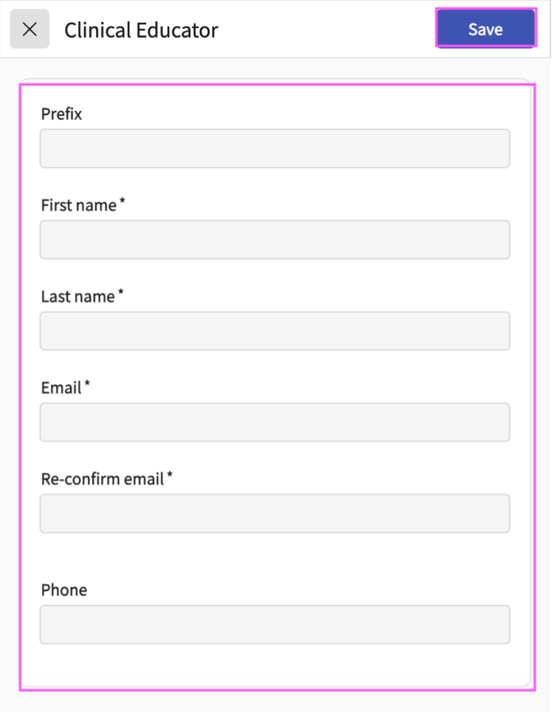

- If your program requires ICD 10 information, as you type in a diagnosis, a dropdown will appear showing you a list of related diagnosis codes, click on the code you’d like to add.
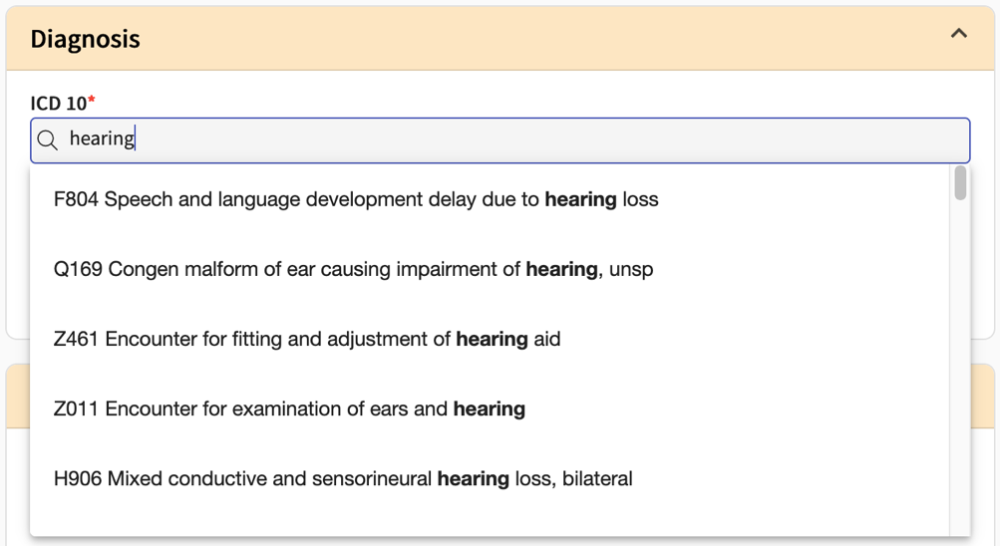
- For Required Diagnosis, begin typing in the search box to find the full list of available options. To remove diagnosis selections, click on the trash bin icon.
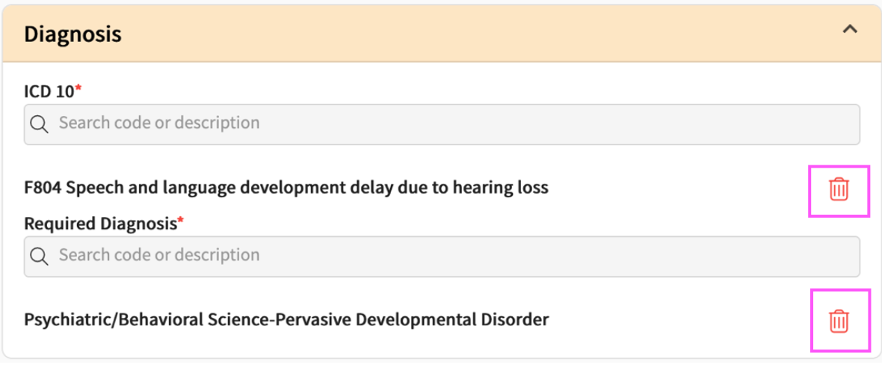
- If your program requires procedure or medication details, you can add this information by typing the procedure or medication in the search box and selecting an option.
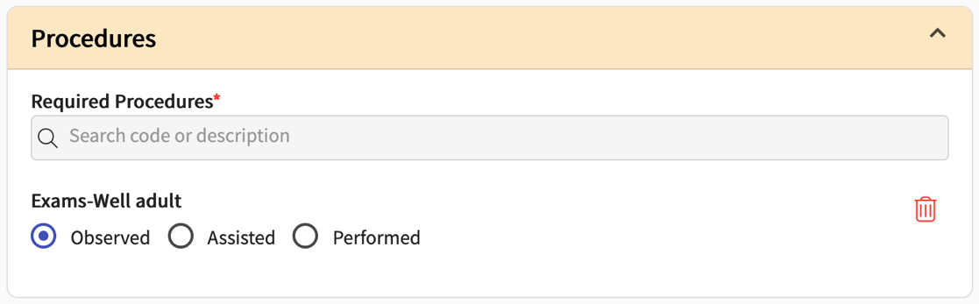
- If you would like to return to this patient log to make further edits at a later time, click Save. This will mark the log as In Progress.

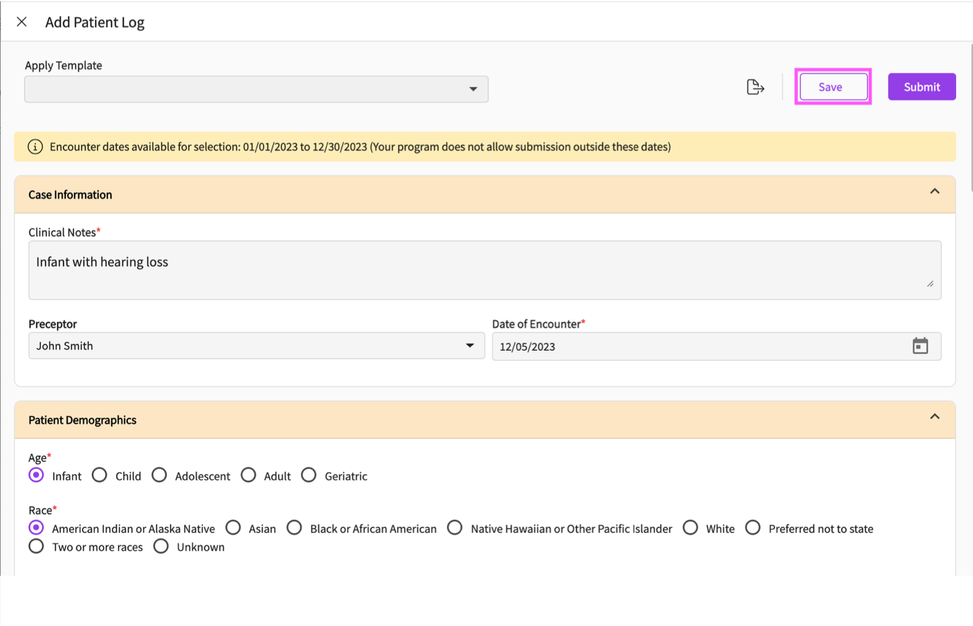

- Once done, click the Submit button. The Patient log will then be sent to your school for them to review. Please note that if you would like to send these patient logs for experiential supervisor review, you will need to do this manually.

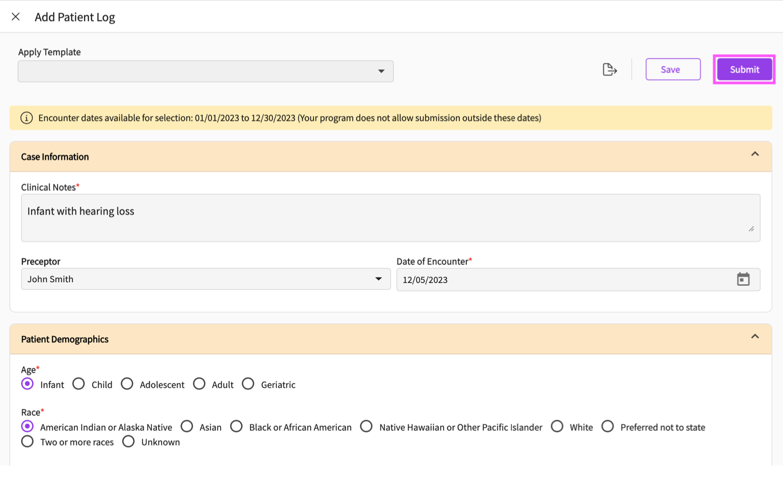

How to Add a Patient Log from your Dashboard:
We offer a quick and easy way to add patient logs directly from your dashboard.
To do so:
- Navigate to the ‘My Placements’ section of your dashboard.

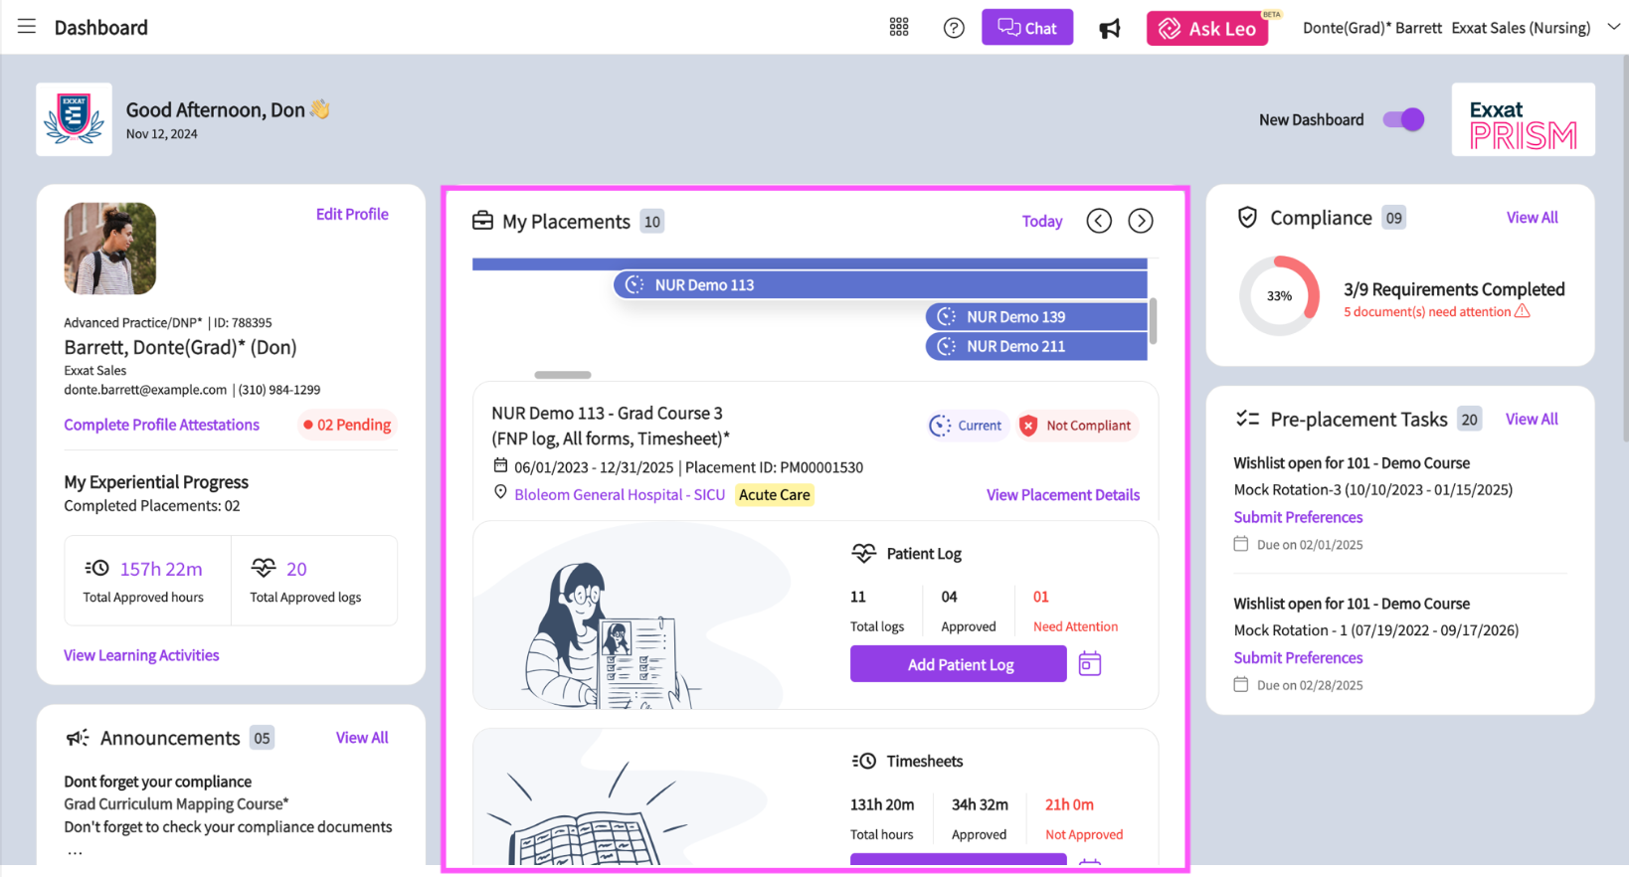
- Select the placement for which you would like to add the patient log to using the placement timeline.

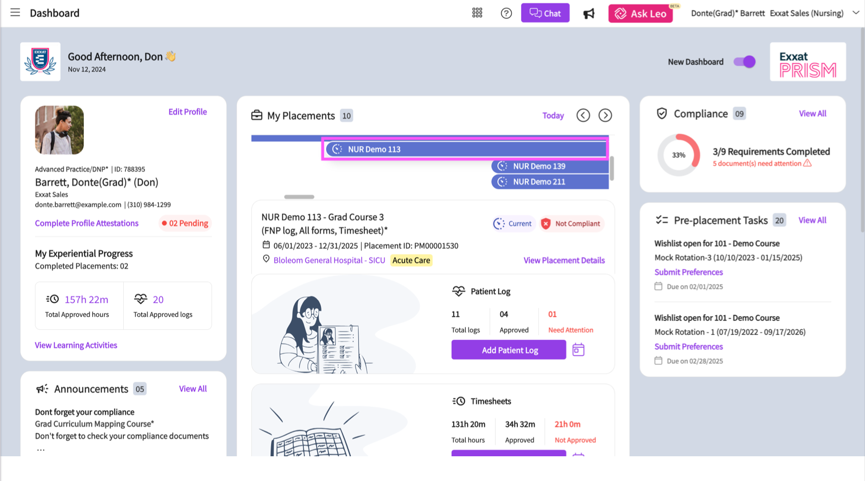
- Scroll down to the patient logs section. In this section you can view the total number of logs submitted, the number of approved logs, and the number of needs attention patient logs in this course.

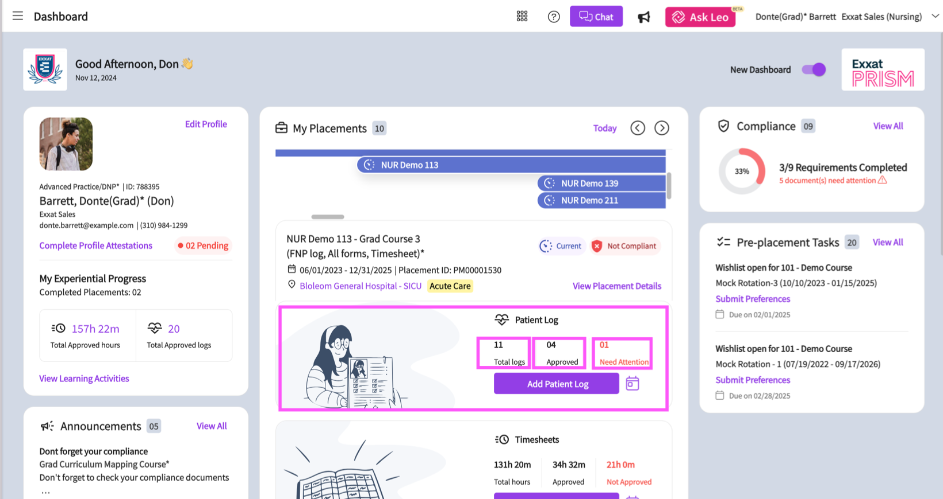
- Click on the calendar icon to view the dates for which patient logs have been submitted.

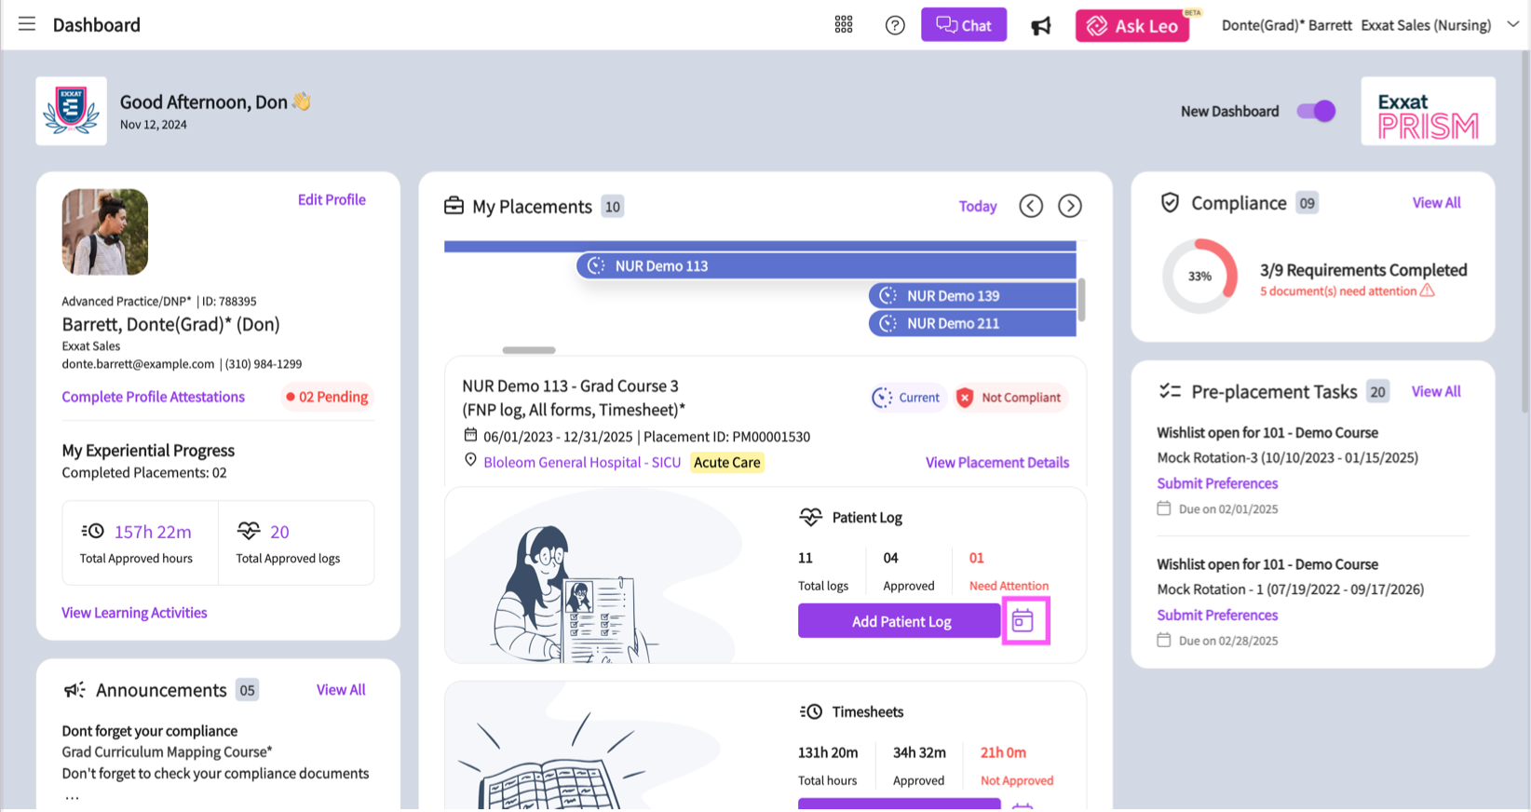
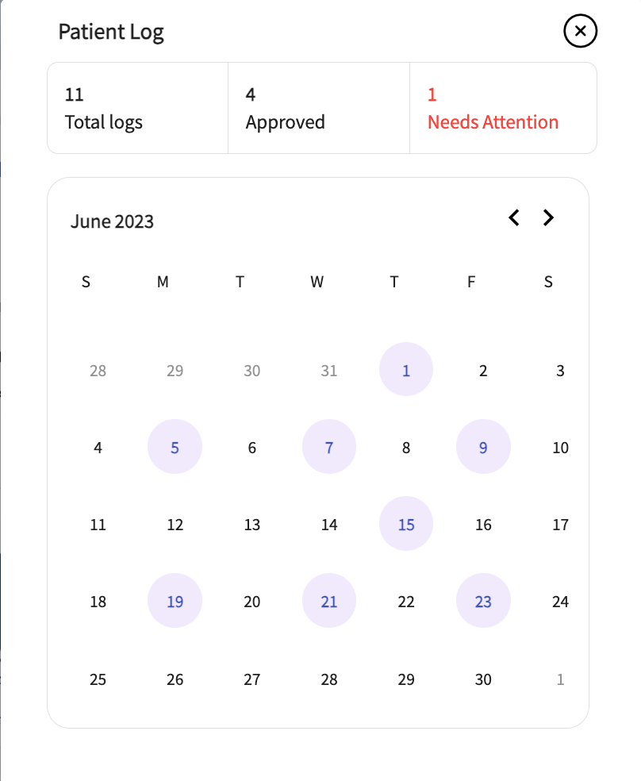

- Click on the Add Patient Log Button to add a new patient log to this course.

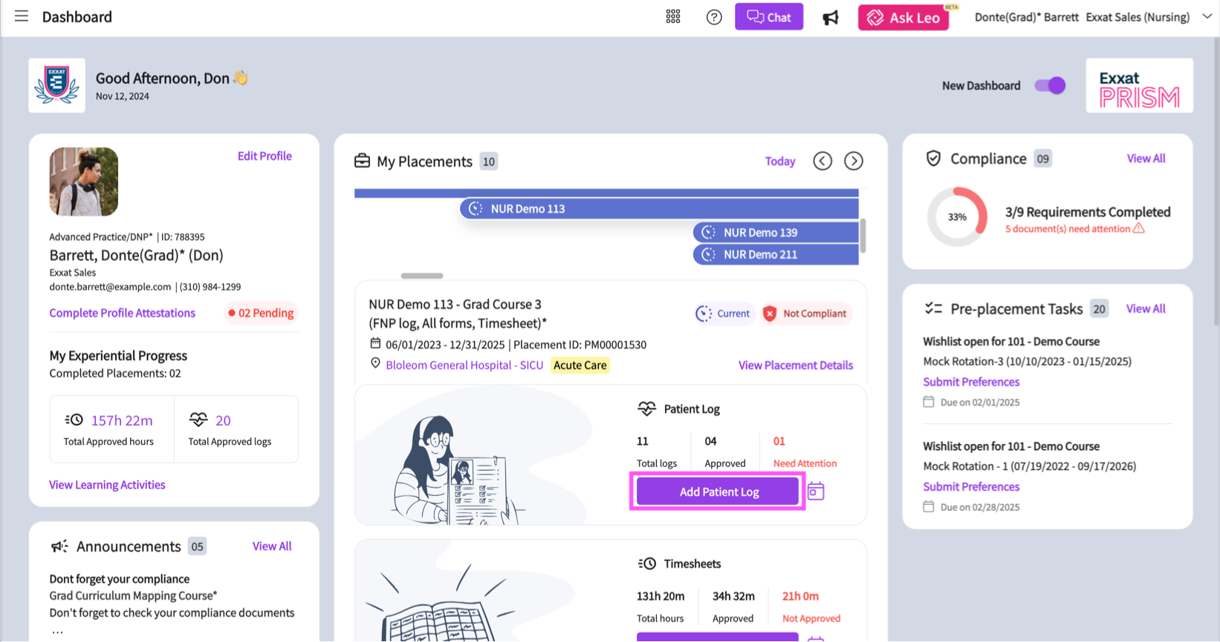
- A window will open for you to fill in the details of the patient log. Once you have filled all the necessary information, be sure to save or submit the log.

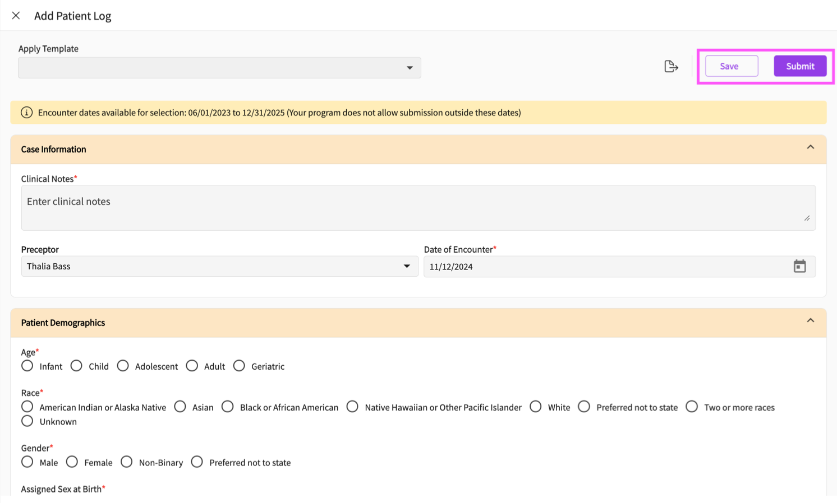

Sending Patient Logs for Experiential Supervisor Review:

If you would like your experiential supervisor to review your patient logs, you will need to send your submitted logs for experiential supervisor review.

- To send patient logs to your experiential supervisor, navigate back to the patient log section of the course activities page and click on the total log count.

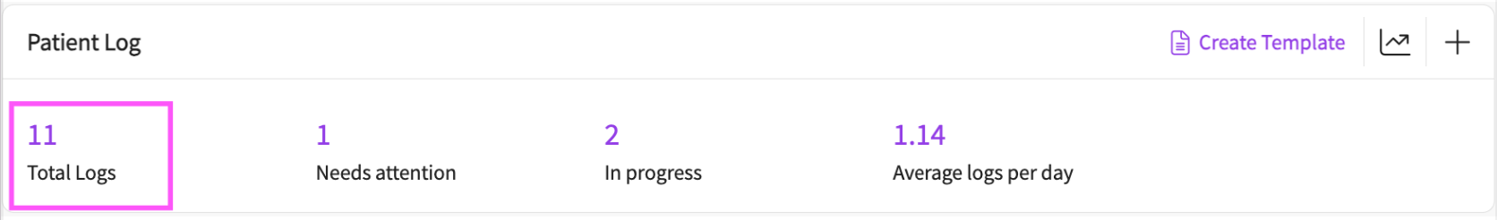
- On the Patient Log page, click on the send for experiential supervisor review button. Please note that you need at least one pending review patient log with an experiential supervisor assigned to it to send your patient logs for review.

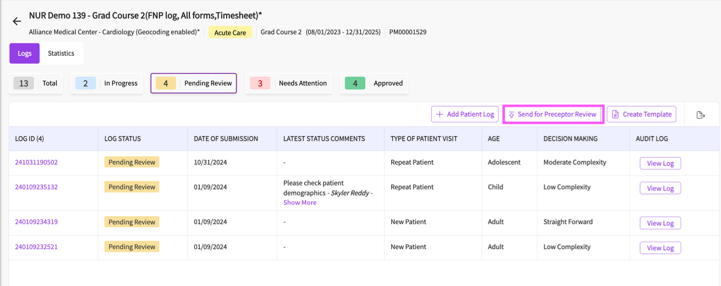
- All of your pending review patient logs with experiential supervisors assigned will be sent at the same time. The system will display a synopsis of who will be sent the logs and the number of logs that will be sent. If you are sure you would like to send your logs, click on the send button.

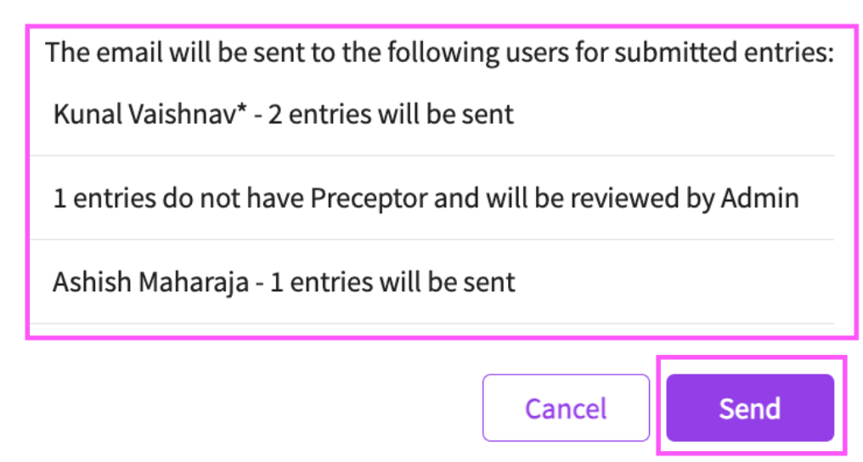

- Your experiential supervisor or supervisors will then review your logs.

Resubmitting ‘Needs Attention’ Patient Logs:

Keep an eye on the status of your logs. Once your school reviews them, they may mark them as Needs Attention. If this happens, you will need to review and resubmit these logs.

To do this:

- Click on the count of ‘Needs Attention’ patient logs.

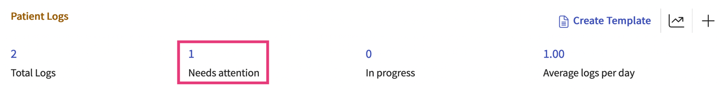
- Click on the Log ID to view feedback provided by your school.

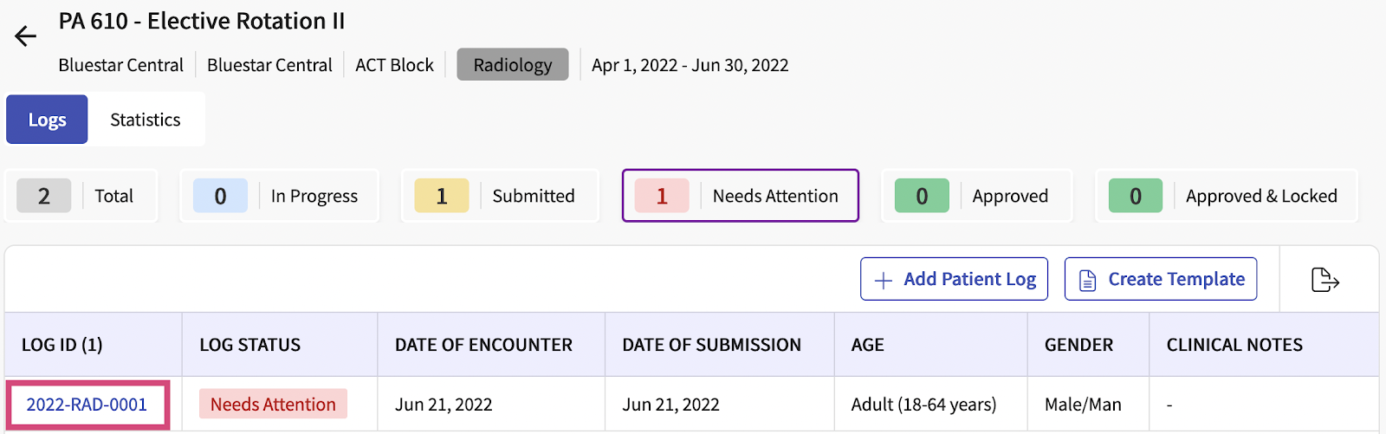
- Review the School Feedback in the school feedback section of the log.

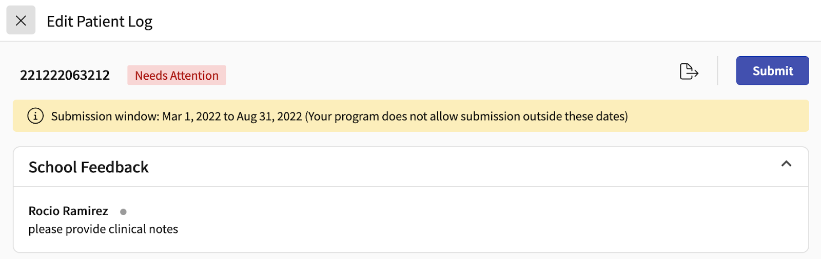

- Make the necessary changes to the patient log and submit the log once again.

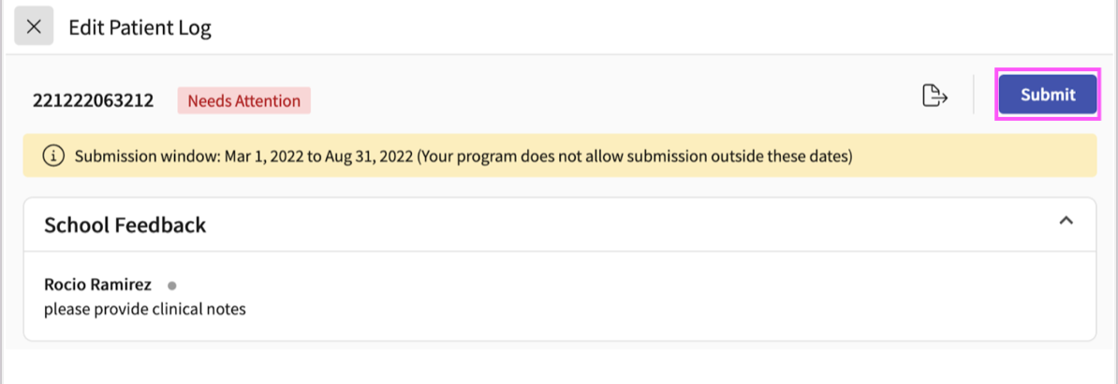
Running the Statistics Report:

We offer a comprehensive statistical report to view statistical information on your submitted patient logs and ensure you are meeting your program requirements.

- There are a few different ways you can run the statistics report. To run the statistics report:

- Click on the statistics icon within the patient log section of a course page.

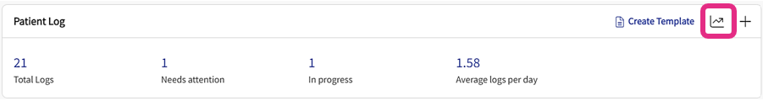

Or

- Click on the total log count, then click on the statistics tab.

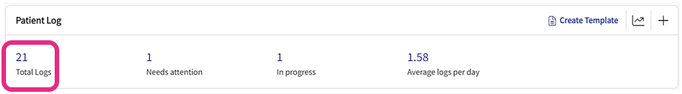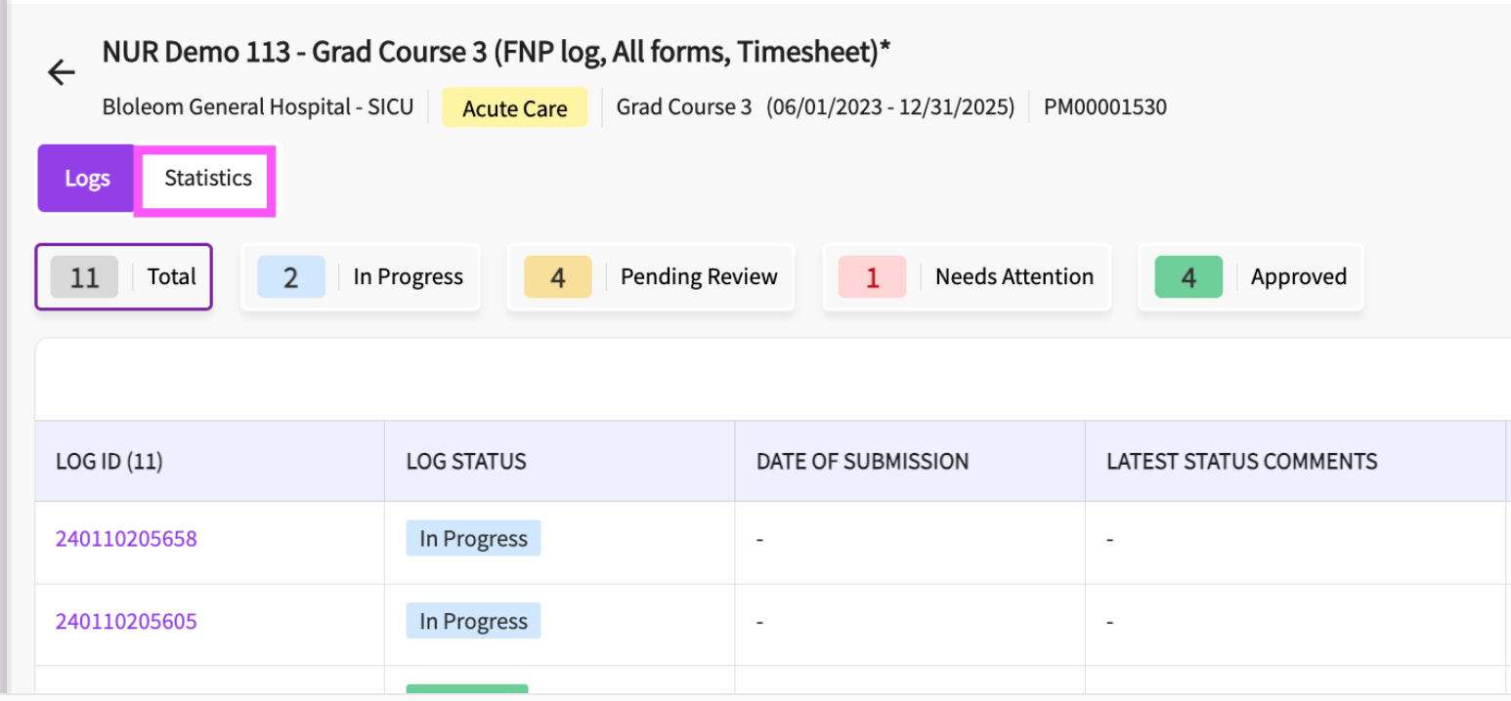
Or

- From the patient log tab of the learning activities section, click on the statistics icon in the statistics column.

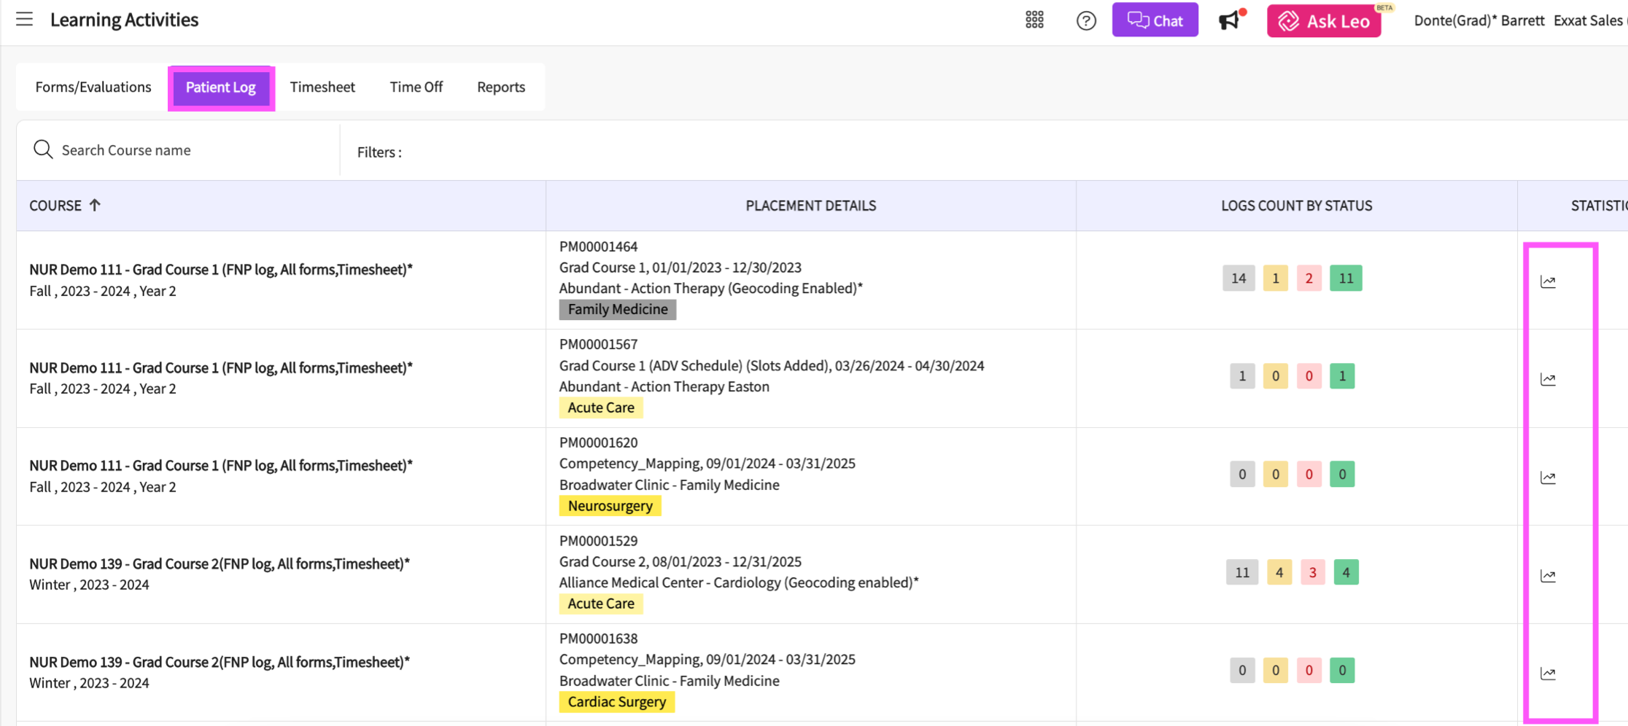

- This will show the statistical information regarding the logs entered in this course.

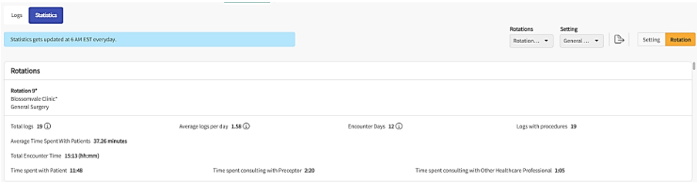
- Each graph will display the frequency that specific options were selected on a patient log.

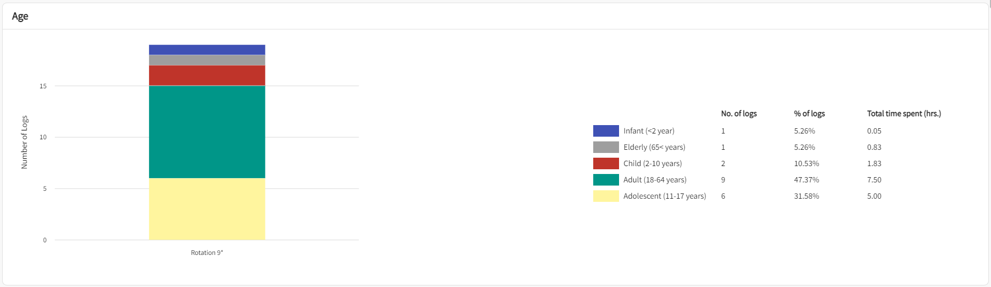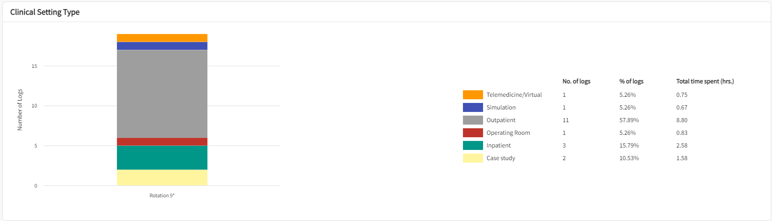
- If you are placed multiple times in this course, you can use the rotations and settings dropdowns to filter the report by rotations or settings. You can also use the Setting or Rotation tabs to view segregate the graphs by setting or rotation.

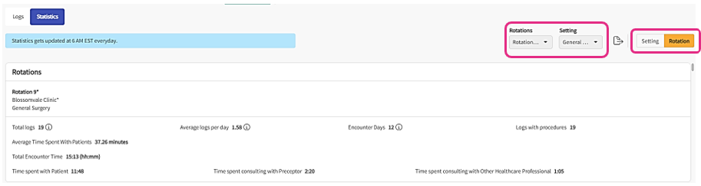

- To download or export this report, click the Export icon located in the upper right hand corner of the page.
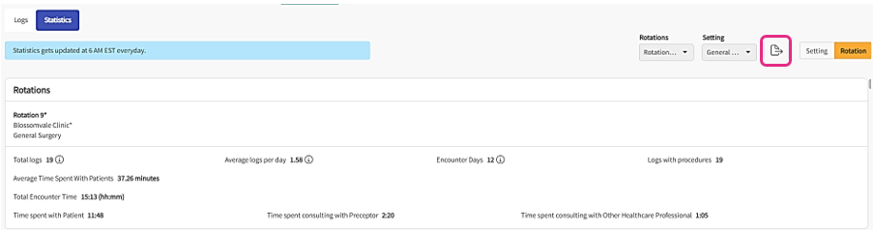

Running the Patient Log Aggregate Report:
The patient log aggregate report aggregates your patient log data for you to ensure that you have enough clinical encounters to meet your graduation requirements.
- To run the clinical log aggregate report, navigate to the learning activities section from your left-hand menu and select the reports tab.

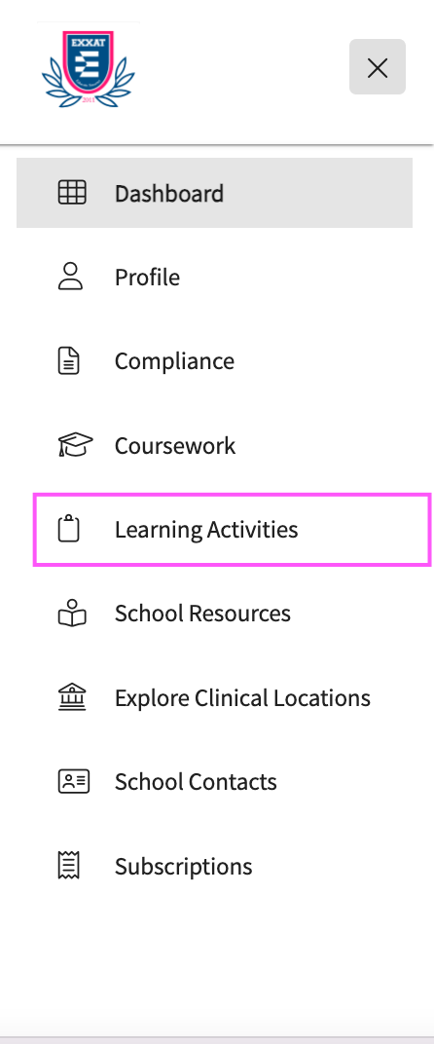
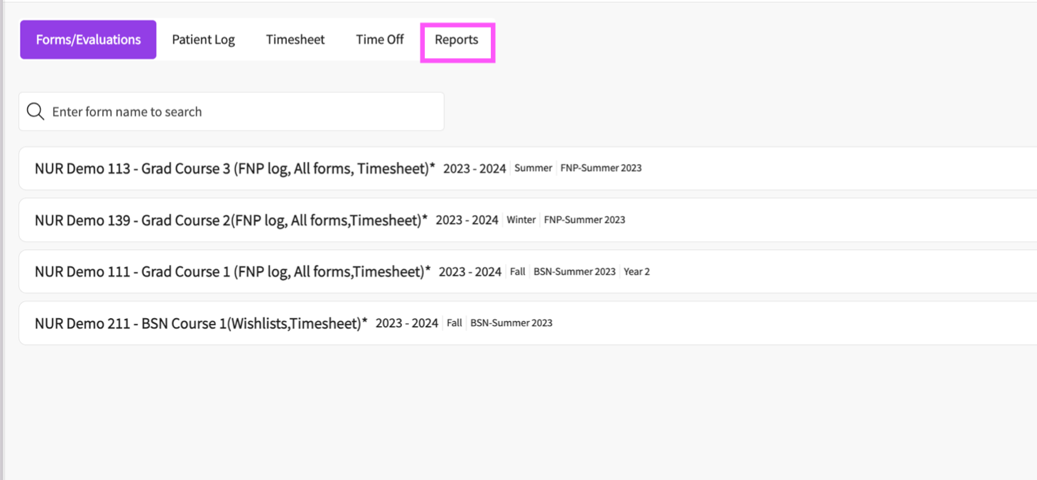
- Then select the Patient Log Aggregate Report hyperlink.

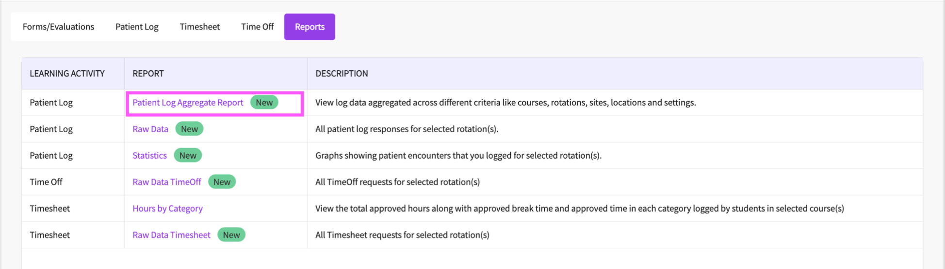
- Then click on the Select Course Offerings button to select the course offerings for which you would like to run the report.

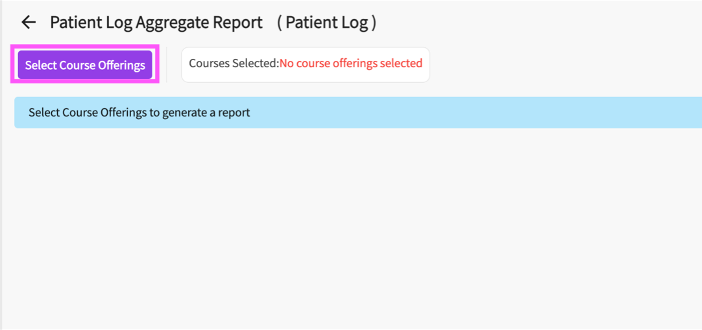
- You can use the search box or filter icon to search for specific course offerings. You can also change the type of the search box using the dropdown to the left of it.

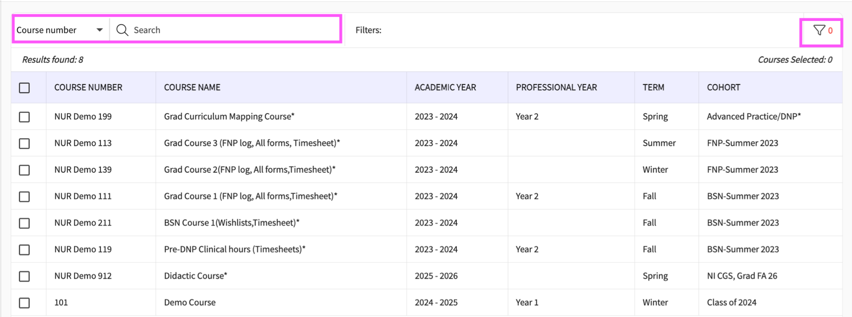
- After you have made your selections, click on the apply button.
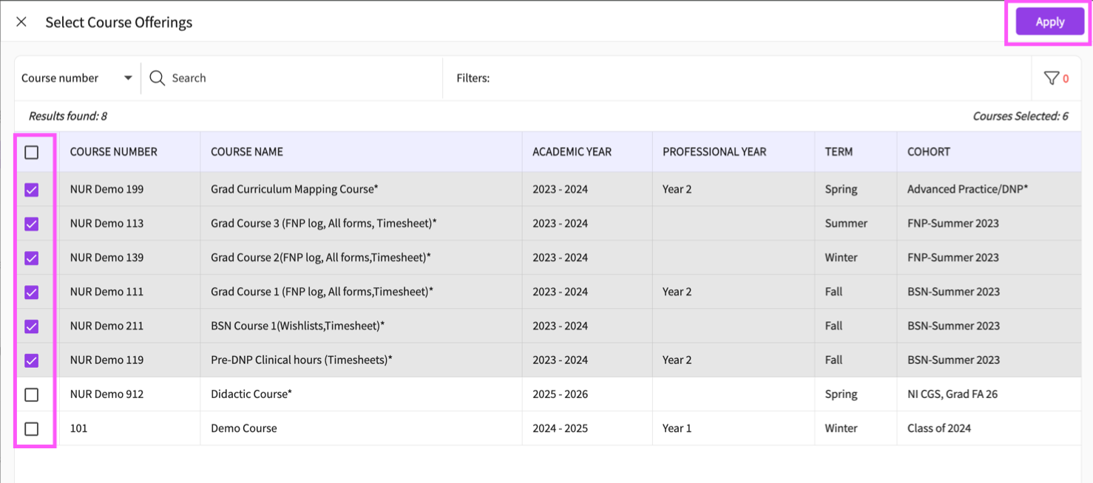
- You will then need to configure the options for the report. You can choose specific Rotations, Settings, Statuses, Sites, or Locations to include in the report.
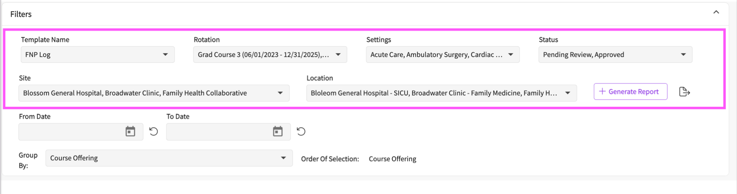
- You can also use the to date and from date fields to filter for logs submitted between specific dates. Click on the calendar icon in each section to do so.
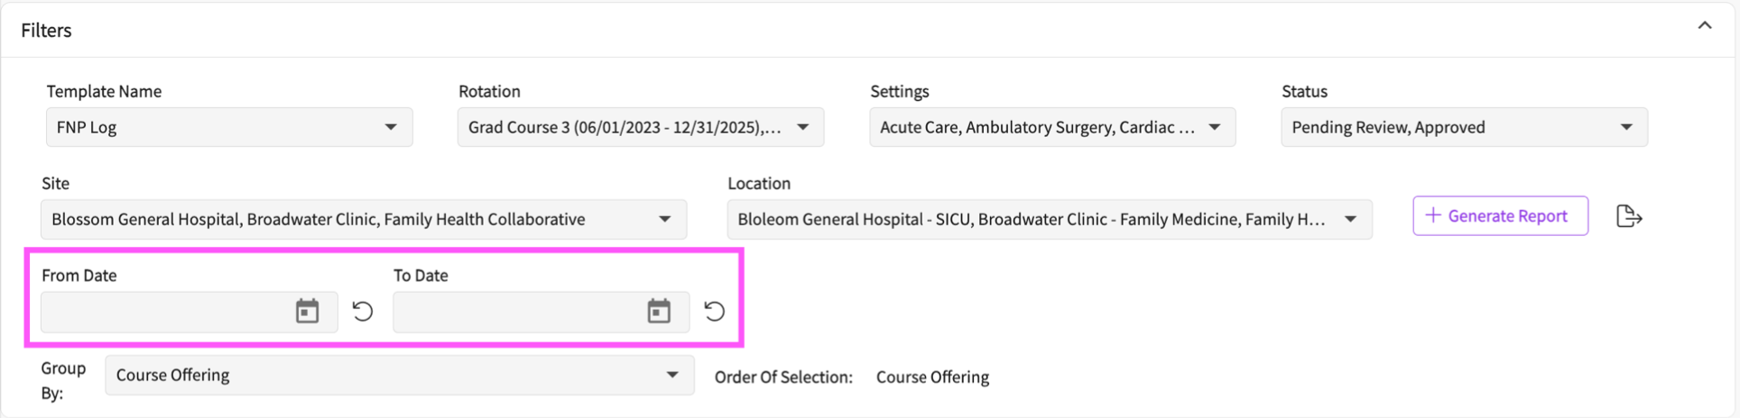
- In the group by section, indicate how you would like to group the aggregation of data. You can aggregate your data by Course offering, Rotation, Setting, Location or Site.

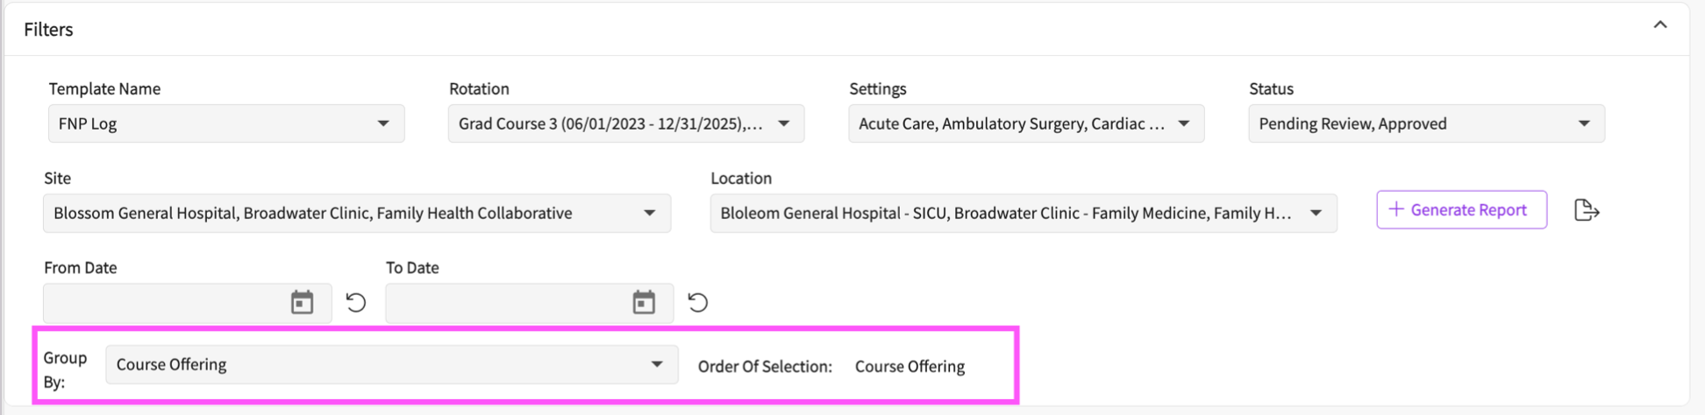
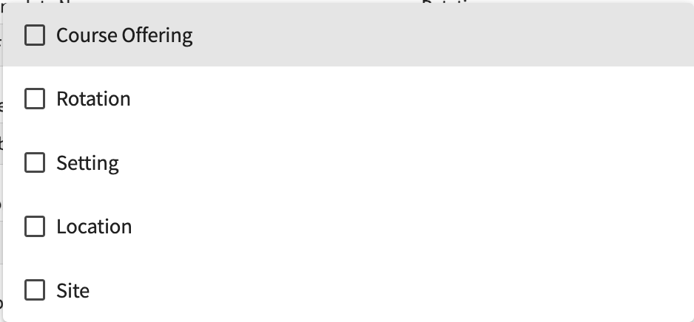
- You can aggregate the data by multiple criteria at the same time. For example, if you are placed in different courses in the same setting, you may want to aggregate your patient log data by setting and then by course. This way you can view the total aggregate patient log data for each setting and break this down further by course.

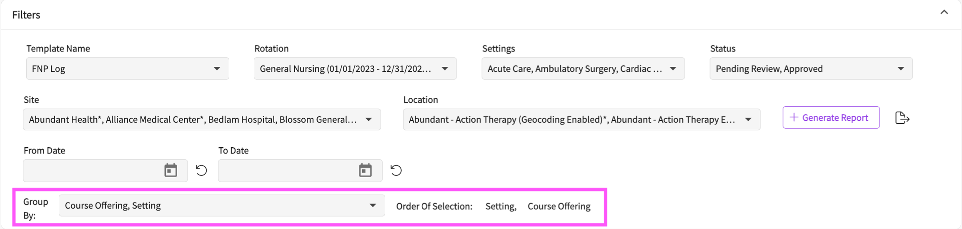
- Once you have configured all of the options, click on the generate report button to run the report.
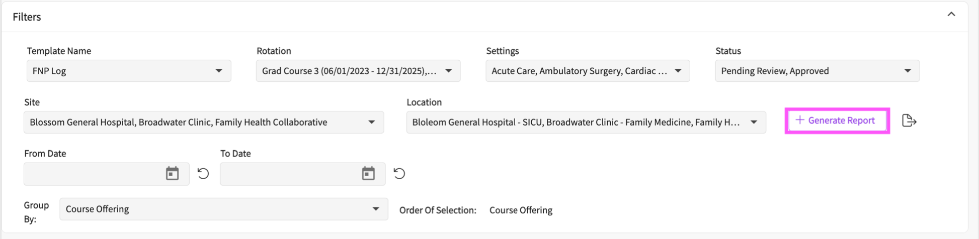
- The report will then be loaded below. You can view the number of times you selected specific options on your clinical logs, aggregated by your predefined criteria. Scroll right to navigate through all of the clinical log options.

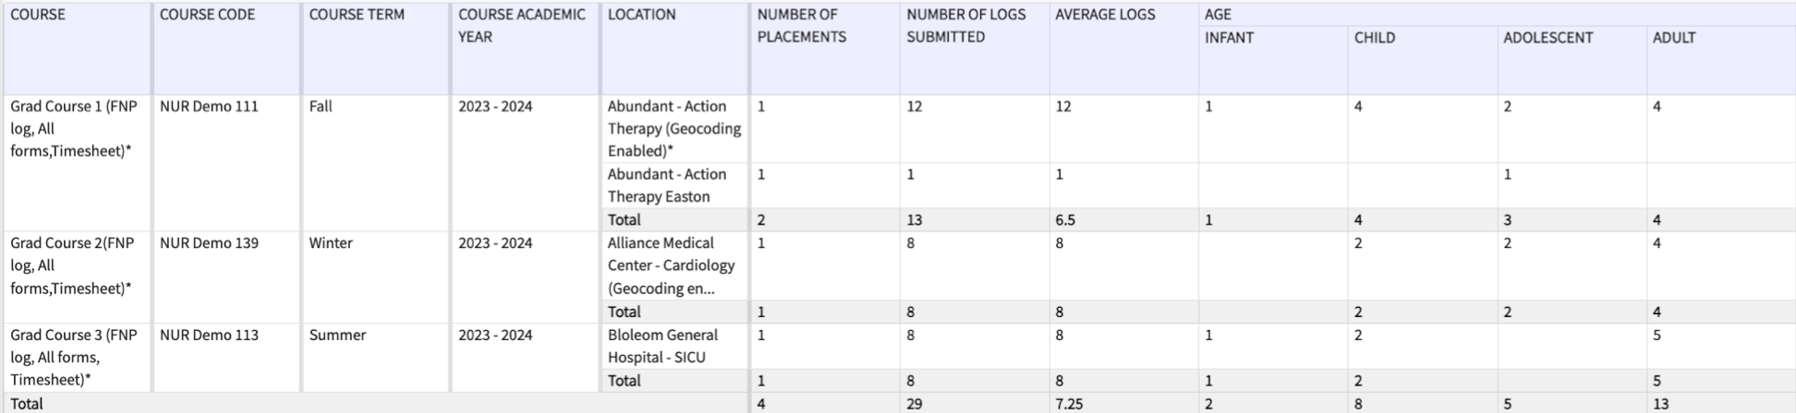
- If you would like to download the report for offline access, click on the export icon to the right of the generate report button.

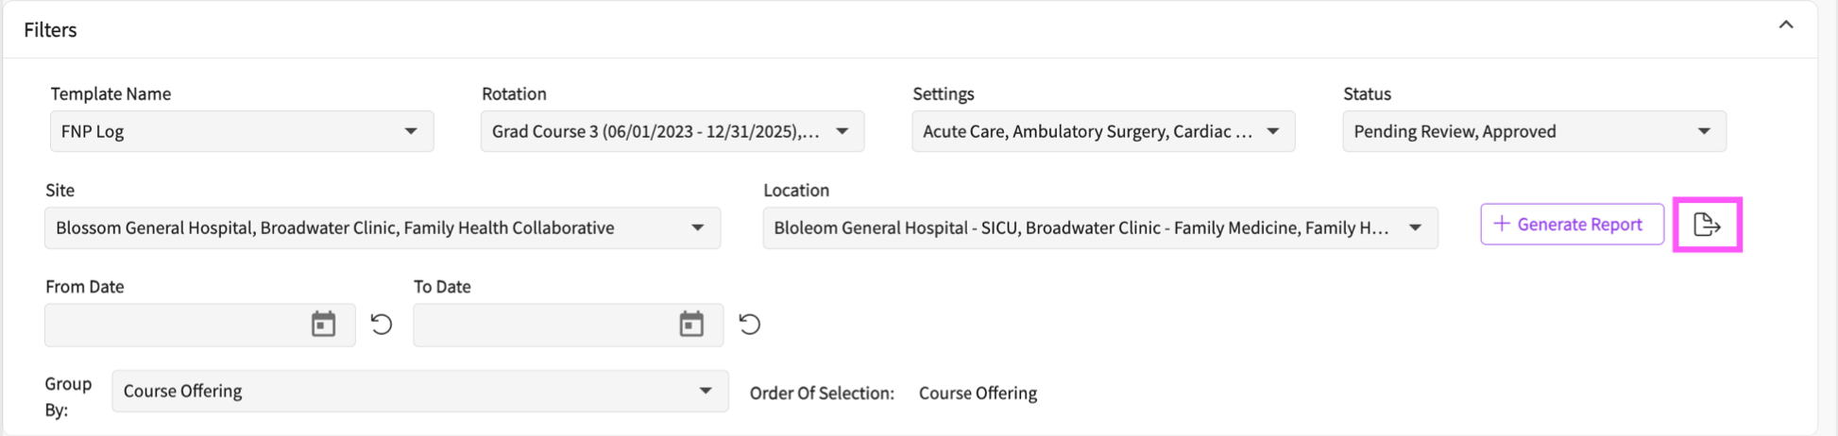
- Click on any of the boxes within the table to view a drill down report which displays the patient logs where this option was selected, or the time was indicated. You can view the placement information for the course to which the log was added and the log itself. Click on the download report button to download this report for offline access.

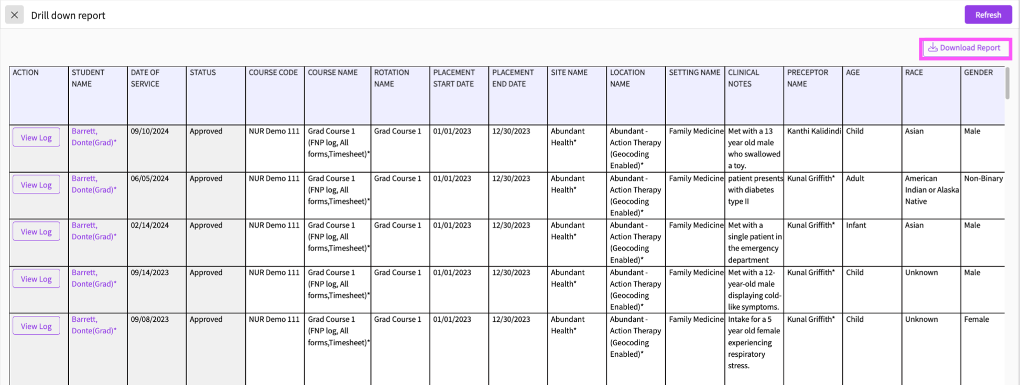
- To view the log in a separate browser tab, click on the view log button.

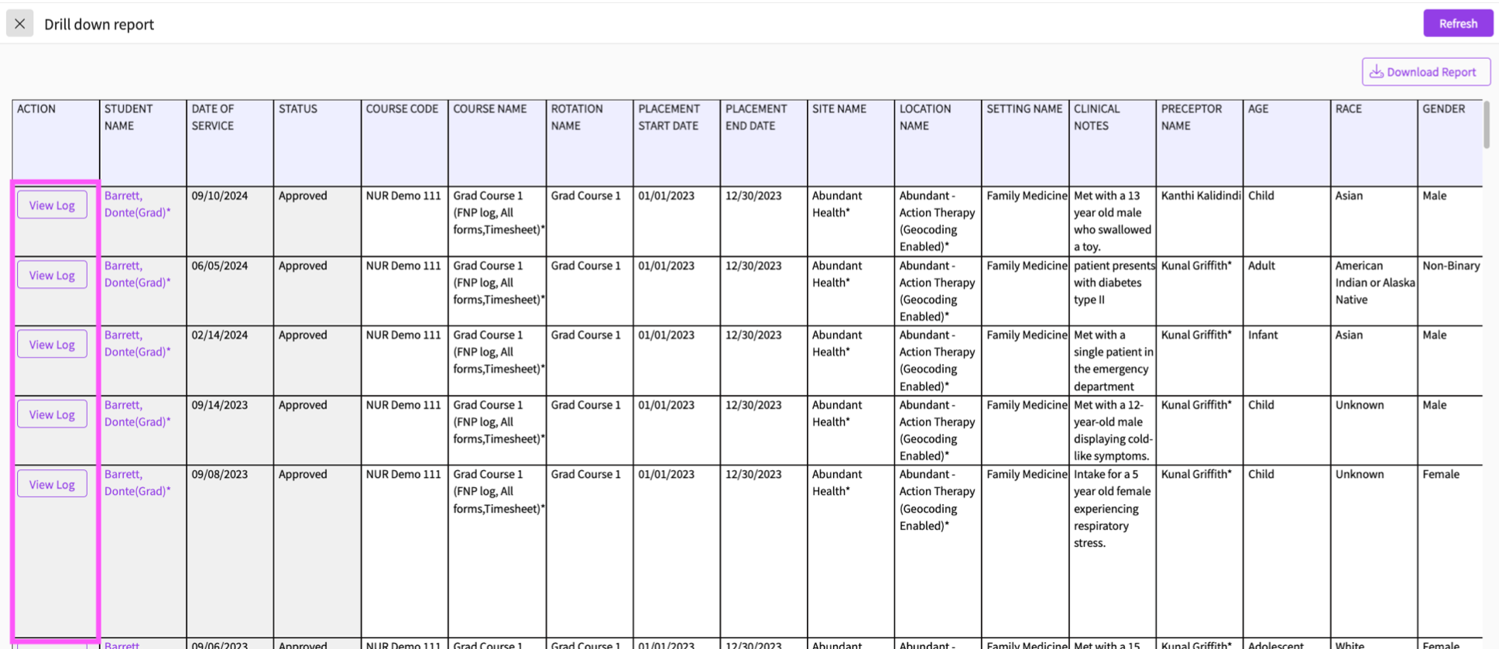
- You can then view and make changes to this patient log.

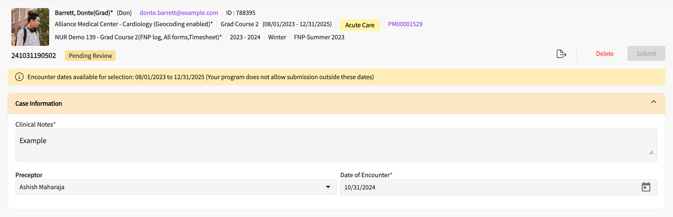
Running the Patient Log Raw Data Report:
The Patient Log Raw Data Report is used to view all of your added patient logs according to your desired criteria.
To Run the Raw Data Report:
- Navigate to the Reports tab of the Learning Activities section. And click on the Patient Log Raw Data Report.

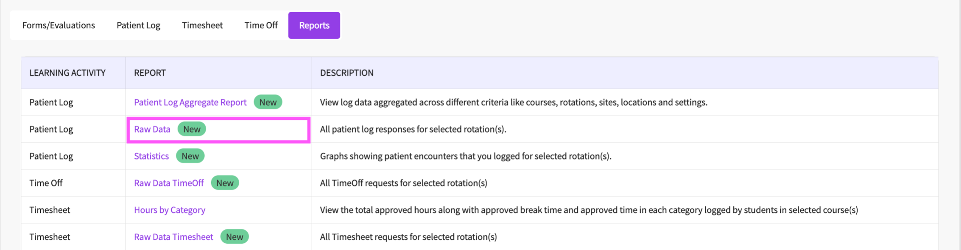

- Select the course offerings to run the report on using the Select Course Offerings button.
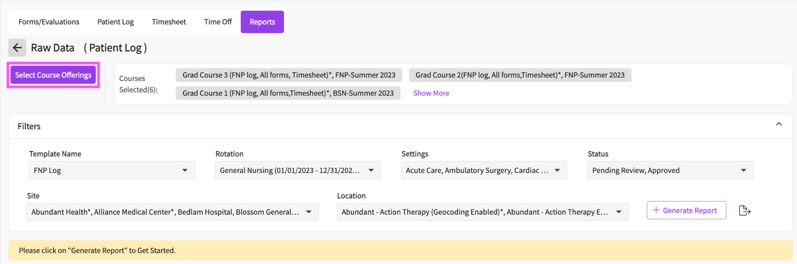
- Configure the report by selecting the rotations, placement settings, submission statuses, sites, and locations you would like to run the report on.
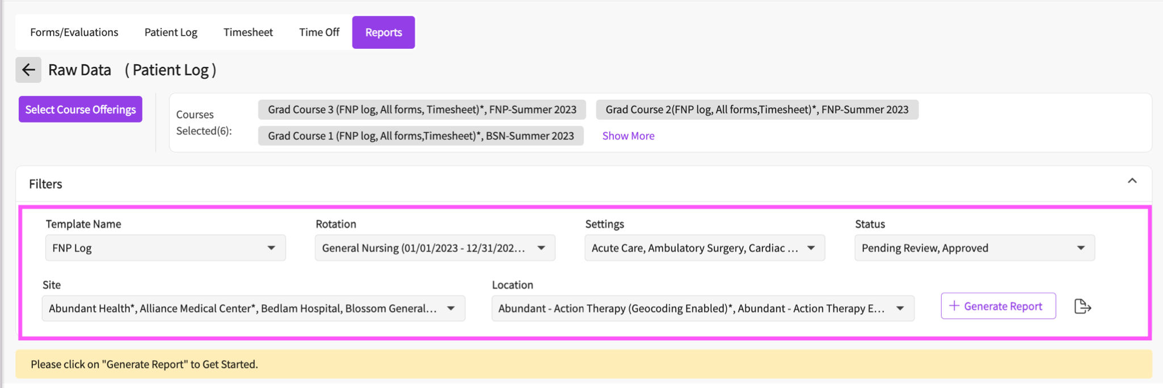
- Click on the generate report button.
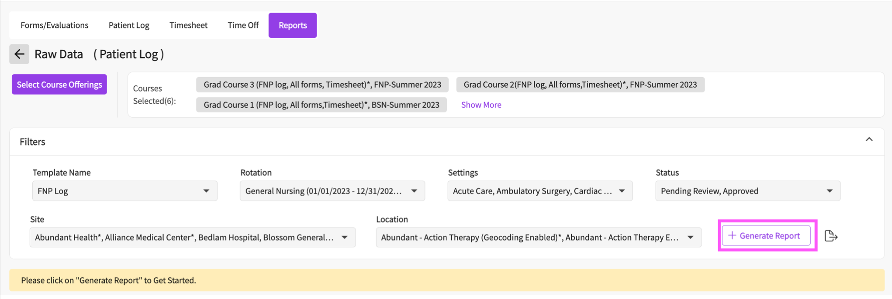
- In the report below there will be a row for each log entry. You can view the date indicated on the log, the log status, course for which the log was added, placement information, and the patient log information. You can scroll right to view all the options selected on each clinical log.
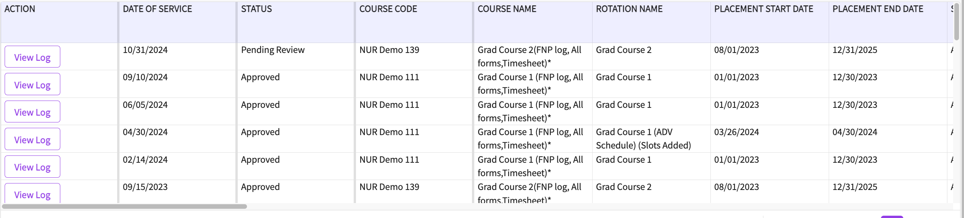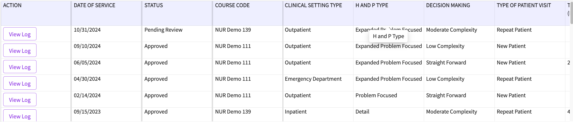
- Click on the download icon to the right of the generate report button to download the report for offline access.
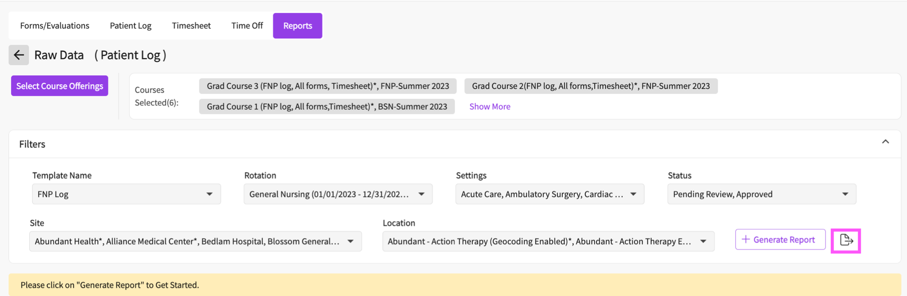
- To view the log in a separate browser tab, click on the view log button.
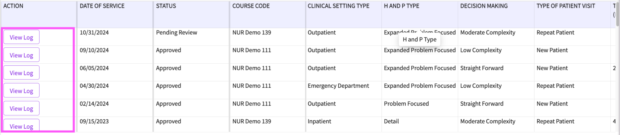
- You can then view and make changes to this patient log. Be sure to save or submit once you are finished.
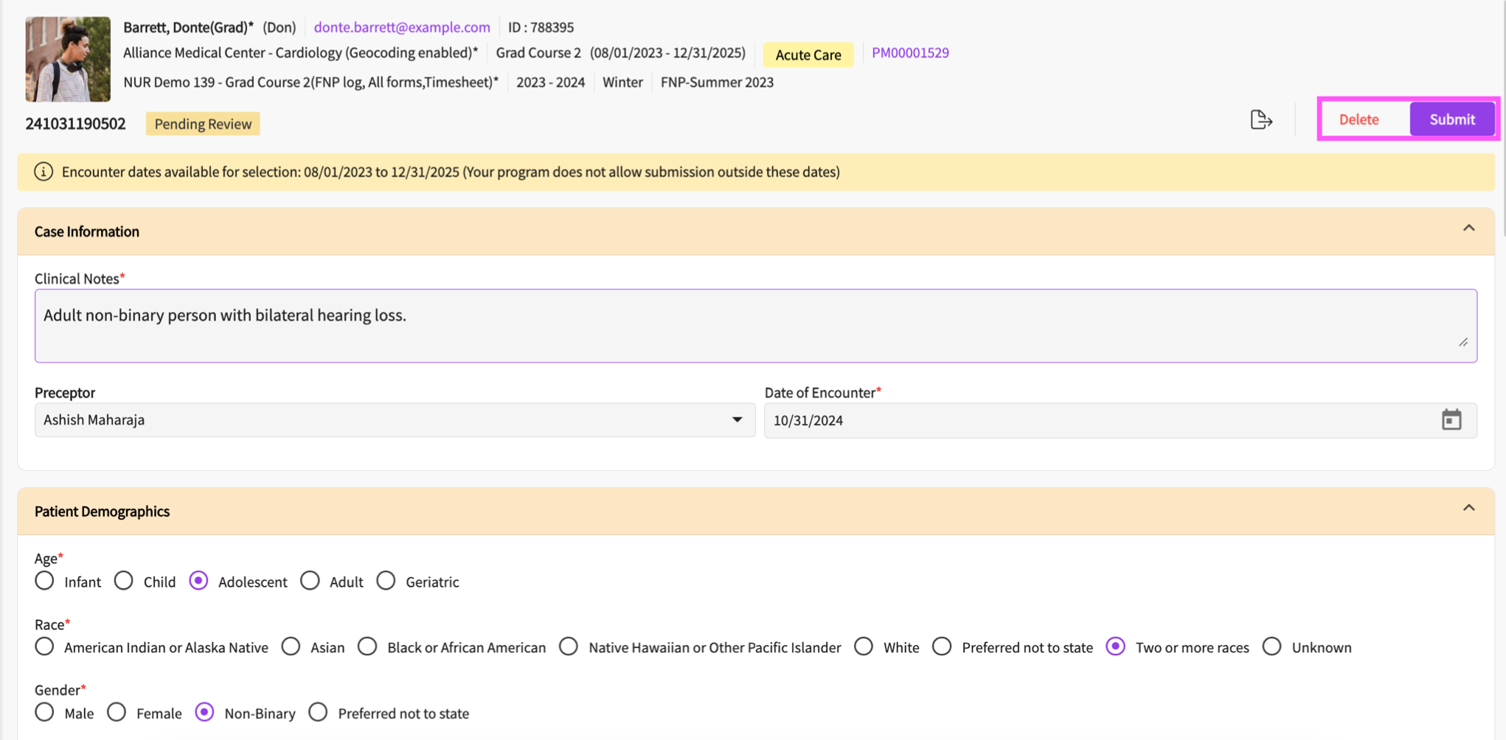
Troubleshooting:
There can be several reasons why you are not able to add a patient log.
Placement Dates: You can fill and submit your patient logs only within your placement start and end date window for the course. You cannot enter or submit patient logs for dates outside of the placement period. If you need to adjust your placement date window, please contact your school.
Restricted Date Choices: If you are unable to select dates or they appear greyed out, your school may have placed limitations on the number of days you are allowed to enter patient log away from the current date. Please reach out to your school to request changes to the setup of these limitations.
Browser Issues: If it seems that parts of your patient log are not loading correctly, try logging out and logging back in or try logging in using a private browser. Additionally, clearing the cache and cookies of your browser may resolve the issue.

