Tenant Level Contracts and Sites Management
The common contract or tenant-level contract serves as a central repository for adding and managing all contracts at the school or tenant level. This contract information can also be extended from the institutional level to specific programs.
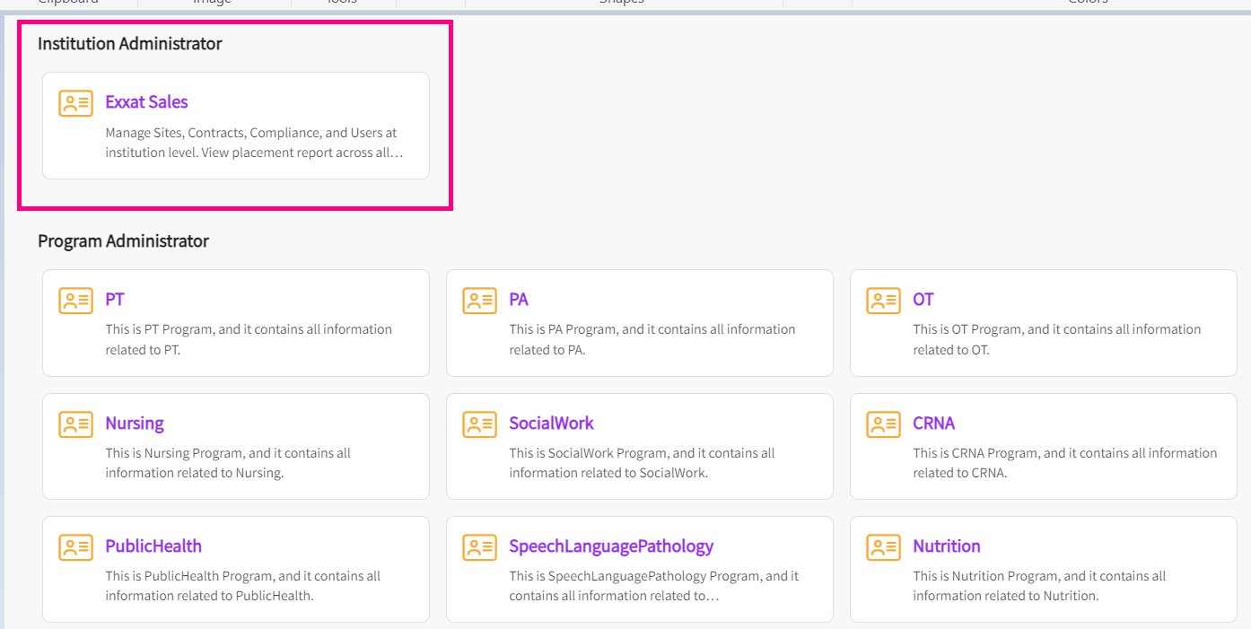

- When you click on the tile for institution administrator, the following dashboard appears:

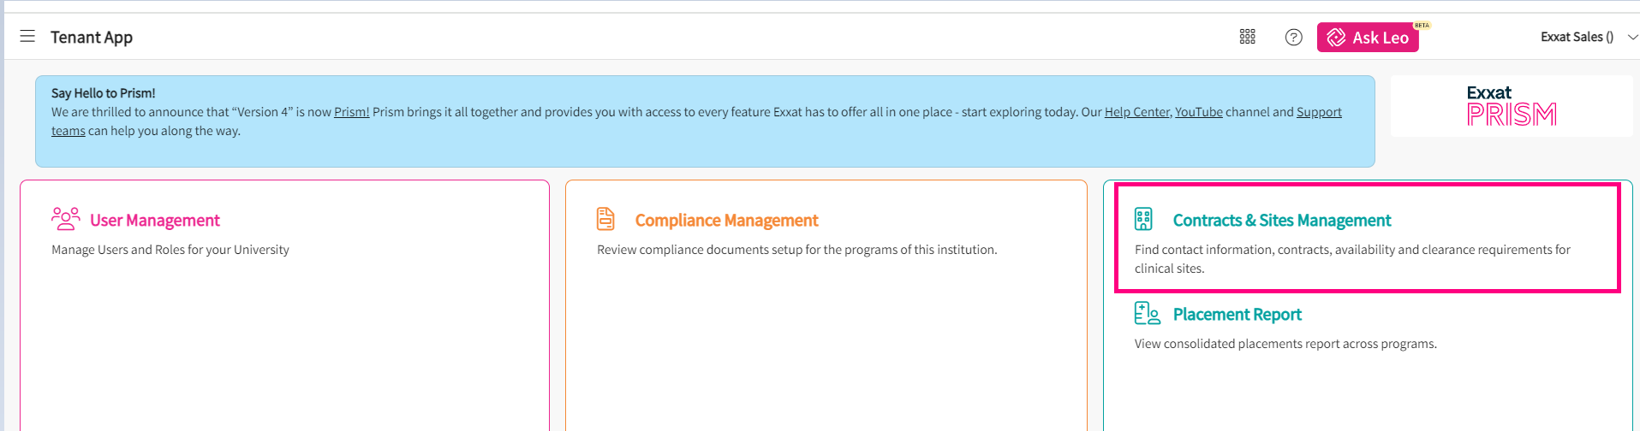

- Click on contracts and site management to view all sites and contracts across all your programs. A dashboard shows up with summary of all contracts, their status spread across all programs. You can switch to list view from here.

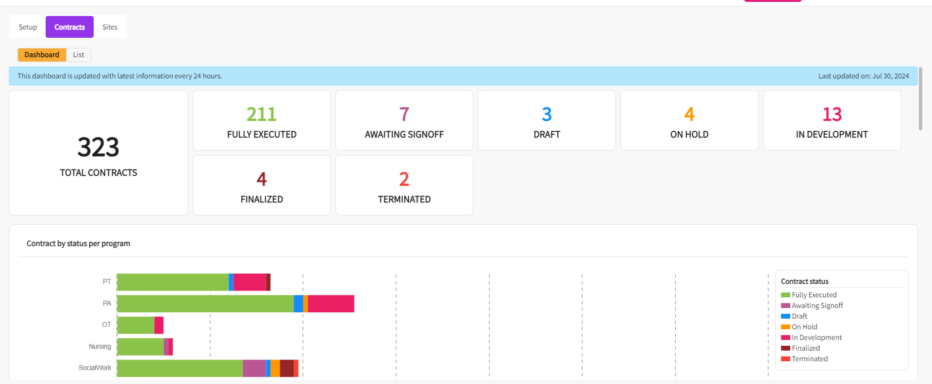

- On the list view, you will be able to see all the contracts and can make changes to it as required. You will find the option to “Add contract” and “export into excel” on right side of your screen.
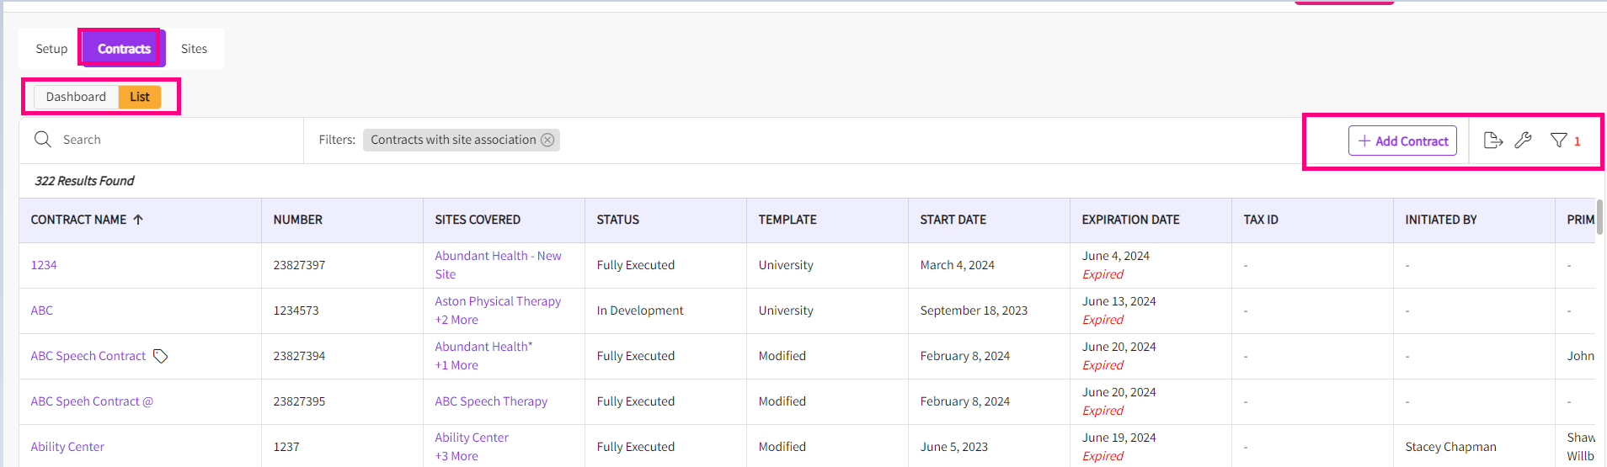

Adding contract:

- Click on Add contract on the right side of your screen. A drawer pops up where you can fill out the contract details and define the program you want to share the contract with and click on save once done.

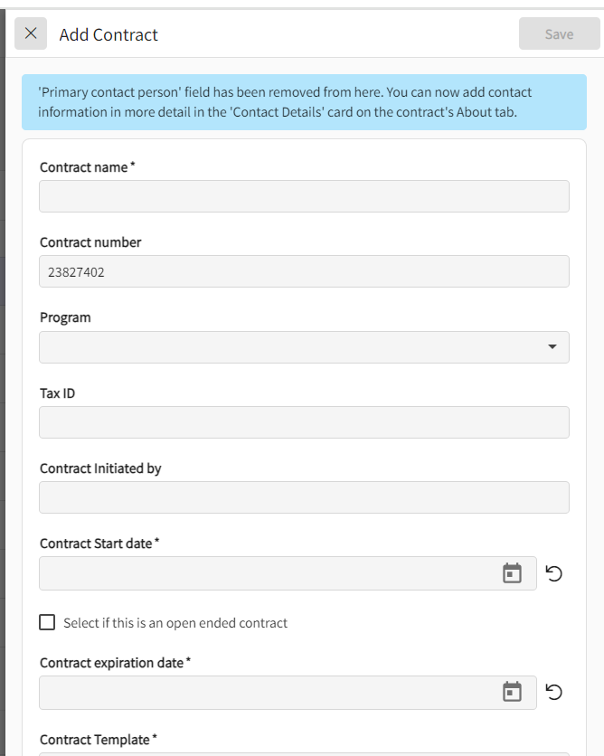

Updating and Managing Contracts

- You can click on the name of any contract that needs to be updated.

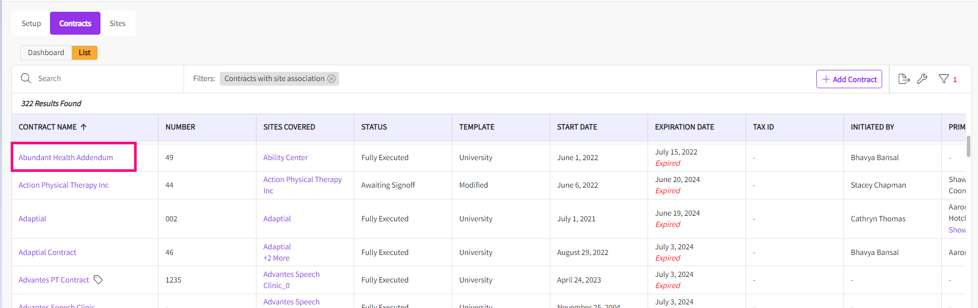

- You will find all the contract details and pencil icons for each card to update the information.

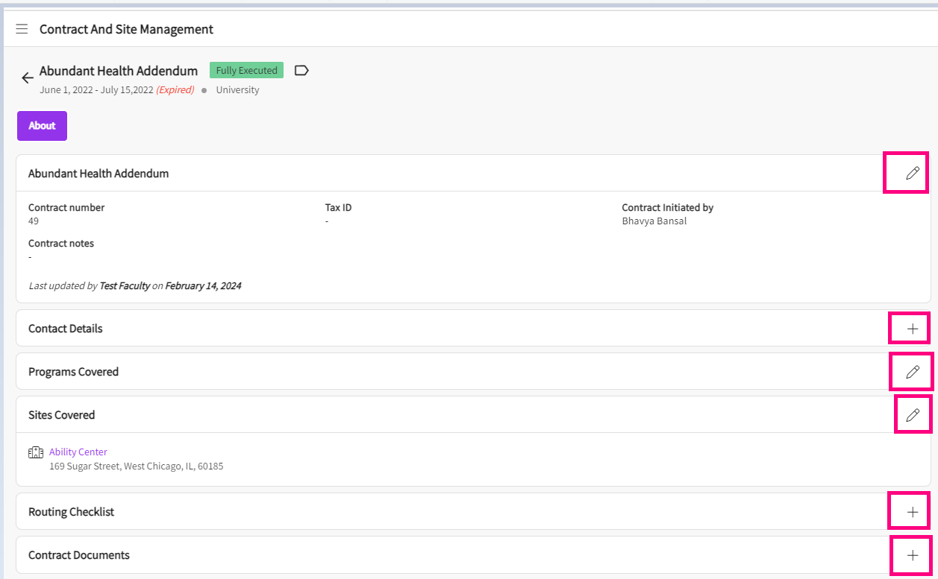

Deleting Contract:

- You can click on name of the contract that needs to be deleted.
- On the right side of the screen, you will find the delete contract button.

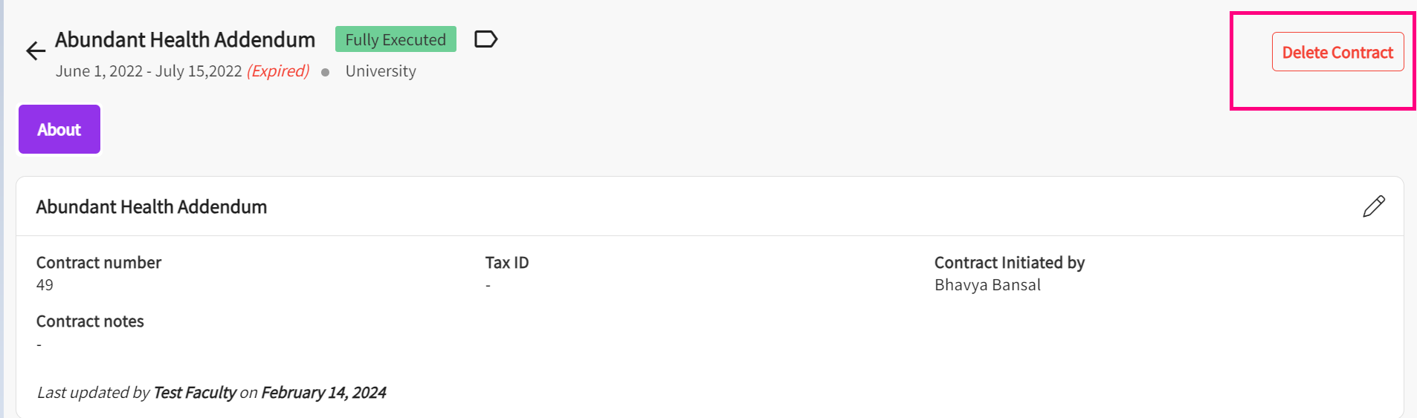
- You can confirm the delete and contract will be deleted.

