Completing Your Student Profile

Your profile is your professional introduction to clinical sites where you will be placed throughout your time in your program. It is important to make a great first impression! Take your time when filling this out, and ensure your information is accurate and updated over time.
- Select Profile from your dashboard or left menu.

- Click on the Profile Tab.
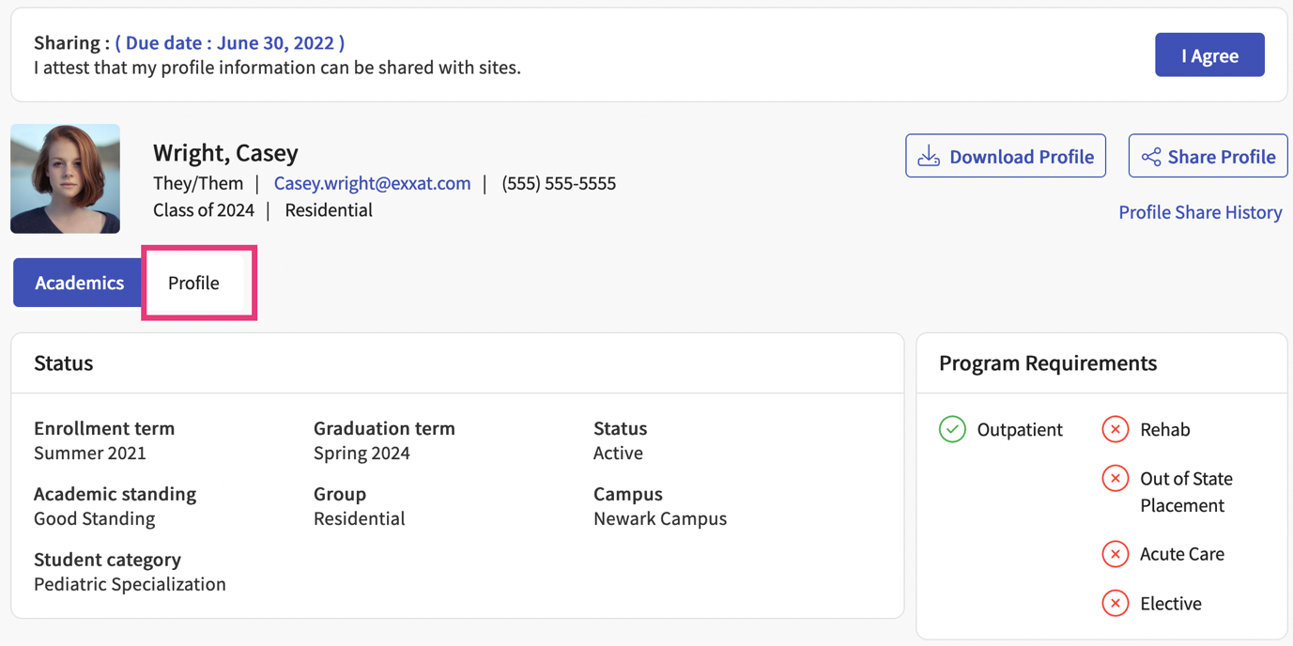
- To upload a profile picture, hover over the gray box and click on the pencil icon.
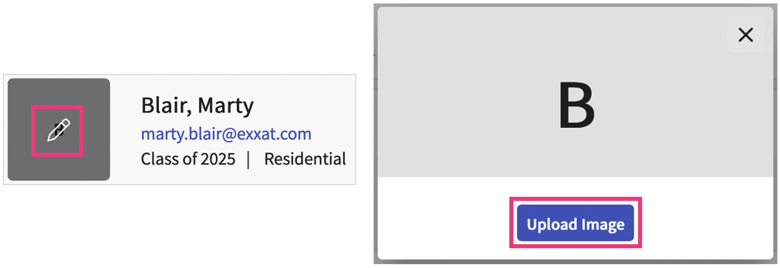

- To delete or change your profile picture, hover over the image and click on the pencil icon.
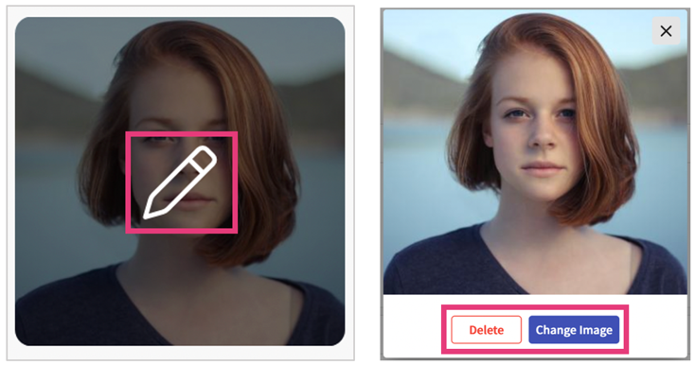

- Your profile will contain the following sections:
a. Demographic information: this is only shared with your program. It will not be shared with clinical sites.
b. Personal & Emergency Contact information
c. Address Information
d. Summary
e. Areas of professional interest
f. Resume
g. Education
h. Work experience
i. Membership
j. Licensure
k. Skills and Accomplishments: this will include Continuing Education information, publications, language skills, certifications, honors and awards, and other scholarly activity.
- For each section, click on the + icon to add information.
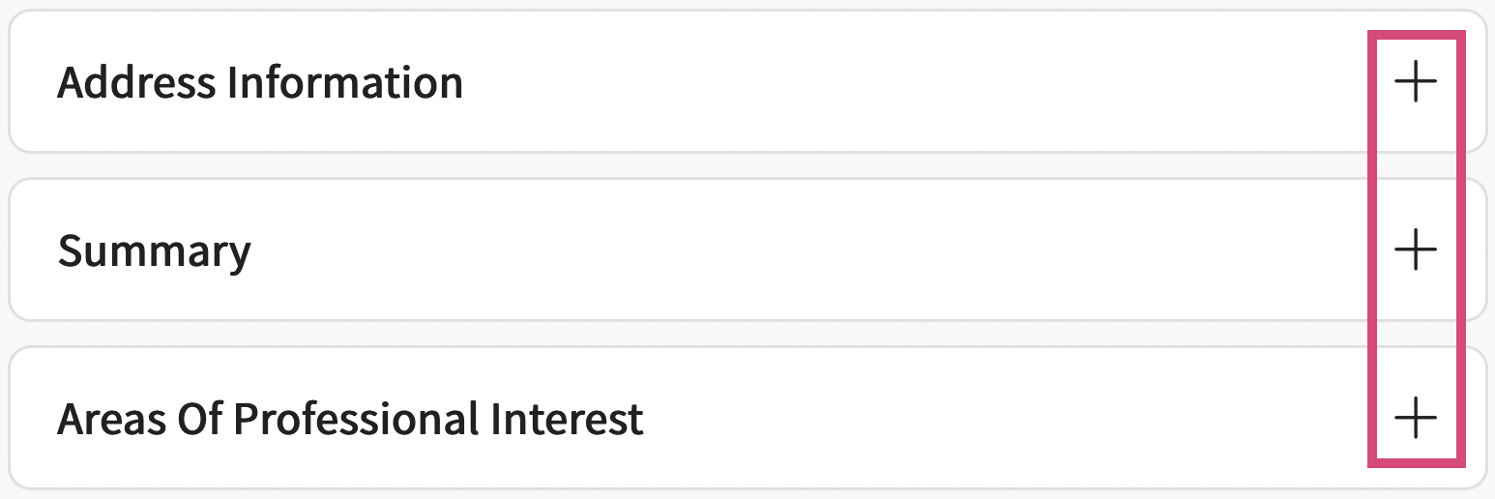

- A drawer will open where you can add details. Click Save when done.
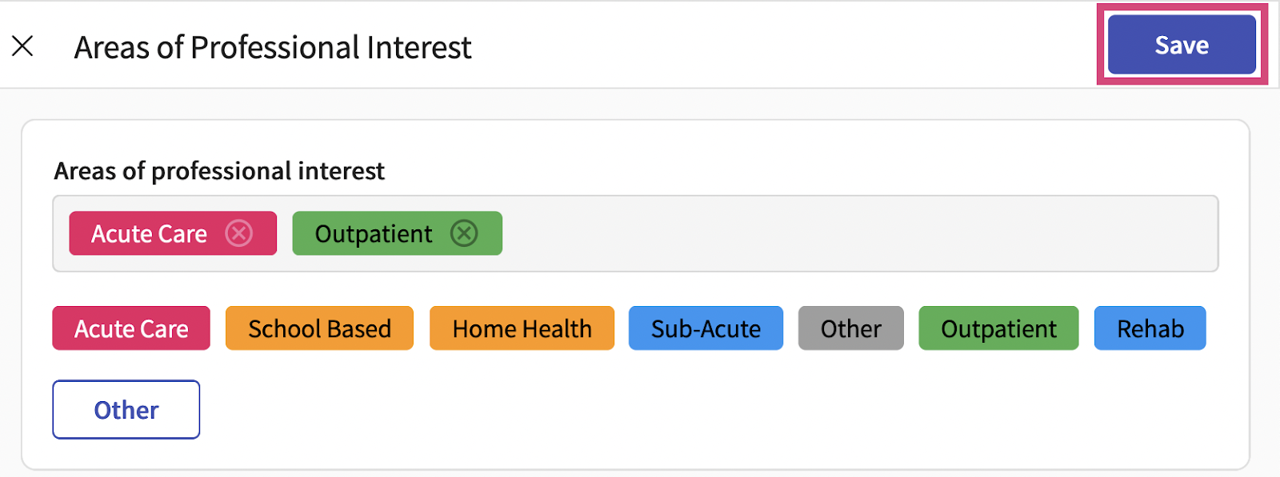

- To modify any information you have previously entered, click on the pencil icon for that entry. A drawer will open, click Save when done.
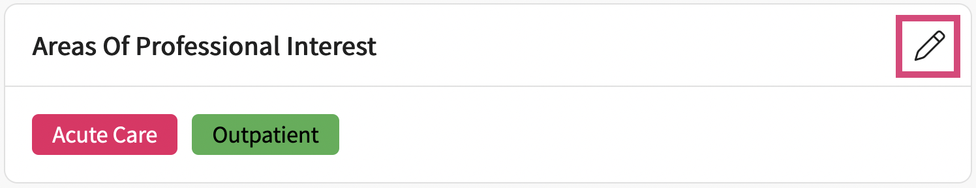

- To delete an item entirely, click on the pencil icon for that entry. Once the drawer opens, click on the vertical ellipsis, and select Delete.
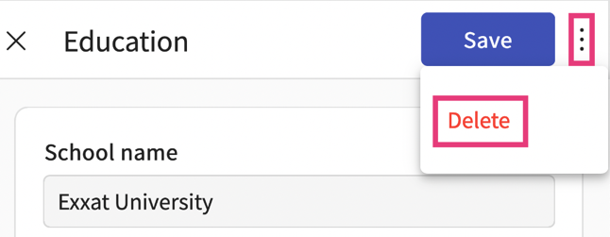
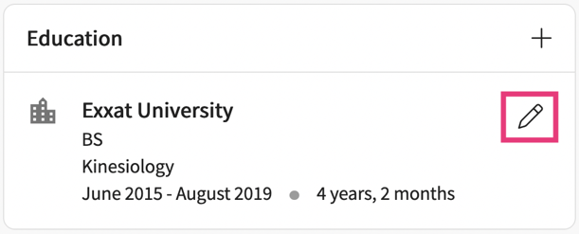

- To upload a resume, you can click on “browse to upload” or drag and drop your file.
  - To delete your resume, click on the trash bin icon.
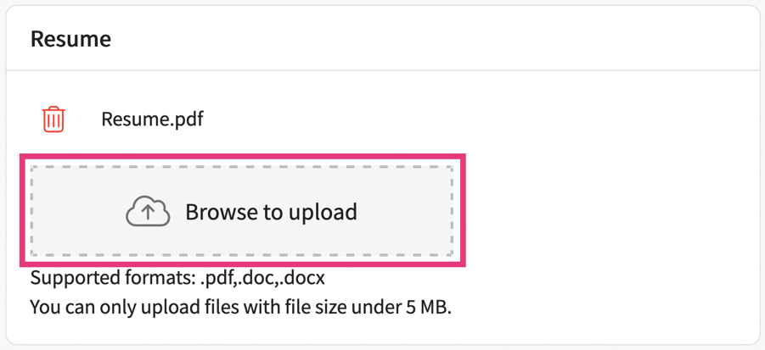
- Completing Additional Profile Details: Your school may have specific questions they want to ask their students.
- Click on Get Started option to access & submit the questionnaire added by the school
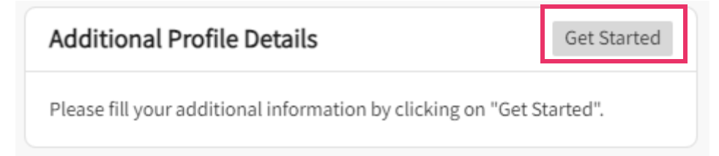
- You can find the list of all the questions and textbox to add your answers. Rich textbox editor allows students to respond in a formatted manner respectively.
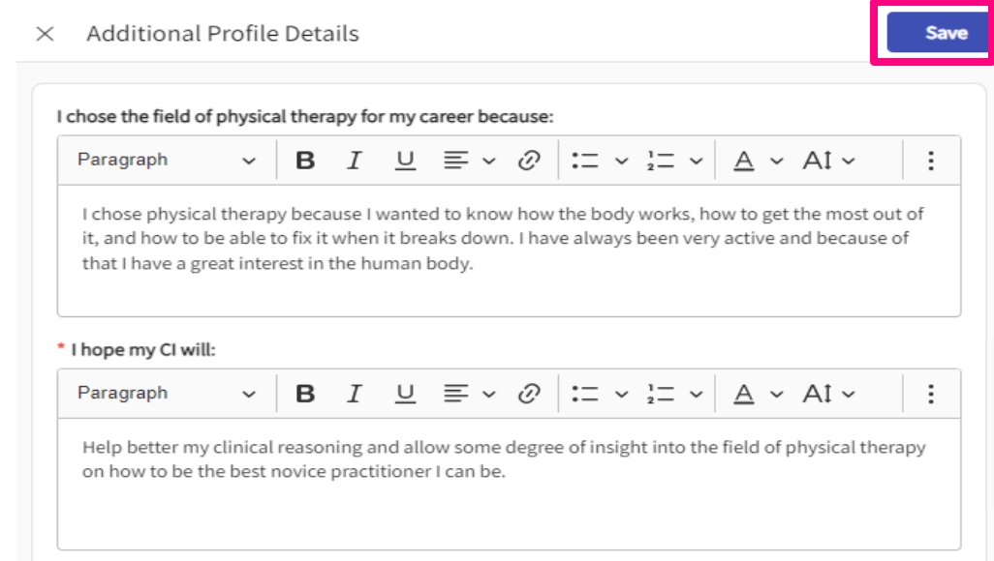
- Click on Save button to save your progress
