# Managing Course Activities – Activating Patient Logs

Within Exxat, your students can add patient encounters for you to track and review during a placement.

1. Select Courses from your dashboard or left menu.  
   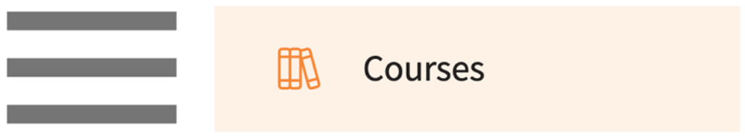
2. Select the course you’d like to manage.
   1. Use the search or filter options to quickly find what you’re looking for.  
      A screenshot of a computer

      Description automatically generated
3. Expand the Learning Activities option on the left panel and select Setup.  
   A screenshot of a web page

   Description automatically generated
4. Another pathway you can take is by going to Learning Activities from your dashboard or left menu.  
   A blue rectangle with black text

   Description automatically generated
5. Find and the course you’d like to manage and click Setup from the action column.  
   A screenshot of a computer

   Description automatically generated
6. The system will load all learning activities and will indicate any that are activated. Click on the pencil icon for Patient Logs.  
   A screenshot of a login page

   Description automatically generated
7. A drawer will open. Make sure to activate the patient log and set your preferences. Once done, click on save.
   1. **Select Log Type**: our support team will create any patient logs that you’d like to utilize. Please contact [v4support@exxat.com](mailto:v4support@exxat.com) for any changes to existing logs or creation of new log types.
   2. **Log must be created within days of patient encounter**: limit how far back in time your students can go to log encounters.
   3. **Customize columns displayed when reviewing patient logs**: set the columns shown to reviewers
   4. **Enable attestation**: show verbiage for acknowledgement by each reviewer (applicable to all reviewers: school, faculty, educator).  
      A screenshot of a computer

      Description automatically generated
8. Once you click on save, you will see the status for the patient log as ‘Activated’.  
   