Courses Overview
A “course” is what a student will enroll in. It is a stand-alone element that can be used time after time. Courses are the foundation of any academic program. You only have to create a course once. Just as the registrar’s office at your academic institution recognizes a course, such as PA 601, and allows students to register for it at any time the department offers it, Exxat STEPS allows the same.
Like a syllabus, each course will have specific learning activities that students complete during that course such as specific evaluations and assignments. Each time a student participates in this course, these activities will be presented to the student for completion.
Get familiar with the Courses section within the system!
- Select Courses from your left menu or dashboard.

- You’ll be taken to the course offerings page, but will have access to:
  - Setup
  - Course Catalog
  - Course Offerings
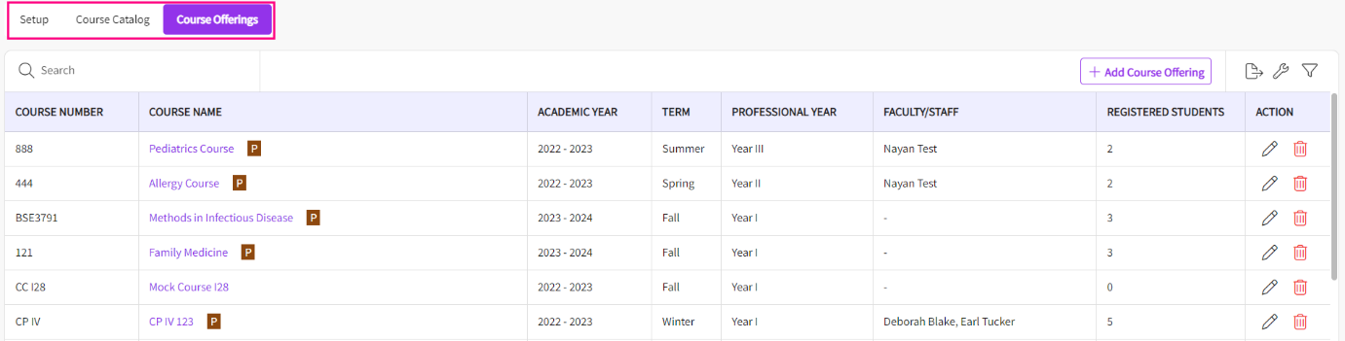

Setup Section
- Within Setup, you can add the details of your Academic Calendar such as Term, Professional Year, and Academic Year.
  - Term: Indicate the specific semester during which the course will be available, such as Fall, Spring, or Winter.
  - Professional Year: Denotes the level of student by academic year of the program during which the student is expected to complete the course, categorized as Year 1, Year 2, Year 3, etc. This is dependent on the length of your program
  - Academic Year: Specifies the academic year in which the course is scheduled to be offered.
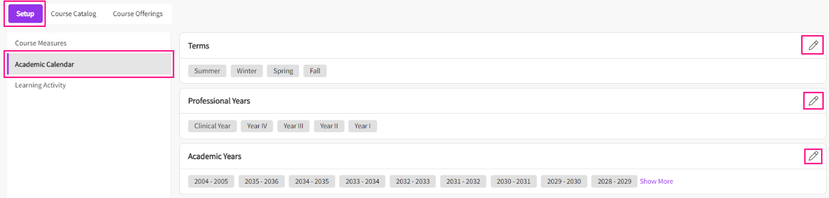
- You can also setup the Learning Activities and decide whether your students can categorize their time entries. Additionally, you can specify the categories from which they can choose.
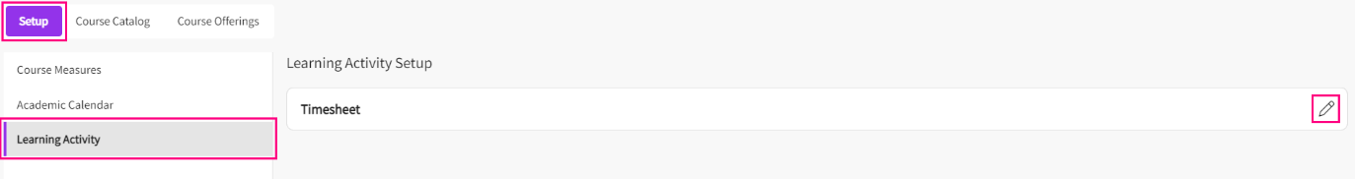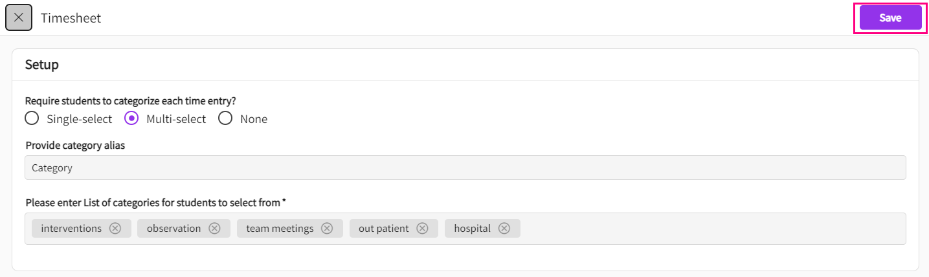

Course Catalog
- The course catalog is where you can add all the courses your program offers. It is a stand-alone element that can be used time after time. You only have to create a course once.
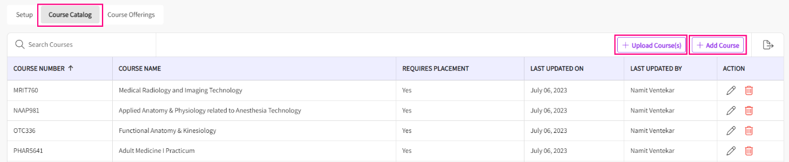
- To Add courses, click on "Add Courses" and provide essential details such as Course Number, Course Name, and specify whether placement is required or not.
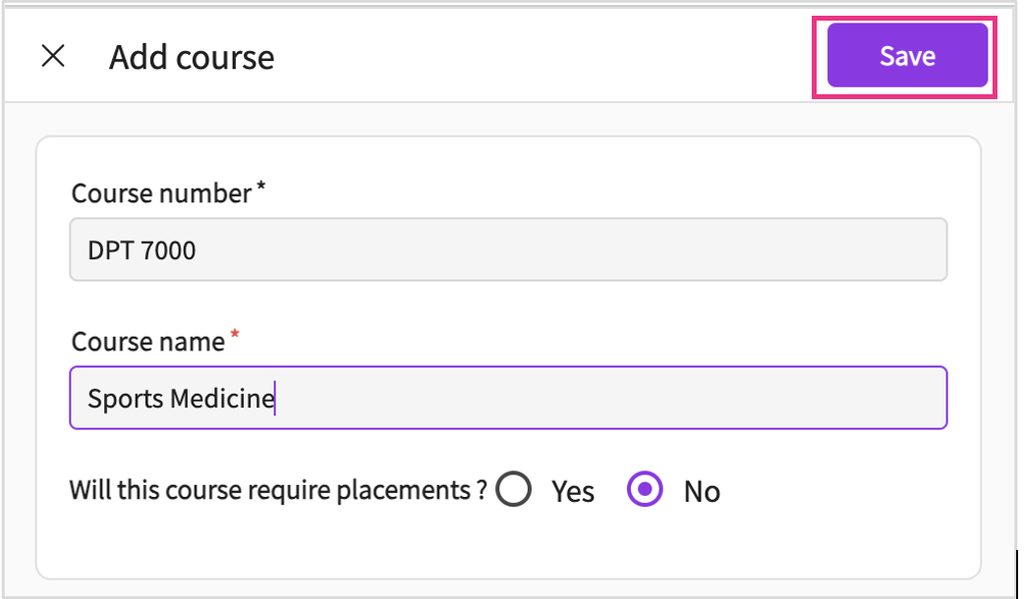
- If you prefer to import multiple courses at once, you can click on "Upload Courses," download the template, add your course details to the CSV file, and upload it to the system. Your courses will then be accessible under the courses catalog.
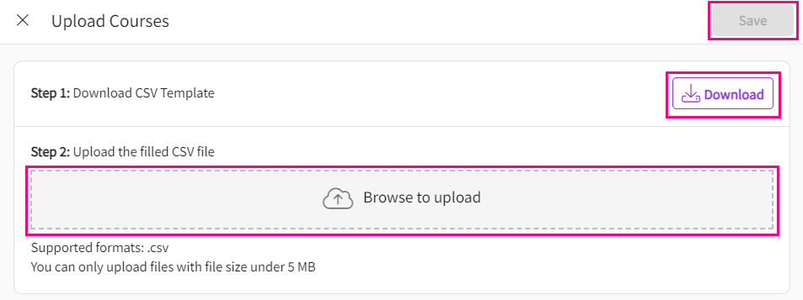

Course Offerings
- Course offerings refer to the courses available to students for enrollment. You'll create a course offering each time the course is available in your program, repeating annually.
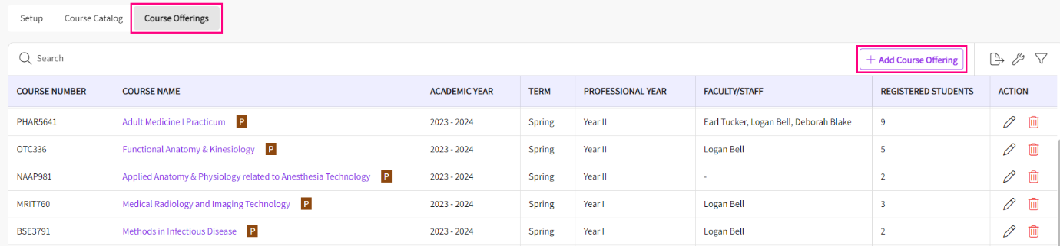
- You can also create a course offering by clicking on "Add Course Offerings" and entering essential details such as Term, Professional Year, and Academic Year, and selecting the specific course. Once you click save, a new course offering will be added to the system. 