Adding Courses to Course Catalog

You can add course offerings within Prism. A course is what a student will enroll in. It is a stand-alone element that can be used time after time. You only have to create a course once.
- Select Courses from your left menu or dashboard.

- You’ll be taken to the course offerings page. Select Course Catalog.
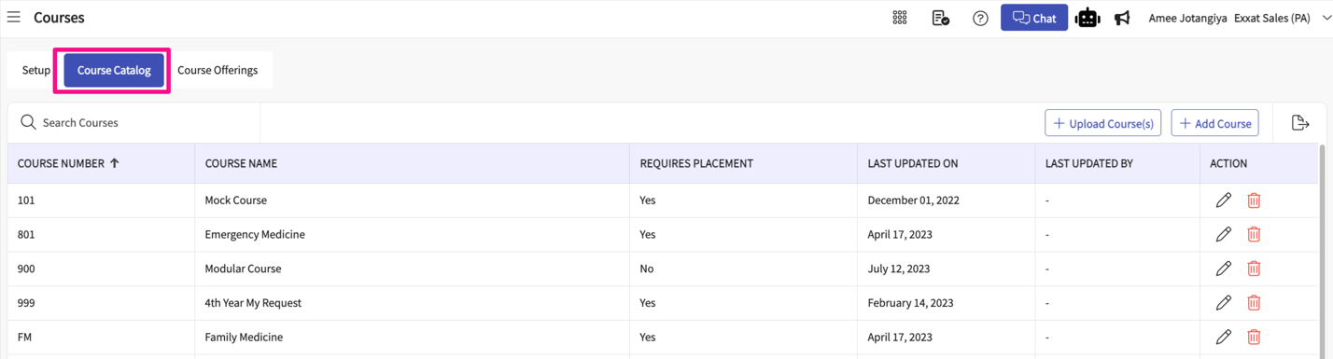

Adding Course
- The page will display all existing courses. You can modify them by clicking on the pencil icon. Click +Add Course.
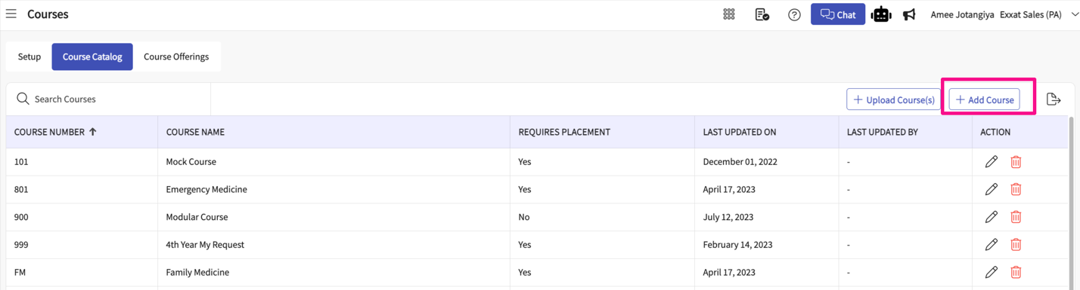
- A drawer will open where you will enter the course number, and course name, and mark whether this course will require placements. Once done, click Save.
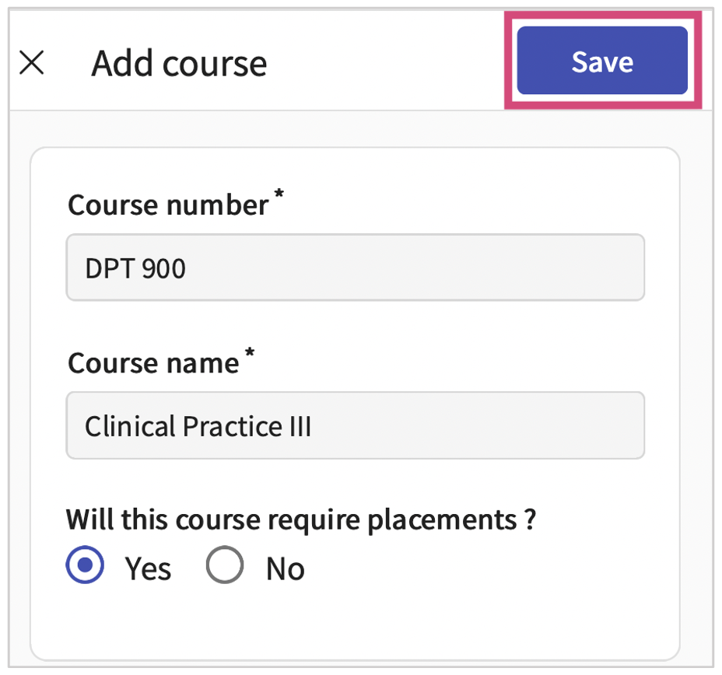

Upload Course
- The page will display all existing courses. You can modify them by clicking on the pencil icon. Click +Upload Course.
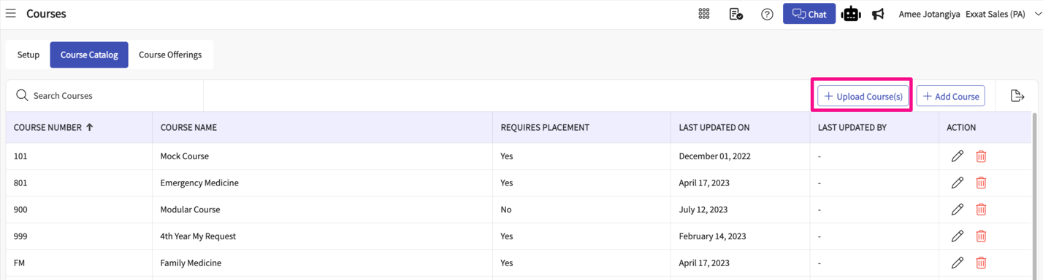
- A drawer will open where you can upload your course catalog data in bulk
- You can click on the download button for the file format which will allow you to upload the courses in bulk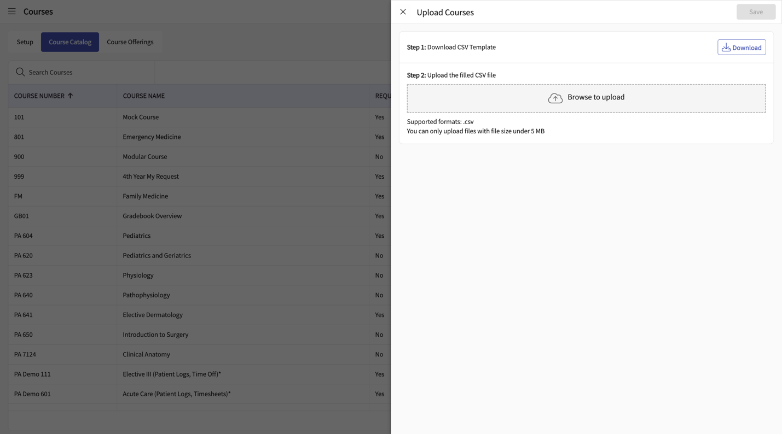
- Click on Save

