Adding & Editing Course Offerings
Once you have created courses within the Course Catalog section, you can begin to associate a course to a specific term, professional year, and cohort. This will allow you to create rotations which will be used for placements.
There are two ways to add a course offering:
1. Add a new course offering
2. Clone existing course offering

Let's learn about Adding a new course offering
- Select Courses from your left menu or dashboard.

- You’ll be taken to the course offerings page. The page will display all existing course offerings. Click +Add Course Offering.
  - To modify an existing course offering, click on the pencil icon. To delete a course offering, click on the trash bin.
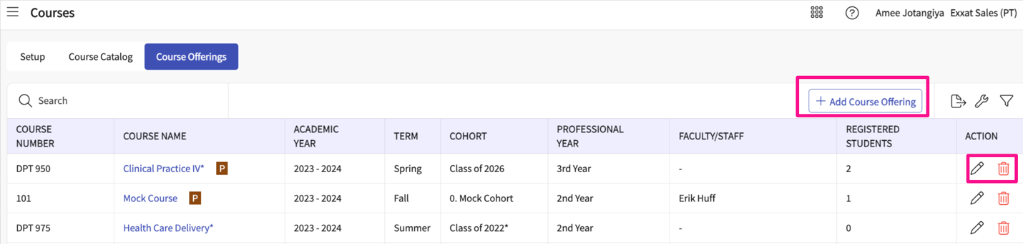
- A drawer will open where you can enter the following information. Click Save when done.
  - Cohort
  - Term
  - Academic year
  - Professional year
  - Click here to add courses: select a course from the dropdown list.
    - Not seeing a course you need? Make sure you’ve added it to your Course Catalog!
  - Courses assigned: any courses associated with the selected cohorts will be shown here.
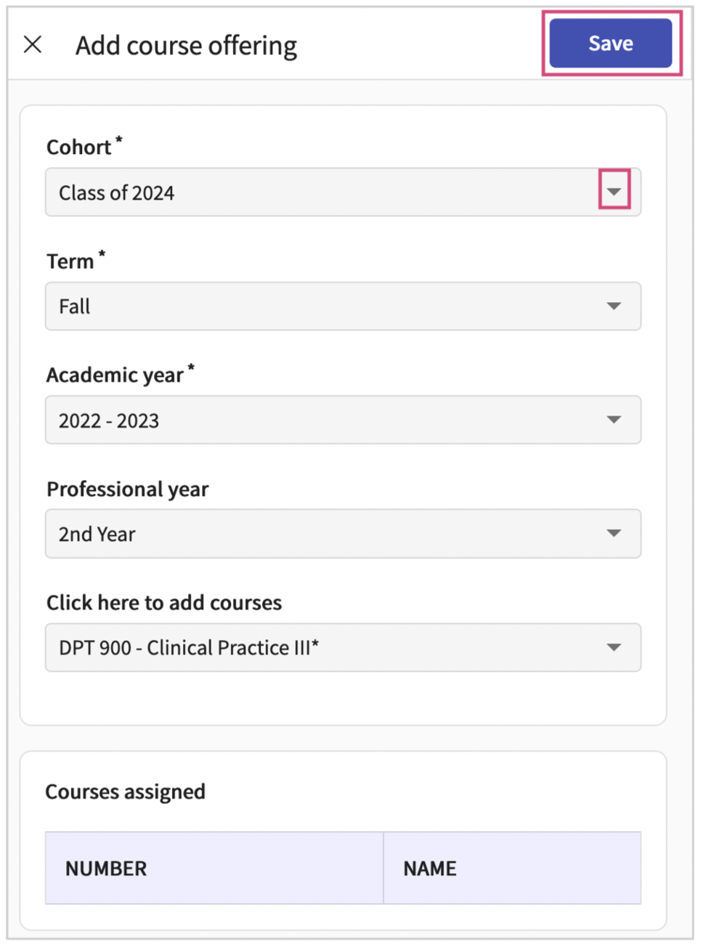

Let's learn about how to clone course offering
Clone from option will allow you to clone the Course offering information section, Resources and LAM setup from any existing course offering to another course offering.
- Select Courses from your dashboard or left menu.

- Select the Course you’d like to manage.
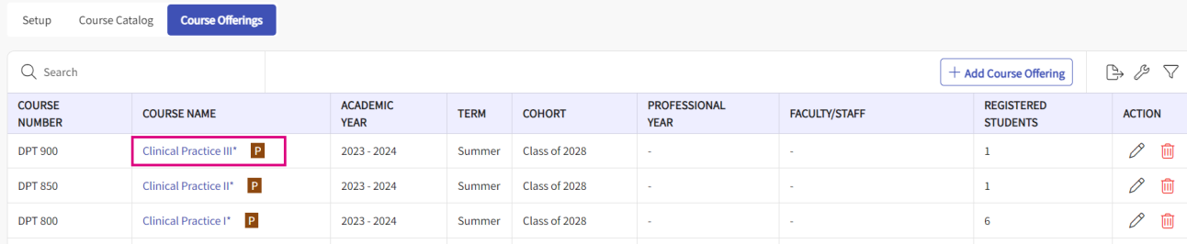
- You’ll be taken to the Course’s About page. In the About page we have the Clone from option available.
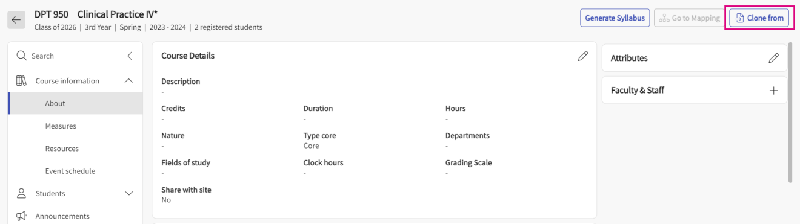
- Click on Clone from the option a drawer will open where all the course offerings will be listed. Select the course from which you would like to copy the Course details, Resources, and LAM, and click next.
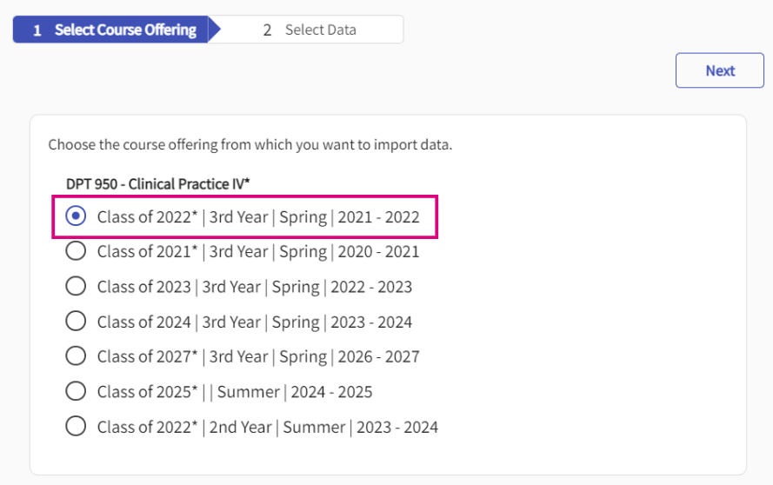
- On the next page, you can decide what info you would like to copy and which you don’t want to copy. Once you are done with your selection you can click save.
