**Key Features for Faculty and Staff Management**

Learn how to effectively manage faculty and staff within Exxat, ensuring seamless access to Prism and optimizing administrative processes.

* [Adding and Inviting Faculty](https://helpcenter.exxat.com/hc/en-us/articles/15612862630289-Key-Features-for-Faculty-and-Staff-Management#h_01HX7XQ1M2HQ60DAXD0H3T9410)
* [Adding Announcements for Faculty](https://helpcenter.exxat.com/hc/en-us/articles/15612862630289-Key-Features-for-Faculty-and-Staff-Management#01HX7XVB7SJ4XF5RZST53KAMKS)
* [Setting Up Faculty Resources](https://helpcenter.exxat.com/hc/en-us/articles/15612862630289-Key-Features-for-Faculty-and-Staff-Management#01HX7XW1RWNMNJCJKP6ZYMXHBD)
* [Control Dashboard Faculty View](https://helpcenter.exxat.com/hc/en-us/articles/15612862630289-Key-Features-for-Faculty-and-Staff-Management#h_01HX7XYQTMV47AK9E7PFWAD4GG)

## Adding and Inviting Faculty

Within Exxat, you can provide your faculty & staff with access to Prism. Once added, their contact information can be shared with Students and Sites.

Faculty & staff must be invited to Exxat Prism to complete their profile, access their courses, student placements, and more. There are 2 ways of sending invitations to faculty or staff:

* Invite them yourself through the system.
* Contact v4support@exxat.com and provide the date, time, and faculty list that should be invited.

If your program uses Single Sign On (SSO), which allows users to use one set of login credentials(for example: university's credentials) to access applications.

**Adding Faculty & Staff**

1. Select Faculty & Staff from your left menu or dashboard.A pink sign with black text

   Description automatically generated
2. The page will load all faculty & staff previously added will show up. To add a faculty or staff, click +Add Faculty/Staff.  
   A screenshot of a computer

   Description automatically generated
3. A drawer will appear on the right-hand side of the page.
   1. Please note that first name, last name, email address, and position are mandatory before you can save.  
      A screenshot of a contact form

      Description automatically generated
4. Each faculty & staff member will have a profile of their own where they can add additional information. To view and edit this information, click on the user’s name.   
   A screenshot of a contact list

   Description automatically generated
5. The faculty & staff profile will contain the following sections:
   1. Profile
   2. Teaching
   3. Scholarship
   4. Service
   5. Associations  
      A screenshot of a computer

      Description automatically generated
   6. If your school uses SSO(Single sign-on service), make sure to enter the SSO Key in the faculty Profile section.
   7. Click on the pencil icon to add the key. This will allow you to share an SSO invite with your faculty member.  
      A screenshot of a computer

      Description automatically generated

**Inviting Faculty & Staff**

1. Select Faculty & Staff from your left-menu or dashboard.  
   A pink sign with black text

   Description automatically generated
2. Click on Setup and then select Invite Faculty.  
   A screenshot of a computer

   Description automatically generated
3. The page will load all active faculty & staff in the system who have not yet activated their accounts.
4. Once you have found the faculty & staff you’d like to invite, select them using the open checkbox and click Invite Faculty.
   1. You can easily verify whether an invitation has been sent, or if a faculty & staff account is active by checking the Account Status column.  
      A screenshot of a computer

      Description automatically generated
5. A pop-up will appear informing you of the limited access your faculty & staff will receive. Click Proceed.  
   A screenshot of a computer screen

   Description automatically generated
6. Faculty & staff access looks a bit like this:  
   A screenshot of a computer

   Description automatically generated
7. If you’d like to provide your faculty & staff with full administrative access, please contact [v4support@exxat.com](mailto:v4support@exxat.com). Administrative access looks a bit like this:
   1. If your faculty & staff already have administrative access, they will get access to both views.  
      A screenshot of a computer

      Description automatically generated
8. A drawer will open showing you a 3-step process you’ll complete to send invitations. The first step will list all the faculty & staff you are inviting. Click Next.
   1. Override recipient’s email: used for testing purposes, if an email is entered here the invitation will be sent to that user instead of the faculty or staff.
   2. Reply to: if a faculty or staff responds to this email, the reply will be sent to the email entered here.
   3. CC or BCC any users as needed.
   4. Upload files as needed.  
      A screenshot of a computer

      Description automatically generated
9. In the second step, you will review the email that will be sent to the faculty & staff. The default email template will be the Standard template, but you can choose from others or create a new template.
10. While adding a new template please make sure you include the merge field "@Invitation Link" to your newly created template. This will ensure that your faculty can click on the link to access their profile on Exxat Prism.
11. Click Preview.  
    A screenshot of a email

    Description automatically generated
12. On the third step, you’ll then decide when to send your emails! You can send your email immediately or schedule it for a specific date and time. Click Send.  
    A screenshot of a computer

    Description automatically generated  
    A screenshot of a computer

    Description automatically generated
13. The drawer will close, and you’ll get a message confirming your emails were sent successfully.  
    A green rectangular object with black letters

    Description automatically generated
14. The grid will update showing you when you last sent an invitation in the Account Status column. Once the faculty successfully logs in, the status will change to Activated.  
    A screenshot of a computer

    Description automatically generated
15. See the example below, an email will be sent to the faculty using which they can create their accounts in Exxat Prism  
    A screenshot of a computer

    Description automatically generated

## **Adding Announcements for Faculty**

You can share important messages with your faculty and staff via announcements!

1. Select Faculty & Staff from your left-menu or dashboard.  
   A pink sign with black text

   Description automatically generated
2. Select Setup from the ribbon at the top of the page.  
   A screenshot of a computer

   Description automatically generated
3. Select Announcements from the left panel.  
   A screenshot of a computer

   Description automatically generated
4. The page will display all existing announcements. Click +Add Announcement.
   1. To edit existing announcements, click the pencil icon.
   2. To delete existing announcements, click the trash bin.  
      A screenshot of a chat

      Description automatically generated
5. A drawer will open. Provide the start and end time, title and description. Once done, click Save.  
   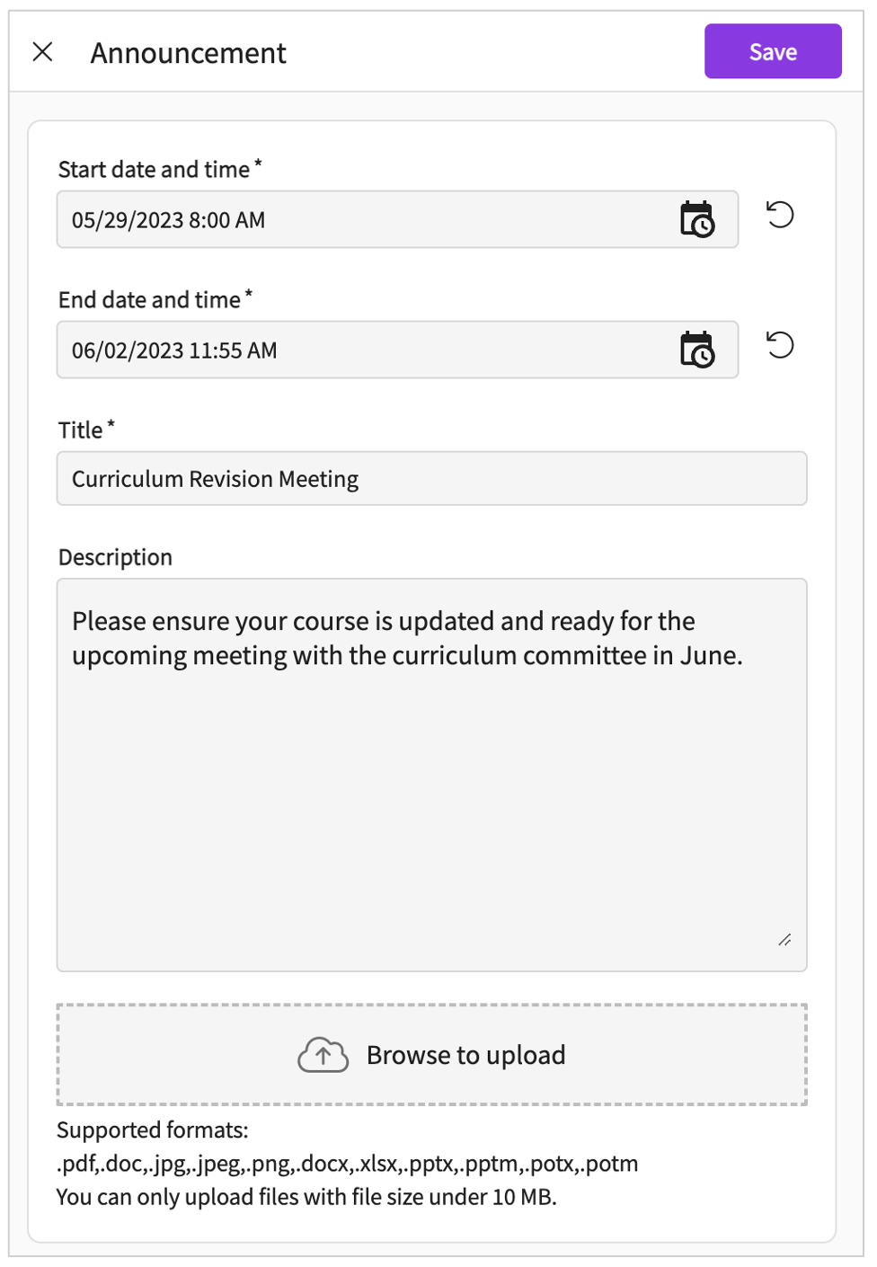
6. Your announcement will be displayed on the list. Live announcements will be displayed to faculty and staff on their dashboard screen.  
   A screenshot of a email

   Description automatically generated

## Setting Up Faculty Resources

You may want to share resources with your faculty and staff. Read on to learn how!

1. Select Faculty & Staff from your left-menu or dashboard.  
   A pink sign with black text

   Description automatically generated
2. Select Setup from the ribbon at the top of the page.  
   A screenshot of a computer

   Description automatically generated
3. Select Resources from the left panel.  
   A screenshot of a computer

   Description automatically generated
4. The page will display your program’s existing Category List. Select an option to view resources available.  
   A screenshot of a computer

   Description automatically generated
5. Not seeing any options within the category list, or would you like to update your list? Click on the pencil icon.  
   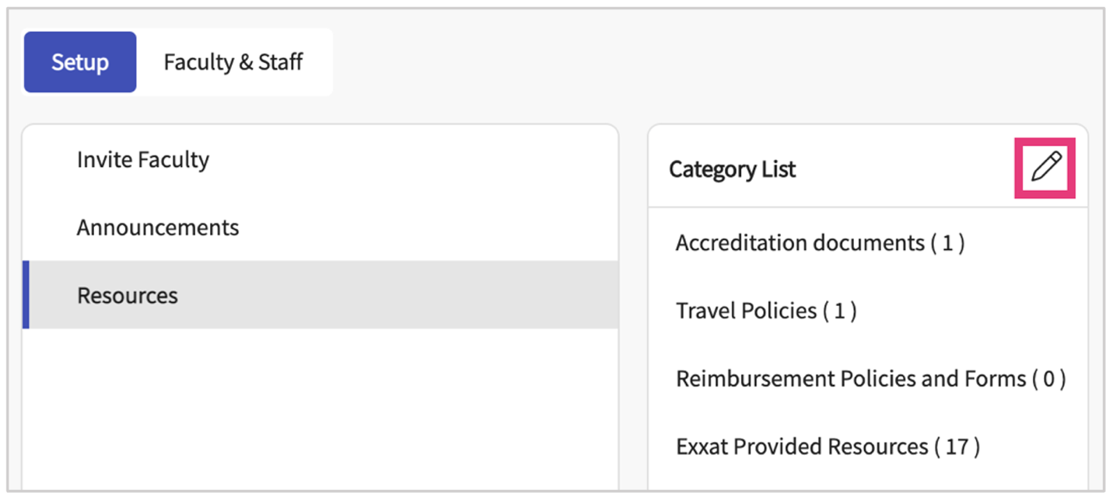
6. A drawer will appear showing you all your categories. Make all necessary changes and click Save once done.  
   A screenshot of a computer

   Description automatically generated
7. Once you select an item within the category list, you will see all resources added for that category.
   1. To edit an existing resource, click on the pencil icon.
   2. To delete a resource, click on the trash bin.  
      A screenshot of a computer

      Description automatically generated
8. To add a new resource, click +Add Resource.  
   A close-up of a sign

   Description automatically generated
9. A drawer will open. Click on the drop down to select the type of resource you’d like to add.  
   A screenshot of a phone

   Description automatically generated
10. Enter the resource information and click save when done.
    1. **Type**: this will show you the option you have previously selected (document, video, link FAQ)
    2. **Category**: this will default to the category you previously selected from your category list  
       A screenshot of a computer

       Description automatically generated
11. You may want to organize the order in which your resources appear. To do so, select Re-order.  
    A close-up of a sign

    Description automatically generated
12. Use the icon on the left to drag and drop items in the order you prefer. Click Save once done.  
    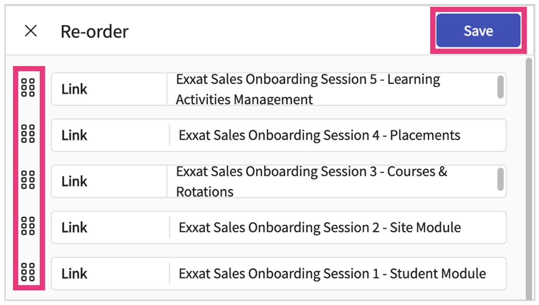

## **Faculty Dashboard View**

Tailor the dashboard experience for faculty and staff by controlling which tiles and features they can access. Navigate to Setup, and adjust visibility settings for dashboard tiles to align with roles and responsibilities.

1. Select the Faculty and Stadd
2. Click on the Setup section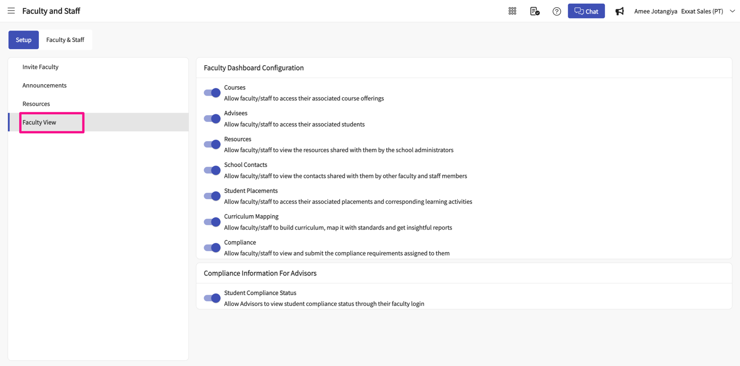
3. Turn off the bit for which you don't want your Faculty and Staff to see  
   