Viewing Student Reports

Once students complete their profile, and you begin entering data in the system, you’ll need to analyze the data! Use our handy reports to find what you are looking for.
- Select Students from the left menu or dashboard.

- Select Reports from the ribbon at the top of the page.
- The reports list will load. The page will list out each report available, with a short description of what that report includes.
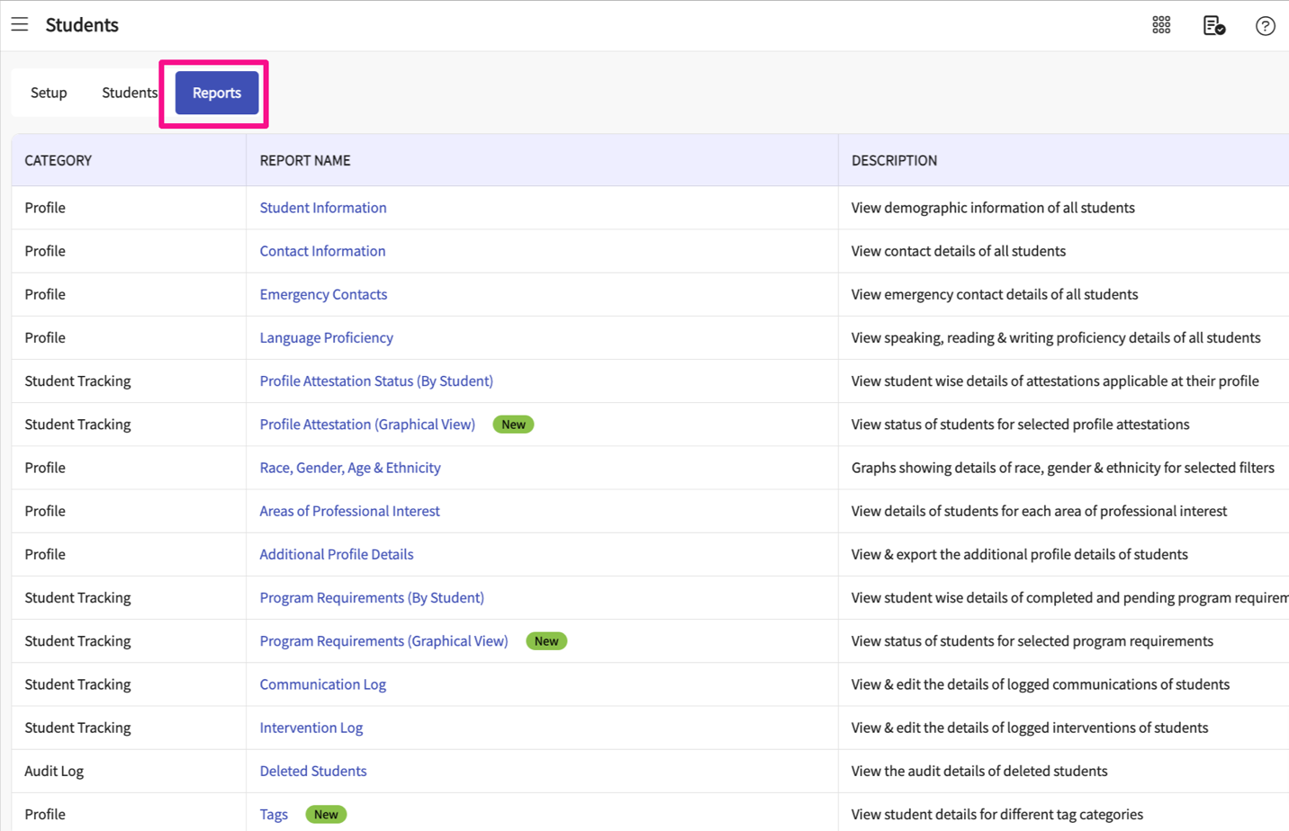
- Many of the student reports will include similar features to help you sort through the data:
  - Export option to excel
  - Ability to edit columns shown on the report, temporarily remove or rearrange the order.
  - Filter option to limit records shown based on different fields like cohort, group, and so on.
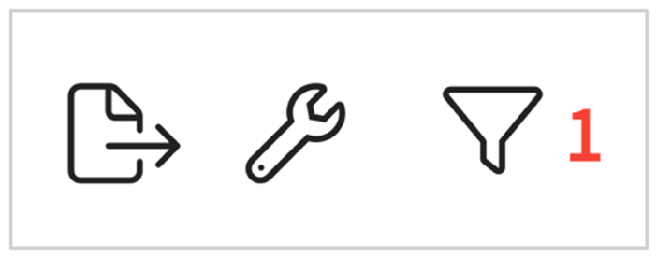
- The Race, Gender, Age & Ethnicity report will look a bit different. This report will show a pie chart for each field. You will first have to select an attribute to view information.
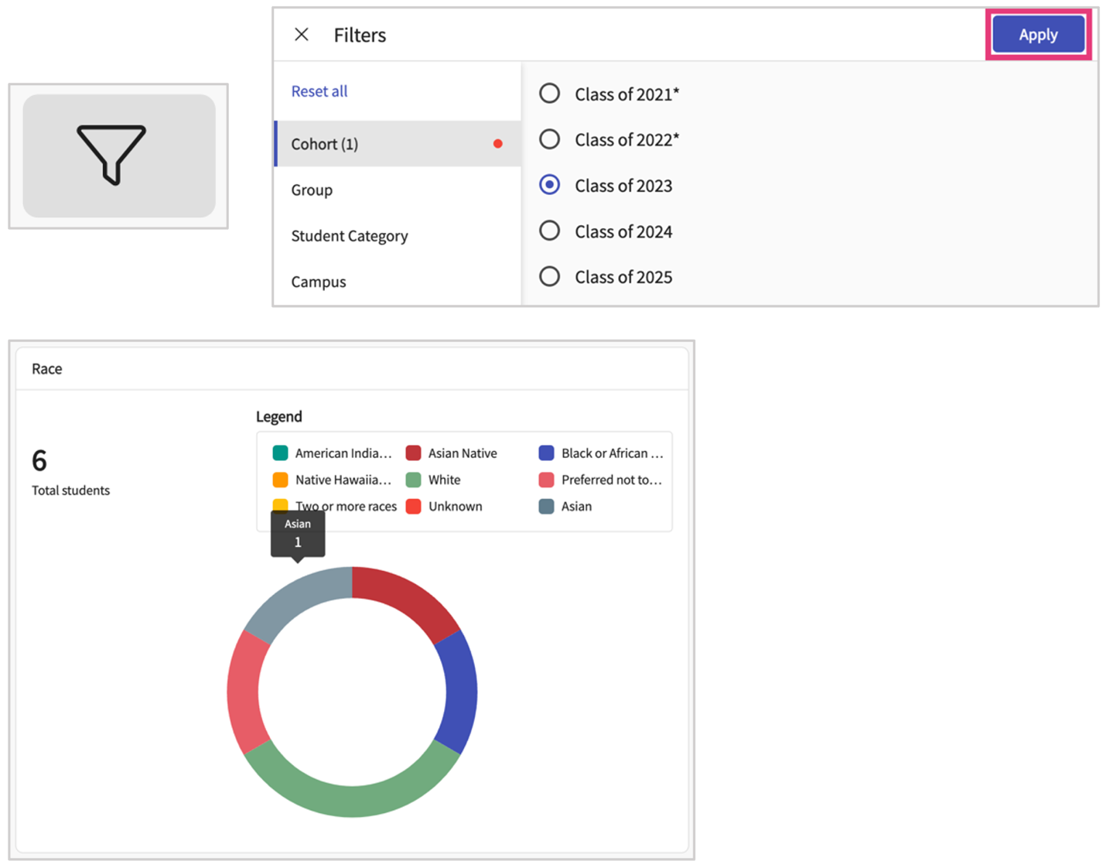
- The Areas of Professional Interest report uses what we call power BI, which finds insights within data to help you organize data sets and showcases via charts and graphs.
  - The bar graphs are clickable. Selecting one of them will filter the list of students below the graph.
  - Clicking on the student’s name will take you to their information page.
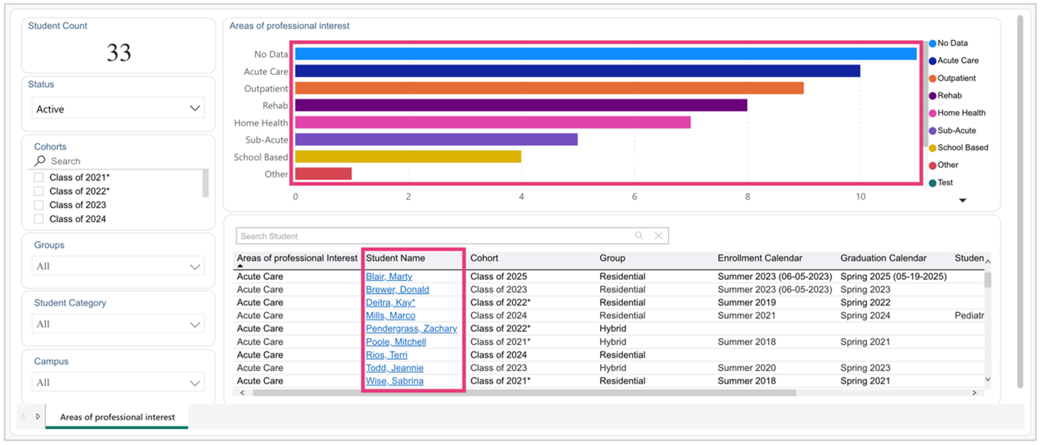
- Here is a full breakdown of the columns each report includes:
  - Student Information
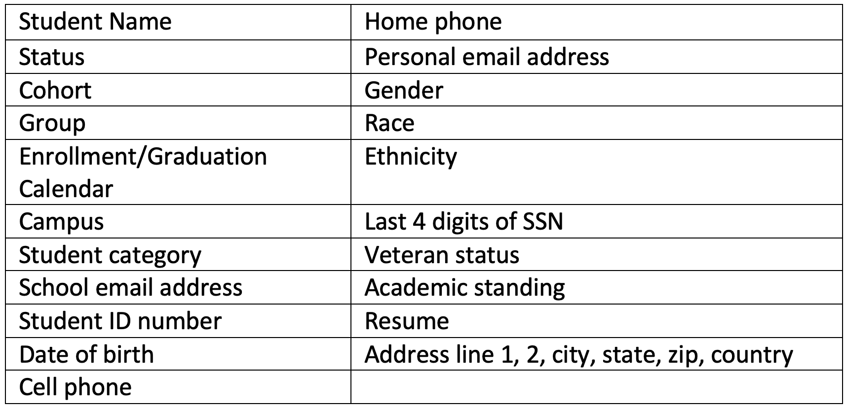
  - Contact Information
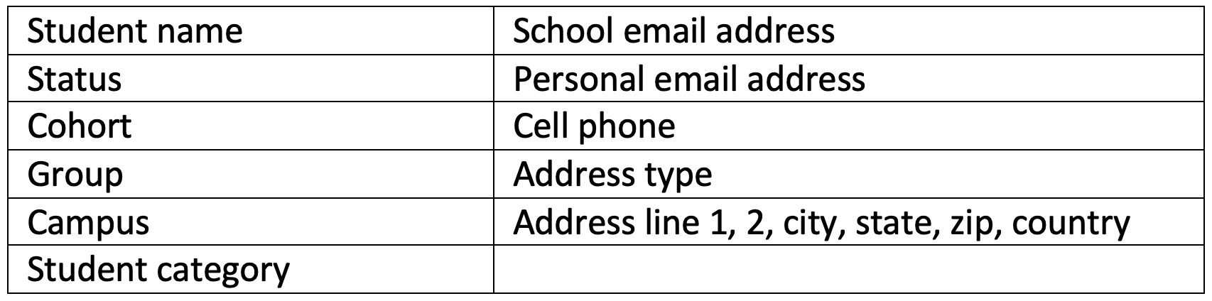
  - Emergency Contacts
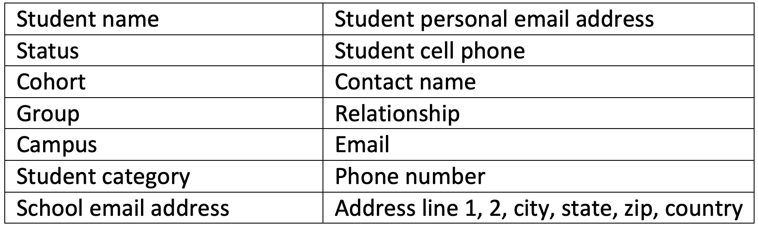
  - Language Proficiency
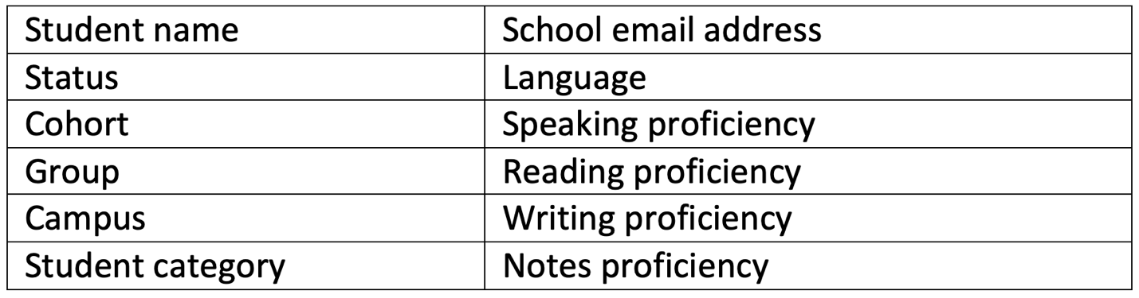
  - Profile Attestation Status
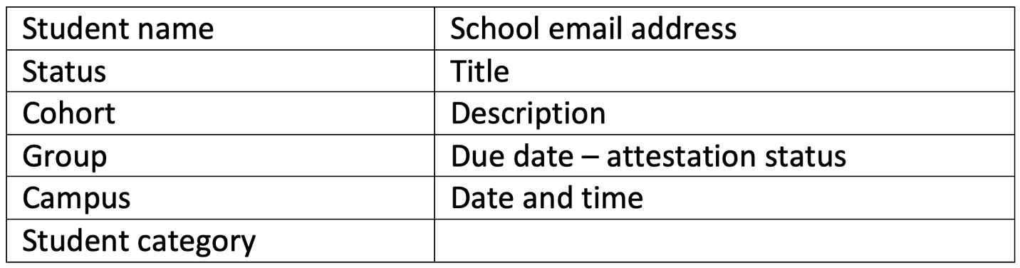
  - Program Requirements
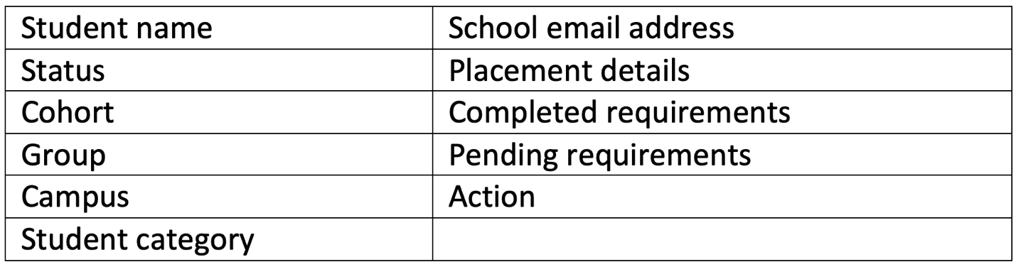
  - Communication Log
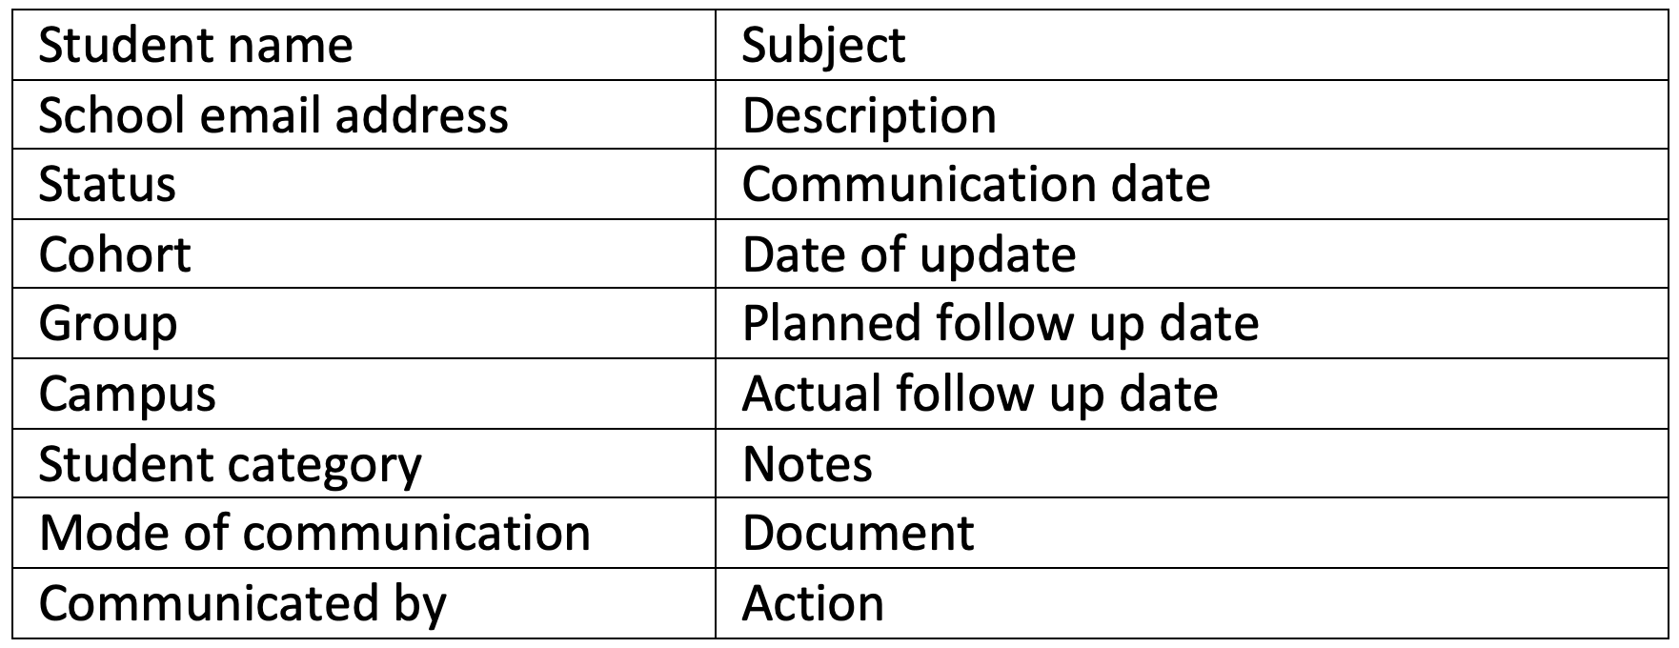
  - Intervention Log
