Organizing Students

In the article learn about how to manage various aspects of student organization within Exxat Prism. It covers the process of adding cohorts, managing enrollment and graduation calendars, creating student categories, and handling campus details. Each section offers step-by-step instructions, including how to access specific features, edit existing entries, and add new information. Additionally, descriptions are provided where necessary to enhance understanding.
- Managing Cohorts
- Managing Enrollment
- Managing Graduation
- Adding Student Categories
- Managing Campus details
- Adding Tags to Students

Managing Cohorts
Each year when you admit a new cohort of students, you’ll likely want them to get access to Exxat Prism for them to start building their profiles and upload compliance items for you.
You’ll first create your new cohort, and then add your students (You can add one student at a time or bulk import a class).
Navigate to Cohorts
- Select Students from the left-menu or dashboard.

- Click on the "Setup" tab.
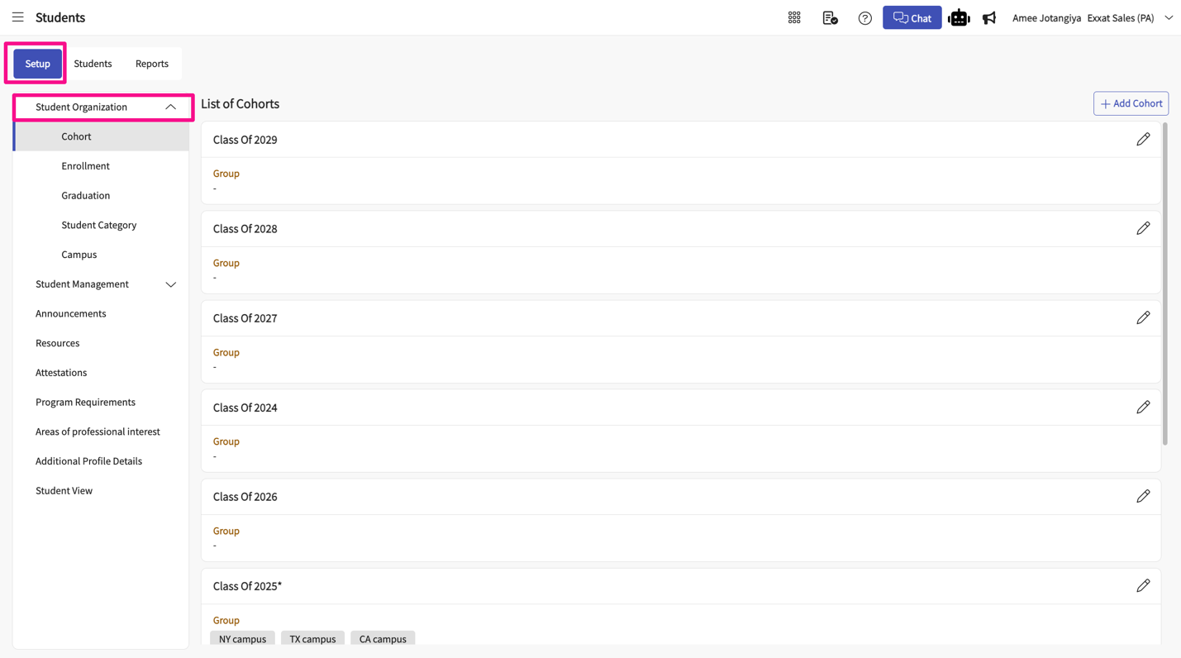
- Within "Student Organization," select "Cohort."
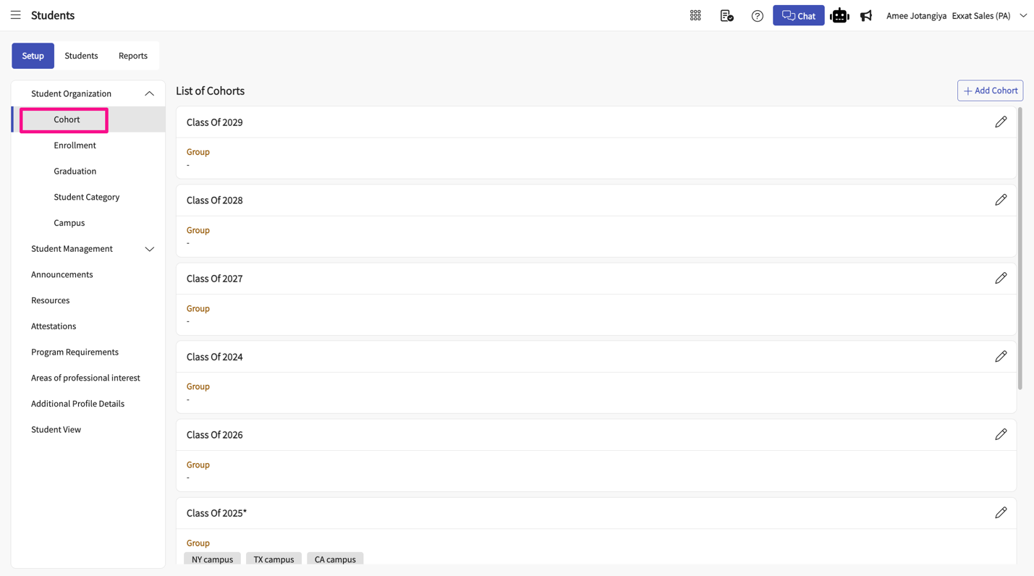Create a New Cohort
- Once there, you will see all existing cohorts.
- Click on +Add Cohort to create a new cohort. 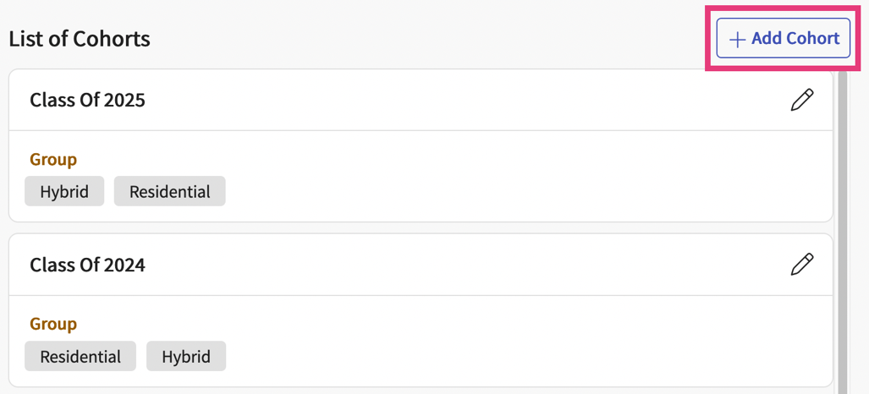
- Click on the pencil to edit any existing cohorts.
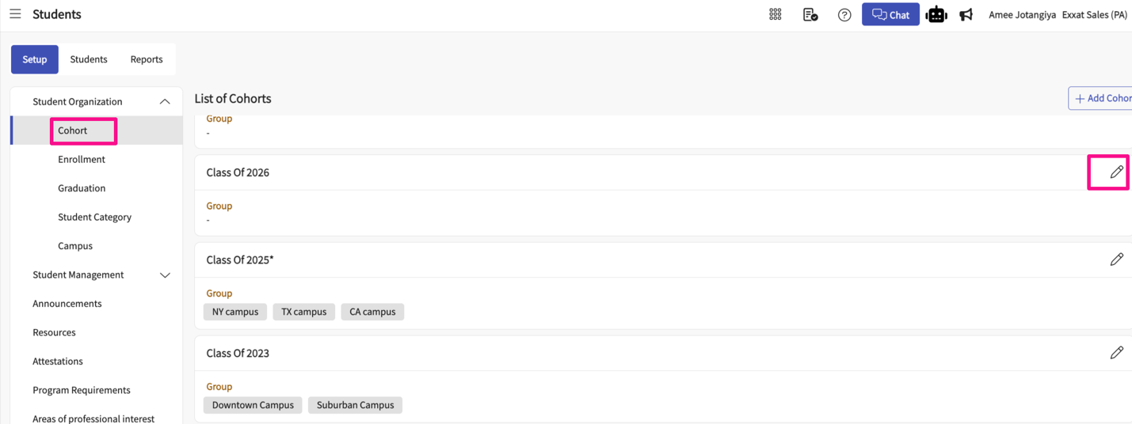
- A drawer will appear. Enter the following details and save when done.
a. Cohort Name: Class of 2023, 2024, etc.
b. Group: used if you have subgroups within your cohort.
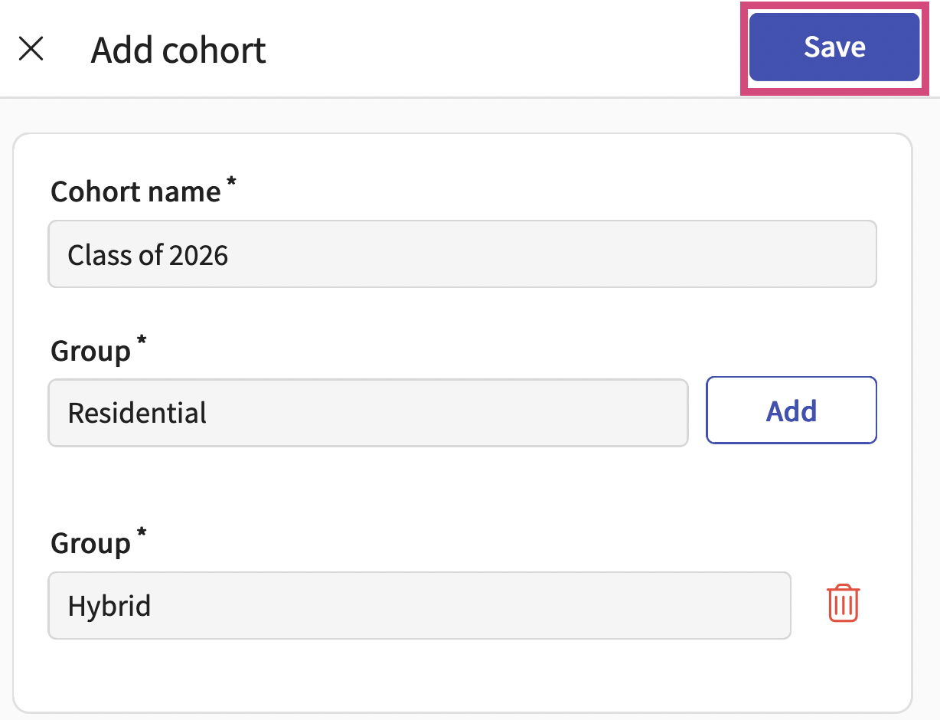
- Click "Save" when done
Managing Enrollment & Graduation Calendar
As you begin to add data to your system, adding cohorts will be one of the first items on your list! When adding a cohort, you can provide the following information:
- Enrollment Term + Date
- Graduation Term + Date
Make sure to add enrollment and graduation information prior to adding any new cohorts.
- Select Students from your dashboard or left menu.

- Select Setup from the ribbon at the top of the page.
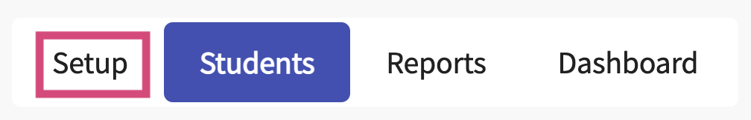
- From the left panel, select the item you’d like to manage, Enrollment or Graduation Calendar.
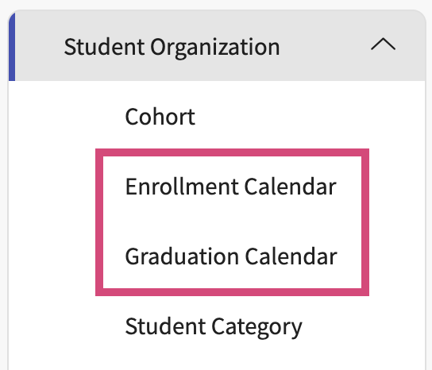
- The system will display all previous enrollment or graduation terms and dates. Click on the pencil icon.
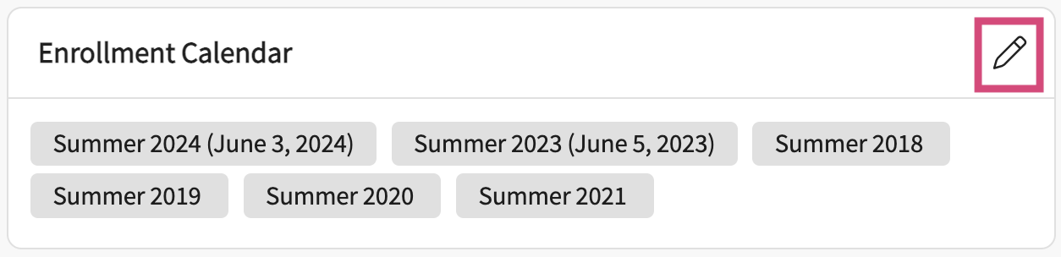
- A drawer will open where you can edit existing entries and add new ones.
- To add a new one, enter the information at the top, and click Add. Once done, it will be displayed on the list below.
- Click Save.
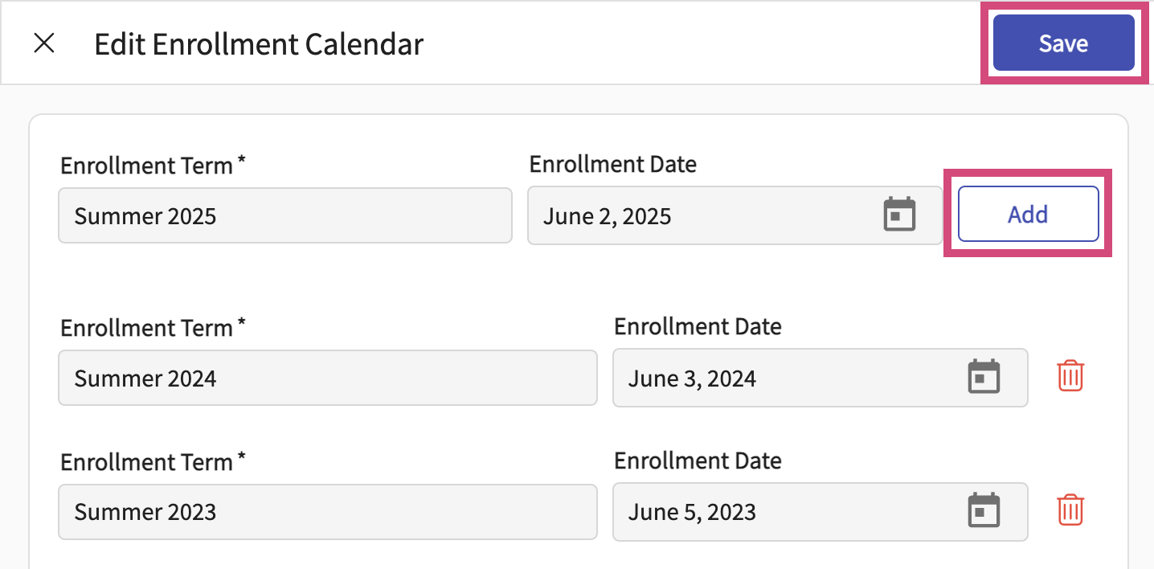
Managing Student Categories
When adding students to the system, you’ll provide identifying information such as cohort, enrollment, graduation information, and more. Aside from details like these, you have categories, which enable you to create a customized list of items to associate students with. Whether that is a focus or specialization, once created you’ll be able to filter and find students using categories.
Categories help organize students based on focus or specialization.
- Select Students from your dashboard or left menu.
- Select Setup from the ribbon at the top of the page.
- From the left panel, select Student Category.
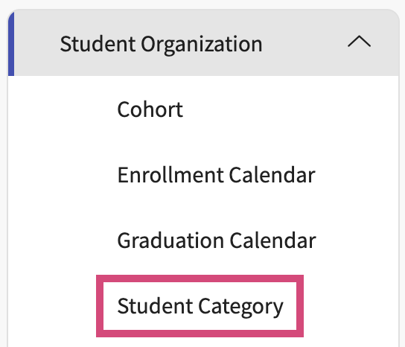
- The system will display all existing categories. Click on the pencil icon.
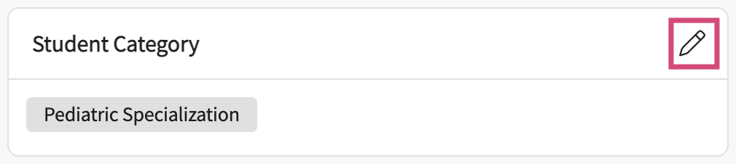
- A drawer will open where you can edit existing entries and add new ones.
- To add a new one, enter the information at the top, and click Add. Once done, it will be displayed on the list below. Click Save.
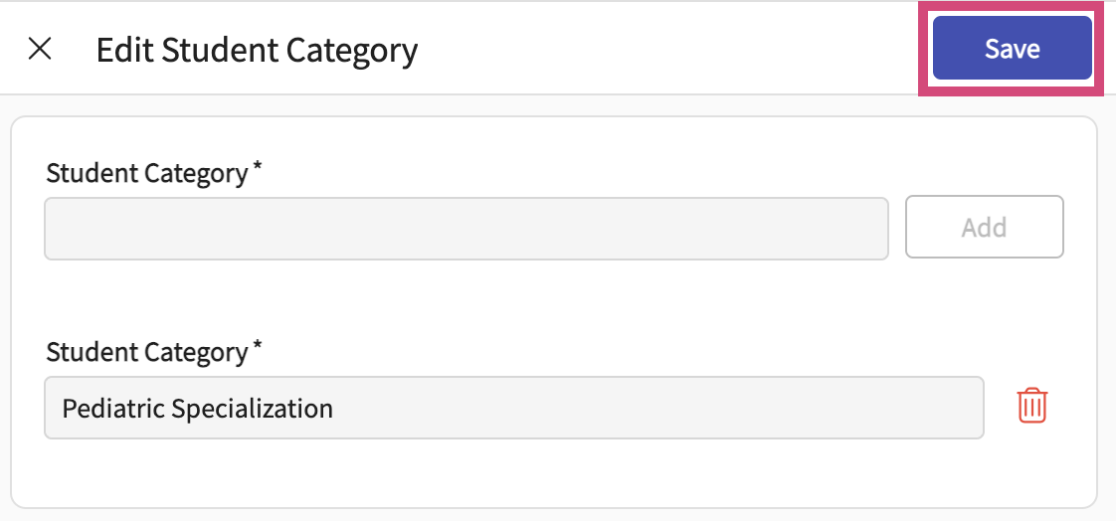
Managing Campus Details
For programs with multiple campuses, track information within Prism and associate it with students.
- Select Students from your dashboard or left menu.
- Select Setup from the ribbon at the top of the page.
- From the left panel, select Campus.
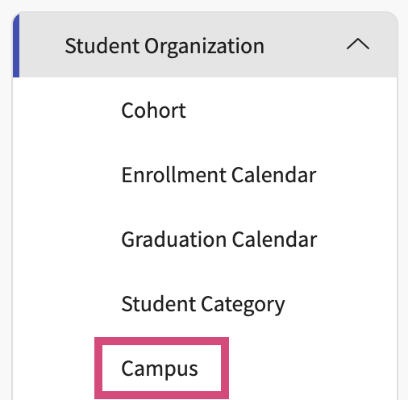
- The system will display all existing campuses. Click on the pencil icon.
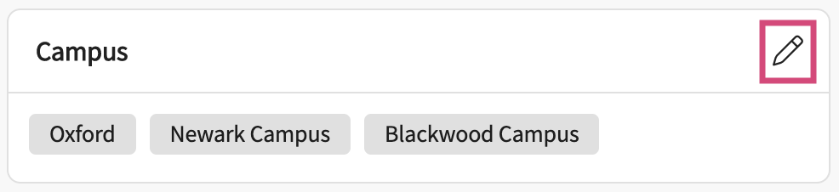
- A drawer will open where you can edit existing entries and add new ones.
- To add a new one, enter the information at the top, and click Add. Once done, it will be displayed on the list below.
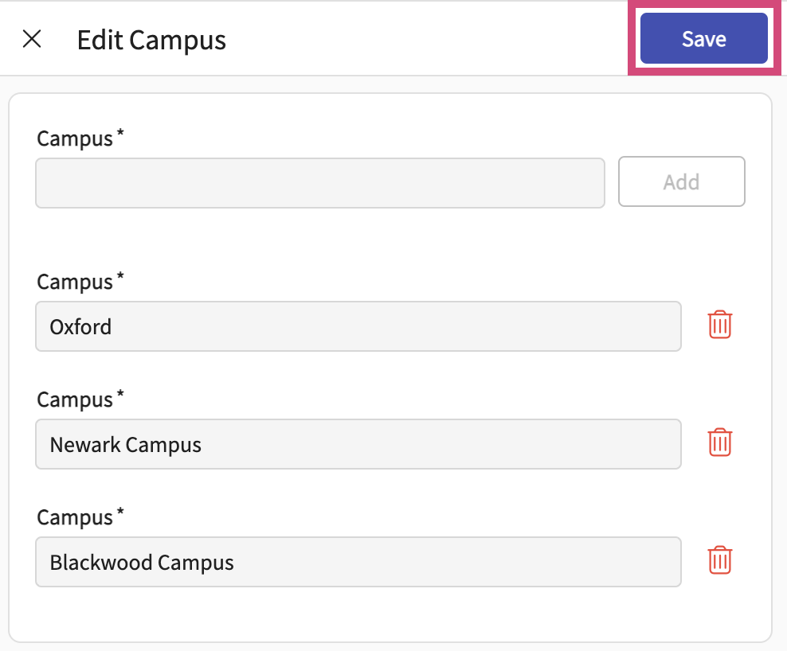
- Click Save.

