Managing User Roles in the Program
As a program administrator, you have the responsibility of managing user roles effectively within the system. Here's a step-by-step guide on how to do it:
Accessing User Roles:
- Log in to the system and navigate to the Program Details section from either the dashboard or the left-hand hamburger menu.
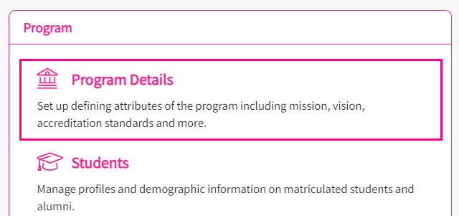
- Click on "User Roles"
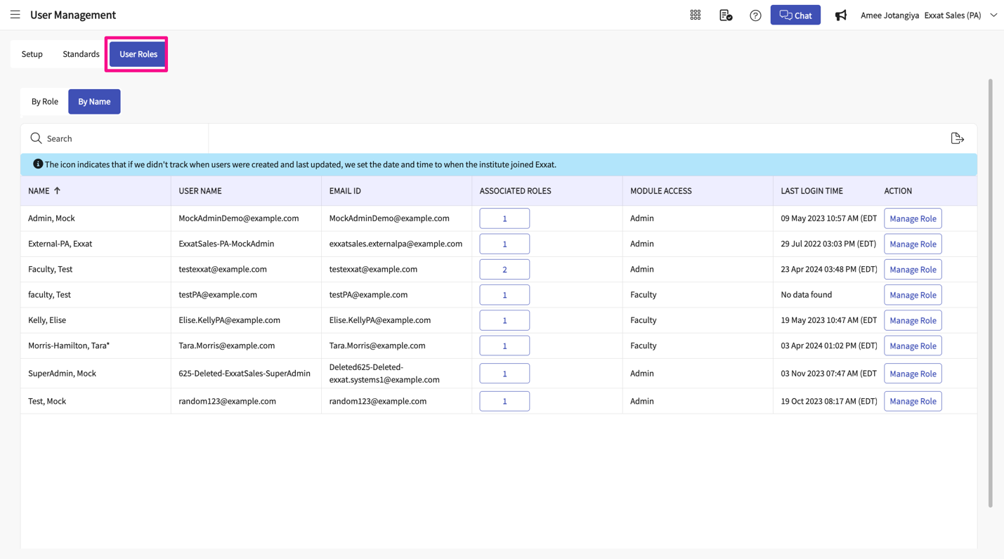
Viewing Roles:
- Within the User Roles section, you'll find two tabs: "By Role" and "By Name".
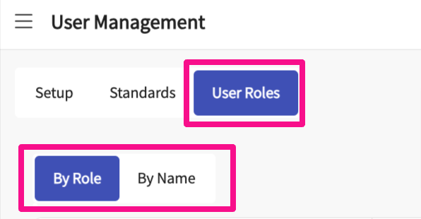
- Select "By Role" to view all roles assigned to the program, along with their details and the total number of users with access.
- You can determine if the assigned access is standard or custom.
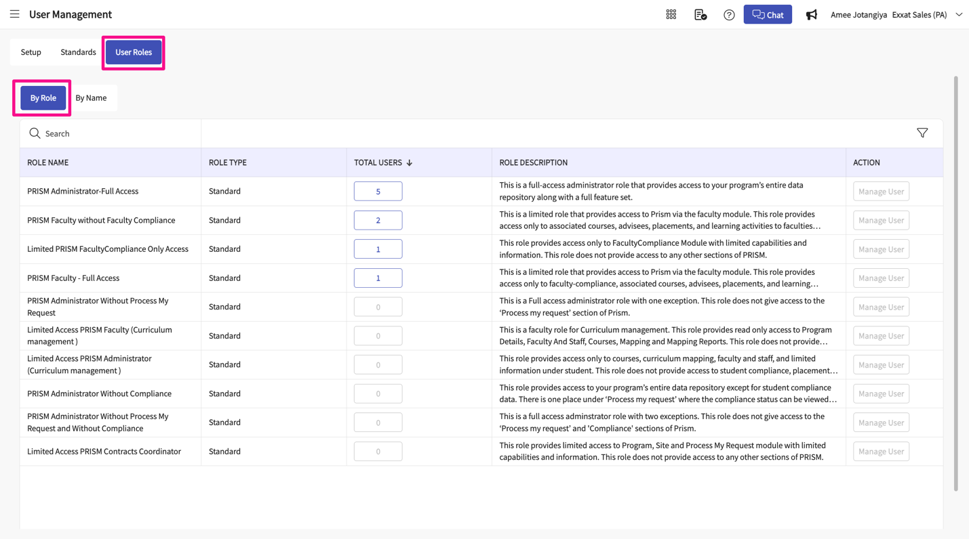
Viewing Users Assigned to Roles:
- To see the users assigned to a particular role, click on the numeric value under the "Total Users" column.
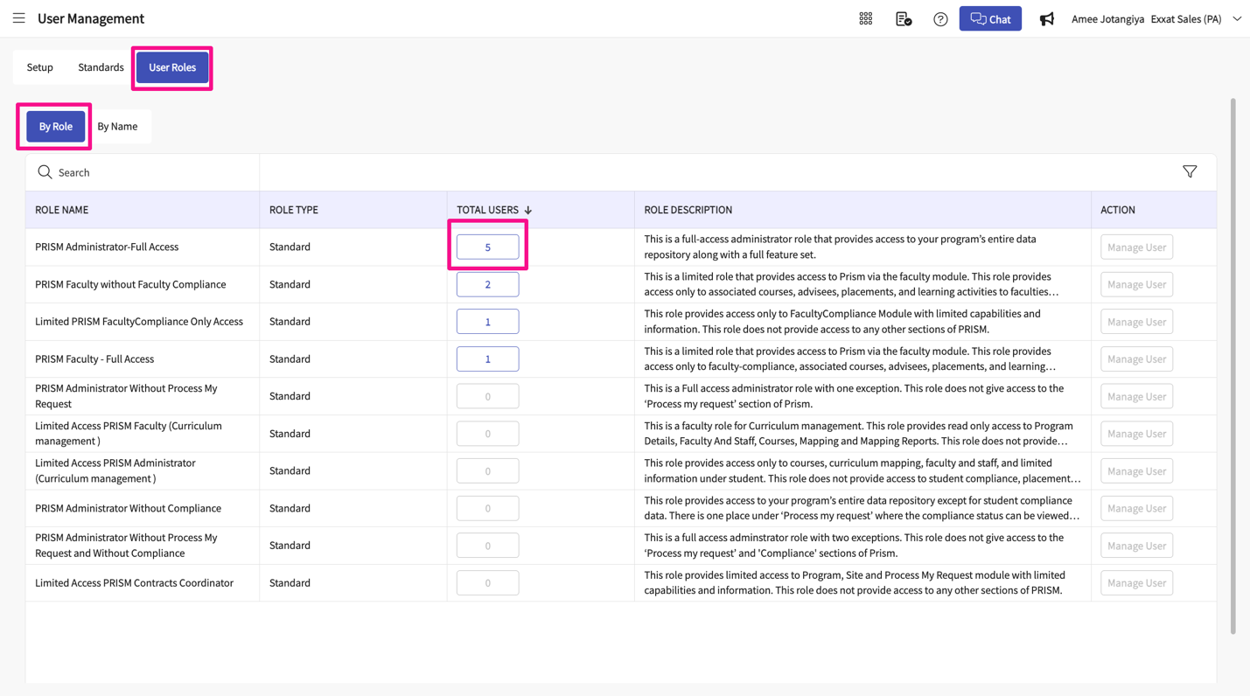
- his action will unfold a drawer, revealing user details such as names, usernames, email addresses, and last login time.
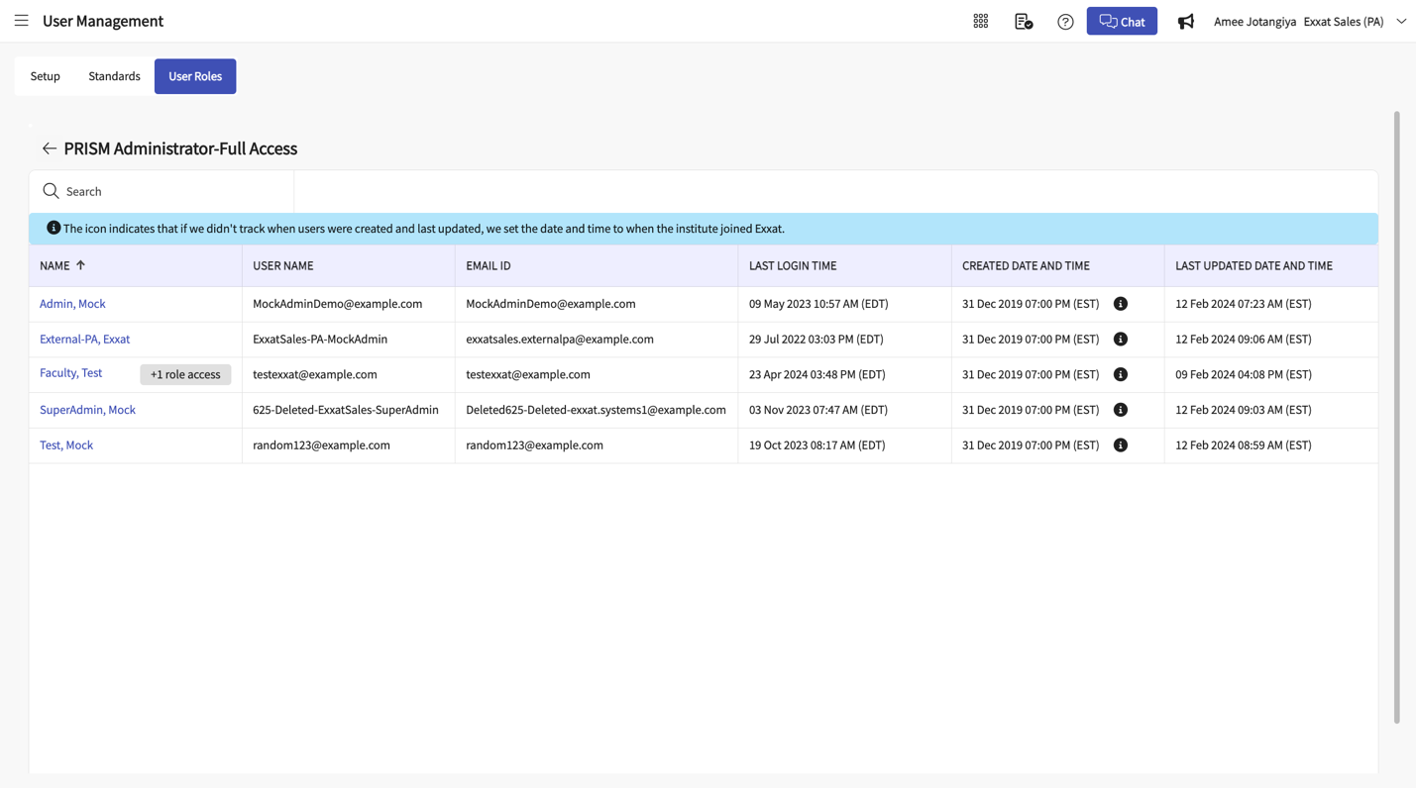
Managing Roles by Name:
- If you prefer to track users by their names, select the "By Name" tab.
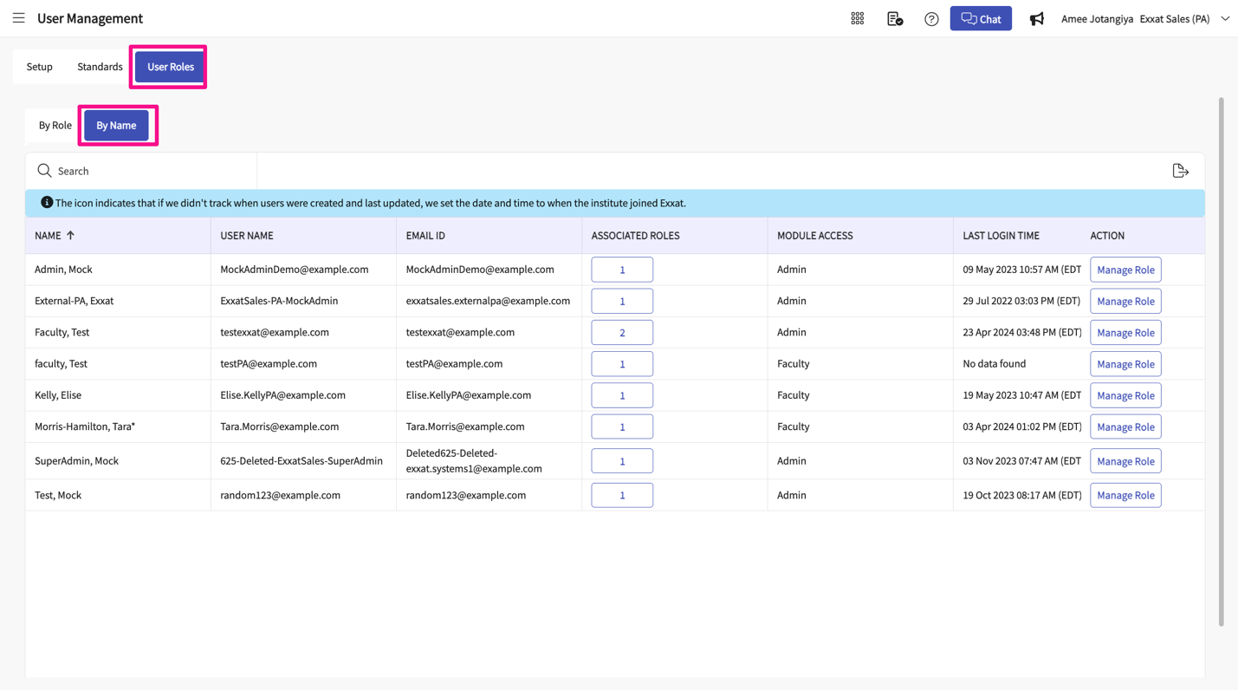
- Here, you can find all individuals with access, along with their user details and the number of roles they are assigned to. Select the number
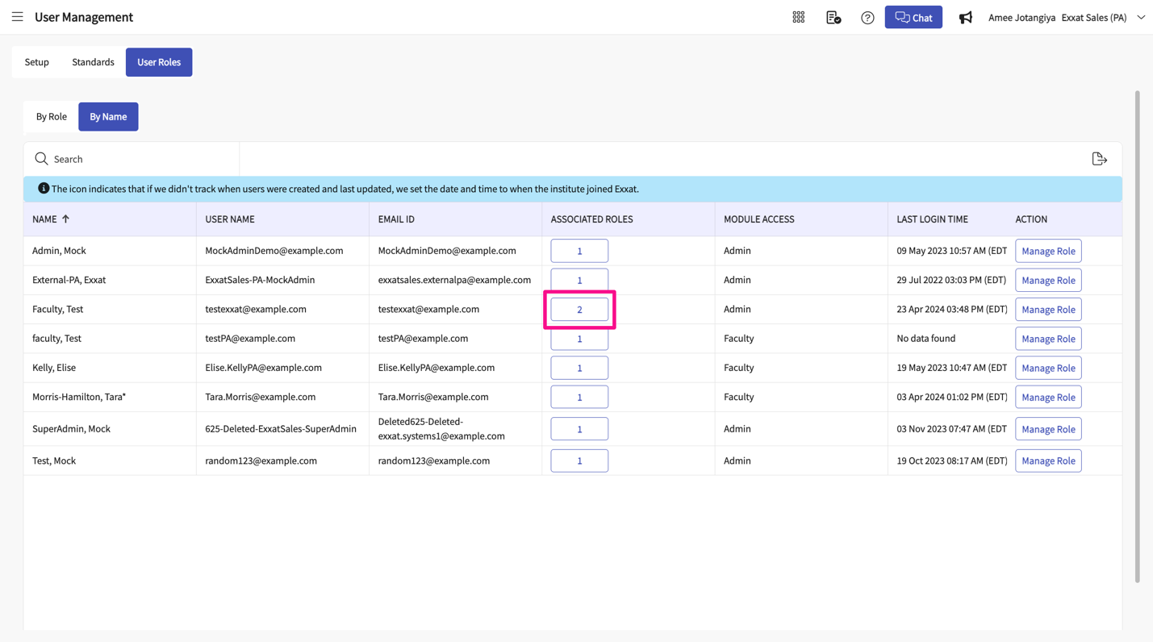
- 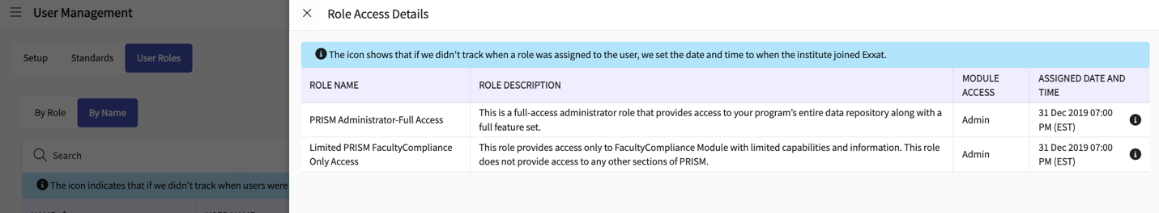
- Utilize the search bar to find specific users by their names.
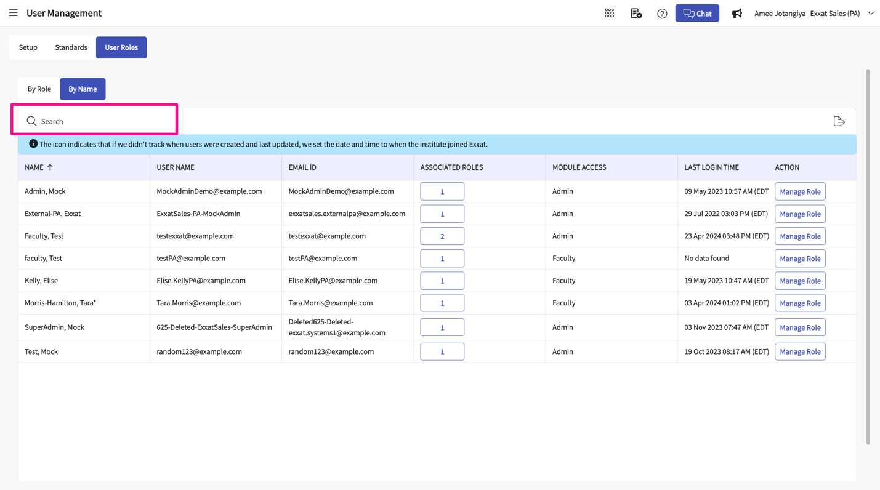
Assigning and Unassigning User Roles:
- To assign or unassign roles to users:
  - Navigate to Program Details > User Roles > By Name > Manage Roles.
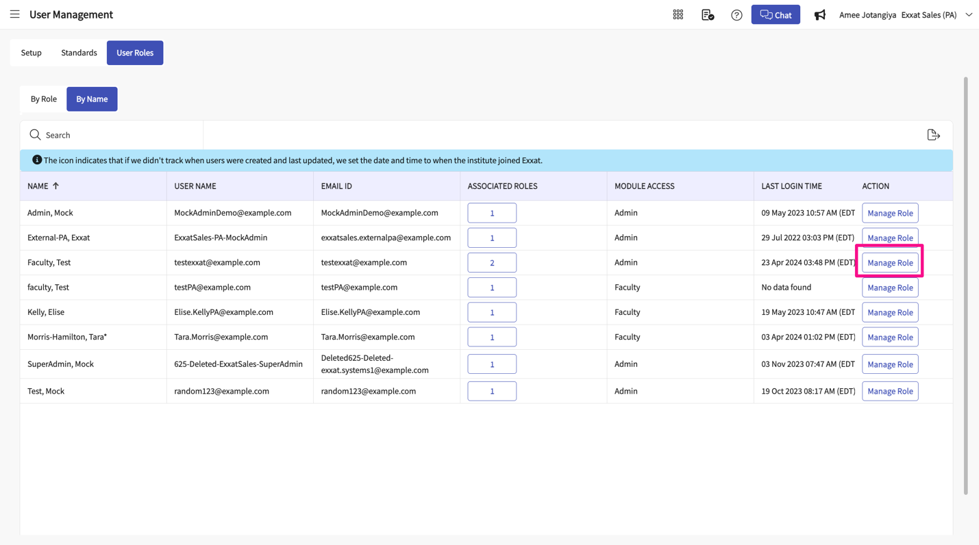
  - Under the "Assign" section, view all roles assigned to an individual and unassign any unnecessary roles.
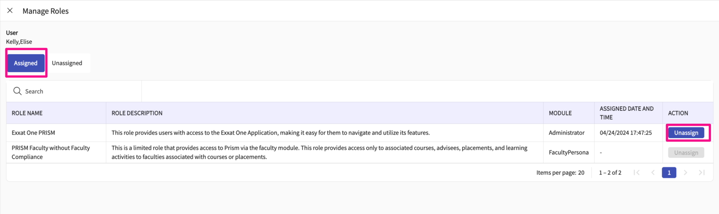
  - Under the "Unassigned" section, view available roles and assign them to users as needed.
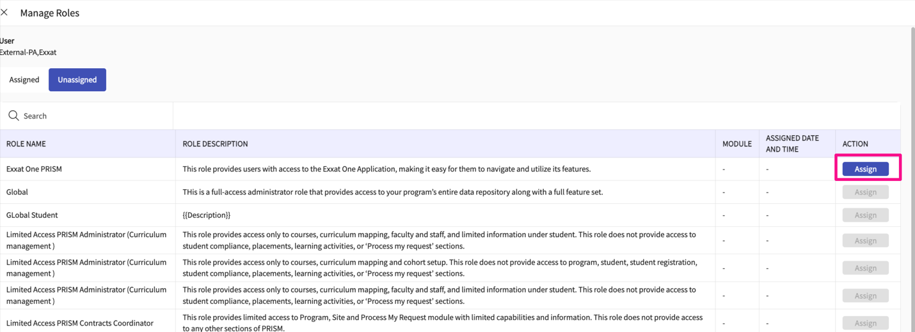
- If you wish to unassign roles for a group of users assigned to one role:
  - Go to Program Details > User Roles > By Role > Manage Users.
  - Select the role you want to manage.
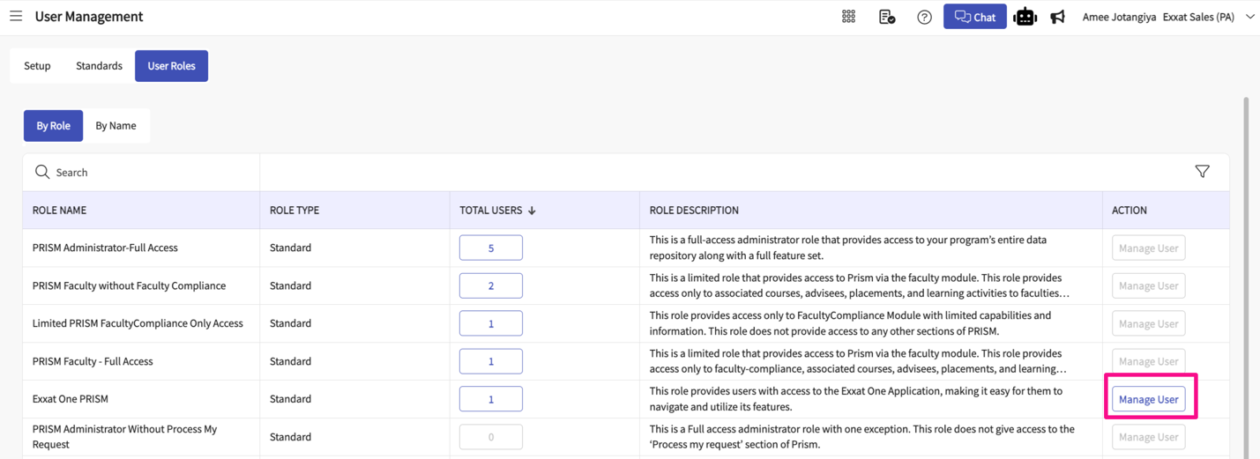
  - Under the "Assigned" tab, you'll see the names of all individuals assigned to the role. Click on "Unassign" to remove any users.
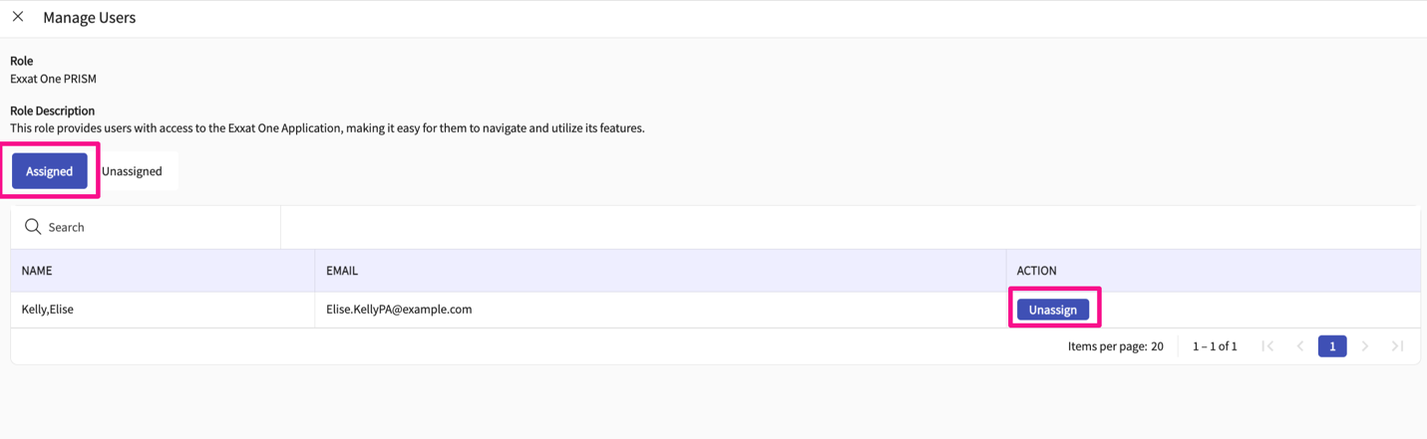
  - Under the "Unassigned" tab, select the "Assign" button to assign new roles to users.
