**Managing Program Information**

The article provides a guide on managing program details within Exxat Prism. It covers various aspects such as

* [Modifying program information](https://helpcenter.exxat.com/hc/en-us/articles/15366569262097-Managing-Program-Information#h_01HW8EVEF9NM3194SQJ614W6H7)
* [Adding mission and vision statement](https://helpcenter.exxat.com/hc/en-us/articles/15366569262097-Managing-Program-Information#h_01HW8CFWNHYJ0DNMMJ6XVMCHF2)
* [Managing accreditation details](https://helpcenter.exxat.com/hc/en-us/articles/15366569262097-Managing-Program-Information#01HW8F3NBGJRX8JFA3Q0XPW7V1)
* [Setting up email communications](https://helpcenter.exxat.com/hc/en-us/articles/15366569262097-Managing-Program-Information#01HW8F3YVG3D516TXTMYAJGD5N)
* [Configuring grading scales and clinical setting](https://helpcenter.exxat.com/hc/en-us/articles/15366569262097-Managing-Program-Information#h_01HW8CNK3S0KKH8QSBEK52ZFET)
* [Customizing the site resource page](https://helpcenter.exxat.com/hc/en-us/articles/15366569262097-Managing-Program-Information#h_01HW8CYE5RRFA52R44N25RJT1A)
* [Sharing information with site partners](https://helpcenter.exxat.com/hc/en-us/articles/15366569262097-Managing-Program-Information#h_01HW8E8DD52KFZS3F930XVP2B8)

**Modifying program information**

The program details section contains information related to your program. Depending on the level of access you have, you may have the ability to modify the following information or view-only access. Please contact [V4support@exxat.com](mailto:V4support@exxat.com)  if you do not have the right level of access. You will be able to add information for the following sections:

* [Details](https://helpcenter.exxat.com/hc/en-us/articles/15366569262097-Managing-Program-Information#h_01HW8CPZ3E2C54JKAJ0Q3Z7Y64)
* [Program Information](https://helpcenter.exxat.com/hc/en-us/articles/15366569262097-Managing-Program-Information#h_01HW8CBPPX54SMXRSGPM6PN1NG)
* [Mission and Vision](https://helpcenter.exxat.com/hc/en-us/articles/15366569262097-Managing-Program-Information#h_01HW8CFWNHYJ0DNMMJ6XVMCHF2)
* [Accreditation](https://helpcenter.exxat.com/hc/en-us/articles/15366569262097-Managing-Program-Information#01HW8F3NBGJRX8JFA3Q0XPW7V1)
* [Grading Scale](https://helpcenter.exxat.com/hc/en-us/articles/15366569262097-Managing-Program-Information#h_01HW8CNK3S0KKH8QSBEK52ZFET)

**School Profile**

1. Select Program Details from the left-menu.
2. A pink sign with black text

   Description automatically generated
3. Select Setup from Program Details be taken to the Setup page where you will be able to view and manage the school profile, grading and clinical settings and setup the site resource page.  
   A screenshot of a program

   Description automatically generated

**Edit Program Name**

1. To add or update the name of your program, please click on School profile under Setup.    
   A screenshot of a computer

   Description automatically generated
2. On the right side of the screen, you will find the pencil icon to edit the name.
3. When you click on the pencil icon, a text drawer opens up where you can update it and save it.    
   A close up of a box

   Description automatically generated

**Edit Program Details**

***In this section, you will learn how to modify your program details***

1. To add or edit Program Details, click on the School profile under Setup.
2. Click on the pencil icon for the details card.   
   A screenshot of a computer

   Description automatically generated
3. A drawer will open where you can enter or modify the Program details.
   1. **Program name**: you can edit and set a new name for your program. This is a mandatory field.
   2. **Program Logo**: you can upload your school logo
   3. **Description**: define a basic description of the program
   4. **Type of program**: select the type of program from the dropdown. If you need additional dropdown options, please contact [v4support@exxat.com](mailto:v4support@exxat.com).
   5. **Degree offered**: degree(s) offered at your program
   6. **Additional program information**: enter any additional details not mentioned above.
   7. **Address**: location of your program
   8. Click **Save** when done  
      A screenshot of a computer

      Description automatically generatedA screenshot of a computer

      Description automatically generated

**Information**

1. The Information section will have the following sections. Click on the pencil icon for any option to add or edit information.
   1. Terms: Winter, Spring, etc.
   2. Professional years: 1st year, 2nd year, etc.
   3. Program clinical settings: settings utilized by your program for placement
   4. *Please note, any edits done on program calendar will impact entire course catalog, course offering and curriculum grid in the system. Kindly reach out to your CSR for any changes on this section.  
      A screenshot of a computer

      Description automatically generated*

**Add/Edit Mission and Vision**

***Learn how to add your Mission and Vision Program statement***

1. Click on the + icon to add mission and vision details for your program.
   1. Once you have added details, you’ll see a pencil icon that will allow you to make changes.  
      A screenshot of a white box

      Description automatically generated

**Add/Edit Accreditation**

***Learn how to add details on accreditation***

1. To add accreditation information, click on the + icon.
   1. To modify information previously added, click on the pencil icon.  
      A screenshot of a computer

      Description automatically generated
2. When adding or editing details, a drawer will open where you can add the following information:
   1. Name of accrediting body
   2. Accreditation status
   3. Type of accreditation
   4. Accreditation details
   5. Next accreditation date
   6. The most recent accreditation date
   7. Click Save when done  
      A screenshot of a medical survey

      Description automatically generated
3. To delete any accreditation entries, click on the pencil icon.  
   A white background with black text

   Description automatically generated
4. Click on the vertical ellipsis next to the Save button and click Delete.  
   A screenshot of a medical survey

   Description automatically generated

**Add/Edit Email Setup**

Learn how to customize the emails

1. You can setup the display name and reply to for every email communication that is done from the system to help the recipient verify the sender.
2. Click on the pencil icon for Email setup drawer.

1. A drawer will open up on right-hand side, you can update the display name and enter the email addresses under the “reply to” drawer.
2. You will be able to add multiple email addresses if separated by a colon (;).

**Add/Edit Grading and Clinical Setting**

Learn how to Set up grading scales for the program and Configure different clinical settings associated with colors.

1. Grading scale  
   A screenshot of a computer

   Description automatically generated.
2. To add grading information, click the + icon if you are adding the details for first time.
   1. Once you add grading information, you’ll click on a pencil icon to make further changes.  
      A white and purple line

      Description automatically generated
3. You will add in the following information:
   1. Letter grade: A, B, etc.
   2. Minimum %: 90%, 50%, etc.
   3. Maximum %: 100%, 30%, etc.
   4. You’ll also have the ability to upload files.
   5. Once done, click Add. You will repeat this process for every letter grade.  
      A screenshot of a survey

      Description automatically generated
4. If you need to delete a letter grade after it’s been added, click on the trash bin. Click Save once done.  
   A screenshot of a number of numbers

   Description automatically generated
5. Similarly, you can set up the different program settings under the clinical settings section.    
   A screenshot of a computer

   Description automatically generated
6. Click on the “+” icon if you are entering it for the first time. You can use the pencil icon to update the existing list
7. A drawer opens up where you can capture the different settings and associate colors to each. Once updated, click on save.    
   A screenshot of a computer

   Description automatically generated

**Site Resource Page**

You may want to share information with your site partners regarding your program, rotation schedule, resources, and school contact information.

* [Accessing your Site Resource Page](https://helpcenter.exxat.com/hc/en-us/articles/15366569262097-Managing-Program-Information#Accessing)
* [Customizing your Site Resource Page](https://helpcenter.exxat.com/hc/en-us/articles/15366569262097-Managing-Program-Information#Customizing)
* [Sharing your Site Resource Page](https://helpcenter.exxat.com/hc/en-us/articles/15366569262097-Managing-Program-Information#Sharing)

***Accessing your Site Resource Page***

1. Select Program Details from your dashboard or left menu.  
   A pink sign with black text

   Description automatically generated
2. Select Site Resource Page from the left panel.  
   A screenshot of a program

   Description automatically generated
3. Click View Site Resources Page.  
   A screenshot of a web page

   Description automatically generated
4. A new drawer will open, displaying your program’s Site Resource Page. This is what your sites will see!
5. The Site Resource Page will have the following sections:
   1. **Clinical Education Schedule**: this will show them course and rotation information
   2. **Resources for Clinicians**: this will include both program wide resources and course specific resources.
      1. Please note course specific resources will not include didactic courses.
   3. **Clinical Education Contacts**: this will include any faculty and staff you’ve chosen to share.  
      A screenshot of a web page

      Description automatically generated

***Customizing your Site Resource Page***

***Learn about a***ccess, customize, and share resources with site partners. Customize welcome messages and announcements. And learn how to share clinical education schedules, resources for clinicians, and contact information with sites.

1. Select Program Details from your dashboard or left menu.  
   A pink card with a pink and black text

   Description automatically generated
2. Select Site Resource Page from the left panel.  
   A screenshot of a program

   Description automatically generated
3. The page will display all of the sections you can customize. Click on the dropdown arrow to start editing.  
   A screenshot of a web page

   Description automatically generated
4. **Welcome Message**: you can choose to include a message to display on the main page of the Site Resource Page. Click on the + icon to add a welcome message.  
   A screenshot of a message box

   Description automatically generated
5. A drawer will open. Add your message and click Save.  
   A screenshot of a email

   Description automatically generated
6. Your message will be saved. Click on the pencil icon to make changes, and the trash bin to delete it entirely.  
   A screenshot of a message

   Description automatically generated
7. **Announcements**: allows you to share time sensitive messages on the main page of the Site Resource Page. Click on the Arrow icon.  
   A screenshot of a computer

   Description automatically generated
8. You’ll be redirected to the Site Setup section. The system will load all announcements created previously. Click on + Add Announcement.
   1. To edit existing announcements, click the pencil icon.
   2. To delete existing announcements, click the trash icon.  
      A screenshot of a list of announcements

      Description automatically generated
9. A drawer will open. Enter in any necessary information and click Save once done.
   1. Show on site resources page: this will be shared with sites on the Site Resources page.  
      A screenshot of a chat

      Description automatically generated
10. **Clinical Education Schedule**: allows you to share course and rotation information. Click on the Arrow icon.
11. You’ll be redirected to the Course Offerings page. Select the Course you’d like to manage.  
    A screenshot of a computer

    Description automatically generated
12. Click on Setup from the ribbon at the top of the page.  
    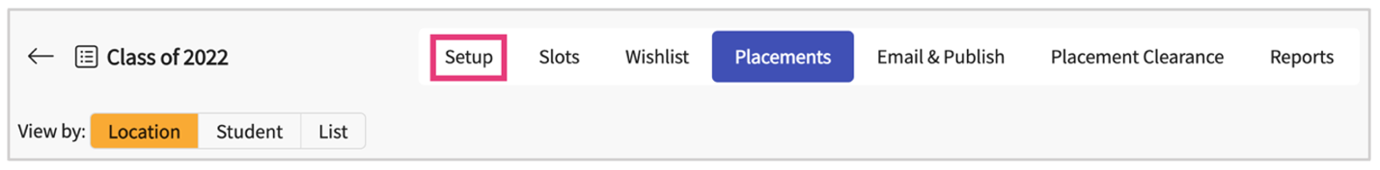
13. If your rotation has already been setup, click on the rotation name.
14. If you are adding a brand-new rotation, click on + Add Rotation.  
    A screenshot of a medical form

    Description automatically generated
15. A drawer will open, make sure the **Show on Site Resources Page**is turned on.  
    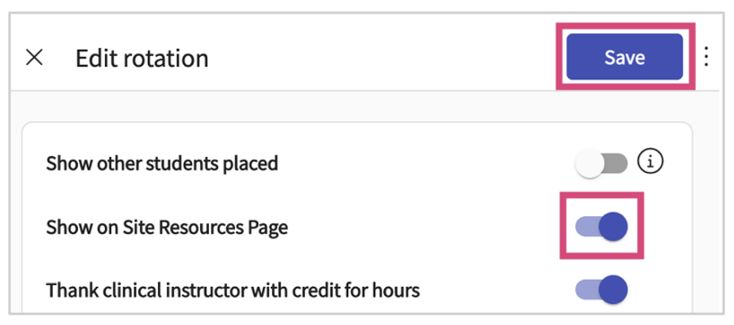
16. **Resources for Clinicians**: will have two options:
    1. **Include Selected Resources:**include program wide resources
    2. **Include selected course documents:**these will be course specific resources for courses which require a placement  
       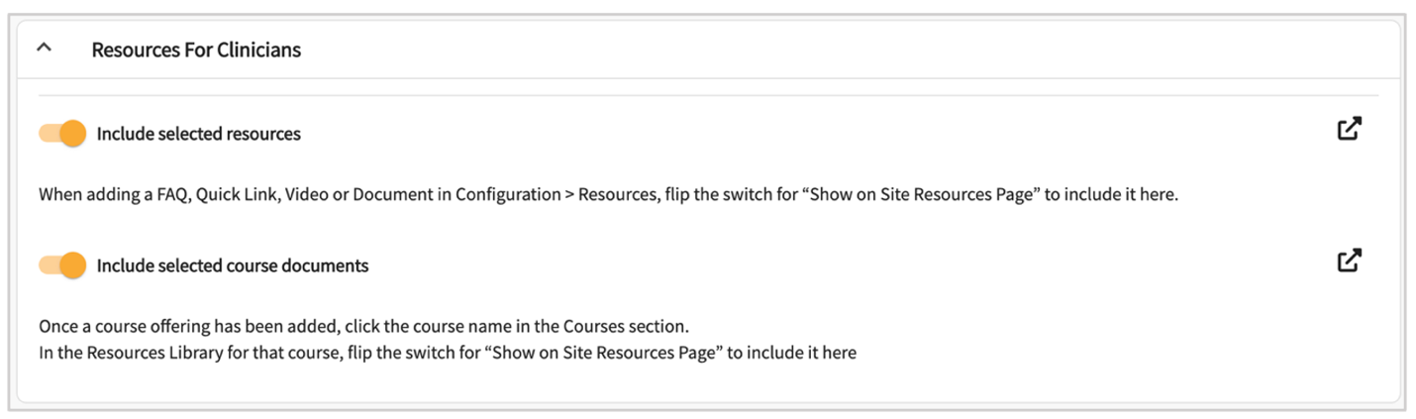
17. Clicking on the arrow for Include Selected Resources will redirect you to the Site Setup section.  
    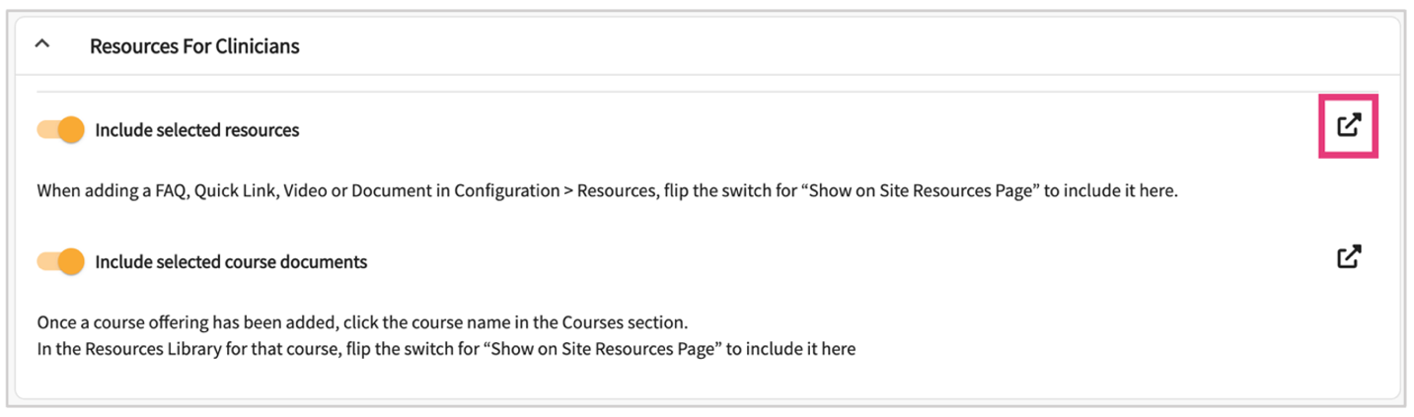
18. It will redirect you to the Site Page >> Setup >> Resources
19. Select a category from the middle panel to start adding resources.  
    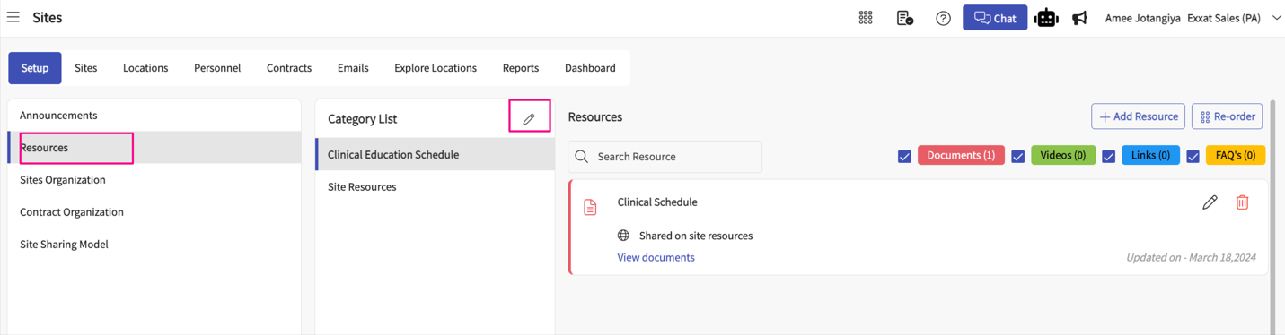
20. Once you select an item within the category list, you will see all resources added for that category.
    1. If you’d like to filter to view only documents, links, etc., you can uncheck any options.
    2. To edit an existing resource, click on the pencil icon.  
       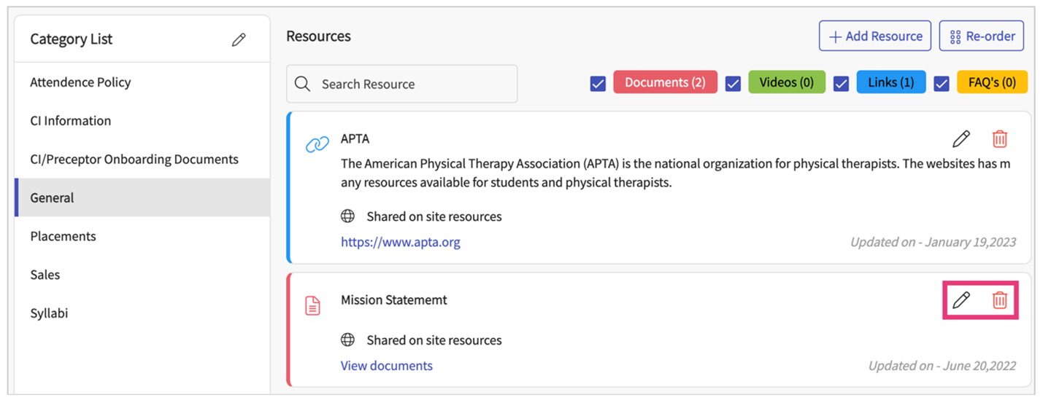
21. To add a new resource, click +Add Resource.  
    
22. A drawer will open. Click on the drop down to select the type of resource you’d like to add.  
    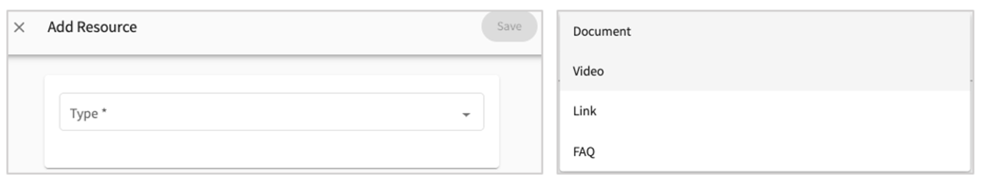
23. Enter the resource information and click save when done.
    1. **Show on site resources page**: if you’d like this resource to be shared with your clinical partners, select this option.  
       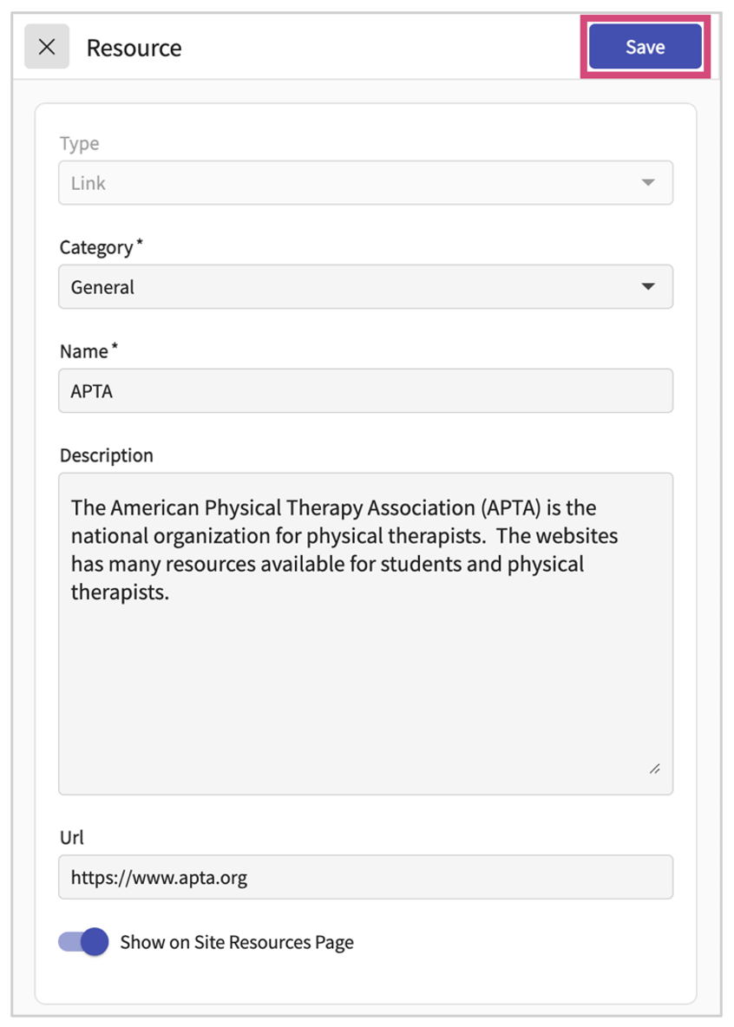
24. Clicking on the arrow for Include Selected Course Documents will redirect you to the Course Offerings page.  
    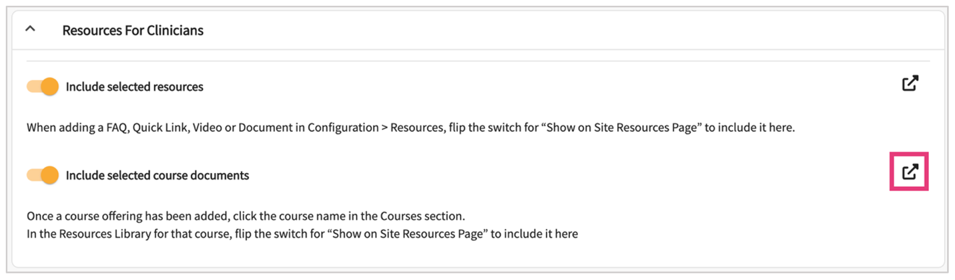
25. It will redirect you to the Courses Offering Page
26. Select the Course you’d like to manage.  
    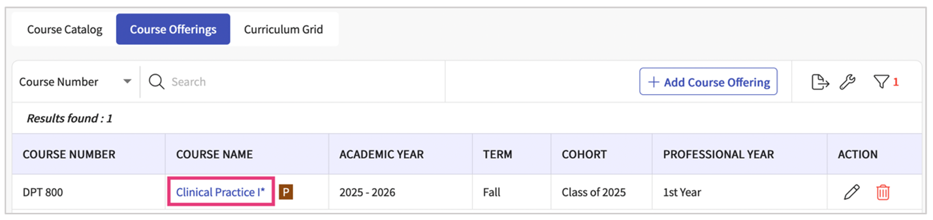
27. Select Resources from the left panel.  
    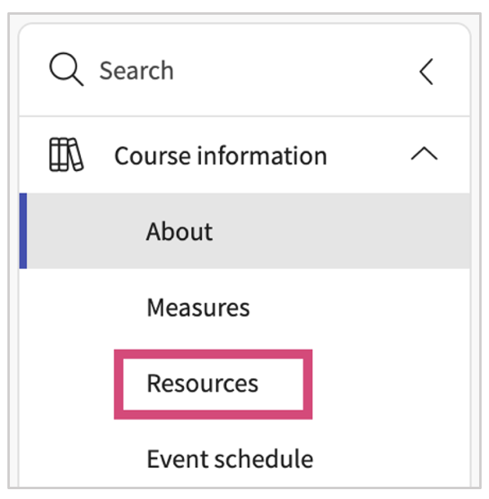
28. Select a category from the middle panel to start adding resources.  
    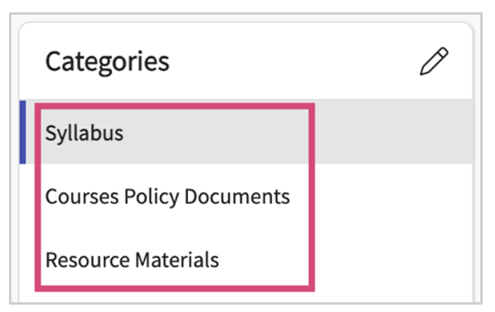
29. Once you select an item within the category list, you will see all resources added for that category.
    1. If you’d like to filter to view only documents, links, etc., you can uncheck any options.
    2. To edit an existing resource, click on the pencil icon.  
       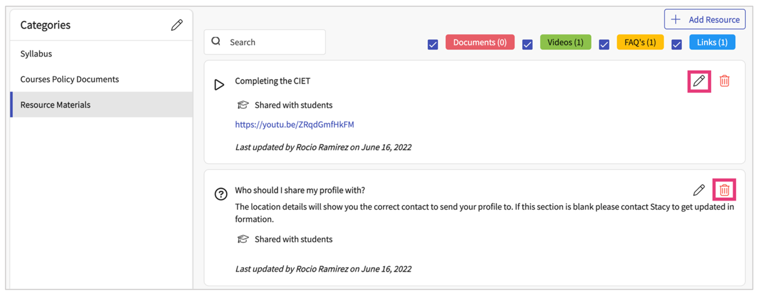
30. To add a new resource, click +Add Resource.  
    
31. A drawer will open. Select the type of resource you are adding, provide a name, and any additional information.  
    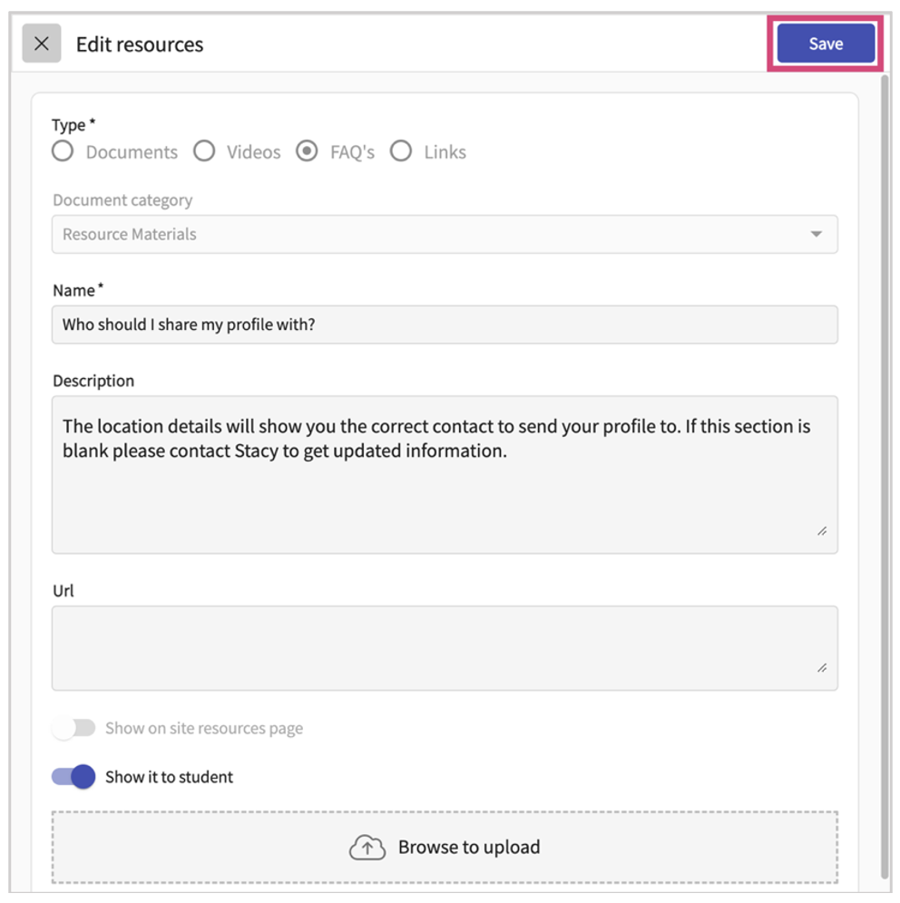
32. **Clinical Education Contacts**: allows you to share contact information with sites. Click on the arrow icon.  
    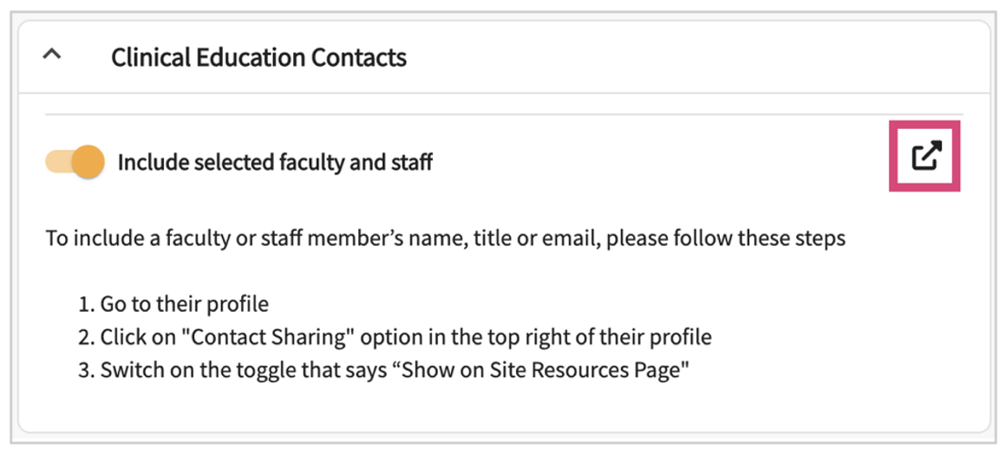
33. You will be redirected to Faculty and Staff Page
34. Select the school contact you’d like to share.  
    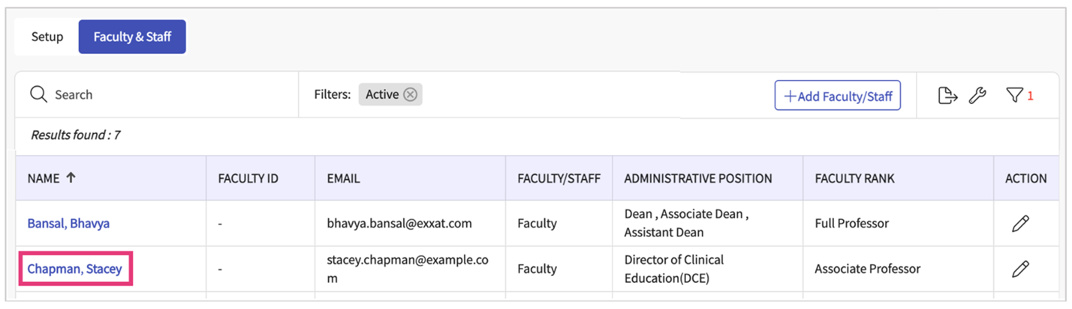
35. Click on Contact Sharing  
    
36. A drawer will open. Three separate sections will load, where you can decide if you would like to share faculty and staff contact information with different stakeholders. Select your preferences and click Save once done.  
    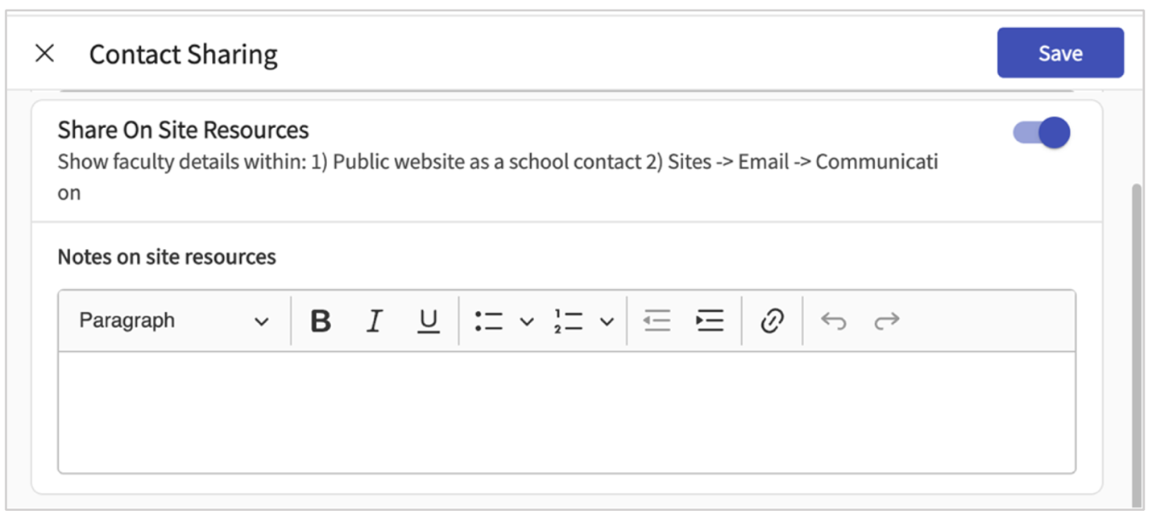

***Sharing your Site Resource Page***

***Learn about how to share the link with your site partners which will allow them to access all the information they would need to work with your program.***

1. Select Program Details from your dashboard or left menu.  
   
2. Select Site Resource Page from the left panel.  
   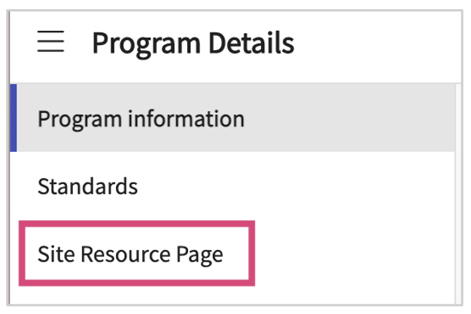
3. Click View Site Resources Page.  
   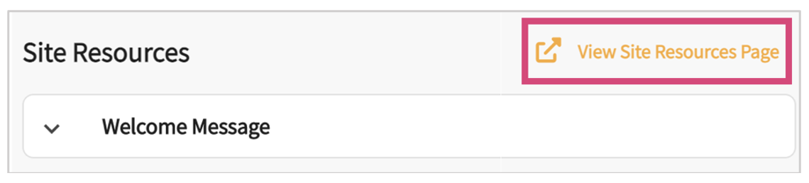
4. A new drawer will open, displaying your program’s Site Resource Page. Copy the link on your browsers address bar.  
   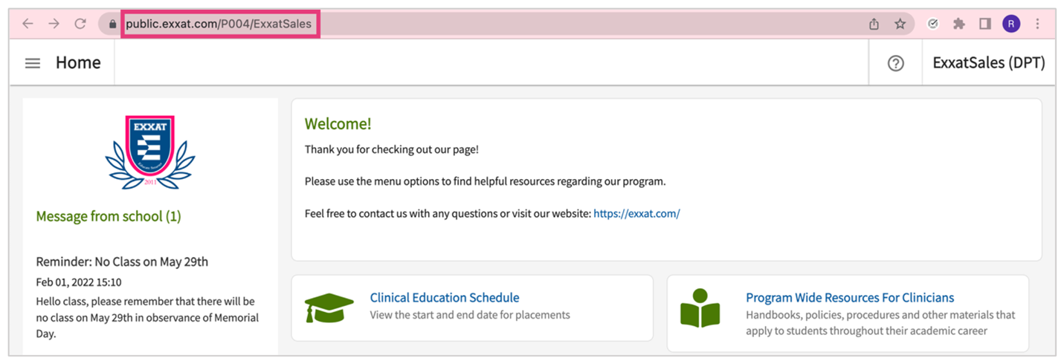
5. You can now paste it anywhere you like! Whether you’re sending an email via Exxat Prism or add it in your personal email.