Navigating Exxat Prism

Welcome to the guide to navigating your Exxat Prism Account.
Below are all the topics that are covered in this document:
Prism Terminology
Logging into Exxat via Email Invitation
Loggin into Exxat via Single Sign On (SSO) Email Invitation
Navigating Dashboard

Prism Terminology
Lets get you familiar with the terminology on a day-to-day basis while working with Exxat Prism:
- Administrative Personnel vs. Clinical Personnel
  - Administrative Personnel: Individuals responsible for managing the business aspects of clinical sites or locations.
- Clinical Personnel:
  - Individuals directly involved in patient care or supervision thereof.
- Announcements
  - Messages displayed to students, Faculty, or Site personnel upon logging into the system, facilitating communication and updates.
- Attestation
  - A formal statement electronically agreed upon by students or clinical sites, indicating compliance or acknowledgment of specific requirements.
- Cohort
  - A cohesive group of students who entered the program simultaneously and will graduate together, is often used for tracking and management purposes.
- Compliance
  - The comprehensive set of requirements, including document uploads (e.g., TB tests, MMR vaccination records, resumes), necessary for students' participation in clinical activities.
- Course & Course Offering
  - Refers to the specific clinical course in which a student is enrolled, including its offerings for a given academic term.
- Encounter Detail
  - An individual entry documenting a patient interaction or case is vital for tracking clinical experience and learning outcomes.
- Group
  - A subgroup within a cohort, typically organized for administrative purposes or specialized tracking.
- Learning Activity Group
  - A collection of courses structured to manage and coordinate learning activities effectively, ensuring comprehensive education delivery.
- Learning Activity Management
  - The centralized platform houses all student assignments and tasks during their clinical experiences, facilitating efficient monitoring and evaluation.
- Location
  - An individual site within a clinical facility or institution is often differentiated for logistical and organizational purposes.
- Placement Group
  - A designated set of courses structured to oversee student placements, manage available slots, and coordinate clinical experiences.
- Rotation
  - The defined timeframe, including start and end dates, during which students undertake their clinical experiences, ensures structured progression and scheduling.
- Site
  - An entity with which the educational institution has a contractual relationship, potentially comprising multiple individual locations for clinical training.
- Statuses
  - Categories such as Get Started, Pending Review, Approved, or Not Approved, indicate the progression or status of various items within the system, including compliance and assignments.
- Tag
  - A labeling system allows for the categorization and organization of sites, locations, personnel, and students, facilitating streamlined management and tracking.
- Wishlist
  - A feature enabling students to express preferences for clinical experience locations; however, it does not guarantee placement and serves primarily as a reference for planning purposes.

Logging into Exxat via Email Invitation
Before you can begin using Exxat, you’ll need to get added to the system! Read on to learn how to set up your account.
- You will receive an email from notifications@exxat.com in your inbox.
a. Click on the hyperlink to go to Exxat.
b. If the link does not work, copy and paste the URL provided in a new tab/window.
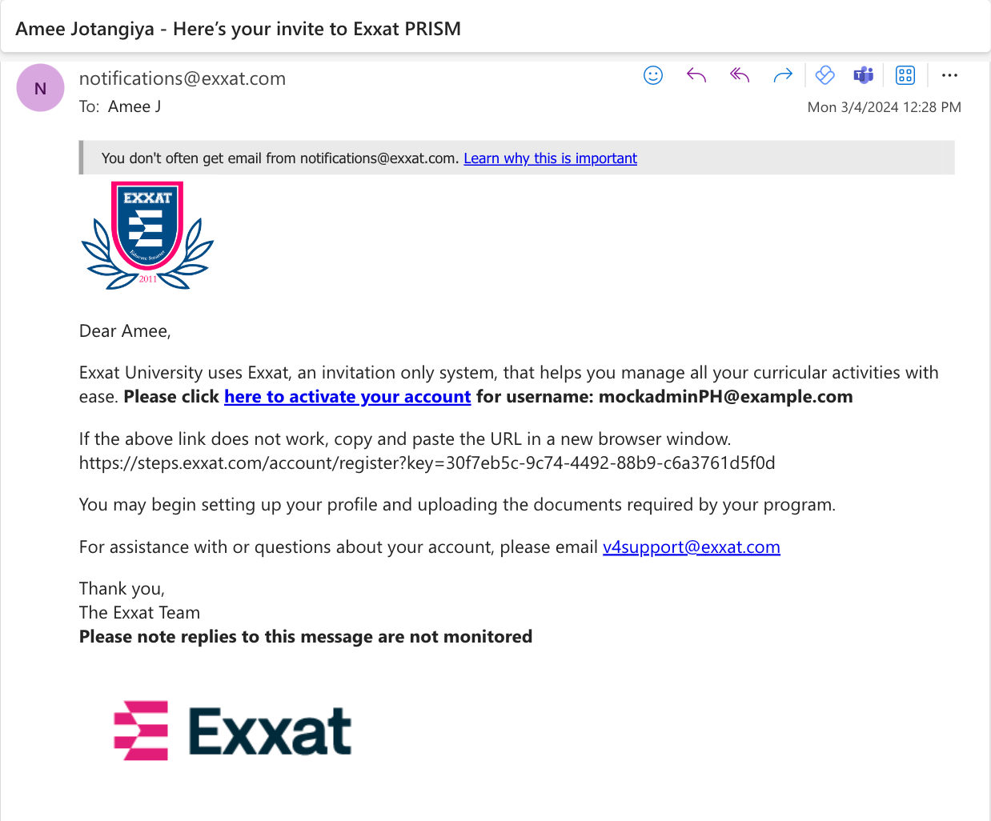
- You’ll be redirected to Exxat. Enter your new password following the guidelines. Click Submit button once ready.
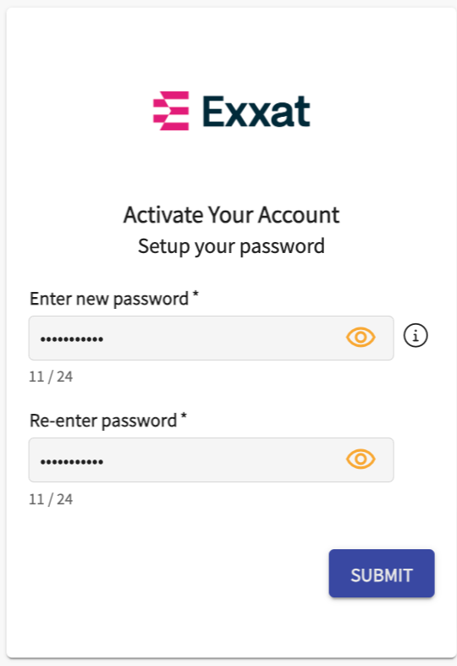 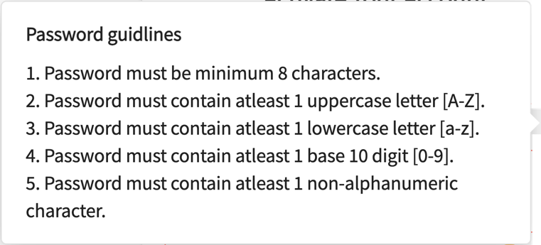
- You’ll then get a confirmation message letting you know your password setup was successful.
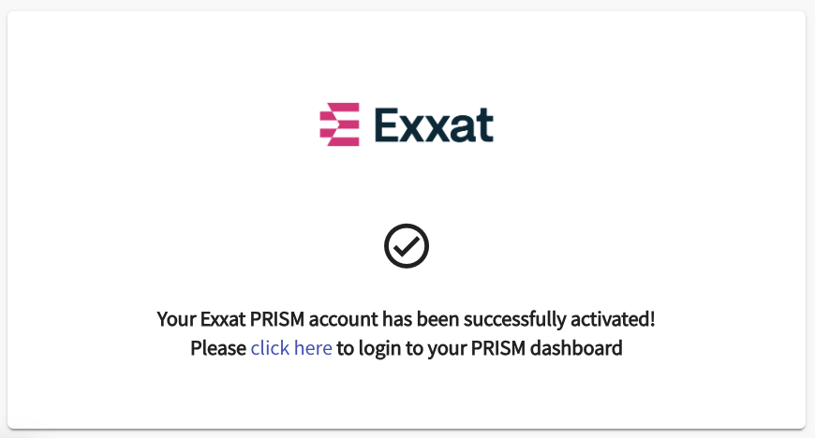
- Congratulations! You can now login to your account
- Navigate to steps.exxat.com and use the email address you received the invitation for along with your new password
Please note, Internet Explorer is not a supported browser.

Logging into Exxat via Single Sign On (SSO) Email Invitation
Single Sign On (SSO) allows users to use one set of login credentials to access multiple applications. If your program has set up SSO, you will use your school credentials to sign onto Exxat Prism!

- Go to steps.exxat.com.
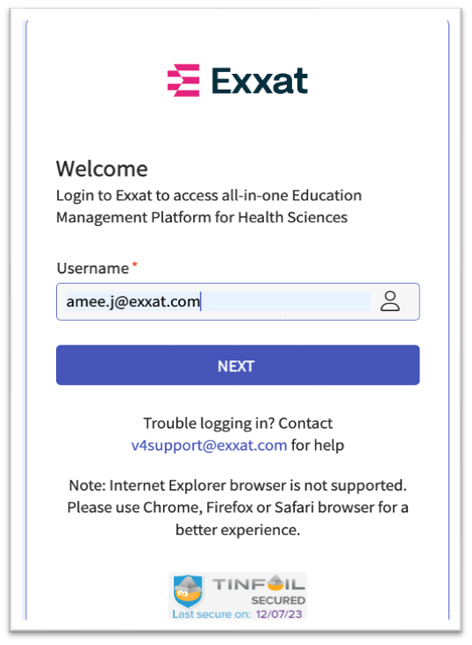
- In the username field, enter your school email address and click Next. You will be redirected to your school’s login page.
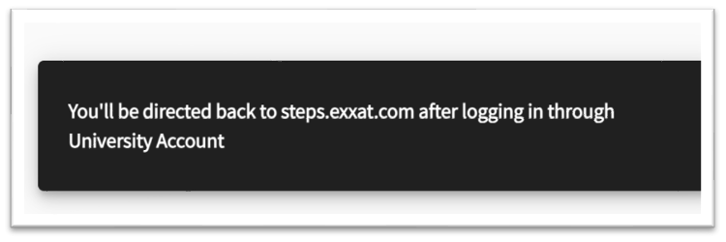
- Login to your school portal. Once done, you’ll be redirected to Exxat Prism.
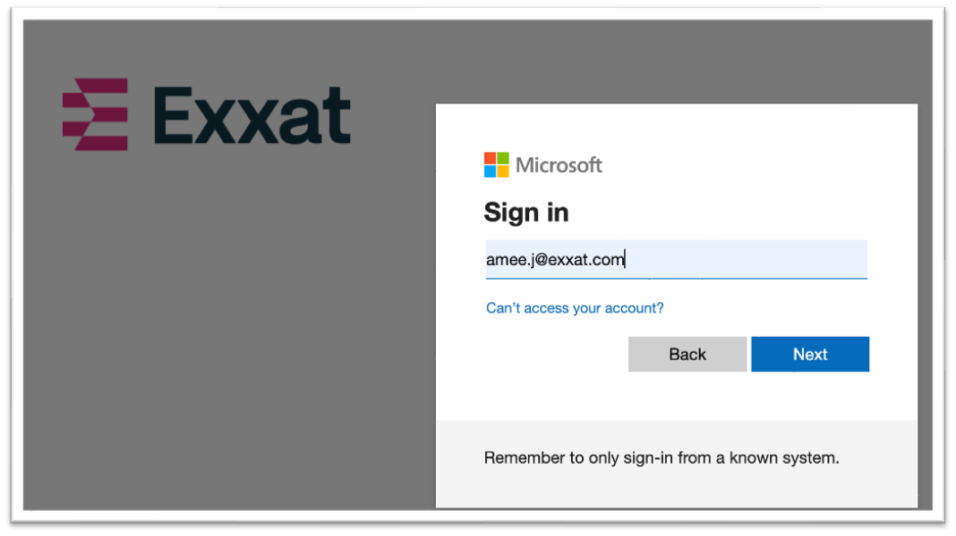

Navigating Dashboard
Once you have access to Exxat, you’ll want to get familiar with the system!
- You’ll first land on the dashboard, which may contain the following sections:
a. Program: details regarding your program, including student and course information
b. Placement Management: clinical site and placement management
c. Curriculum Management: managing courses and mapping objectives and measures.
- You can click on each of these menu options to view and manage information.
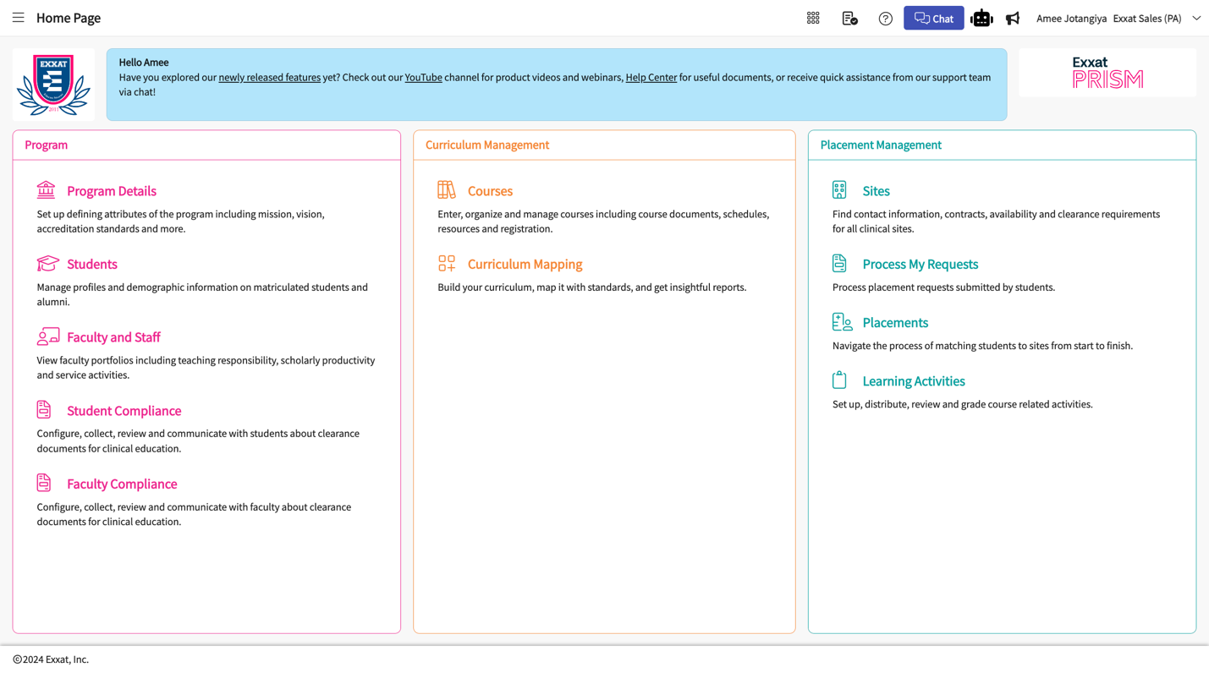
- At the top of the page, you’ll find the following you Navigation bar, You will see following comments on the top bar:
  - Hamburger Menu: Click on the hamburger menu to access all the different pages and sections to manage your day-to-day work
  - Page Name: See the name of the section next to the hamburger menu of the section where you are at.
  - Main Dashboard Icon (symbol with nine dots): Allows you to go back to the go back to main menu where you can switch to a different school program (if you are managing multiple program disciplines)
  - Notes icon: Allows you to access the onboarding notes. A central place to store any notes or discussion to be shared with the Exxat Team or your internal team members
  - Question Mark icon or Help: Allows you to access all the help and resources that can be accessed for Exxat Prism
  - Chat button: Allows you to initiate a chat with any of our Support agents for quick turnaround
  - Megaphone Icon: Allows you to access any of the new releases and feature improvements made to Exxat Prism.
  - Your Name and School Name: See your name on the Account along with your Program Name and domain
  - User Profile: Click on your name or dropdown icon Allows you to change the theme, accessibility mode, or change your password, click the dropdown arrow.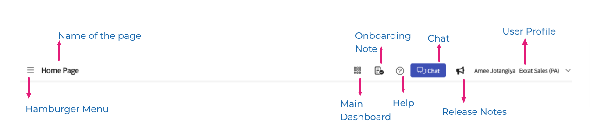
- Learn how to change your Password [only applicable if you are not using an non-SSO account]
  - Click on the drop-down icon on the extreme right-hand side
  - Click on Change password
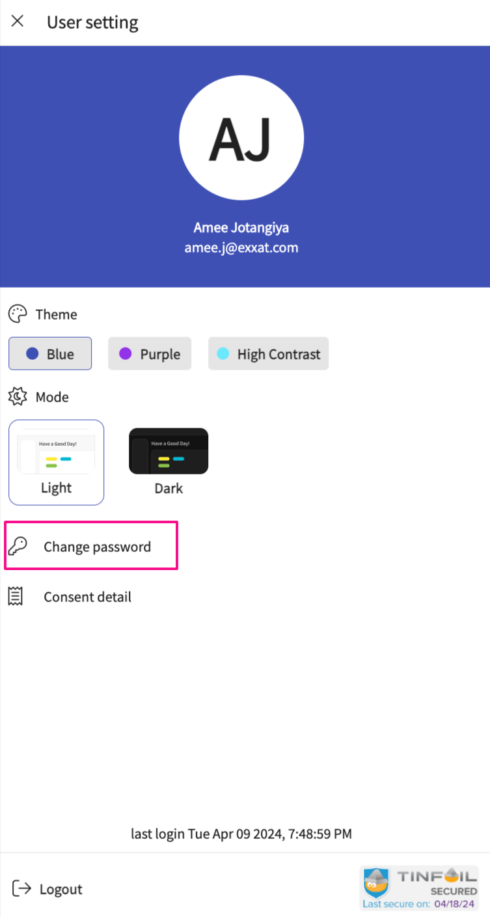
  - A drawer will open up to change your password, add all the details and click Save
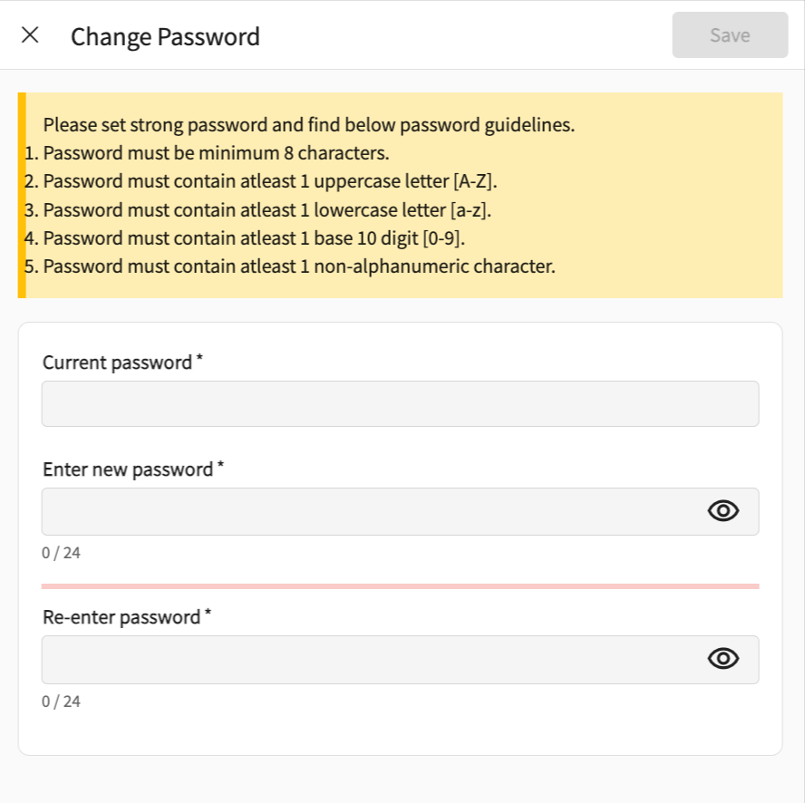
- Learn how to change your User profile theme and mode
  - Click on the drop-down icon on the extreme right-hand side
  - Choose the desired theme by selecting any color options
  - Choose the desired mode by selecting any mode
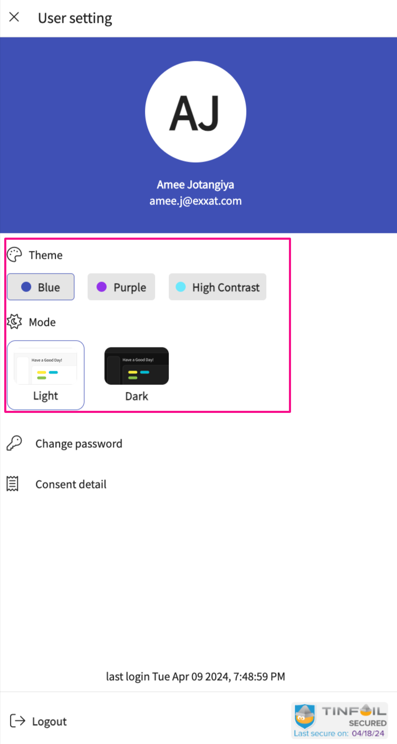
  - Your preferred theme and mode is setup
- Learn how to Log out of your account
  - Click on drop-down icon on the extreme right-hand side
  - At the bottom of the page, Click the "Logout" button
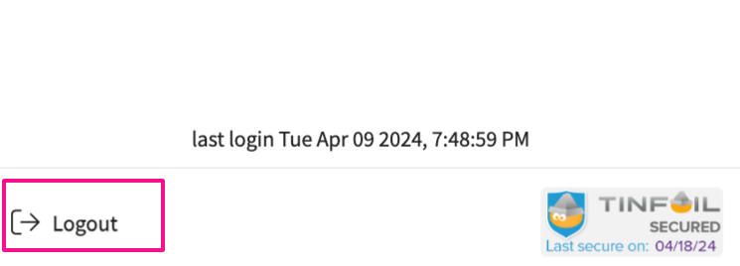
- Learn how to jump to any section using the Hamburger menu

    - Click on the top left side, You will see all the main section pages
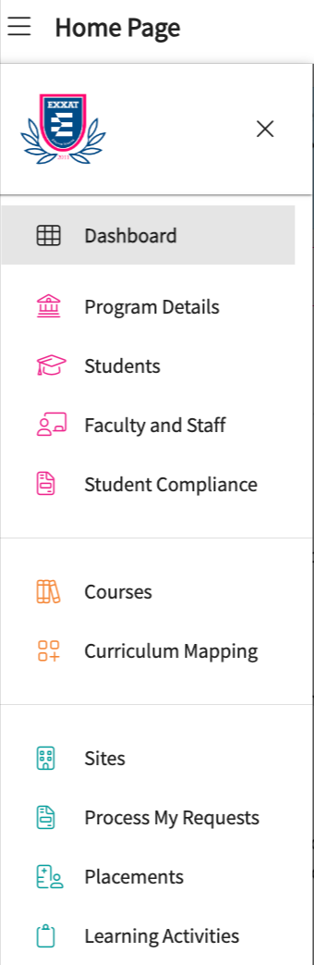
- Learn how to be updated about all the latest updates made to Exxat Prism via the Megaphone icon
  - Click on the Megaphone icon
  - Access all the detailed release notes and link to the recording
