Clearing browser cache

This article aims to provide a step-by-step guide on how to clear the browser cache in two popular web browsers, Chrome and Safari. Clearing the cache can help resolve issues with slow loading times, outdated content, and various browsing errors. By following these simple instructions, users can effectively remove cached files and images, improving browser performance and ensuring a smoother browsing experience.
Learn how to clear the cache for your browser:
- Chrome Browser
- Safari Browser

Chrome Browser
Step: 1 - On your computer, open Chrome.

Step: 2 - At the top right, click More. (Marked in red)

Step: 3 - Click on More tools. (Marked in green)
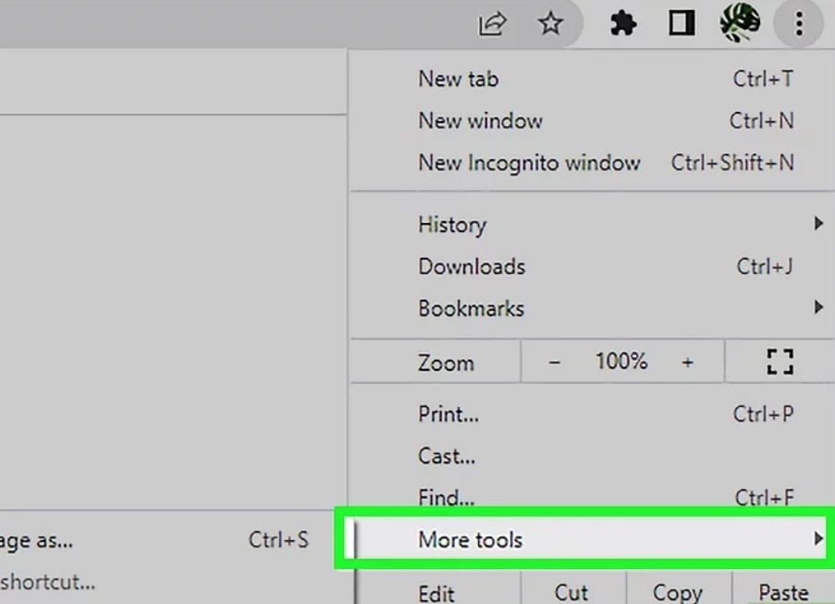
Step: 4 - Click on clear browser data. (Marked in green)
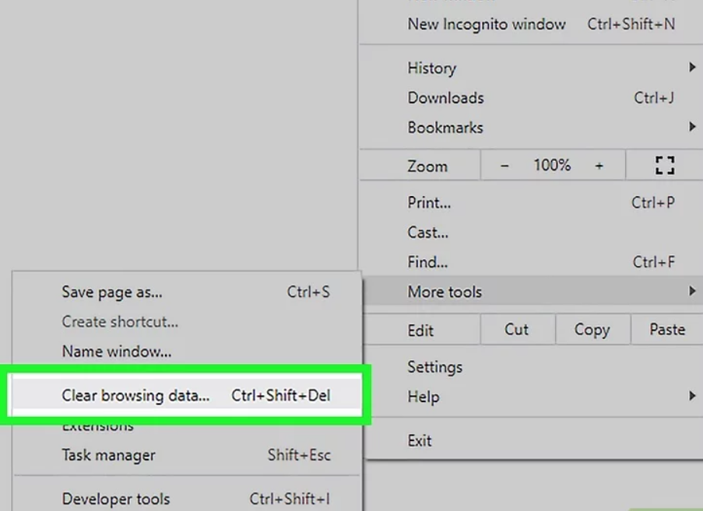
Step: 5 - Click the "Time range" drop-down box. It's near the top of the window. A drop-down menu will appear and select “All time”
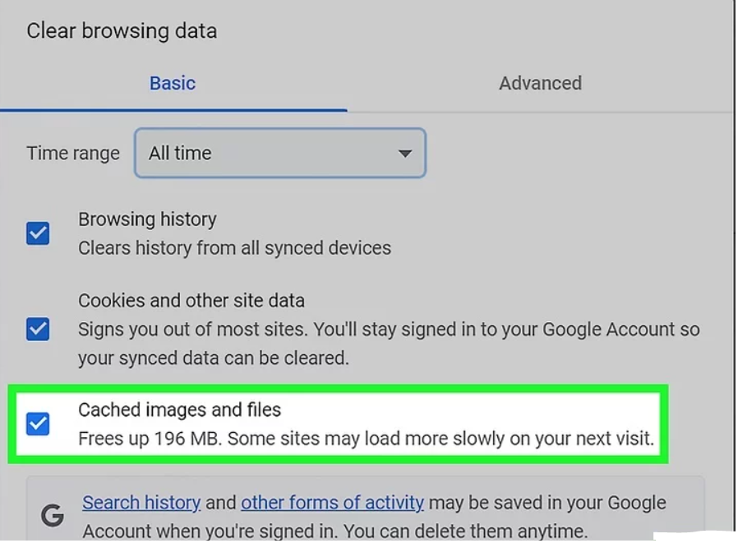
Step: 6 - Check the "Cached images and files" box. It's in the middle of the window.
- Uncheck every other box on this page if you only want to clear the cached files.
- If you also want to clear your cookies or other site data, check the "Cookies and other site data" box. Clearing cookies can also sign you out of some sites. For these sites, just sign in again and all of your account-related data will still be there.
Step: 7 - Click on Clear Data. This blue button is in the bottom-right corner of the window. Doing so will prompt Chrome to delete your cached files and images from your computer and browser.

Safari Browser
On your computer, open Safari.
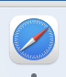
Step: 1 - Click the Safari Menu.
- If you want to clear your web browsing cache in Safari, you'll need to enable the Develop Menu first.
- Start by clicking the Safari Menu at the top of the screen, If you already see a Develop Menu item in the bar at the top of the screen, Skip to Step 5.
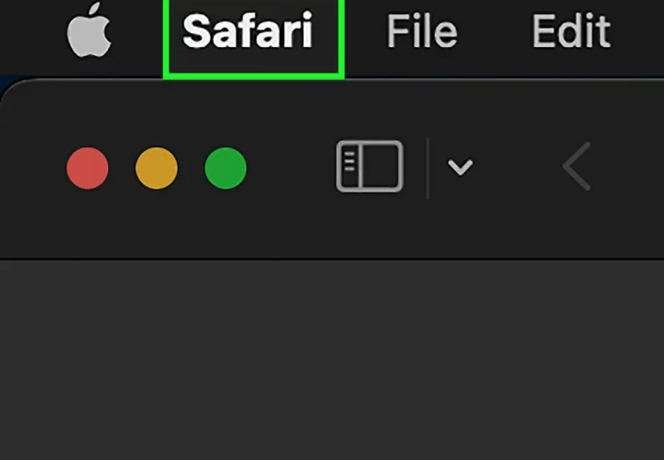

Step: 2 - Click Settings, It's near the top of the Safari drop-down menu.
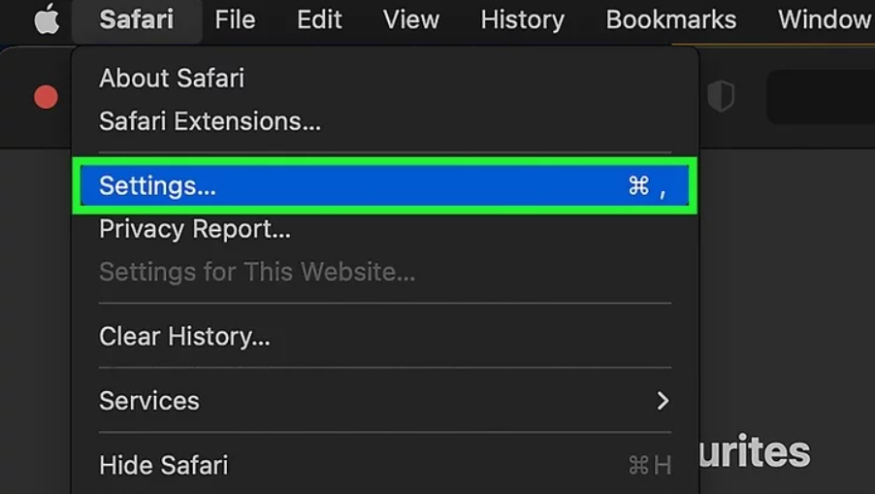

Step: 3 - Click Advanced, Here you'll find several more Safari settings, including Reading List settings and the option to enable the Develop menu.
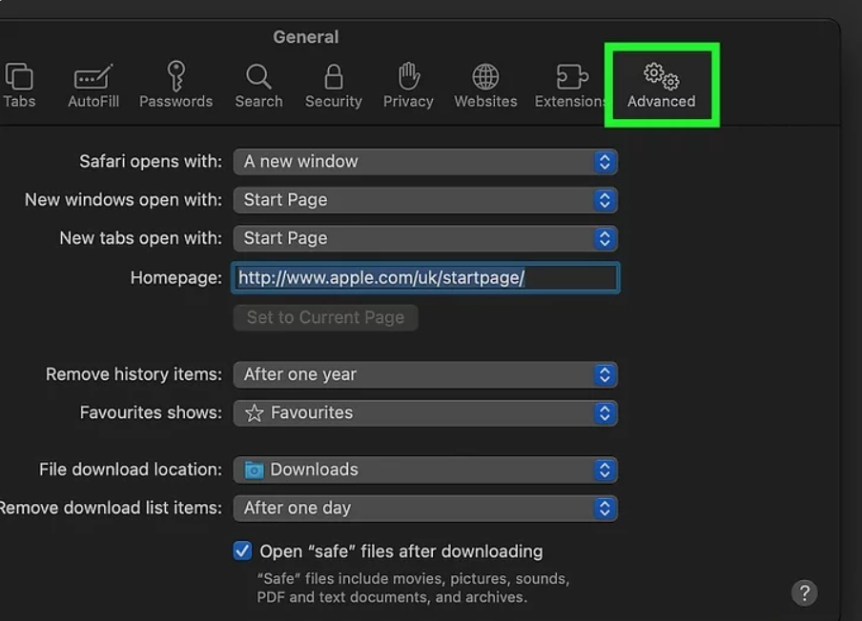

Step: 4 - Check the "Show Develop menu in menu bar" box. It's at the bottom of the Preferences window. This adds the Develop tab to the menu bar for Safari. You can now close the Advanced window.
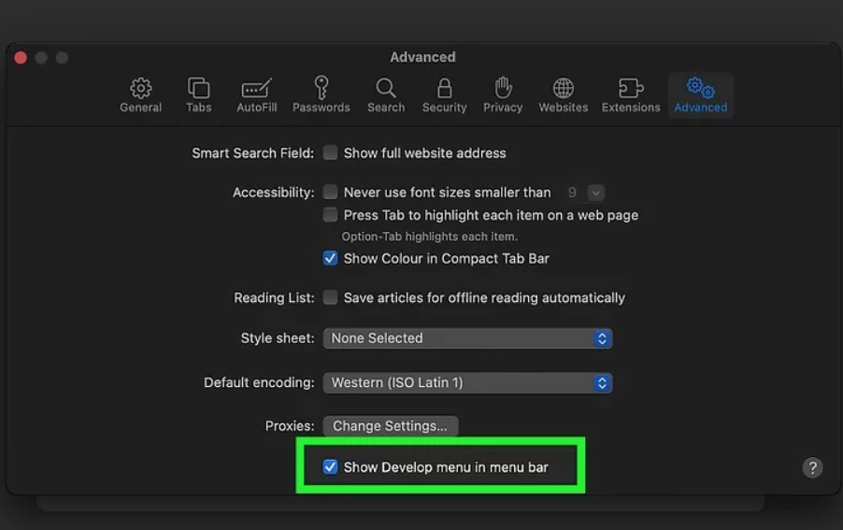
Step: 5 - Click the Develop menu. You'll see it in the menu bar at the top of the screen.
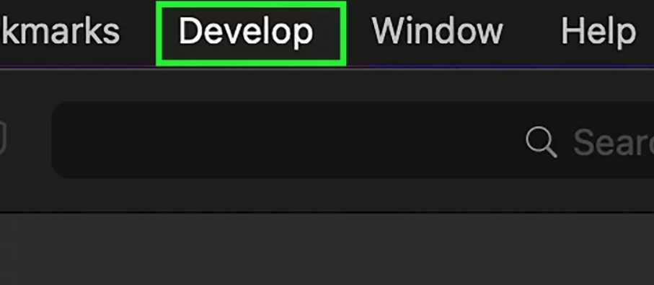

Step: 6 - Click Empty Caches. This clears your web browsing cache in Safari.
