Overview of Student Page
You can do more than just review student information, read on to learn more about all the things you can manage via the Student Page
- Grid View and Student Selection: The system provides a grid view to display student information. By selecting a student's name, you can access their detailed profile.
- View As Feature: Allows you to see what students see on their end in a read-only mode for assistance.
- Share Profile: Enables sharing of student profiles via email, allowing selection of specific information to share.
  - Share Profile
  - Download Profile: Facilitates downloading student profiles for sharing with external parties.
  - Generate Profile URL: Creates a direct link to a student's profile for easy sharing.
  - Profile Share History: Provides a history of shared profiles, showing status updates like link clicks and email delivery.
- Student Deletion: Allows administrators to delete student profiles, subject to certain conditions.
- Student Profile Tabs Overview:
  - Academics Tab
    - Update student status (Active, Inactive, Graduate).
    - Add and manage SSO keys.
    - Update student cohort.
    - Associate Faculty and Staff
  - Compliance Tab: Review and update student compliance information and Download compliance documents.
  - Communications Tab: Log and track communications with students.
  - Interventions Tab: Log and track interventions related to student progress.
  - Coursework Tab: Manages clinical placement-related coursework.
  - Learning Activities Tab: Review and manage specific learning activities, including forms, patient logs, timesheets, and time off requests.
Learn all the things you can do

Grid View and Student Selection
- Select Students from your dashboard or left menu.
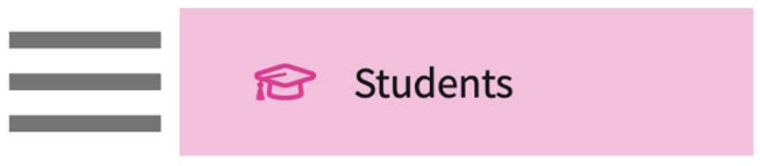
- The Grid View student information, the system
  - To view additional information for a single student, select the student's name.
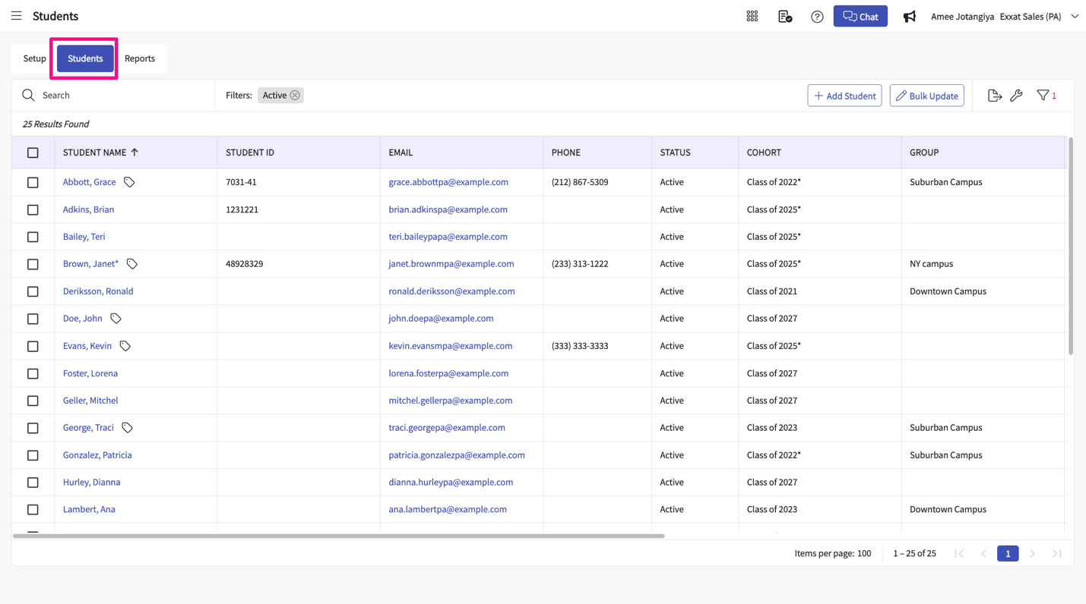
- On the Grid View, find and select the student you’d like to manage. Use the search box or filter to quickly find what you are looking for. Select the desired student name.
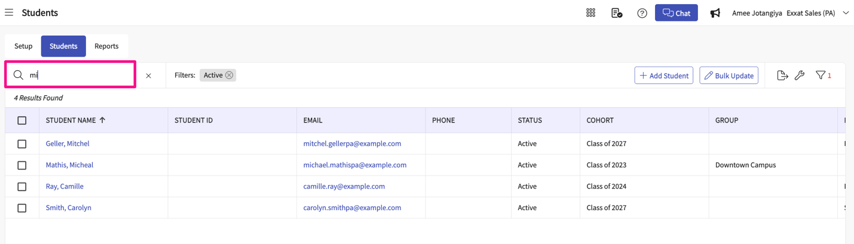
- The student’s profile will load. A few handy features available to you:

View As
    - View as allows you to look at all the information that student see on their end.
    - At times you may need to view what your students are seeing to assist them. In Exxat Prism you have the ability to do so by using the “View As” feature. This feature will allow you to see what your students see.
    - Please note, the View As feature will not allow you to make any edits and will be in view-only mode.
    - Select the View As Button, Clicking on this option will take you the student view (view/read-only). Feel free to navigate to any necessary pages using the dashboard or left menu
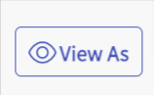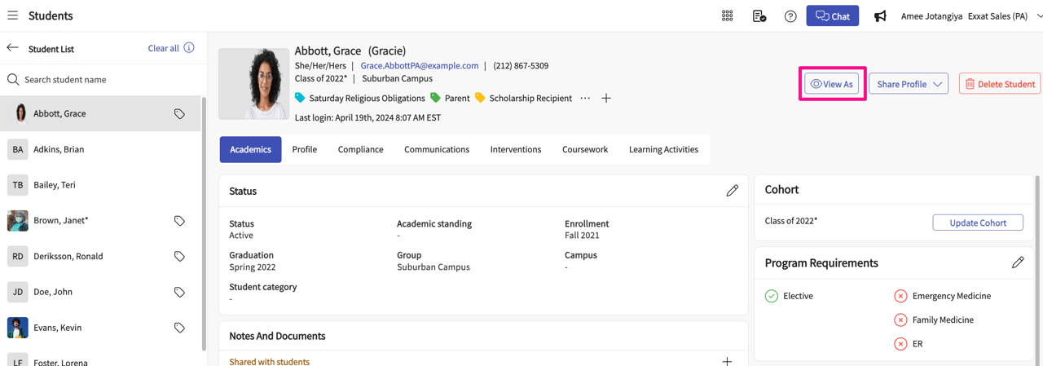
    - Once done, click Switch Back to revert to your account.
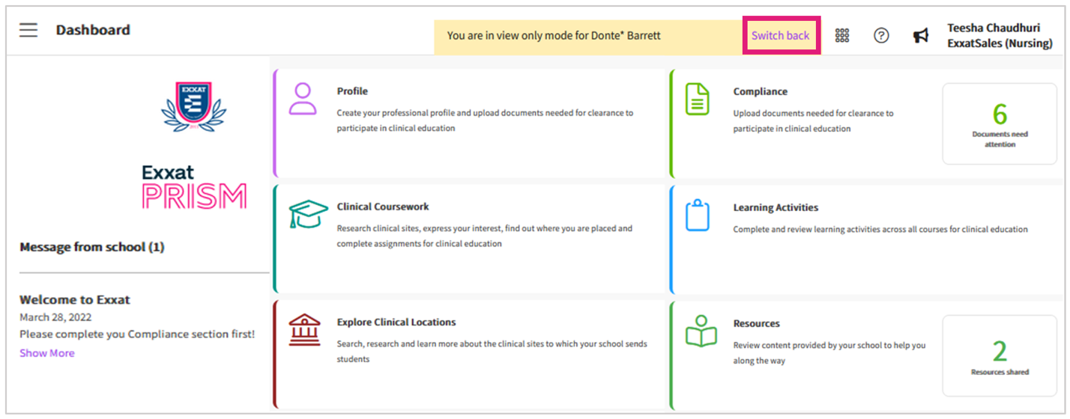

Share Profile:

Share Profile:
      - Click on the Share Profile button, you will see a couple of different options.
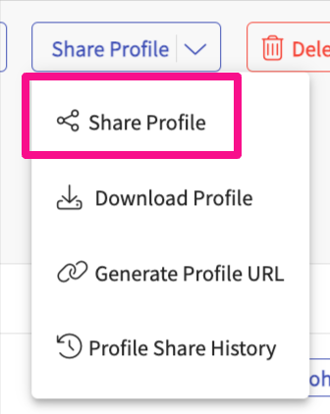
      - Click on Share Profile, and a drop-down will appear, click on Share Profile, this will allow you to share individual student profiles via Email
      - You will be able to pick and choose specific information from the student profile like their contact information, Completed program requirements, Compliance documents, and students completed placement information.
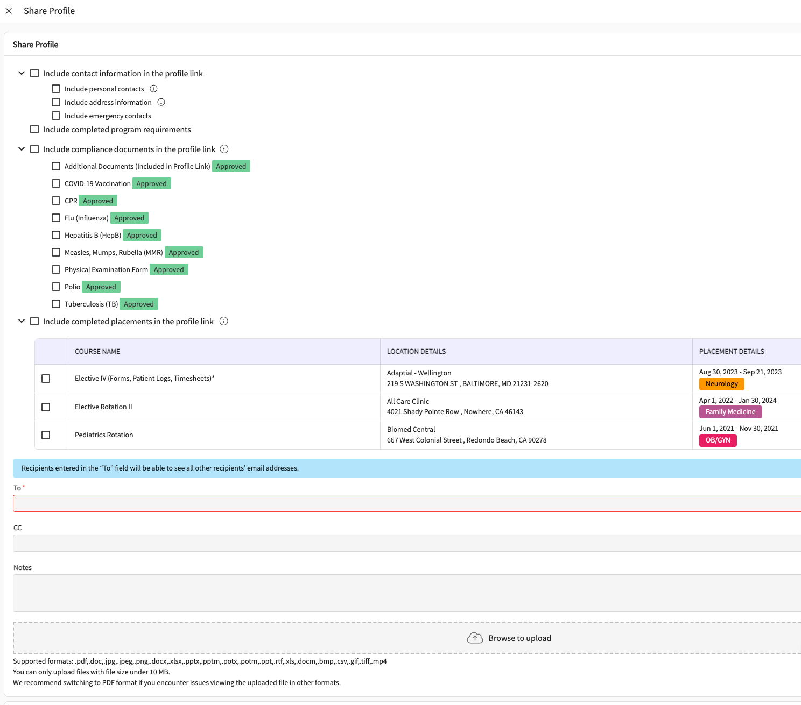

Download Profile:

          - Easily download your student’s profile to share with clinical sites when needed.
Click on Share Profile and a drop-down will appear choose the "Download Profile" option.
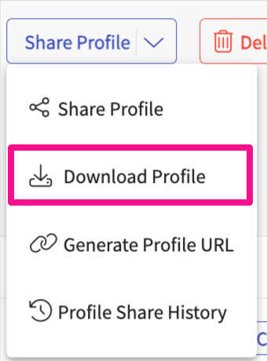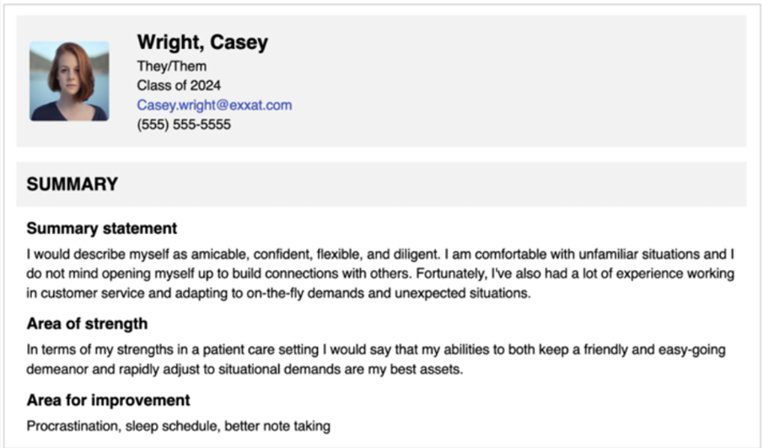

Generate Profile URL

            - This will allow you to share a direct link for your student's profile. Think of this as your student's portfolio link
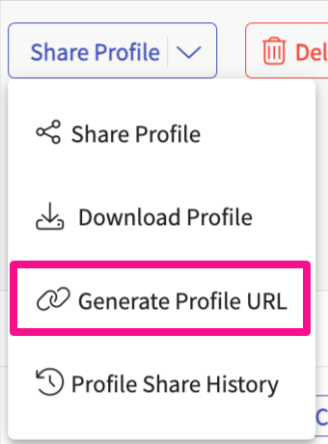
              - Click on Share profile, a drop-down will appear to select "Generate Profile URL". You will be able to pick and choose specific information from the student profile like their contact information, Completed program requirements, Compliance documents, and students completed placement information.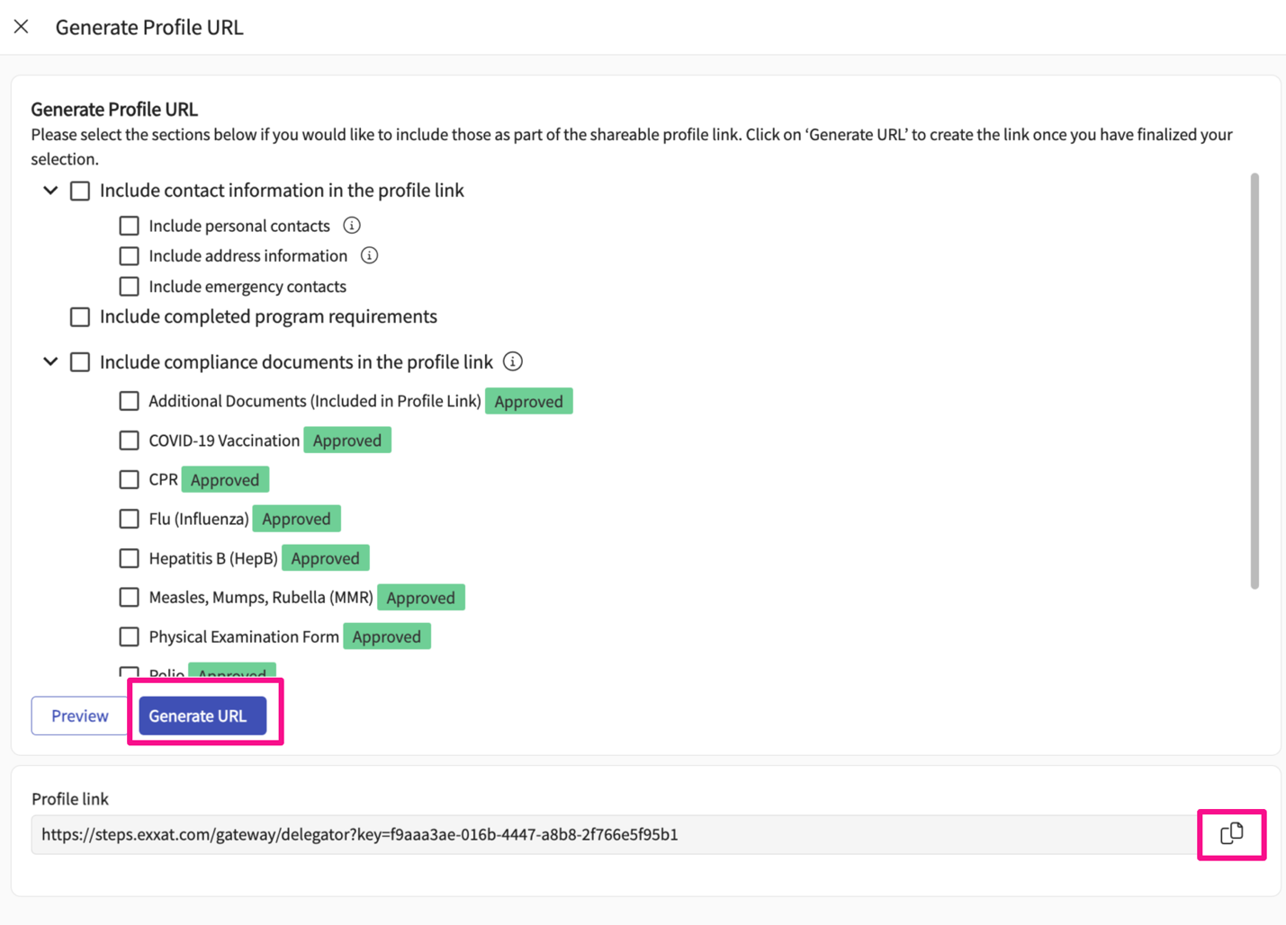
              - Click on the Generate URL button, you will find the URL under the profile link
              - Click on the copy button to copy the URL link generated.

Profile Share History:

                - Allows you to view the history of profile shared
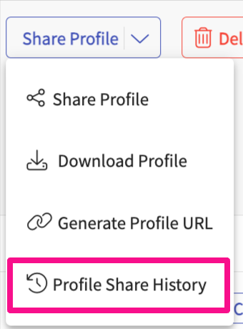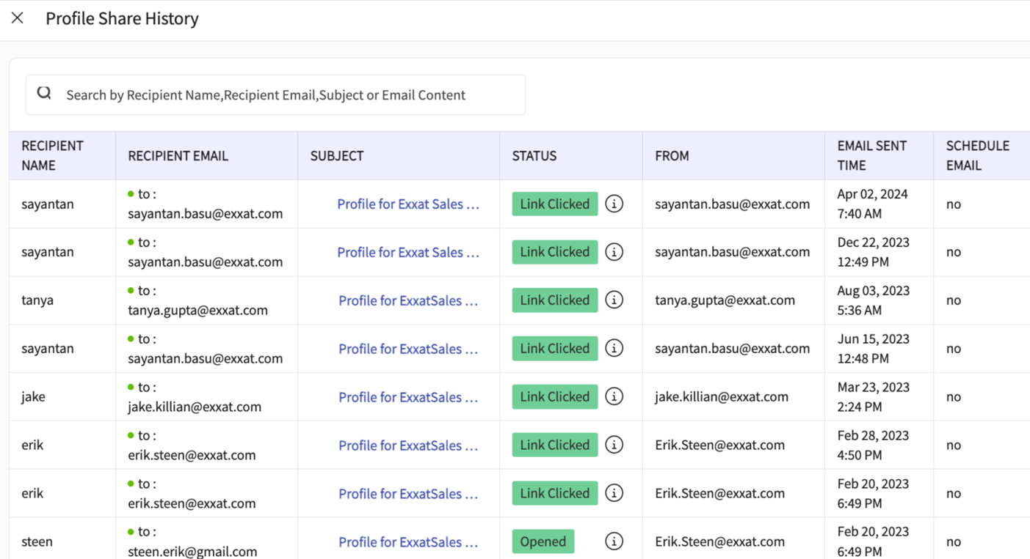
                - Click on the Share Profile button, and select the Profile Share History option. On the grid, you will be able to track the history of all the profiles shared and you will be track the status of the link.
                - Under the Status column, learn about all the different status
- Link Clicked means the recipient has clicked the profile link
- Opened means the email was delivered and opened by the recipients
- Delivered means the email was delivered to the recipients' inbox
- Bounced means the email was not delivered to the recipients' inbox

Student Delete:

      - Allows admins to delete students who did not fill out any learning activities. Admins are advised to contact support for the deletion of students who have saved or submitted any learning activity data.
      - Click on the Delete Student button to delete student
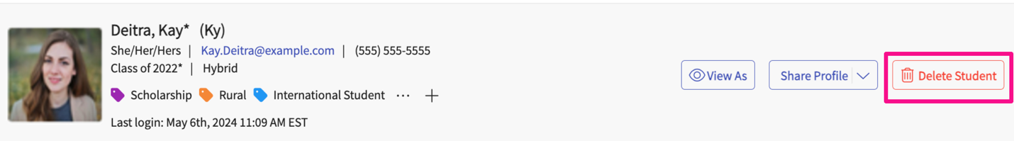
      - In case the student has any learning activities data, you will receive a warning message stating you will not be able to delete it. 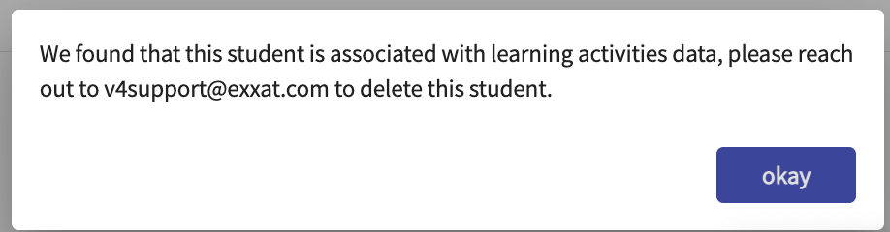
- Switch to view other student profiles using the left panel.
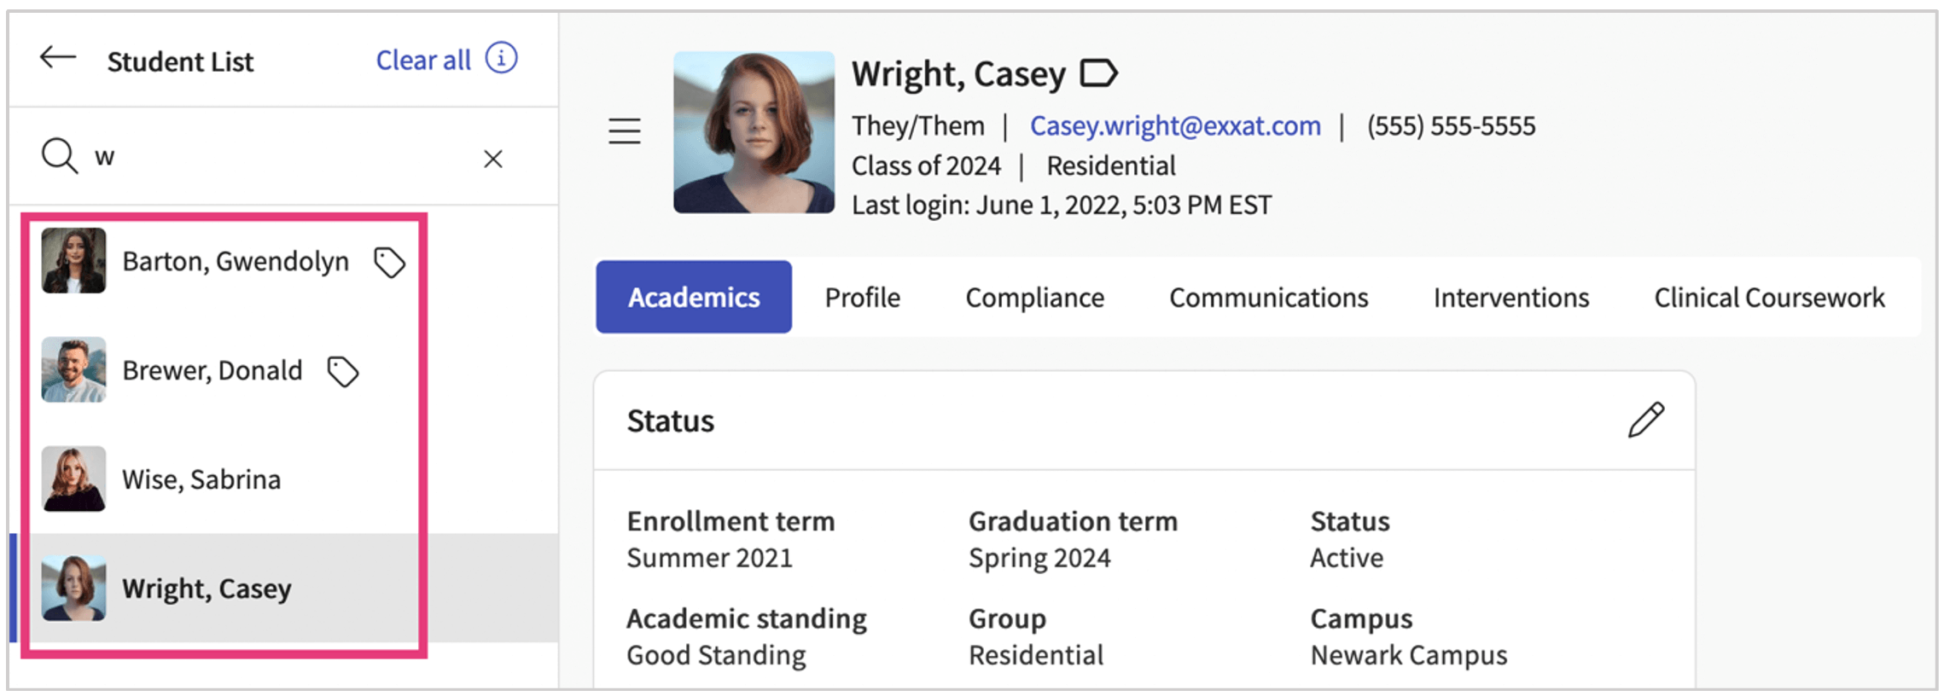

Profile Tabs Overview
The profile will contain the following tabs. Click on each of them to view and manage information!

  - Academics: you can update program information, requirements, and associated faculty, view attestations, and add any specific notes and documents here. This section will be viewed only for your students.
  - Profile: view and edit information student provided on their profile.
  - Compliance: review and approve (if applicable) compliance information.
  - Communications: log any communications you’ve had with your student.
  - Interventions: log any interventions for your student.
  - Coursework: review all placements for your student. This will include completed assignments!
  - Learning Activities: View all the learning activities that are added for a student
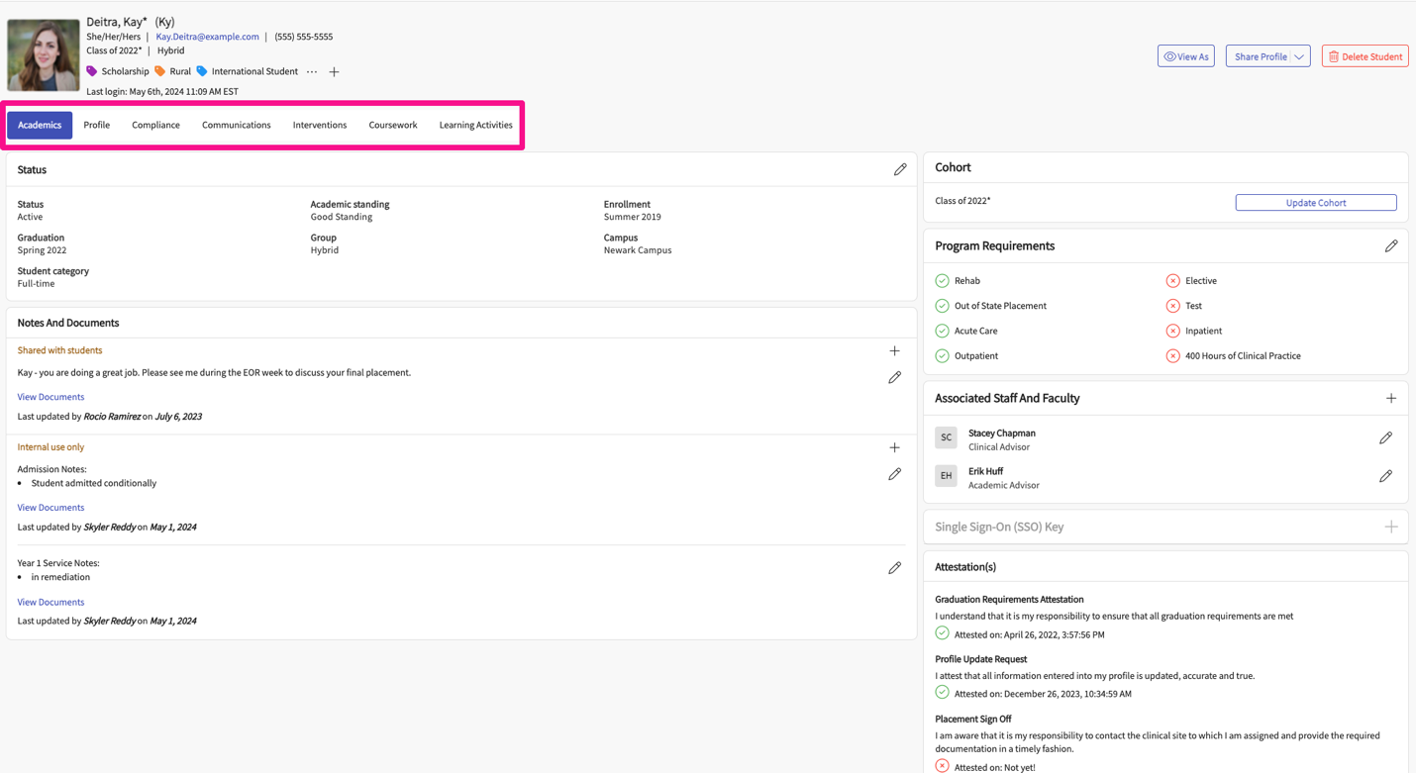

Academics Tab:
Administrators will be able to change the student status to Active, Inactive or Graduate via the Status section.
- Status: Click on the Academic section, Under the Status section, click on the pencil icon, and change any status attributes 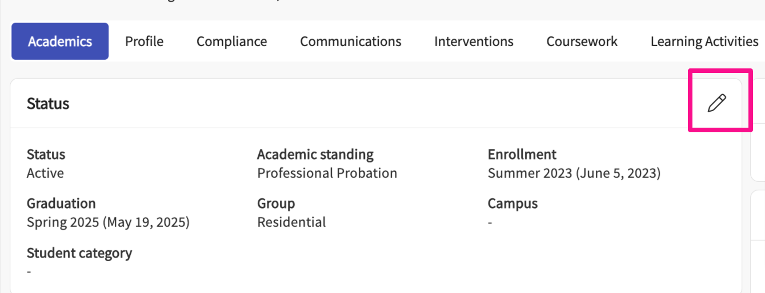
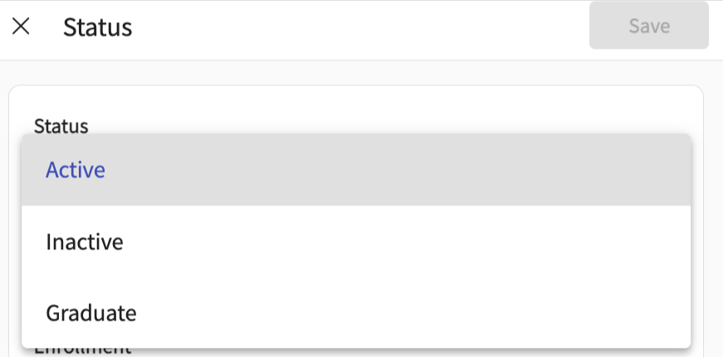
SSO: Administrators will be able to add SSO keys within the student academic section and send SSO invitations. Admins can now view already added SSO keys within the student profile as well.
- Adding SSO Key: Select the Student, then under the Academic section click on the Single Sign-On SSO Key section and click on + icon to add the key
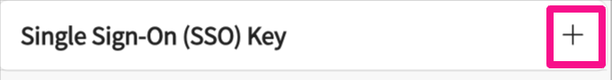
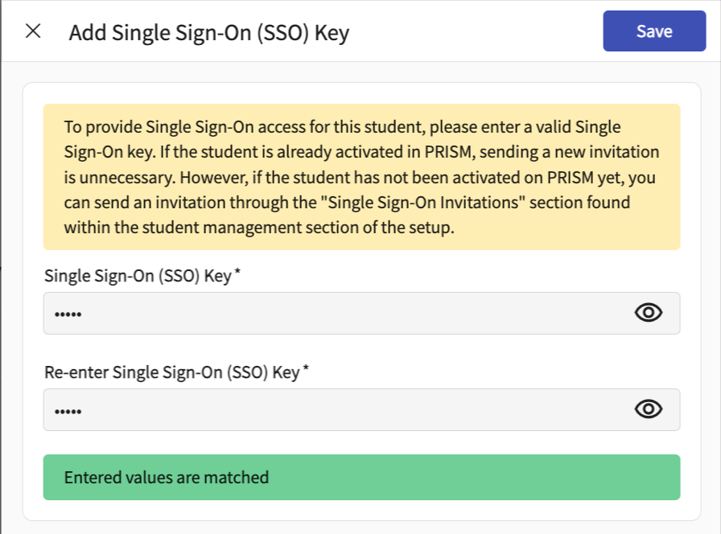
Update Cohort: At times you may need to change the cohort of your existing student due to various reasons.
- Like if the student changes their plan of study or must take a leave of absence. You can now move the student from one cohort to the next to accommodate this change.
- In order to change or update the cohort you can follow the below-mentioned steps:
- Select the student you would like to move from one cohort to another cohort.
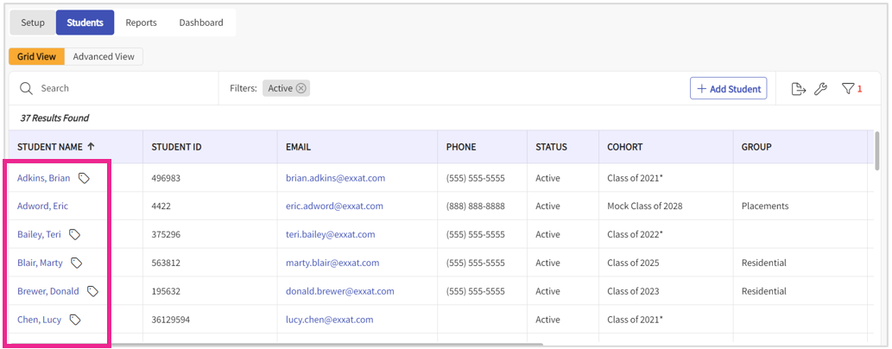
- Click on the Update Cohort button from the right to change the cohort.
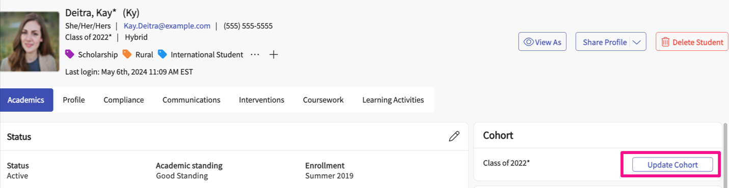
- A drawer will open where you can find the instructions about the data which will move along with students and the data you lose. Click on Next option for the Cohort Selection.
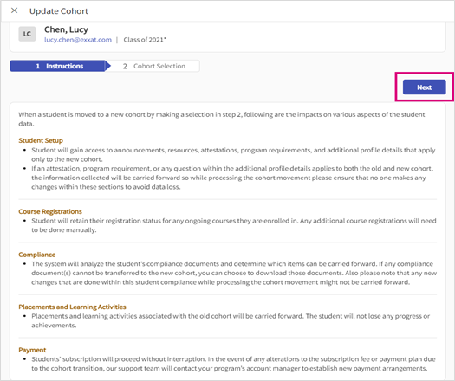
- Select the new cohort from the New Cohort option where you would like to move the student. Program administrators can also download the compliance documents uploaded by students.
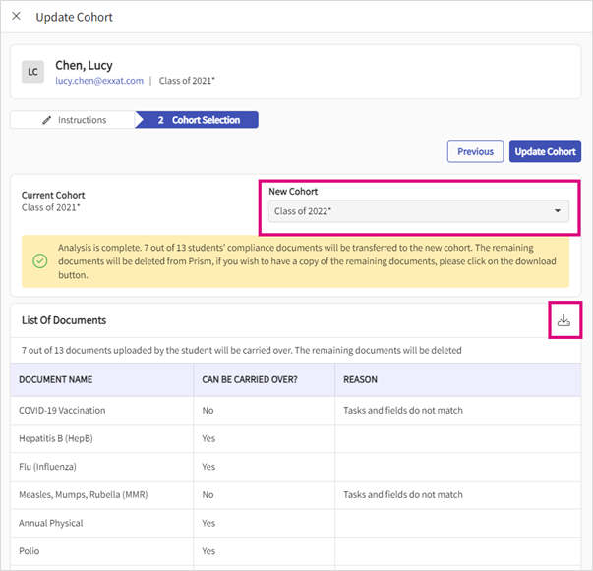
- Once done click on Update Cohort option.
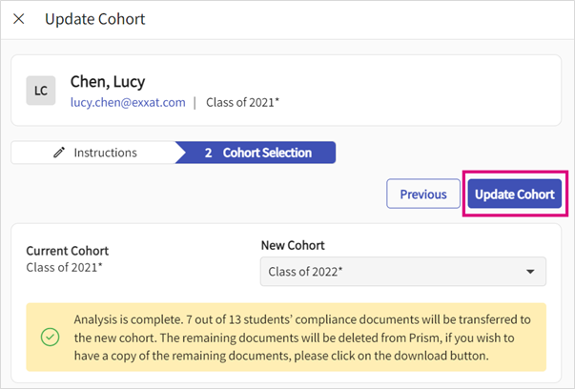
Program Requirement: Allows you to track the program requirements that the student has completed and met. You will see a cross icon for the requirements that the student has not met and a green check icon for the requirements met.
- To update the Program Requirements,
  - Select the student,
  - Click on the Academic section
  - Select the pencil icon
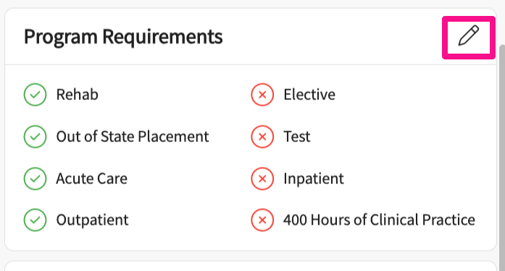
  - Select check/uncheck any requirements
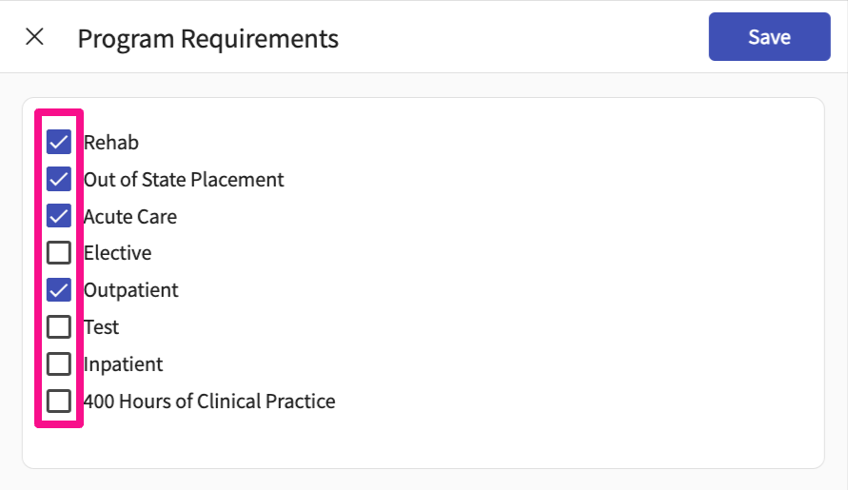
  - Click on Save
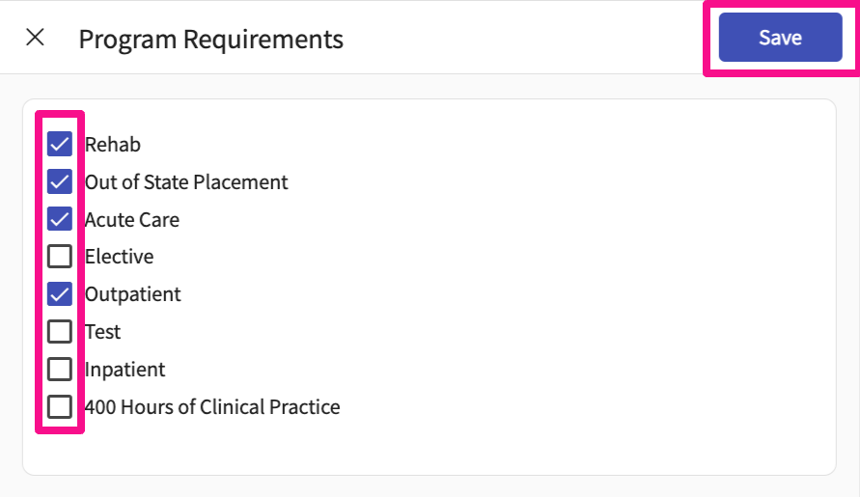
Notes and Documents: Allow you to Add any notes and documents that you want to track for internal use or to share it with students.
- Shared with students
  - Click on Notes and Documents section, click on + icon to upload any new documents or notes to be shared with students
  - 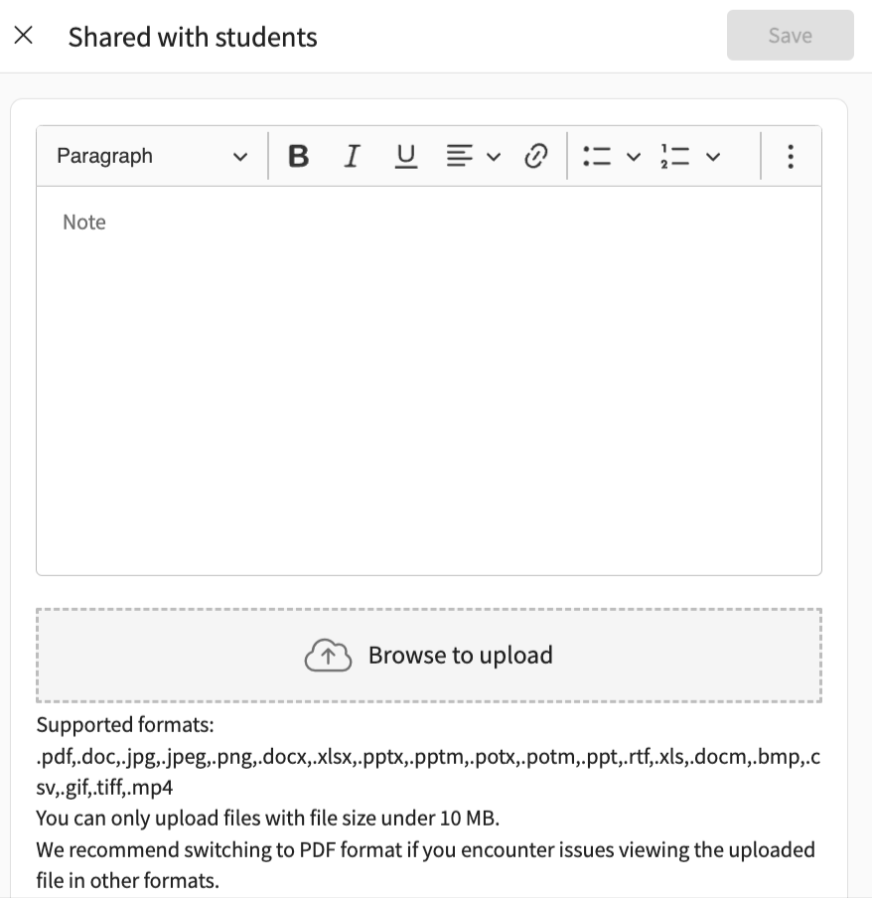
- Click on Notes and Documents section, click on + icon to upload any new documents or notes to be shared for Internal use only
To associate a single student with Faculty & Staff:
- Select Students from your left-menu.
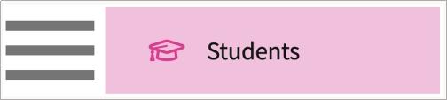
- The page will load all students in the system. Click on the student’s name.
a. To find a particular student, use the search bar.
b. To find a specific cohort, use the filter option.
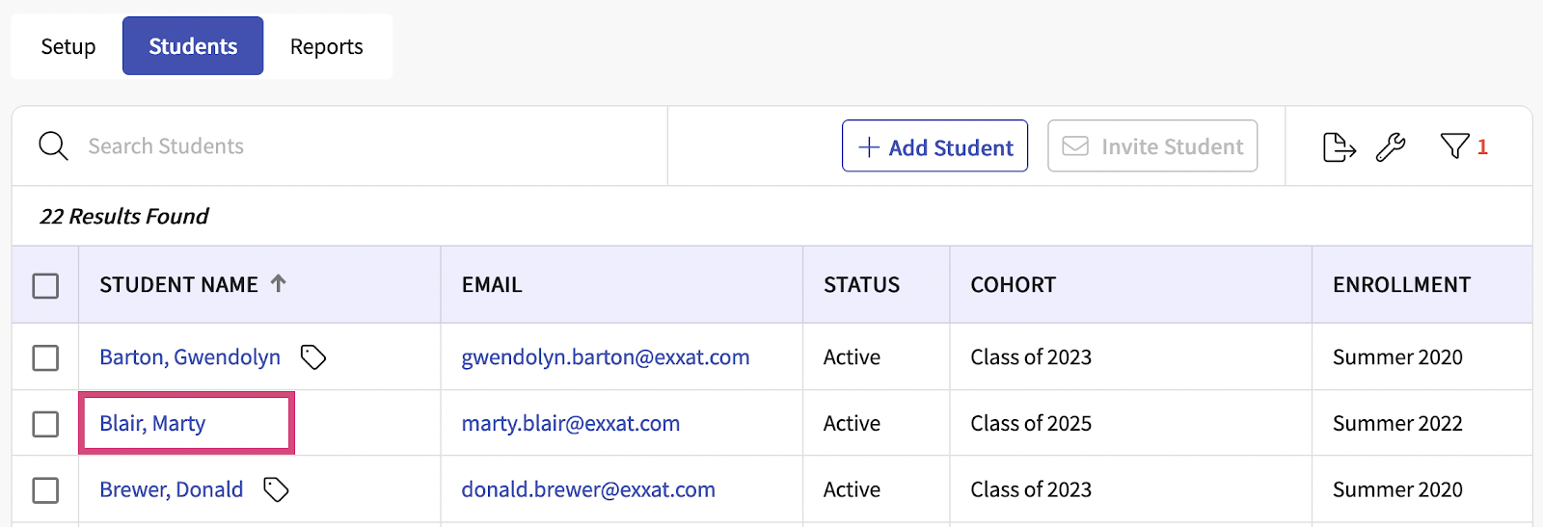
- You’ll be taken to the student’s information page.
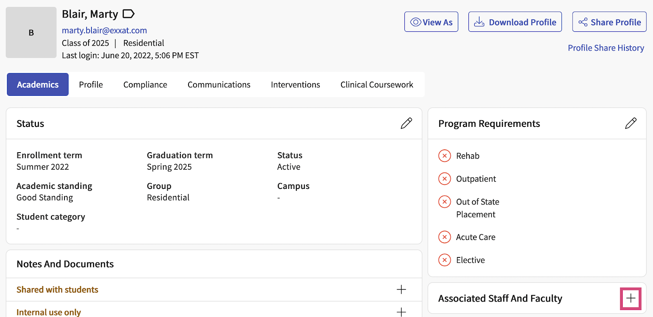
- Click on the + icon within the Associated Staff and Faculty card.
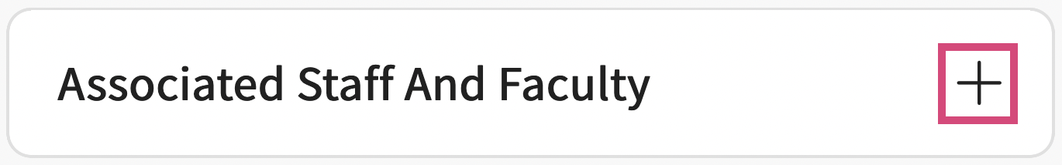
- A drawer will open. Fill out the form and click Save when done.

  - Contacts added within the Staff & Faculty section will appear in the dropdown.
  - When you associate the staff and faculty, it would allow them to access all the profile and coursework data for this student
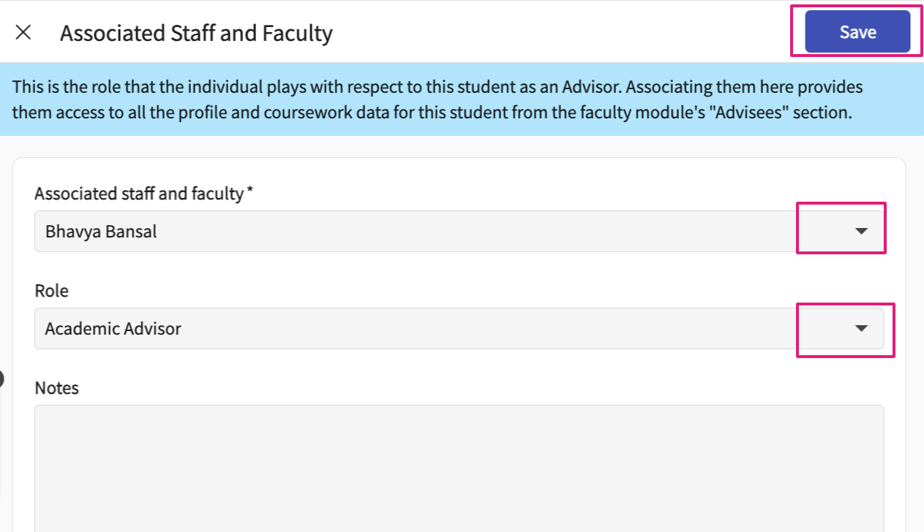

Compliance Tab:
Once your students start to provide compliance information, you’ll be able to review and update that within the system!
- Select Students from your dashboard or left menu.
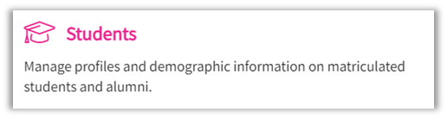
- Find and select your desired student.
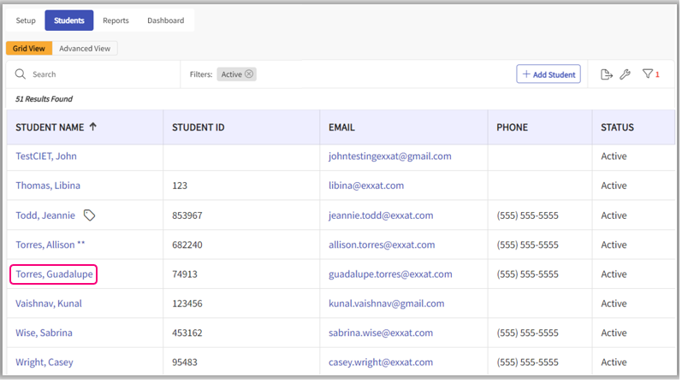
- Select Compliance.
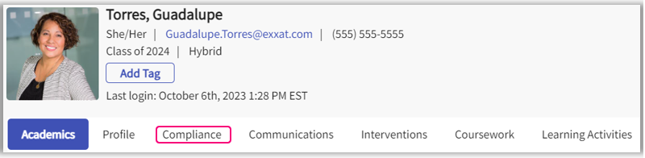
- The page will load all requirements enabled along with the current status. Click on the requirement or on the status to view information provided by the student.
  - The tally at the top will quickly show you how many items are approved, pending review, and needs attention.
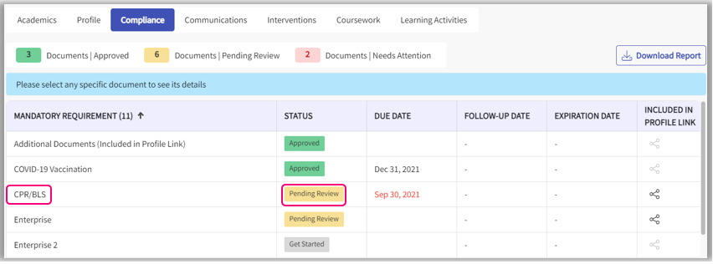
- A drawer will open. Review information provided by the student. You can update the document status, select the reason from the drop down and provide comments (if needed). Once done, click Update Status.
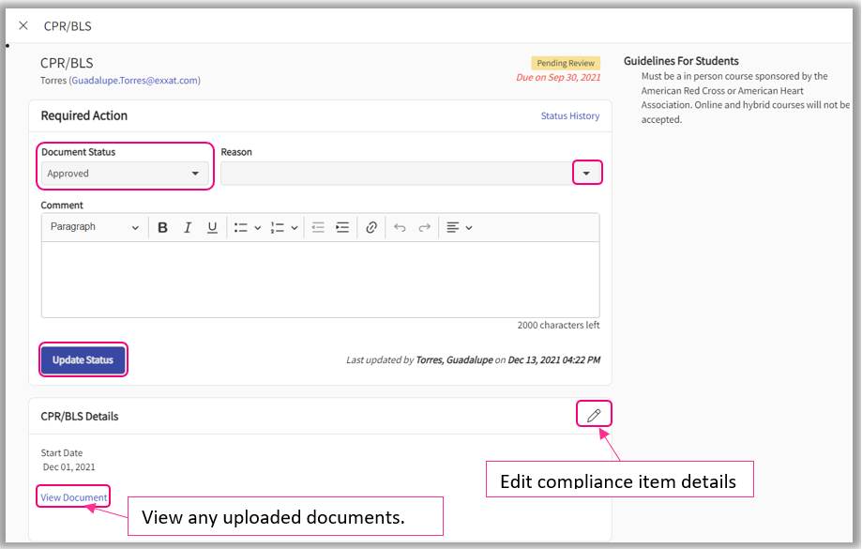
- The requirement will update. Close the drawer to review other compliance items.
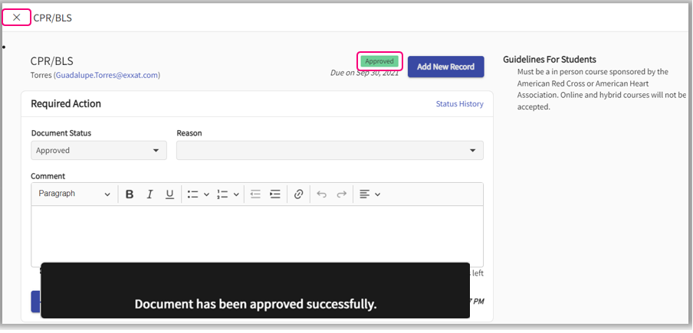
- If you’d like to download documents uploaded by the student, click Download Report.
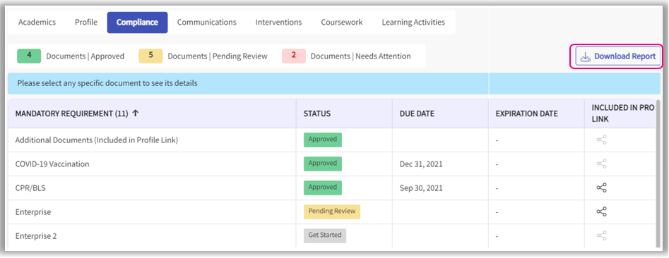
- A drawer will open, and all items will be selected by default. Unselect any documents you would like to exclude from your download. Please note, if you only select items which do not have file uploads, the system will not provide a download file.
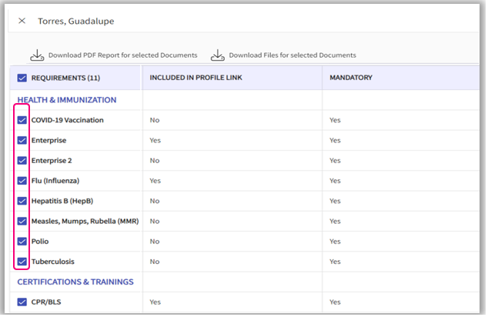

Communications Tab:
When working with students, there may be items you’d like to keep a note of, and you may not be sure of the best place to store this information.
You may have ongoing discussions with your student about a possible placement, or regular check-ins. For this type of information, we recommend you utilize Communications. For incidents, and ongoing problems during a placement, we recommend you use Interventions.
- Select Students from the left menu or dashboard.
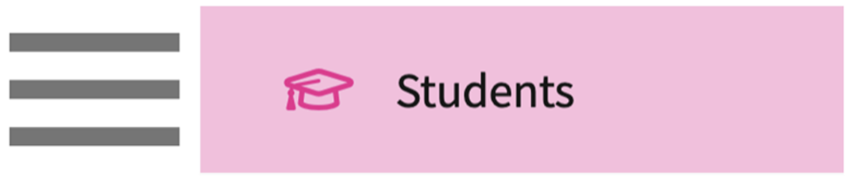
- Find and select the student you’d like to manage.
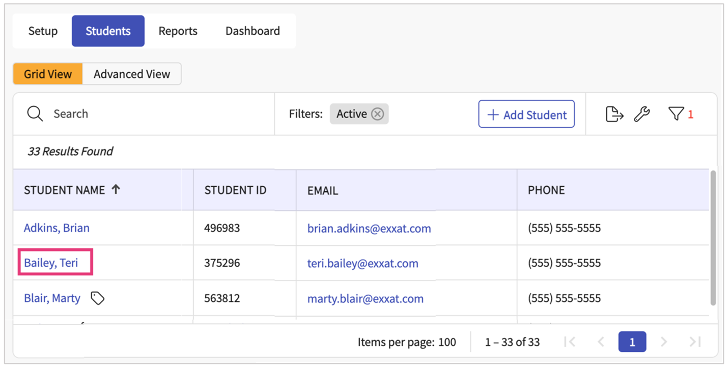
To log a communication:
- Select Communications.
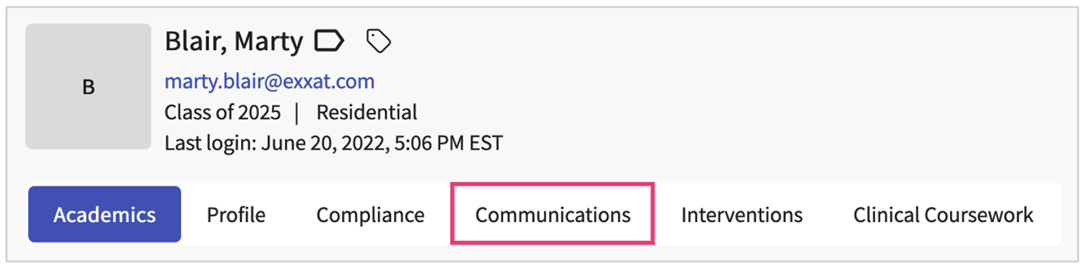
- The page will load all previously added communications. Click on the + icon to add an entry.
  - Click on the pencil icon to make edits to existing communications.
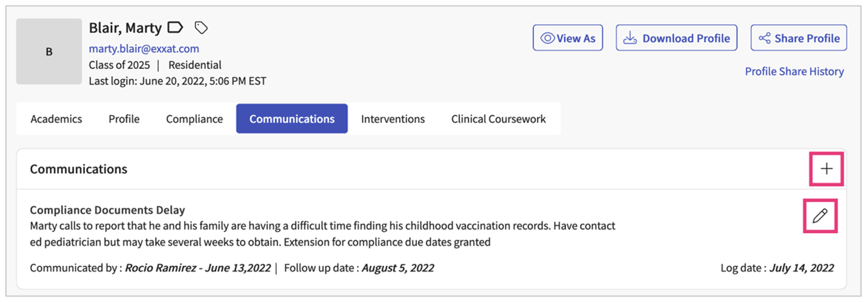
- A drawer will open. You’ll be able to enter the following information. Click Save when done.
  - Mode of communication
  - Details of communication
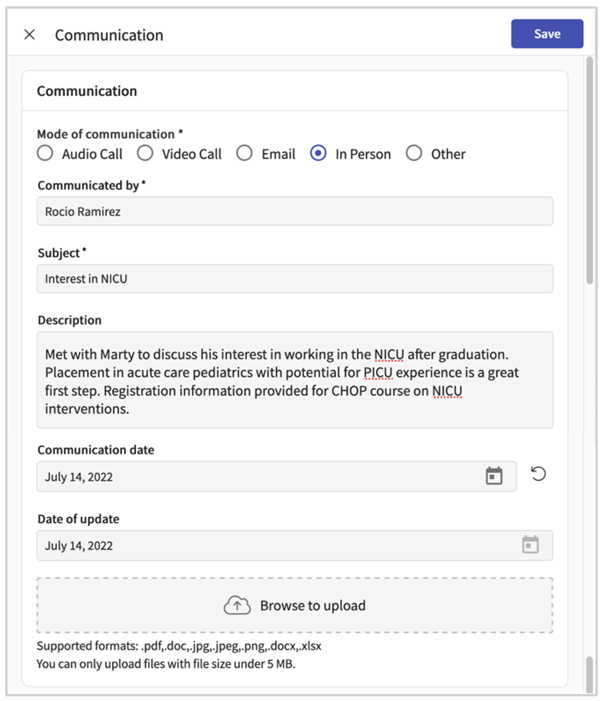
  - Details of follow up if needed.
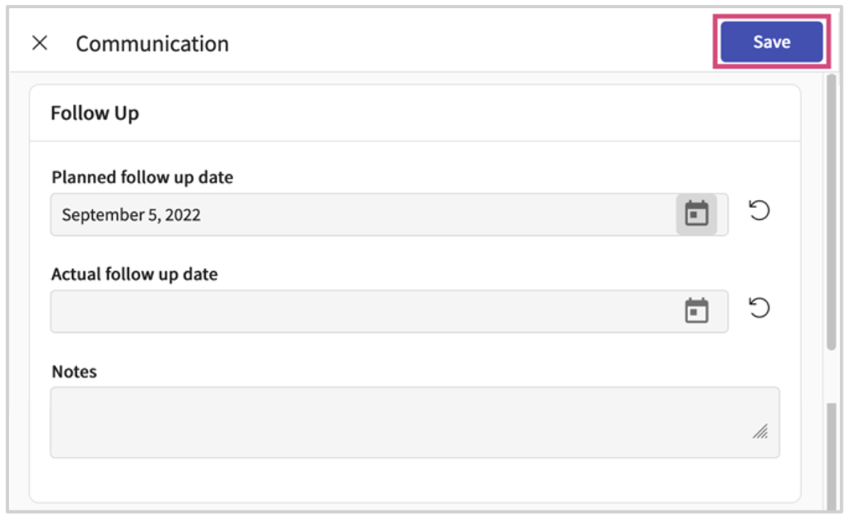

Interventions Tab:
- Select Interventions
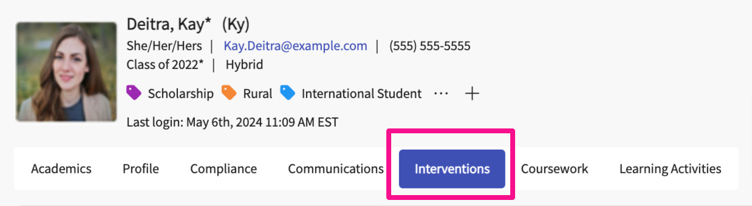
- The page will load all previously added interventions. Click on the + icon to add an entry.
  - Click on the pencil icon to make edits to existing interventions.
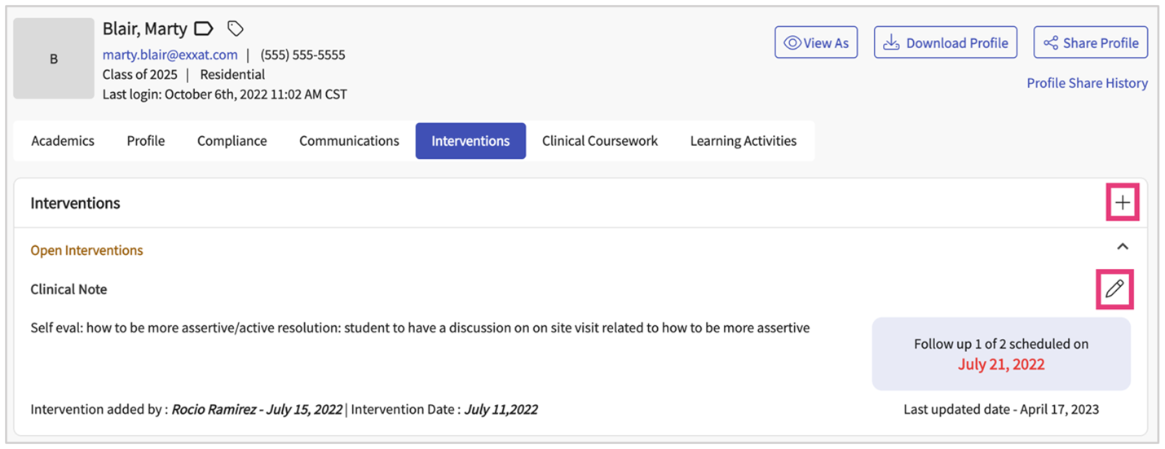
- A drawer will open. You’ll be able to enter the following information. Click Save when done.
  - Mode of intervention
  - Details of intervention
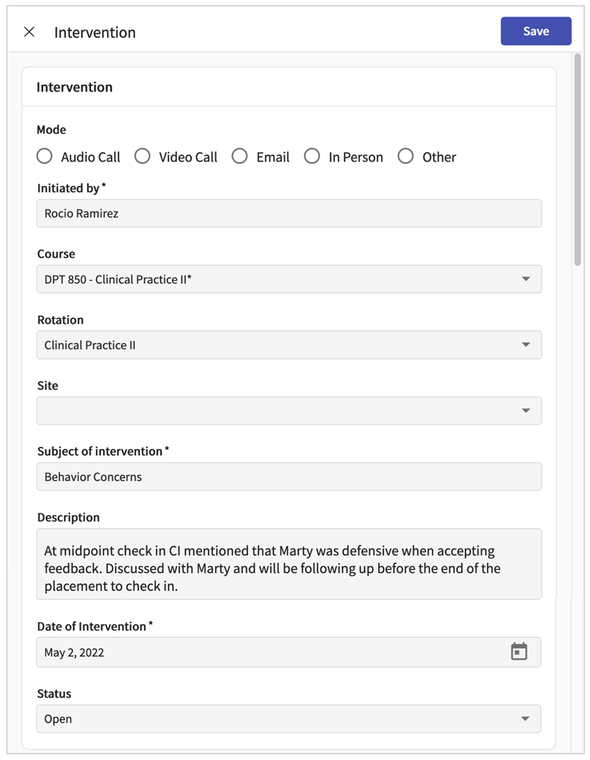
  - Attach any files, and add details of follow-up if needed
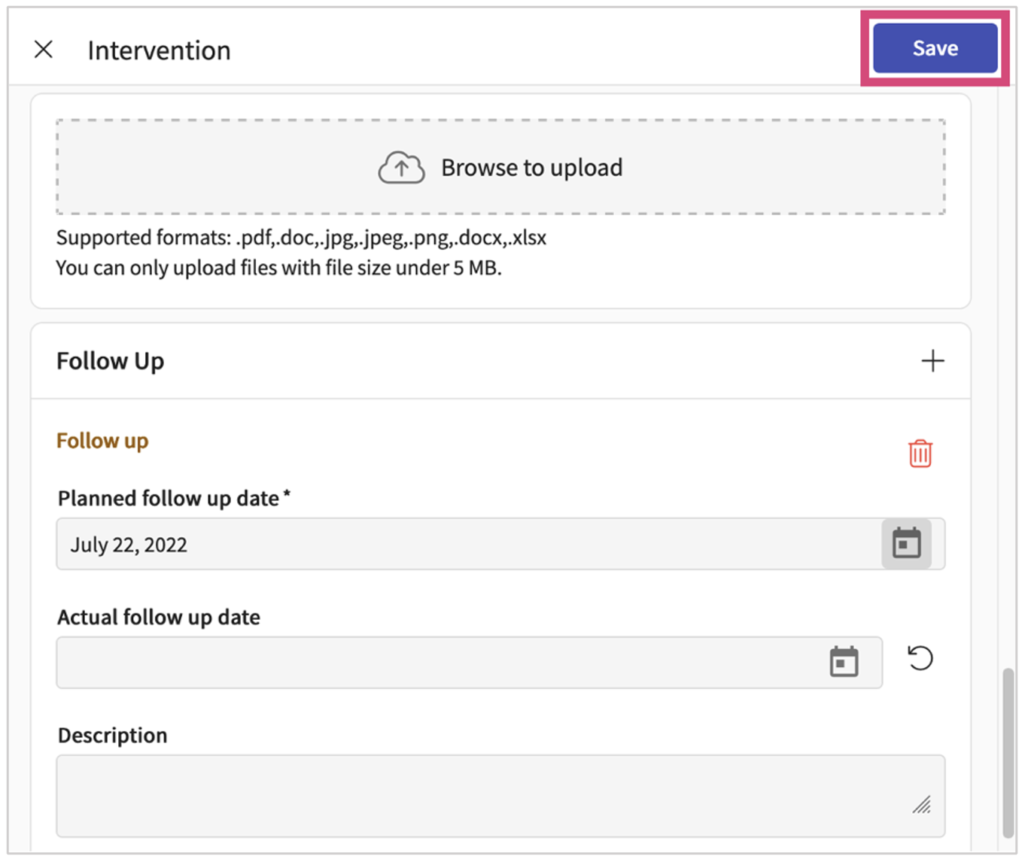

Coursework Tab:
View all the past and future courses that a student has undergone. You will find the list of all the courses that a student has been enrolled in. It shows you the information like if the course was associated with a placement or not, the course dates, and any additional details.
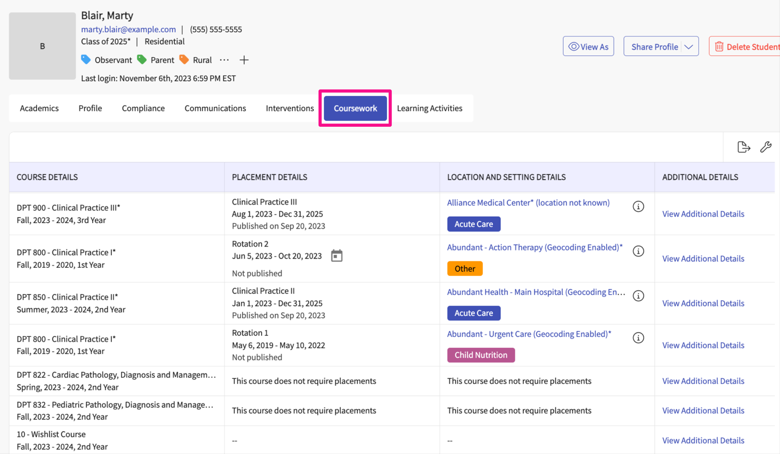
- Click on Coursework
- On the grid you will be able to find the following information like:
  - Course details: View course name
  - Placement Details: View rotation name, and placement dates and track if it was published or not
  - Location and setting details: View the location name and settings for the placement that the student has been assigned to
  - Additional details: View additional details related to the course

Learning Activities Tab:
When reviewing learning activities, it may come in handy to focus on one individual learning activity for a student at a time. Here’s how to access that information.
- Select Learning Activities tab
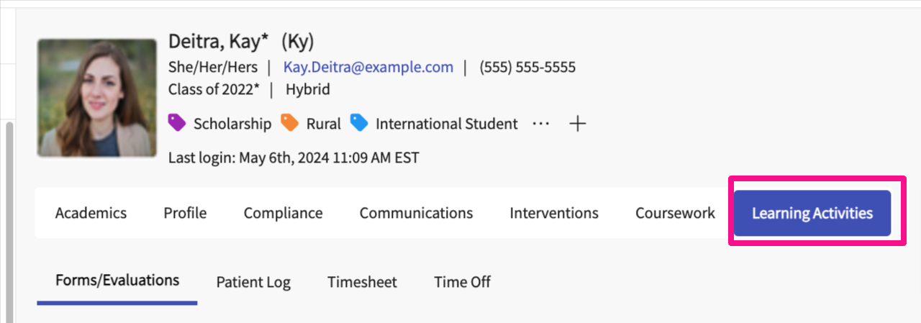
- The page will load, and you will select the learning activity you’d like to review – Forms/Evaluations, Patient Log, Timesheet, and Time Off.
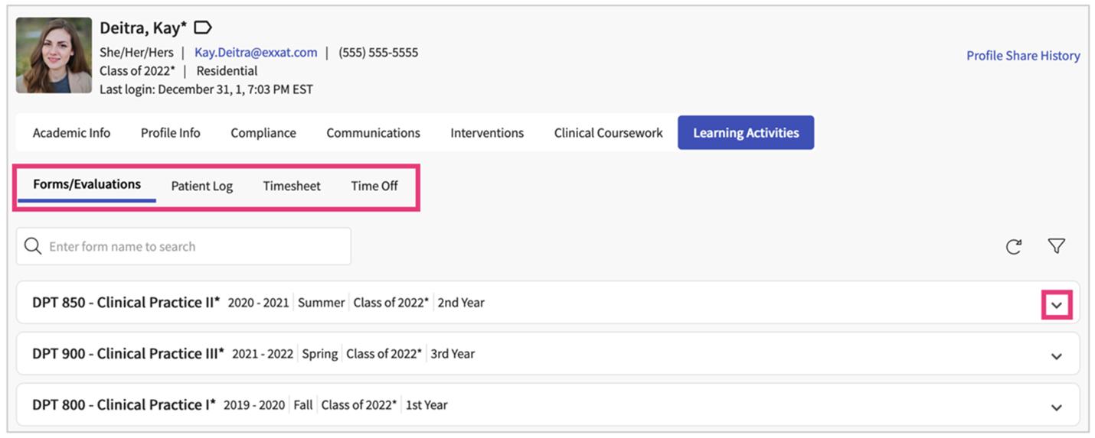
- For each learning activity, a status will indicate where they are in the process. Click on the status to view their assignment and review the item if needed.
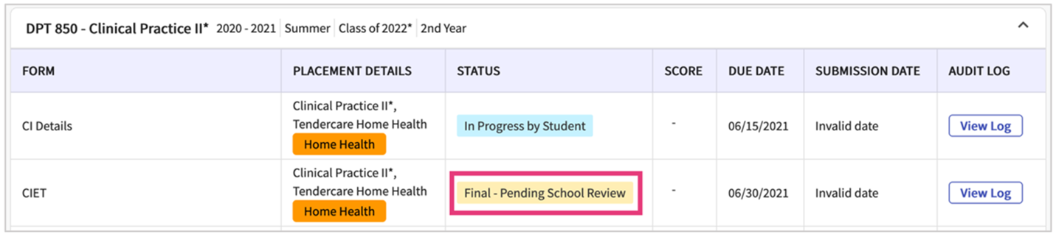
- With forms/evaluations, you will see the form, will be able to update the status, provide feedback, and click Update once done.
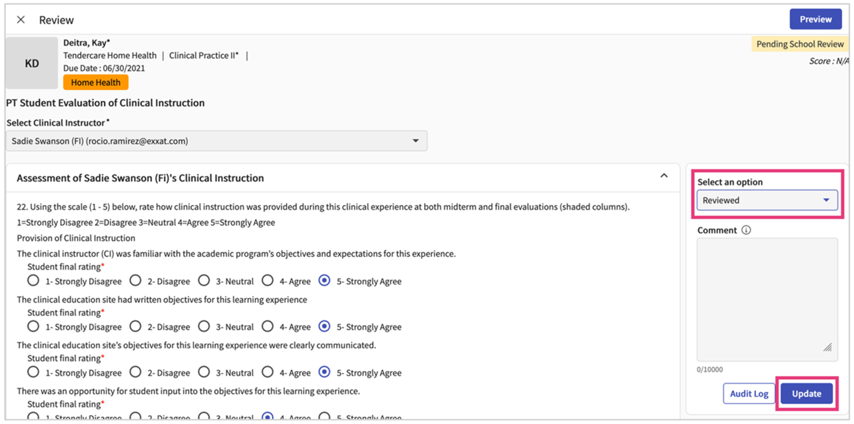
- With patient logs, timesheets, and time off requests, click on the number highlighted in yellow to begin reviewing. You can also view entries in other statuses.
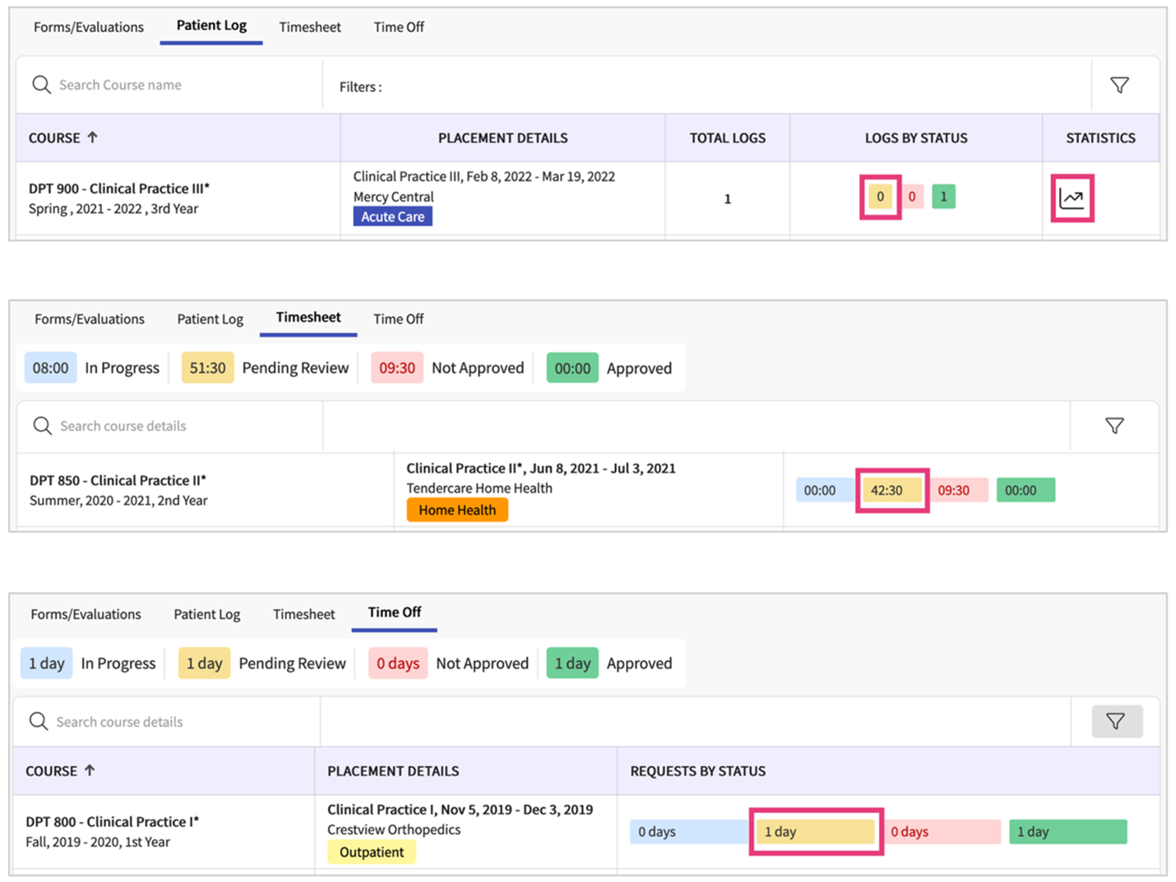
- With patient logs, once the drawer opens, you can:
  - Select multiple logs at a time to approve
  - Approve all logs without having to select each entry
  - Click on the Log ID to view the full log
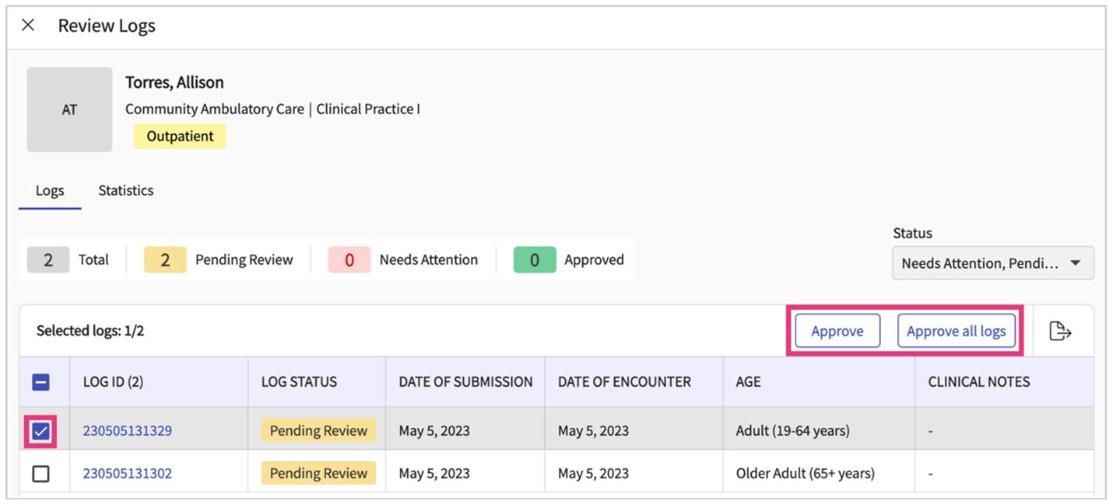
- If you clicked on the Log ID, another drawer will open, allowing you to:
  - View the full log
  - Provide feedback to the student
  - Approve or indicate the log needs attention
  - Please note, if you are marking a log as “Needs Attention”, feedback is required.
- With timesheets, you can select single or multiple entries to approve or not approve.
  - If you are marking any entries as “Not Approved”, comments are required.
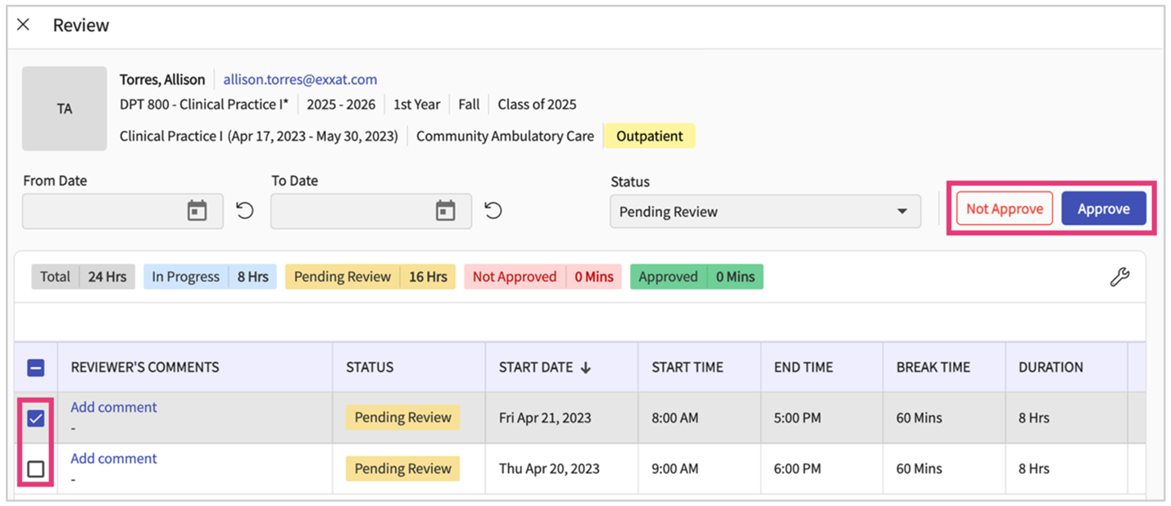
- With time off requests, you can select single or multiple entries to approve or not approve.
  - If you are marking any entries as “Not Approved”, comments are required which are located on the far right of the grid.
