Completing PT-PTA MACS for Students

Prism

Your school will require you to complete the PT-PTA MACS in Exxat. Here is how you will access and complete them!

1. Select Coursework from your left-menu or dashboard.



1. Select the placement for which you would like to complete the PT-PTA MACS by clicking View Details.

1. Scroll down to the Forms/Evaluations section. The system will load any forms or evaluations your program has requested you to complete. Click on the name of the evaluation (PT-PTA MACS) to get started.
   1. Be mindful of due dates!

1. The PT-PTA MACS form is a lengthy form and also includes several sections. Once completed please click on Submit. This will send the form to the clinical instructor who will now review the form.

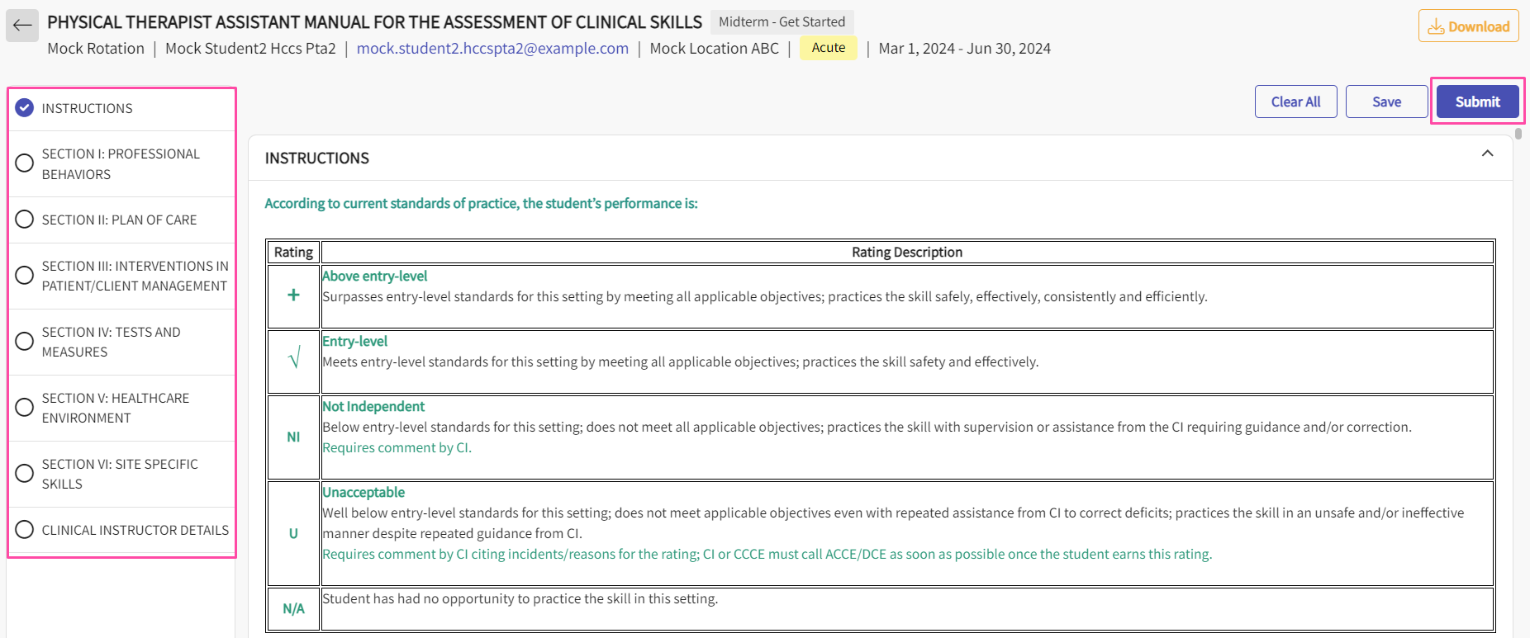

1. Before submitting the form, please ensure you select the name of the clinical instructor who will complete the PT-PTA MACS.

1. Once the midterm form is submitted the status of the form will change from “In Progress” to “Midterm – Pending CI Review”. A screenshot of a computer

   Description automatically generated
2. Once CI completes the form, You can then review the form and submit it to school.

1. You will now have to review the form.

1. Once a you review the form and submits to school the status of the form will change from “Midterm – Pending Student Review” to “Midterm – Pending School Review”.  
     
   A screenshot of a computer

   Description automatically generated
2. Once the Midterm form is reviewed by the school, the Final PT-PTAMACS will become available for you to start work on. Click on the form name to start filling it for Final term.

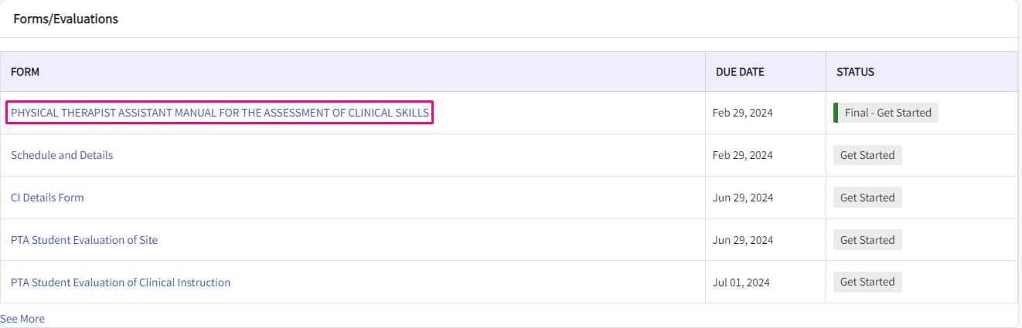

1. The PT-PTA MACS form is a lengthy form and includes several sections. Once completed please click on Submit. This will send the form to the clinical instructor who will now review the form.

1. While filling in the form students will be able view the midterm ratings and comments.

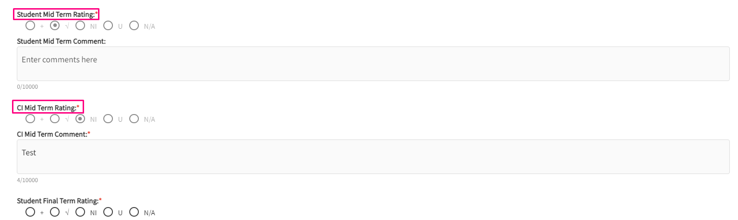

1. Before submitting the form, please ensure you select the name of the clinical instructor who will complete the PT-PTA MACS.

1. If you want to add an additional skill during midterm or Final , please choose Yes to the below questions (Skill 35,36,37) to add additional questions.

1. By default, your rating will be set to N/A and you can change it to the specific rating.

1. Once the Final term form is submitted by you, the status of the form will change from “In Progress” to “Final Term– Pending CI Review”.

1. Once CI completes the form, you can then review the form by clicking on the form name and submit it to school.

1. You will now view the comments and ratings given for Final Term by the CI and click on “Review” to submit for the school review.

1. At the end of the form, you can enter your signature to mark the form as reviewed.

1. Once a you review the form and submit it to school, the status of the form will change from “Final Term – Pending Student Review” to “Final Term – Pending School Review”.

1. Once the school reviews the form, the status will be changes to “SECEE Get Started.”

1. You can fill the SECEE Evaluation Section and sign off at the end of it and then choose the CI and then click on Submit.

1. The form is now sent to the Clinical Instructor for review

1. Once the Clinical instructor reviews the form, it goes to the school for review.

1. Once the School reviews this form, you will see the status as Reviewed.

1. You can always click the form and click download to download the copy of the form

