Completing the PT-PTA MACS for CIs

Prism

If you are working with a program who uses Exxat and also utilizes the PT-PTA MACS you will be asked to complete the form.

1. Once the student completes the PTAMACS, you will receive an email from [notifications@exxat.com](mailto:notifications@exxat.com) which will include a link for you to access the form.
   1. We suggest that you please try to use any of the following internet browsers for the best experience: Google Chrome, Safari, Firefox.
   2. Please note that you may experience performance issues (difficulty saving information, submitting, etc.) when using Internet Explorer.

1. Once you click on the link, a new tab will open and you will find the form that has been submitted by the student.
2. On the form, you will see a menu to the left showing all of the sections you will complete.
3. To the right, you will see the actual form. Questions with a red asterisk are mandatory.

1. For each question, you will see the student’s rating and comment, and a place to add in your own rating and comment.
   1. Please note, the system will not process any comments that are added once you pass the 10000-character limit.

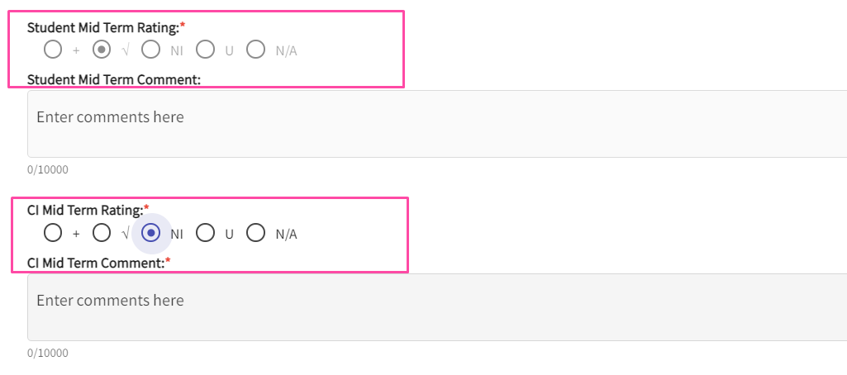

1. Towards the end of the form, you can add any overall comments.

1. You can also rate the student - “Evaluation of Student Performance” on a scale of 1 to 10.

1. Once all the questions are answered, click on Submit. A pop-up will appear asking you to confirm. Click OK to confirm.

1. Your form is submitted!

1. For the Final, you will receive an email again from the student to fill the form.

1. Click on the link to provide the Final Rating for each question.

1. Towards the end of the form, you can provide the responses for the Summative Section and Final Overall Rating

1. If a student has not added an additional skill and if you wish to add another, please choose Yes to the below questions (Skill 35,36,37) to add additional questions.

1. By default, your rating will be set to N/A and you can change it to the specific rating.

1. Once all the questions are answered, click on Submit. A pop-up will appear asking you to confirm. Click OK to confirm.

1. Your form is submitted!

1. You will now receive an email from the student to review the Student Evaluation of Clinical Experience.(SECEE). Click on the link in the email to review the form.

1. Sign off at the end of the SECEE Evaluation and Click on Review

1. Your form is submitted!

1. You can always click on the link and click on view submitted responses to get the read-only view of the filled responses. You can also click on the download button to download the copy of the form.