**Key Features of Student Management and Administration**

The article provides a comprehensive guide to setting up various student-centric features in Exxat Prism. It covers topics like:

* [Creating announcement](https://helpcenter.exxat.com/hc/en-us/articles/15366820809873-Key-Features-of-Student-Management-and-Administration#h_01HW8YMRQ2P7ZQBK7T3FXZVQCT)
* [Sharing resources](https://helpcenter.exxat.com/hc/en-us/articles/15366820809873-Key-Features-of-Student-Management-and-Administration#h_01HW8VK8FDXTNZCYHJZCEF1PHX)
* [Adding attestations at profile](https://helpcenter.exxat.com/hc/en-us/articles/15366820809873-Key-Features-of-Student-Management-and-Administration#h_01HW8W66SDX66NWWF5V63E27TN)
* [Adding course-level attestations](https://helpcenter.exxat.com/hc/en-us/articles/15366820809873-Key-Features-of-Student-Management-and-Administration#h_01HVMBDFT11BD87FGH21FF9V3M)
* [Defining program requirements](https://helpcenter.exxat.com/hc/en-us/articles/15366820809873-Key-Features-of-Student-Management-and-Administration#h_01HW8X8FKXCMVT1MATF018GNKG)
* [Setting up areas of professional interest](https://helpcenter.exxat.com/hc/en-us/articles/15366820809873-Key-Features-of-Student-Management-and-Administration#h_01HW8XMY90F8WPT0GAT5YABBMK)
* [Configuring additional profile details](https://helpcenter.exxat.com/hc/en-us/articles/15366820809873-Key-Features-of-Student-Management-and-Administration#h_01HW8Y09082HJMEA2VAY9HJFJR)
* [Managing student views](https://helpcenter.exxat.com/hc/en-us/articles/15366820809873-Key-Features-of-Student-Management-and-Administration#h_01HW8Y6YGJS2162DF7FVPMY46W)

Each section offers step-by-step instructions, accompanied by visual aids where applicable, to help administrators efficiently organize and customize student-related aspects within the system.

**Setting Up Student Announcements**

**You can use the announcements feature to provide updates or inform students  of upcoming items!**

1. Select Students from your left-menu.  
   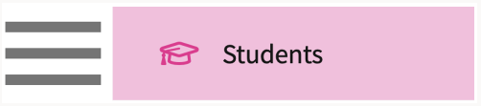
2. Click on the Setup Tab.  
   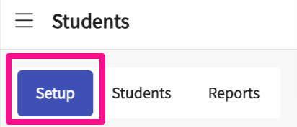
3. Select Announcements. The system will load all announcements created previously. To view announcements for a specific cohort, use the filter option.  
   A screenshot of a computer

   Description automatically generated
4. Click on +Add Announcement.  
   A screenshot of a computer

   Description automatically generated
5. A drawer will open with the following fields:  
   **a. Start date and time**: When the message should appear on the dashboard  
   **b. End date and time**: When message should no longer appear on the dashboard  
   **c. Title**: Title of your message.  
   **d. Description**: Message content  
   **e. Shared with all cohorts**: the system will always set an announcement to be shared with all cohorts by default. If the content is cohort specific, unselect the option. You will then have the ability to choose a specific cohort.   
   f. **Click Save when done.  
   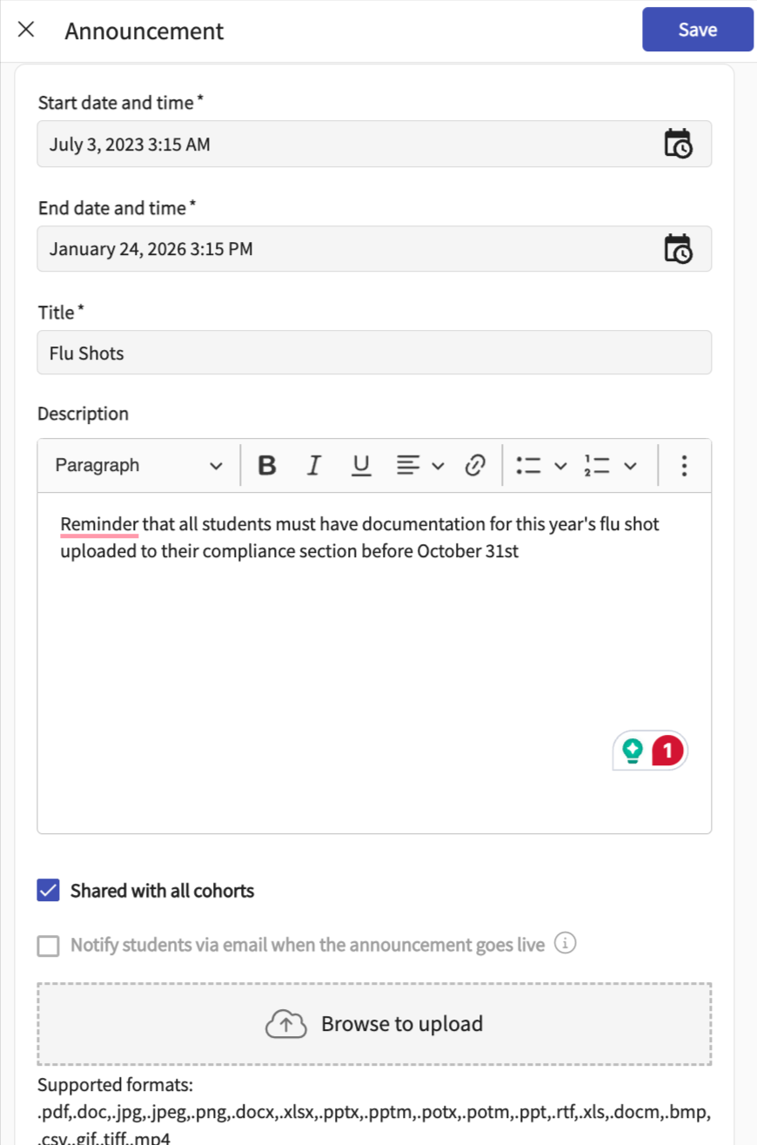**

**Setting Up Student Resources**

**You may want to share resources with your students such as program information, handbook policy information, syllabi, and more!**

1. Select Students from your left-menu.  
   Text

   Description automatically generated
2. Click on the Setup Tab.  
   
3. Select Resources from the left-menu, and then select a specific item from the category list.  
   A screenshot of a computer

   Description automatically generated
4. Not seeing any options within the category list, or would you like to update your list? Click on the pencil icon.   
   Graphical user interface, text, application

   Description automatically generated
5. A drawer will appear showing you all your categories. Make all necessary changes and click Save once done.  
   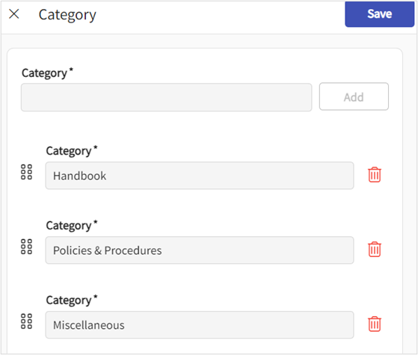
6. You may want to organize the order in which your Categories appear, you can drag and drop category using this icon below. Click **Save**button to save your changes.  
   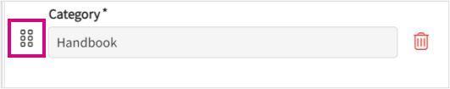
7. Once you select an item within the category list, you will see all resources added for that category.   
   A. If you’d like to filter to view only documents, links, etc., you can uncheck any options.  
     
     
   B. To edit an existing resource, click on the pencil icon.  
   C. To delete a resource, click on the trash bin.  
   Graphical user interface, text, application, email

   Description automatically generated
8. To add a new resource, click +Add Resource.  
   A picture containing shape

   Description automatically generated
9. A drawer will open. Click on the drop-down to select the type of resource you’d like to add.  
   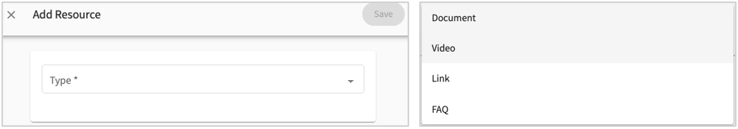
10. Enter the resource information and click save when done.  
    **a. Type**: this will show you the option you have previously selected (document, video, link FAQ).  
    **b. Category**: this will default to the category you previously selected from your category list.  
    **c. Show on site resources page**: if you’d like this resource to be shared with your clinical partners, select this option.   
    **d. Show it to student**: this is defaulted to yes, but if your resource is for clinical partners only, turn this option off.   
    **e. Shared with all cohorts**: the system will always set a resource to be shared with all cohorts by default. If the content is cohort specific, unselect the option. You will then have the ability to choose a specific cohort.  
    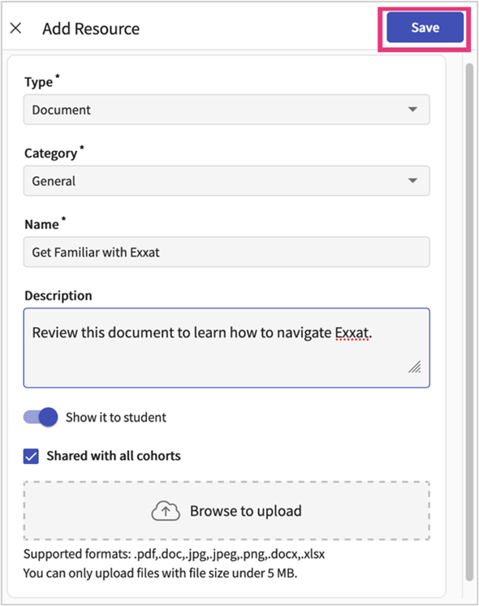
11. You may want to organize the order in which your resources appear. To do so, select Re-order.  
    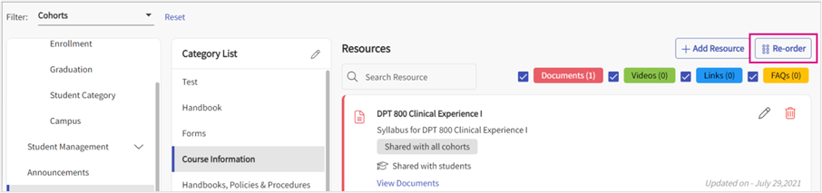
12. Use the icon on the left to drag and drop items in the order you prefer. Click Save once done.  
    Graphical user interface, application, email

    Description automatically generated
13. Once this is complete, students should be able to view these documents under the **Resources section tile** from Student’s view of the Prism Dashboard:  
      
    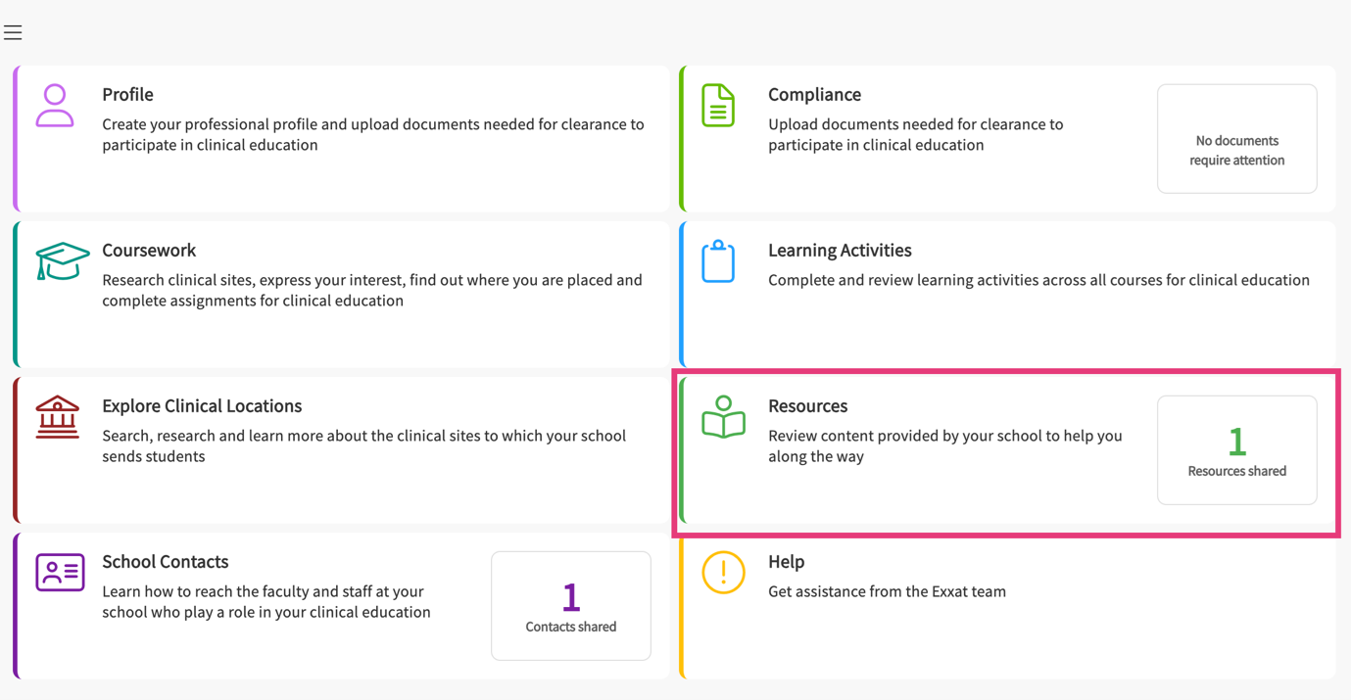

**Setting Up Student Attestations**

**You can have students sign off on statements on their profile or for their coursework at the beginning of the placement. This helps them understand their responsibilities, how information is shared or anything you want them to confirm.**

**Learn how to add attestations at:**

* [Student Profile](https://helpcenter.exxat.com/hc/en-us/articles/15366695227281-Setting-Up-Student-Attestations#h_01HVMBEJG2YFAB269MXT30VVVW)
* [Student Course](https://helpcenter.exxat.com/hc/en-us/articles/15366695227281-Setting-Up-Student-Attestations#h_01HVMBDFT11BD87FGH21FF9V3M)

**Adding Attestations at Student Profile**

1. Select Students from your left-menu.  
     
   Text, application

   Description automatically generated
2. Click on the Setup Tab.  
     
   
3. Select Attestations from the list.  
     
   Graphical user interface, text, application, email

   Description automatically generated
4. You’ll be taken to the attestations page where you can view all attestations created previously. To view attestations for a specific cohort, use the filter option.  
   A screenshot of a computer

   Description automatically generated
5. To add a new attestation, click +Add Attestation.  
     
   A picture containing text

   Description automatically generated
6. A drawer will open. Enter your attestation details and click Save when done.  
   **a. Title  
   b. Content  
   c. Due Date**: when sign-off is due  
   **d. Audience**: who is required to sign off on the attestation  
   **e. Applicable**: decide if this is something you want them to sign off on their profile, or during a placement.  
   **f. Shared with all cohorts**: the system will always set attestations to be shared with all cohorts by default. If the content is cohort-specific, unselect the option. You will then have the ability to choose a specific cohort.   
   **g. Show it to the student**: If you don’t want it to be visible yet, turn this off.  
     
   A screenshot of a computer

   Description automatically generated

**Adding Attestations at Course Level for Students**

1. Select Courses from your dashboard or left menu.    
   Text

   Description automatically generated with low confidence
2. Select the Course you’d like to manage.    
   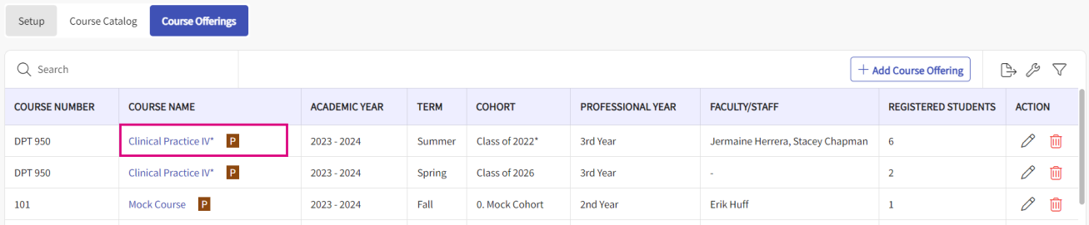
3. Select Attestation from the left panel.    
   A screenshot of a phone

   Description automatically generated
4. You’ll be taken to the attestations page where you can view all attestations created previously.   
   A screenshot of a computer

   Description automatically generated
5. To add a new attestation, click +Add Attestation.   
   A blue and white rectangle with text

   Description automatically generated
6. A drawer will open. Enter your attestations details and click **Save** when done.
   1. Show it to students
   2. Title
   3. Content
   4. Due date – When sign off is due.   
      A screenshot of a computer

      Description automatically generated

**Setting Up Student Program Requirements**

You can set up program requirements that your students must complete before graduating. You can also designate which settings satisfy a specific requirement. This list will be unique to your school.

1. Select Students from your left-menu.  
     
   Text, application

   Description automatically generated
2. Click on the Setup Tab.  
     
   Graphical user interface, application

   Description automatically generated
3. Select Program Requirements from the list.  
   A screenshot of a computer

   Description automatically generated
4. The page will load all your program requirements. If you have cohort specific requirements, you can view them by using the filter option.  
   Graphical user interface

   Description automatically generated
5. To add a requirement, click +Add Program Requirement.  
   A picture containing diagram

   Description automatically generated
6. Enter the name of the program requirement, add a description, and select the settings which fulfill the requirement.  
   A screenshot of a program

   Description automatically generated
7. Click Save when done.

**Setting up Student's Areas of Professional Interest**

You can set up Student Areas of Professional Interest, providing your students with the opportunity to select their professional interests throughout their program. They can also share their Professional Interest with their CIs through their profile link

1. Select **Student** Module from your dashboard  
   A pink rectangular sign with a graduation cap

   Description automatically generated
2. Click on the **Setup** Tab  
   A screenshot of a computer

   Description automatically generated
3. Select Areas of professional interest from the left-menu  
   A screenshot of a computer

   Description automatically generated
4. Select the **pencil icon**, you'll have the chance to choose the names for settings and assign color codes  
   These settings are meant for your students to select when specifying their Areas of Professional Interest, which can be shared with their CI's via their profile link   
   A screenshot of a computer

   Description automatically generated  
   A screenshot of a computer

   Description automatically generated
5. You would also have the flexibility to delete any selected settings at your convenience  
   However, please be aware that the system restricts you from deleting any settings to those ones already included in your Program Details. This is because your program settings may be tied to other data i.e. Placements in Exxat Prism system  
   A screenshot of a computer

   Description automatically generated

**Setting Up Additional Profile Details**

**You may have specific questions you’d like your students to answer. Whether it is related to placement or not, the Additional Profile Details section can assist via the Questionnaire. Once available, students will access the questionnaire via their profile.**

1. Select students from your dashboard or left menu.  
     
   Text, application

   Description automatically generated
2. Select Setup from the ribbon at the top of the page.  
   A screenshot of a computer

   Description automatically generated
3. Select Additional Profile Details from the left panel.  
   Graphical user interface, text, application

   Description automatically generated
4. In this section, you will find the Questionnaire section. Any questions you’ve previously added will be listed. Click on + Add Question.   
   a. To view questions added for specific cohorts, use the filter option.  
     
   Graphical user interface, application, Teams

   Description automatically generated
5. A drawer will open. Enter your question, decide if it is mandatory, and whether it should be shared with all cohorts. Once done, click Add.  
   a. If the question is cohort specific, uncheck the box and select the desired cohort.  
     
   A screenshot of a computer

   Description automatically generated
6. Once, you’ve added all necessary questions, click Save.  
     
   A screenshot of a computer

   Description automatically generated
7. The drawer will close, and your questions will be listed.
8. If you’d like to rearrange your questions, click Re-order.  
     
   Graphical user interface, text, application, Teams

   Description automatically generated
9. A drawer will open; drag and drop each question to the desired order, and click Save once done.  
     
   Graphical user interface, application

   Description automatically generated
10. You can also update or edit existing questions. Click on Pencil available under the Actions section.  
    A screenshot of a phone

    Description automatically generated
11. A drawer will open to update existing questions, make changes, and click on Save + Proceed.  
    A screenshot of a computer

    Description automatically generated

**Managing Student View**

Students can access and abundance of information on Prism and can complete specific activities within their account. Each program, however, can restrict specific items, whether they show to the student, or not. Keep on reading to understand how you can manage your student’s view.

1. Select Students from your dashboard or left menu.   
   Graphical user interface, text, application

   Description automatically generated
2. Select Setup from the ribbon at the top of the page.   
   A screenshot of a computer

   Description automatically generated
3. Select Student View from the left panel of the page.   
   Graphical user interface, text, application, chat or text message

   Description automatically generated
4. The page will display all the options available for you to either show or hide from your student’s view.
5. For each item, decide if it is something you’d like your students to have access to by turning items on or off. This preference will apply to all students.   
   A screenshot of a computer

   Description automatically generated
   * Housing and Parking  
     Map

     Description automatically generated
   * Add Clinical Instructor  
       
     Graphical user interface, text, application, email

     Description automatically generated
   * Contract Documents  
     Graphical user interface, application, table, Teams

     Description automatically generated
   * Other Students Placed Here  
     Graphical user interface, text, application, Word, Teams

     Description automatically generated
   * Allows the students to upload or change profile pictures.  
     A screenshot of a computer

     Description automatically generated