Managing Student Access and Attributes
In this article learn about the process of managing students in Exxat Prism, covering key tasks such as:
- Adding Individual Students
- Adding Students in Bulk
- Inviting Students
- Deleting Students
- How to Edit Student's Attributes in Bulk

Adding Students
Once a new cohort is admitted, you will want to give them access to Exxat Prism! You can add individual students, or bulk import multiple students at a time

Adding Individual Students
- Select Students from your left-menu.

- The page will load all the students in the system.
- Click on the +Add Student button.
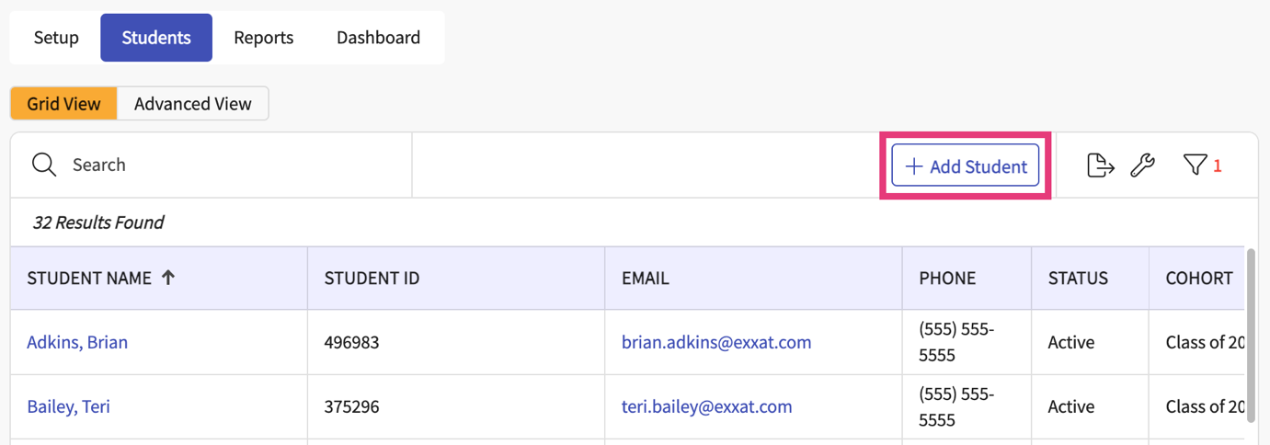
- A drawer will open where you can enter the student details. Click Save when done.
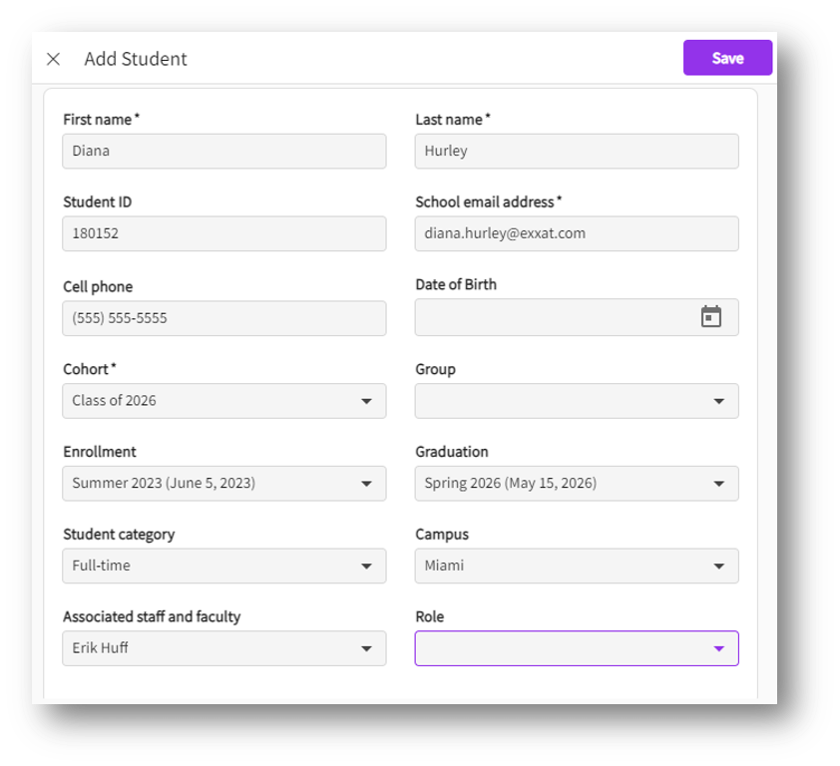
- If your school uses SSO(Single sign-on service), make sure to enter the SSO Key on the Academic section, Click on pencil icon to add the key
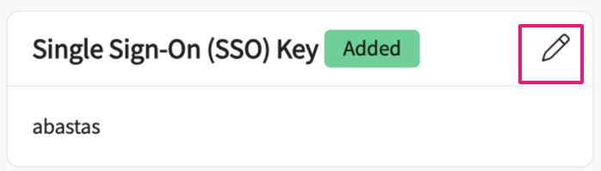
You also can update the key if needed.
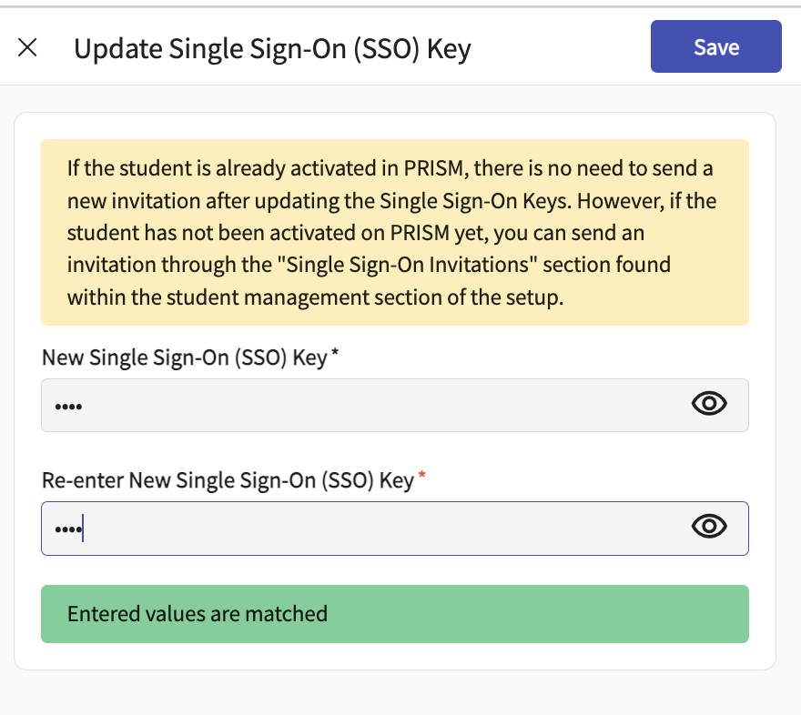
- Please note that first name, last name, school email address, and cohort are mandatory fields.
- The newly added student will show on the top of the grid after successfully adding them. The grid will re-arrange to alphabetical order once any action has been taken on the screen.

Using Bulk Import:
- Select students from your dashboard or left menu.
- Select Setup from the ribbon at the top of the page.
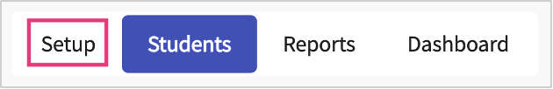
- Open Student Management on the left panel and select Bulk Import.
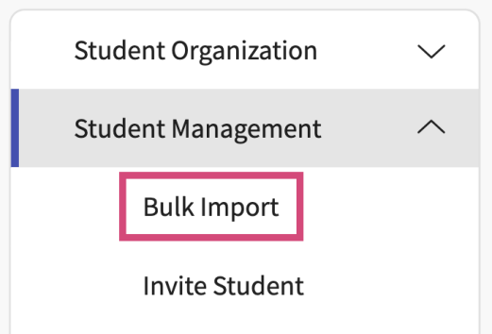
- The system will display any previous bulk imports. Click the + icon to begin a new import.
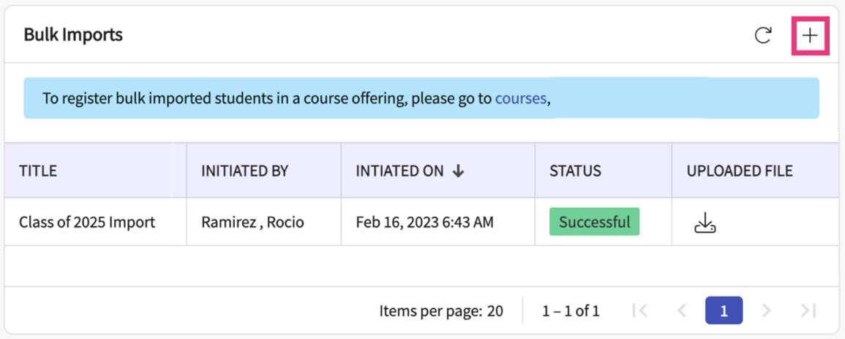
- A drawer will open with three steps. On step one, first read the given instruction and download the import template.
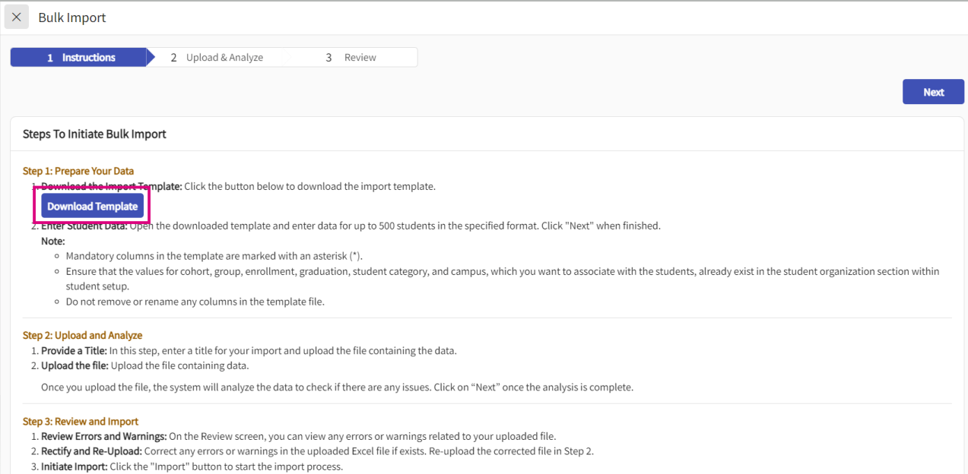
- The import template will have various columns, make sure you have the following information as it is required:
  - Student first name
  - Student last name
  - Email address
  - Cohort
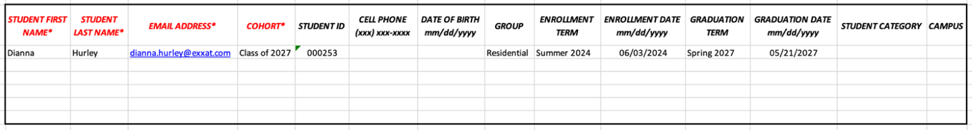
- Add in the data for the students you’d like to import on the template. Once done, save your change and head back to the system.
- Some items to keep in mind:
  - Some fields require information to exist in the system before you can associate it with any students. If you provide details for an item that does not exist in your database, the system will not be able to process it.
    - Cohort
    - Group
    - Enrollment Calendar (term + date)
    - Graduation Calendar (term + date)
    - Student Category
    - Campus
  - The Student ID field will remove zeros from ID numbers that begin with a zero. To prevent this, highlight the entire column (column D) and change the format to Text.
  - If providing date of birth, enrollment date, or graduation date, please change the format to Text before adding data. The import file will remove zeros from your dates and will not meet the format requirement (MM/DD/YYYY).
  - You will not be able to associate staff and faculty when importing students, but you can do this once the import is complete.
  - On step 2, provide your template a name, and upload the import template you recently added student information to.
- Once the analysis is complete, click Next.
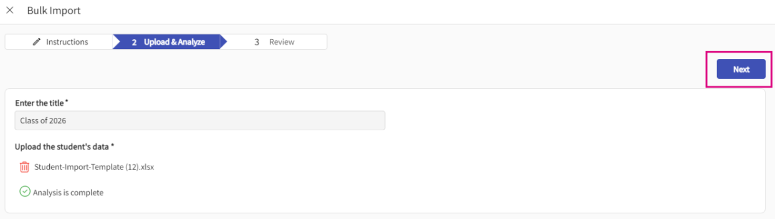
- If you realize you added the wrong file, click the trash bin to upload another file.
- On step 3, the system will show you any errors or warnings. Hover over the highlighted items to see what needs to be addressed before proceeding.
- If you need to make changes, click Previous and re-upload the import template once done making edits.
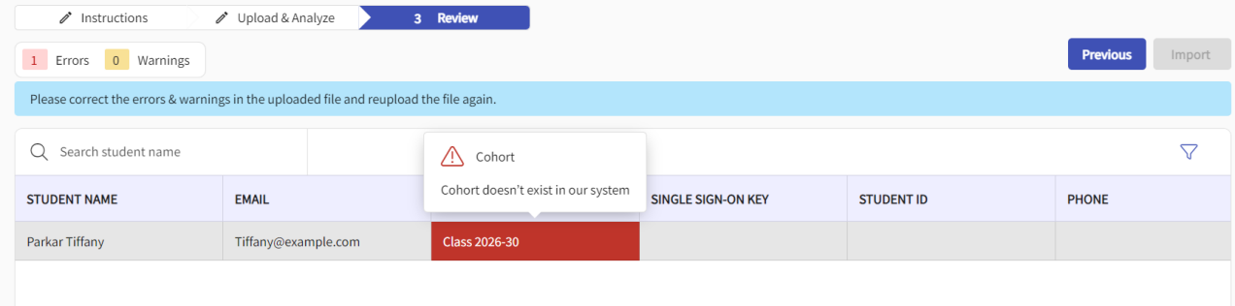
- If there are no errors, click Import.
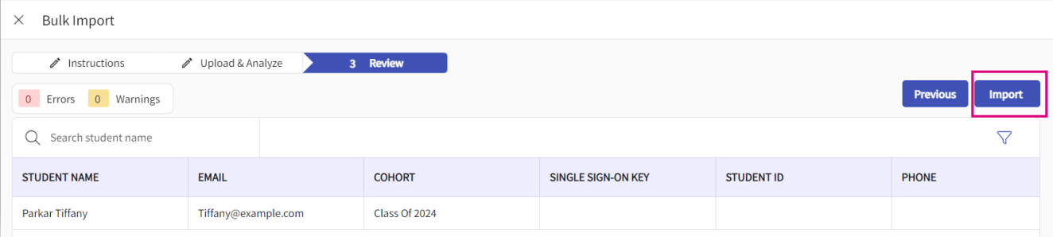
- A validation message will appear. Enter the # shown and click Import to proceed.
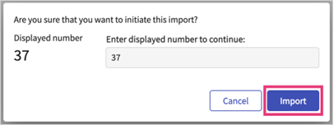
- The drawer will close, and your import will be listed and show as In Progress. Click on the refresh icon to view any updates.
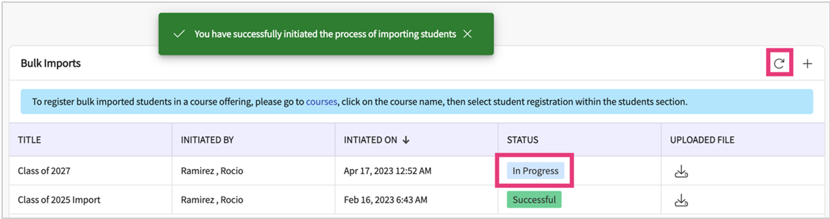
- Once successful, the status will update, and your students will be loaded in the system!
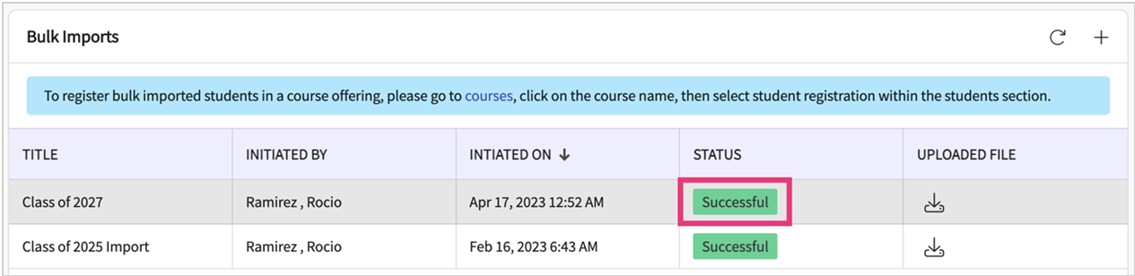

Inviting Student:
Students must be invited to Exxat Prism in order to fill out their profile, see placements, and more. There are 2 ways of sending invitations to students:
- Contact v4support@exxat.com and provide the date, time and specific cohort or student that should be invited.
- Invite them yourself through the system, read on to learn more!
Please note, if your program has enabled Single Sign On (SSO), our support team must activate their accounts on your behalf.
- Select Students on your left-menu.
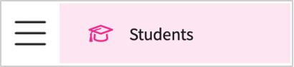
- Select Setup from the ribbon at the top of the page.
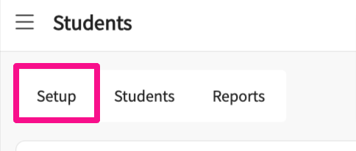
- Open the drop-down for Student Management and select Invite Student.
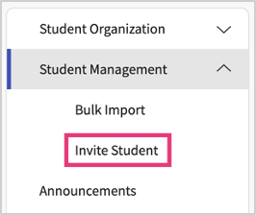
- The page will load all active students in the system who have not yet activated their accounts.
  - To find a particular student, use the search bar.
  - To find a specific cohort, use the filter option.
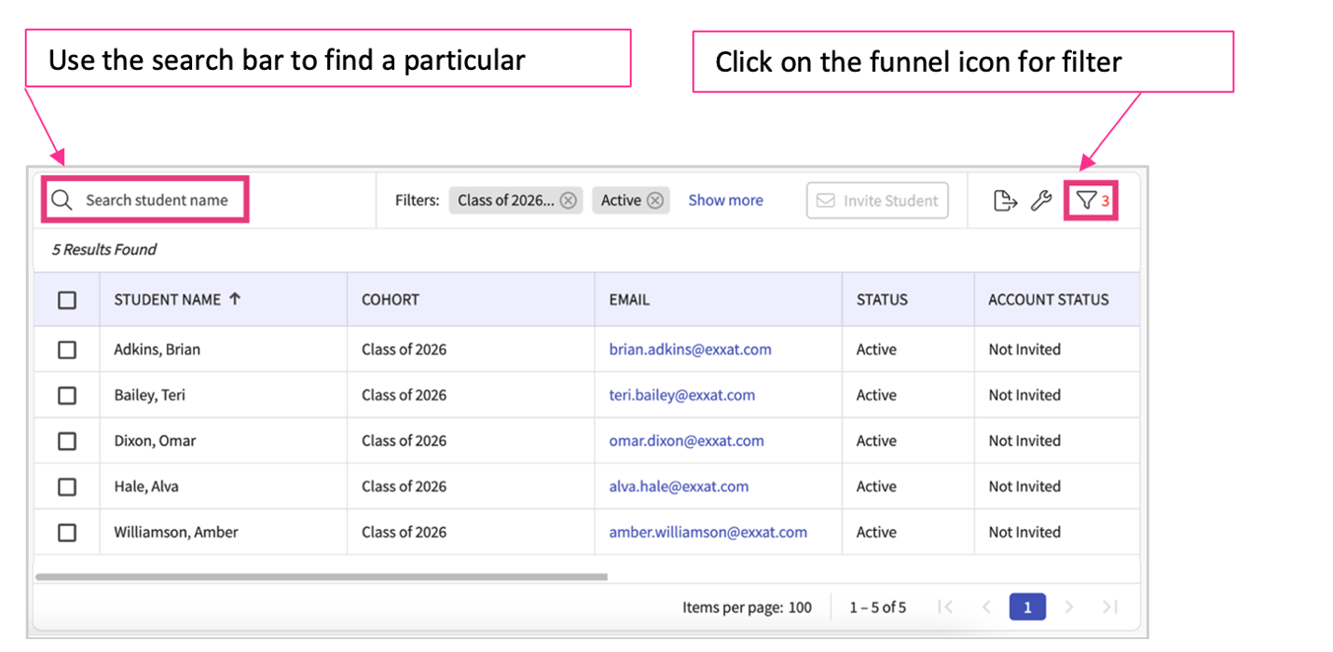
  - You can also click on any student name to view/edit their profile information
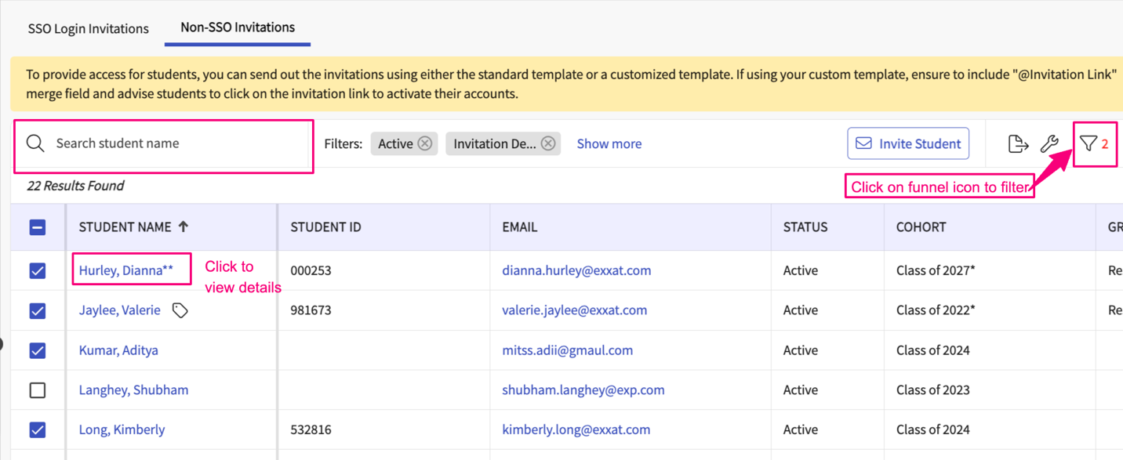
- Use the search bar to find a particular student
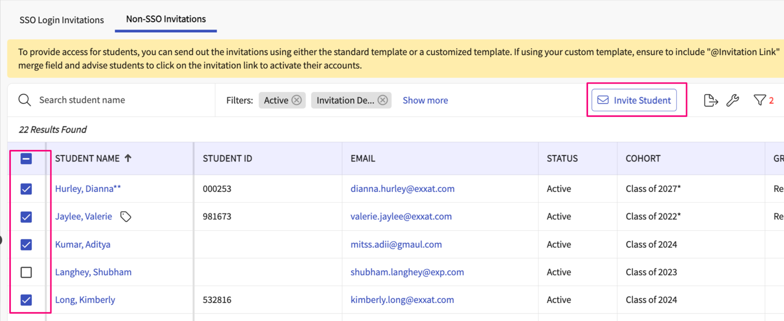
- Once you have found the student(s) you’d like to invite, select them using the open checkbox and click Invite Student.
  - You can easily verify whether an invitation has been sent, or if a student account is active by checking the Account Status column.
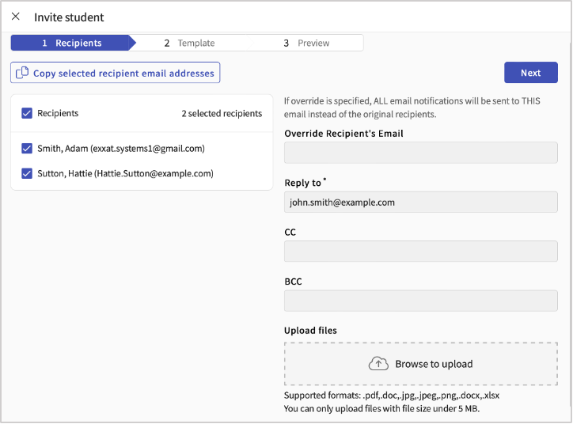
- A drawer will open showing you a 3-step process you’ll complete to send invitations. The first step will list all the students you are inviting. Click Next.
  - Override recipient’s email: used for testing purposes, if an email is entered here the invitation will be sent to that user instead of the student.
  - Reply to: if a student responds to this email, the reply will be sent to the email entered here.
  - CC or BCC any users as needed
  - Upload files as needed.
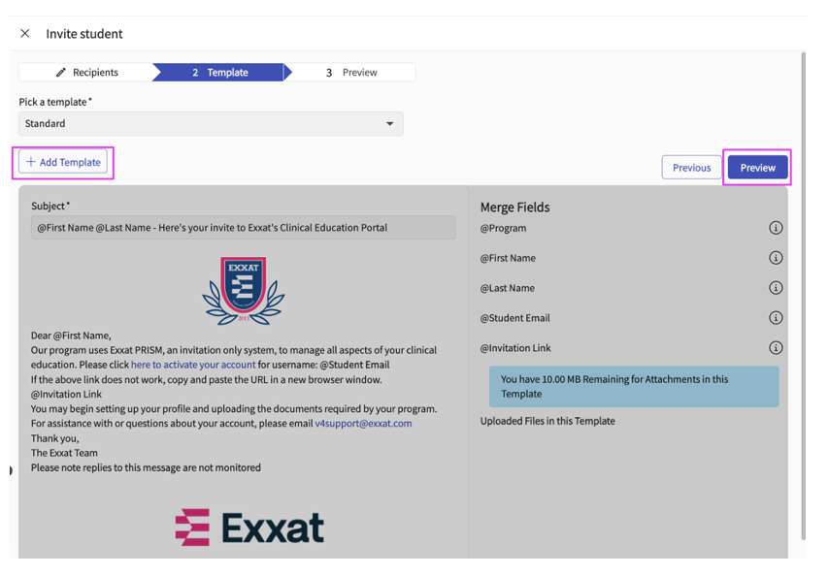
- On the second step you will review the email that will be sent to the student. The default email template will be the Standard template, but you can choose from others or create a new template.
You can also have the ability to edit any selected template
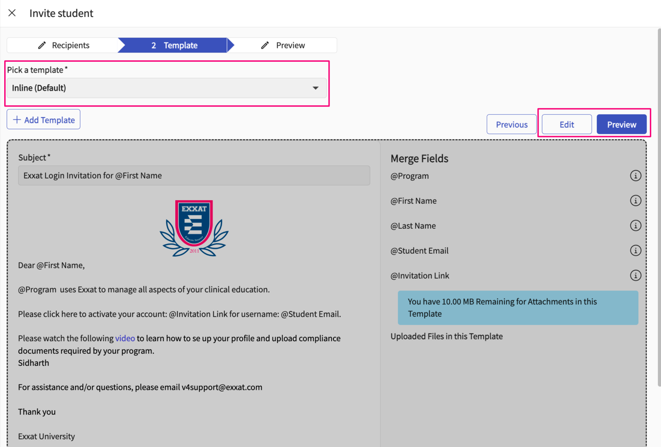
- On the third step you’ll then decide when to send your emails! You can send your email immediately or schedule it for a specific date and time. Click Send.
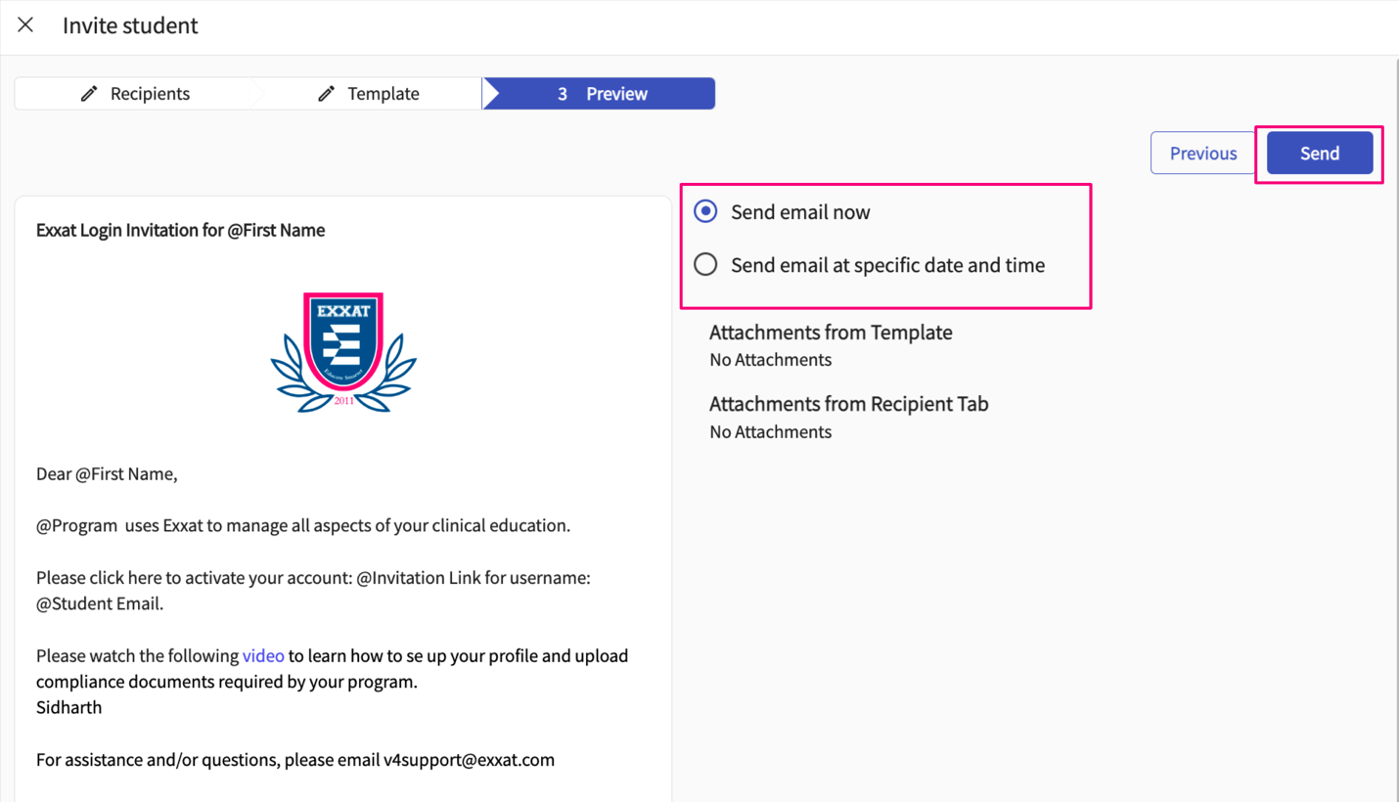
- The drawer will close, and you’ll get a message confirming your emails were sent successfully.
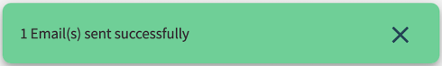
- The grid will update showing you when you last sent an invitation in the Account Status column. Once the student successfully logs in, the status will change to Activated.
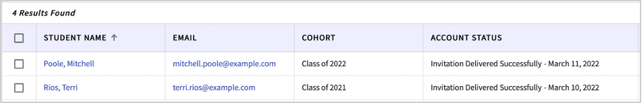
- If you are inviting Students with SSO Key please refer to the document here: https://exxat.zendesk.com/hc/en-us/articles/17889816062097-Inviting-Students-to-Exxat-Single-sign-on-SSO-

Deleting Student:
You will be able to delete the students for which the learning activity data such as patient log, evaluations, timesheets etc has not been submitted.
- The newly added student will show on the top of the grid after successfully adding them. The grid will re-arrange to alphabetical order once any action has been taken on the screen.
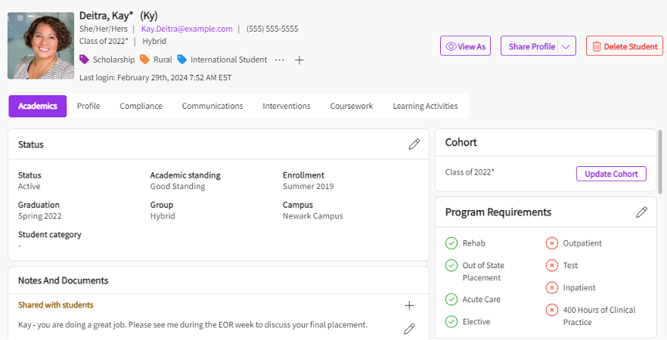
- To delete a student, click on student's name from the student page, their profile will open
- A Drawer will open which will show us all the data associated with the student and if you delete the student, you will lose all that data. Add the Reason for deleting the student under Note and then Hit Delete button.
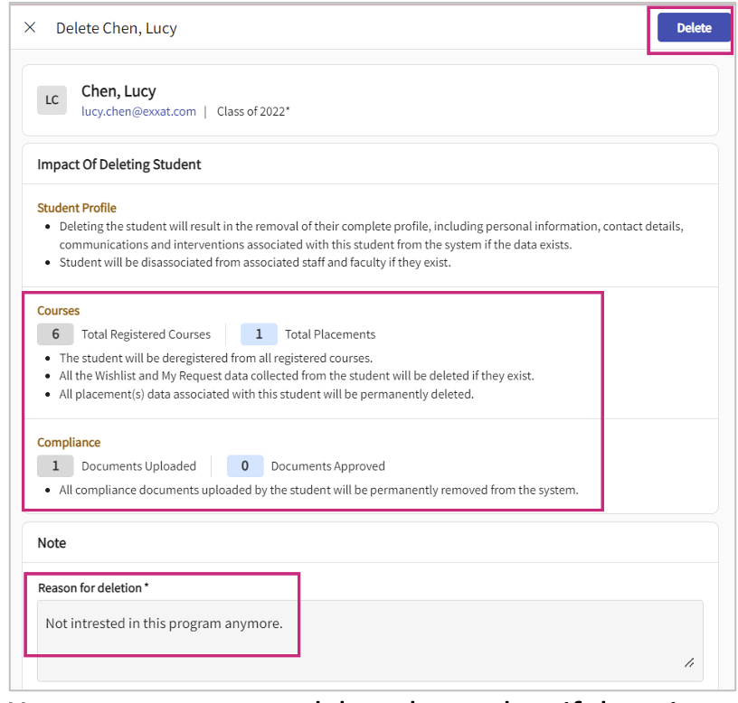
- A confirmation message like shown below will pop up, asking if you want to proceed with deleting the student, Add the number displayed and click Proceed to complete the process.
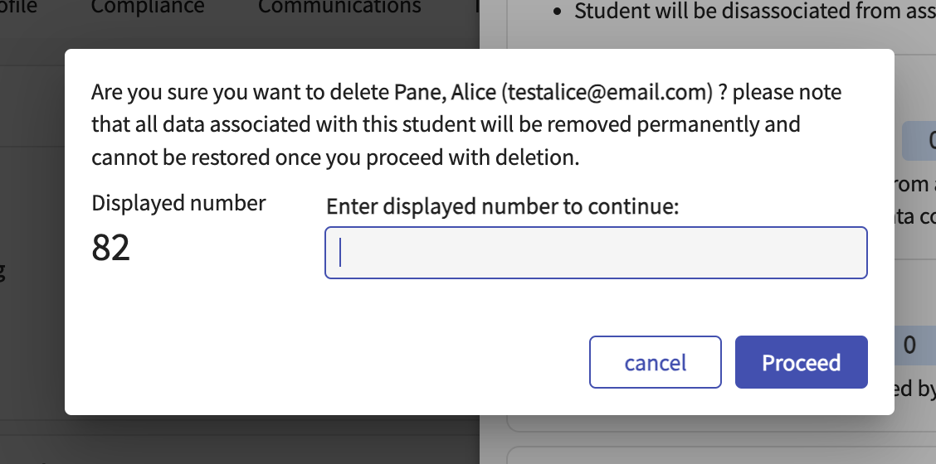
- However, you cannot delete the student if there is any learning activity completed by them. In this case, you must contact support to delete the student.
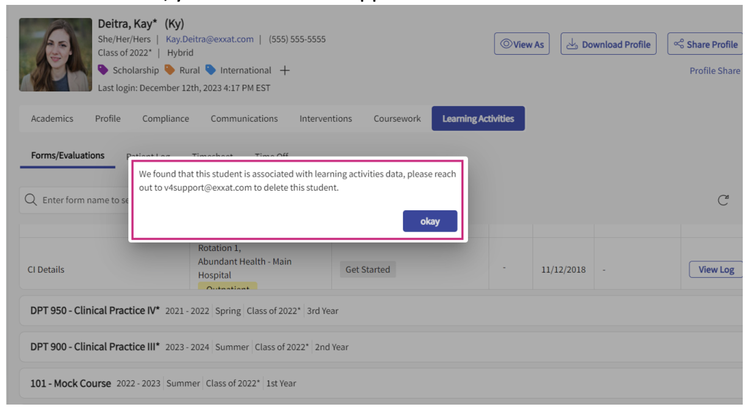
- When you try to delete the students who have completed some learning activity data you will not be allowed to complete the action. You will have to contact the support to delete the student.
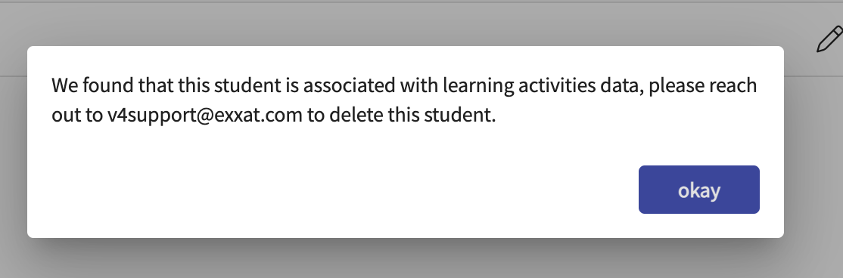

Bulk Update Students
Program administrators can update a selected student attribute in bulk for up-to 100 students.
Steps:
- Click on Coursework tab from your left-menu or dashboard.

- Click on Student tab, select students with help of Check box and Click on Bulk Update option.
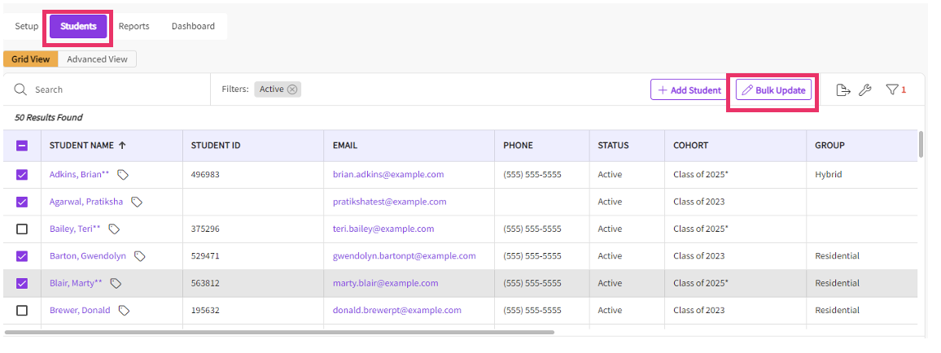
- Select Attribute you’d like to update for selected students.
  - You can bulk update the student's status:
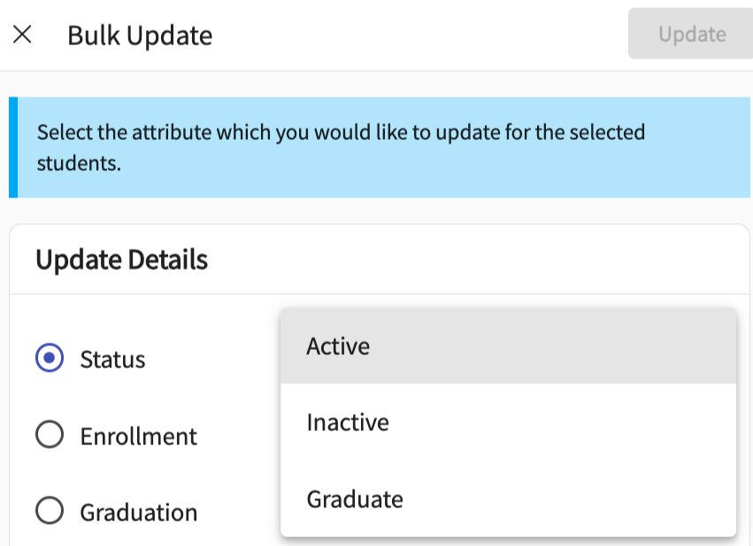
  - You can bulk students' enrollment term
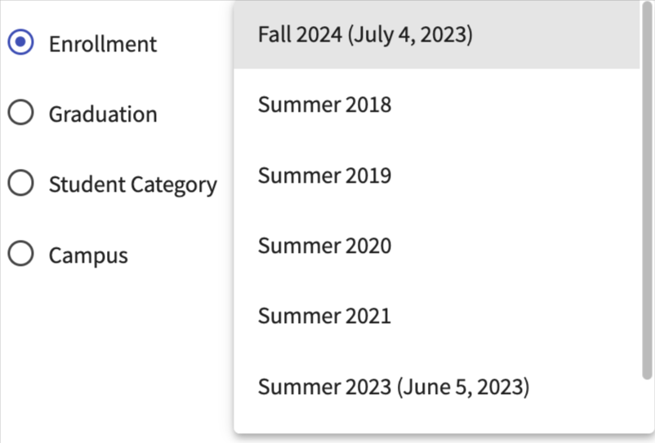
  - You can bulk students' graduation term
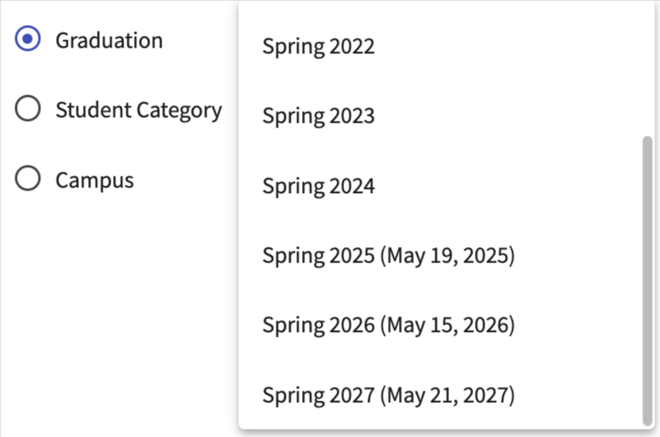
  - You can bulk students' category status
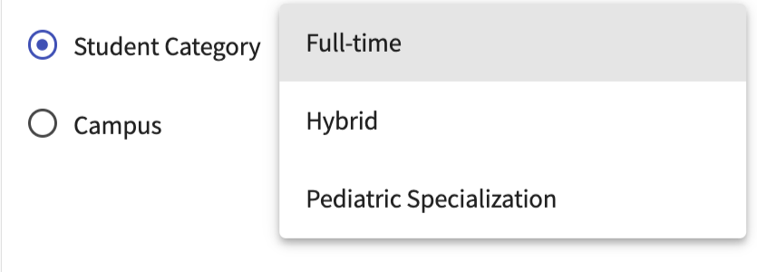
  - You can bulk students' campus status
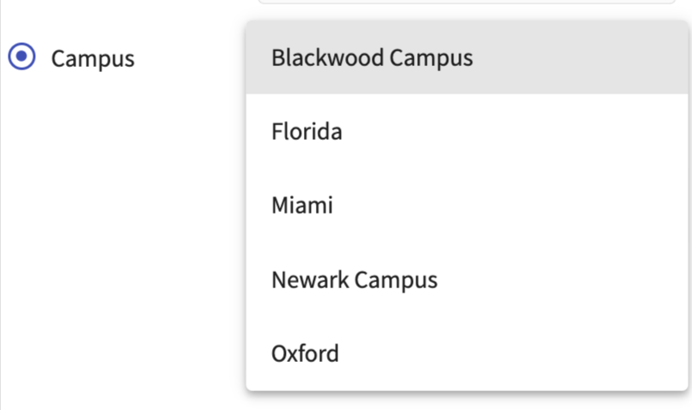
- Select the values from the drop-down option and click on Update.
Note: The system does not allow to select multiple attributes at the same time.

