Managing Program Information

The program details section contains information related to your program. Depending on the level of access you have, you may have the ability to modify the following information, or view-only access. Please contact [V4support@exxat.com](mailto:V4support@exxat.com) if you do not have the right level of access. You will be able to add information for the following sections:

* [Program Name](#_Program Name)
* Details
* [Mission and Vision](#_Mission and Vision)
* Accreditation
* [Grading Scale and Clinical Settings](#_Grading Scale)

1. Select Program Details from the left-menu.



1. The following page will appear. You’ll be taken to the Setup page where you will be able to view and manage the school profile, grading and clinical settings and setup the site resource page.

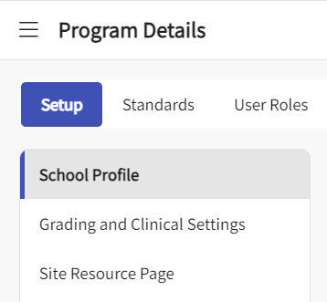

# Program Name

1. To add or update the name of your program, please click on School profile under Setup.
2. On the right side of the screen, you will find the pencil icon to edit the name.

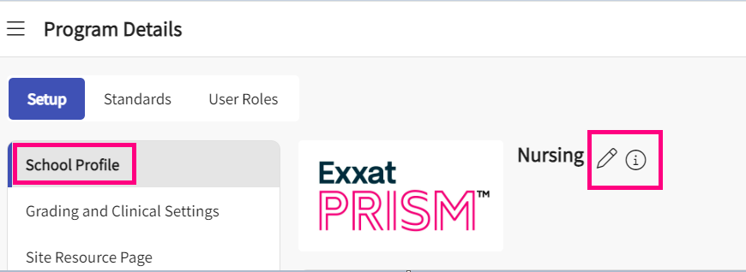

1. When you click on the pencil icon, a text drawer opens up where you can update it and save it.

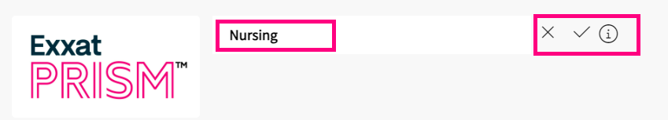

# **Details**

1. To add or edit Program Details, click on the School profile under Setup.
2. Click on the pencil icon for details card.

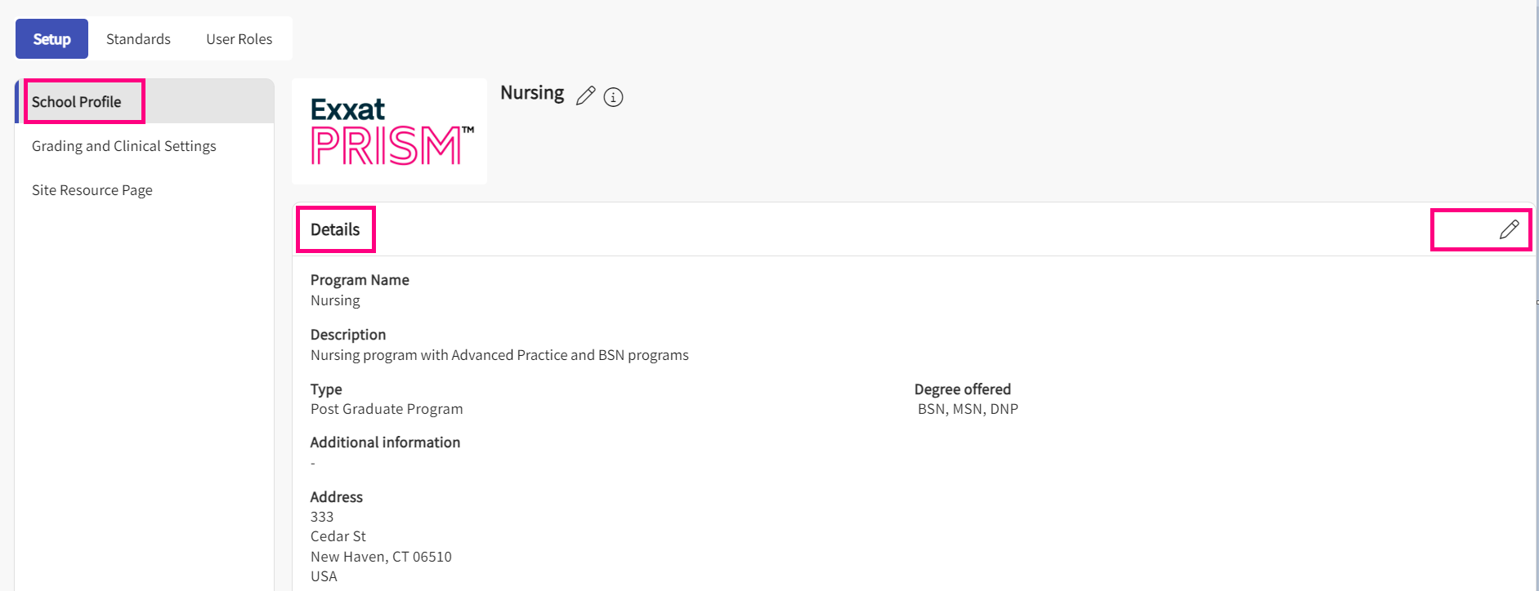

1. A drawer will open where you can enter or modify the details.
   1. **Program Logo**: you can edit and set a logo for your program.
   2. **Description**: define a basic description of the program
   3. **Type of program**: select the type of program from the dropdown. If you need additional dropdown options, please contact [v4support@exxat.com](mailto:v4support@exxat.com).
   4. **Degree offered**: degree(s) offered at your program
   5. **Additional program information**: enter any additional details not mentioned above.
   6. **Address**: location of your program
   7. Click Save when done

# **Mission and Vision**

1. Click on the + icon to add mission and vision details for your program.
   1. Once you have added details, you’ll see a pencil icon that will allow you to make changes.

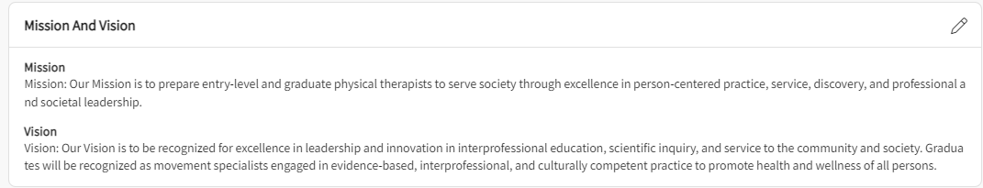

# **Accreditation**

1. To add accreditation information, click on the + icon.
   1. To modify information previously added, click on the pencil icon.

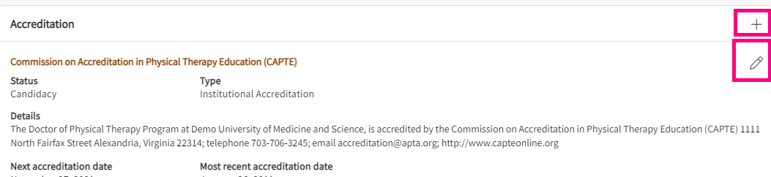

1. When adding or editing details, a drawer will open where you can add the following information:
   1. Name of accrediting body
   2. Accreditation status
   3. Type of accreditation
   4. Accreditation details
   5. Next accreditation date
   6. Most recent accreditation date
   7. Click Save when done

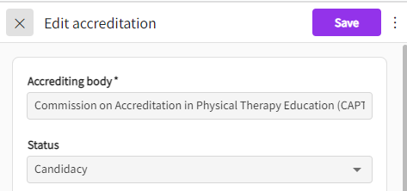

1. To delete any accreditation entries, click on the pencil icon.

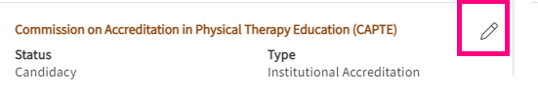

1. Click on the vertical ellipsis next to the Save button and click Delete.

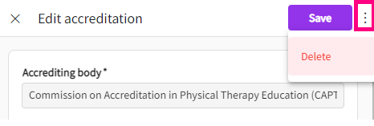

# **Email Setup**

1. You can setup the display name and reply to for every email communication that is done from the system to help the recipient verify the sender.
2. Click on the pencil icon for Email setup drawer.

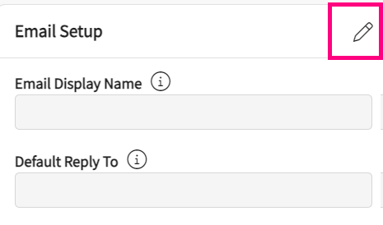

1. A drawer will open up on right hand side, you can update the display name and enter the email addresses under “reply to” drawer. You will be able to add multiple email addresses if separated by colon (;).

# **Grading Scale and Clinical Settings**

1. Grading scale and Clinical settings is under school profile.

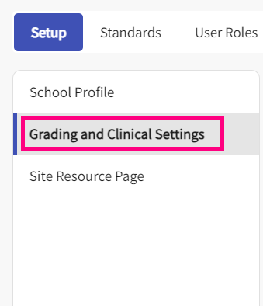

1. To add grading information, click the + icon if you are adding the details for first time.
   1. Once you add grading information, you’ll click on a pencil icon to make further changes.

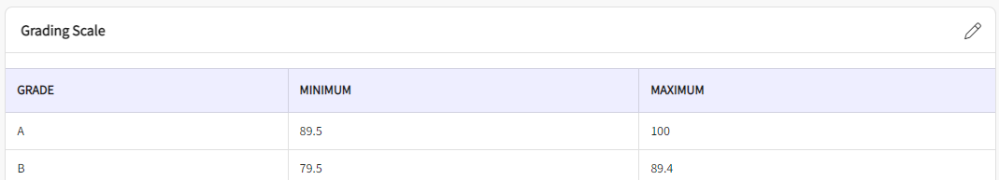

1. You will add in the following information:
   1. Letter grade: A, B, etc.
   2. Minimum %: 90%, 50%, etc.
   3. Maximum %: 100%, 30%, etc.
   4. You’ll also have the ability to upload files.
   5. Once done, click Add. You will repeat this process for every letter grade.

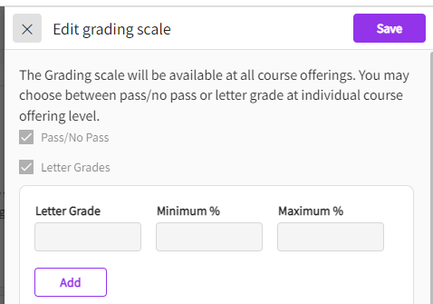

1. If you need to delete a letter grade after it’s been added, click on the trash bin. Click Save once done.

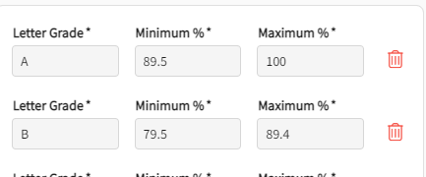

1. Similarly, you can setup the different program settings under clinical settings section.

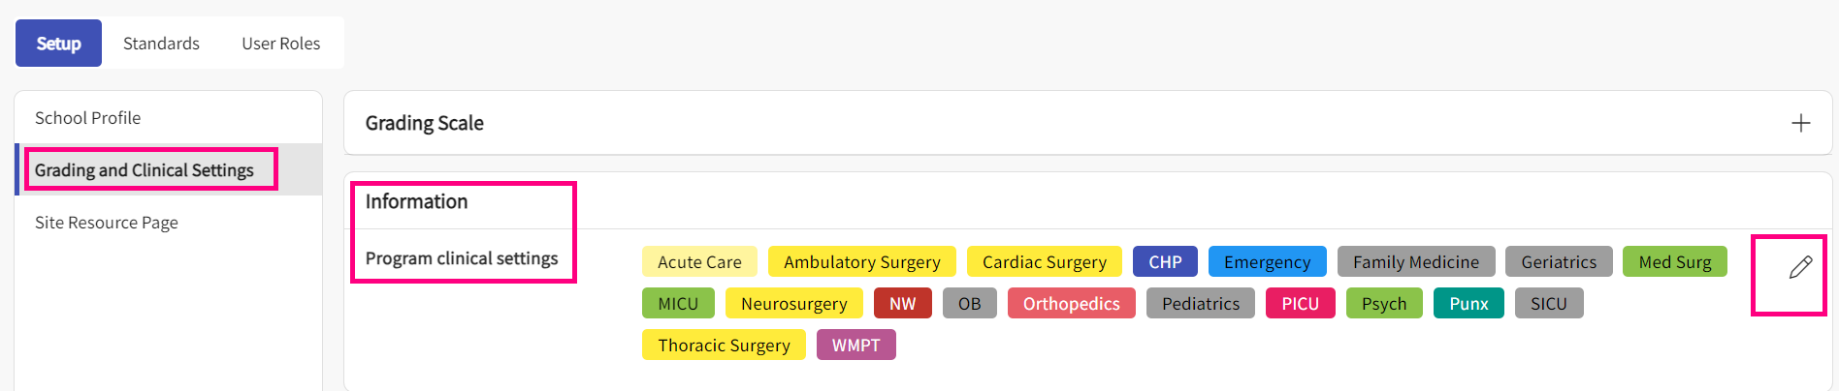

1. Click on the “+” icon if you are entering it for the first time. You can use the pencil icon to update the existing list.
2. A drawer opens up where you can capture the different settings and associate colors to each. Once updated, click on save.

