Follow the Preceptor Model

This workflow allows you to enhance the coordination between students, preceptors, and multiple associated locations, providing a cohesive and efficient system for learning experiences for your students.

## **How to Enable the "Follow the Preceptor"?**

### **Program Administrator side implementation:**

If a preceptor is associated with multiple locations, and the student has to visit those locations along with the preceptor, the student may be required to comply with the requirements of all the associated locations.

If you want your students to view other locations that their supervisor is associated with, this article will help you understand how to set up preceptor-based placement for your students.

Steps:

1. Select the Placement module from your dashboard or left menu  
   A blue and black sign with a person in the middle

   Description automatically generated
2. Click on the Setup option from the left-side menu and enable the “Follow the Preceptor” toggle button  
   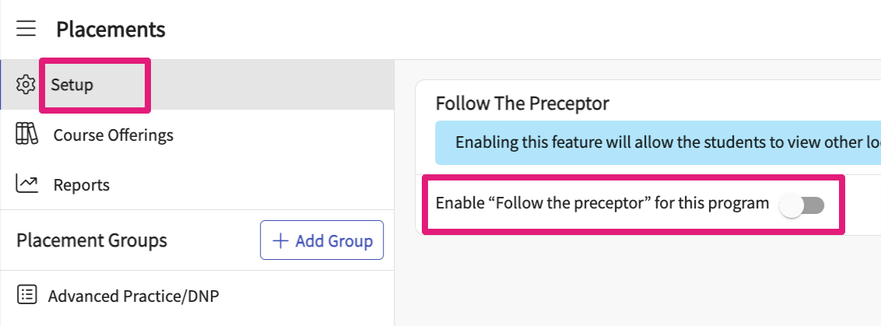
3. Click on the Course Offering tab and select the Course to set up a placement for your students  
   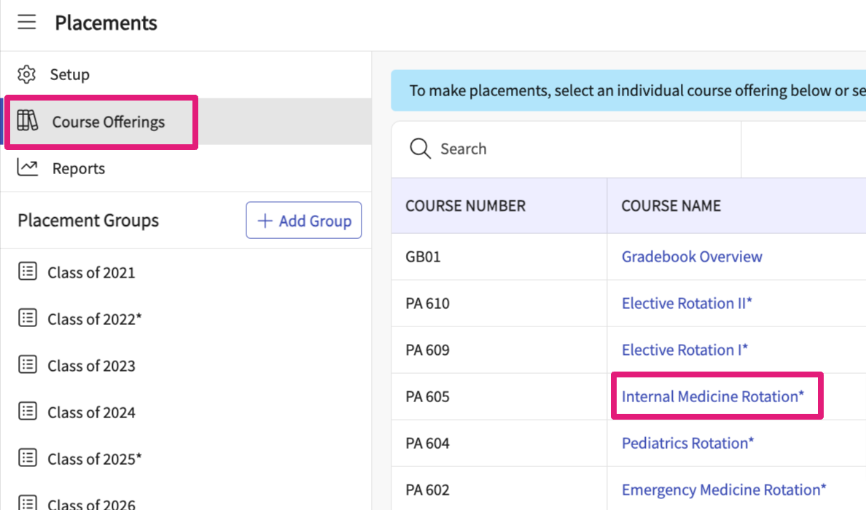
4. Search for the student and rotation, and click on the + sign to add placement information.  
   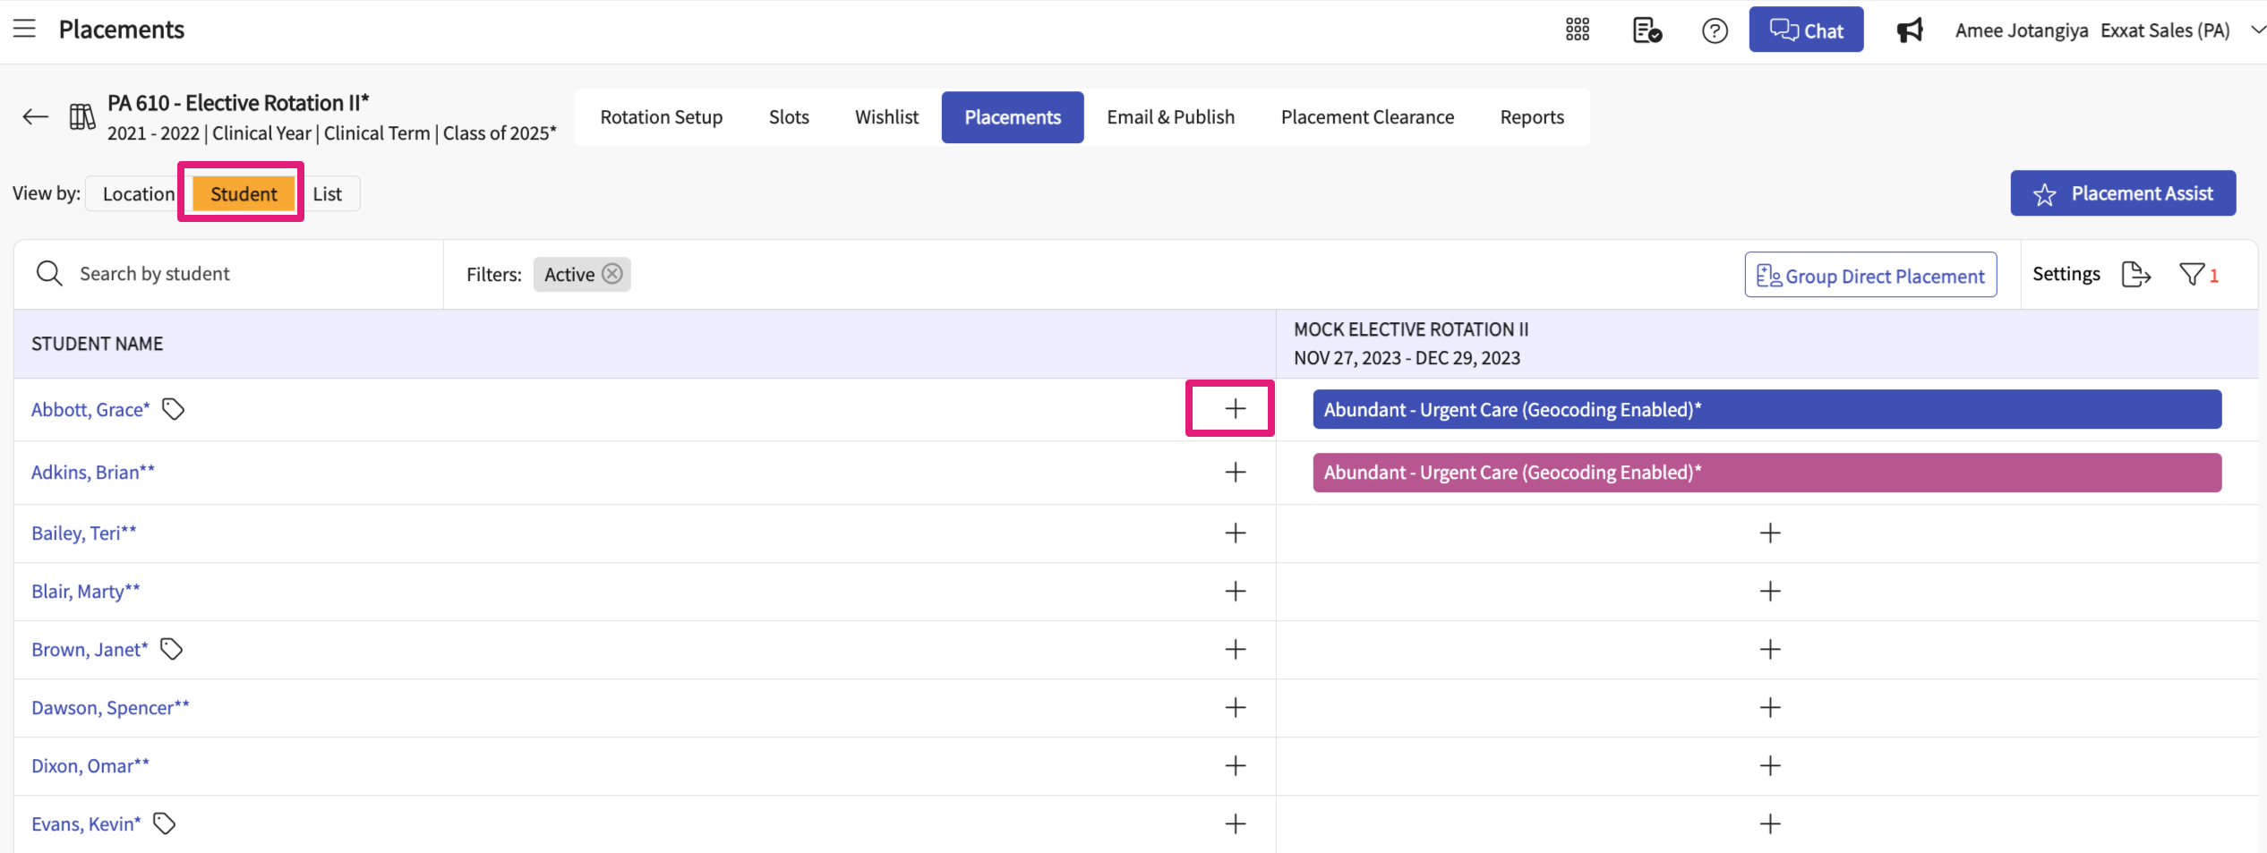
5. The drawer will then show you all available locations. Click the Select button for the Location you'd like to place the student in.  
   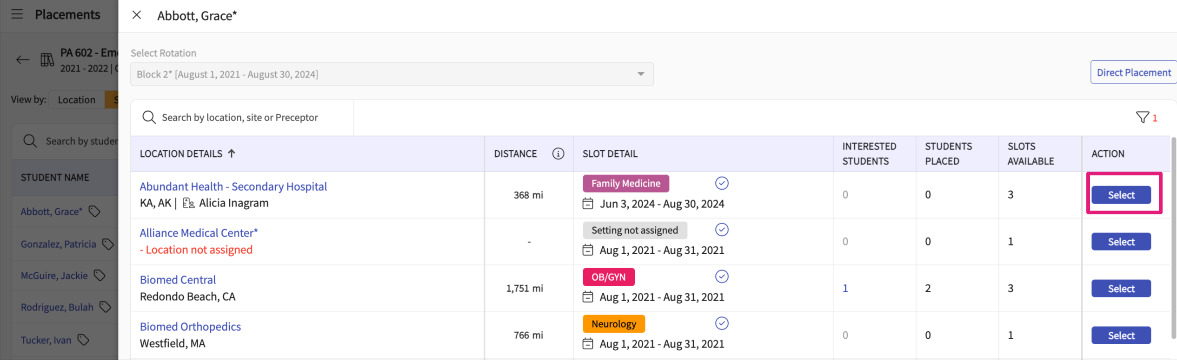
6. Go to the placement page and enable the Follow the Preceptor option.  
   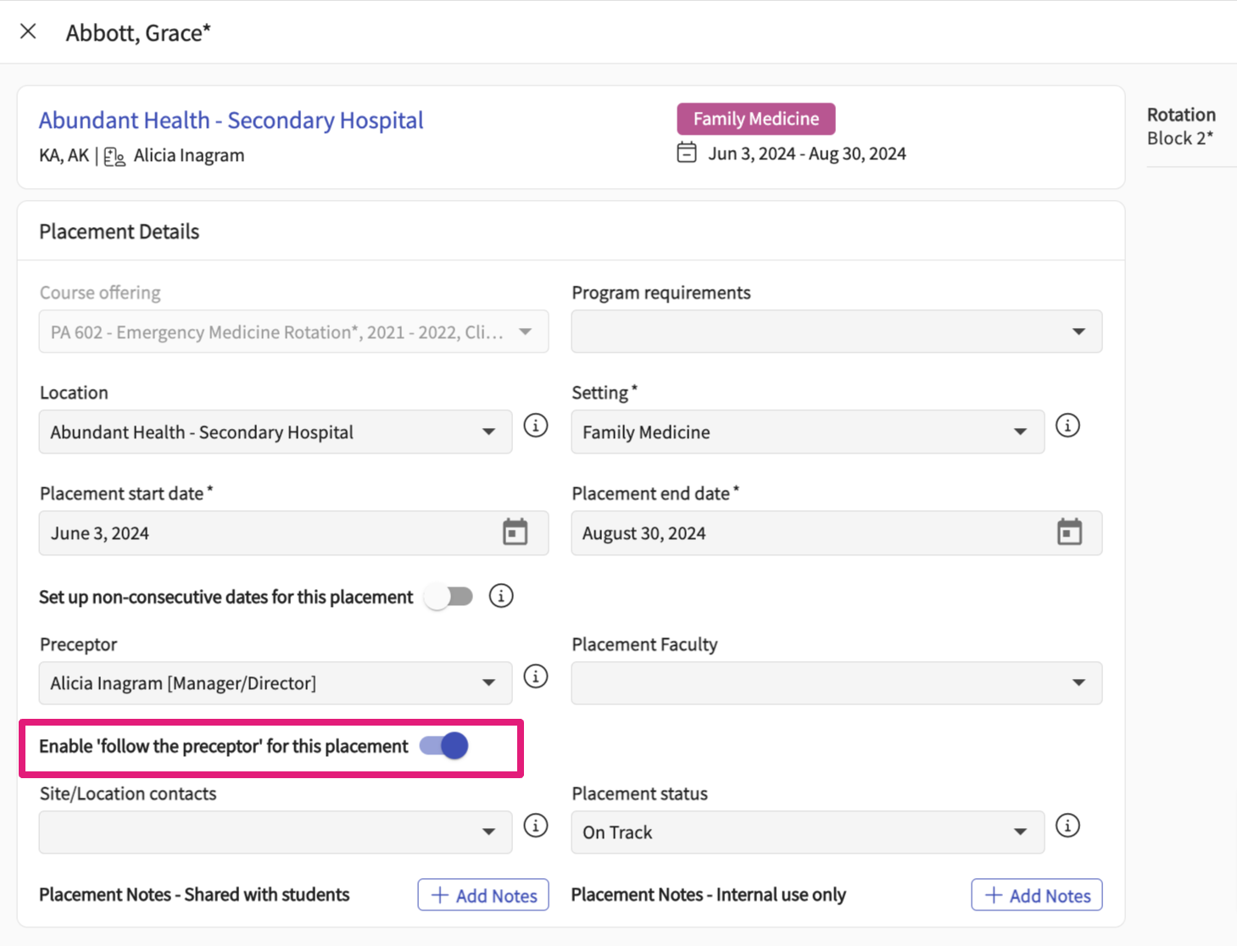7. Students can check the preceptor details and associated locations under their coursework section.  
   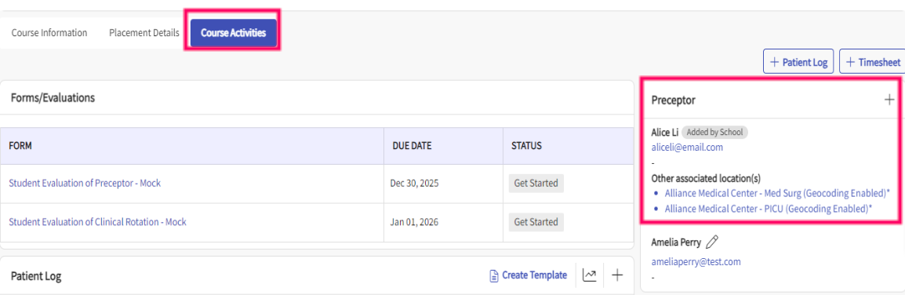

### **Student View for Follow the Preceptor button**

Your school may want to share other locations (including requirements) associated with your placement preceptor. You can access this information via coursework tab.

**Steps:**

1. Select Coursework from your dashboard or left menu.   
   
2. Click on the Course Activities tab.
3. Under the preceptor section, you can check the other locations associated with the placement preceptor.   
   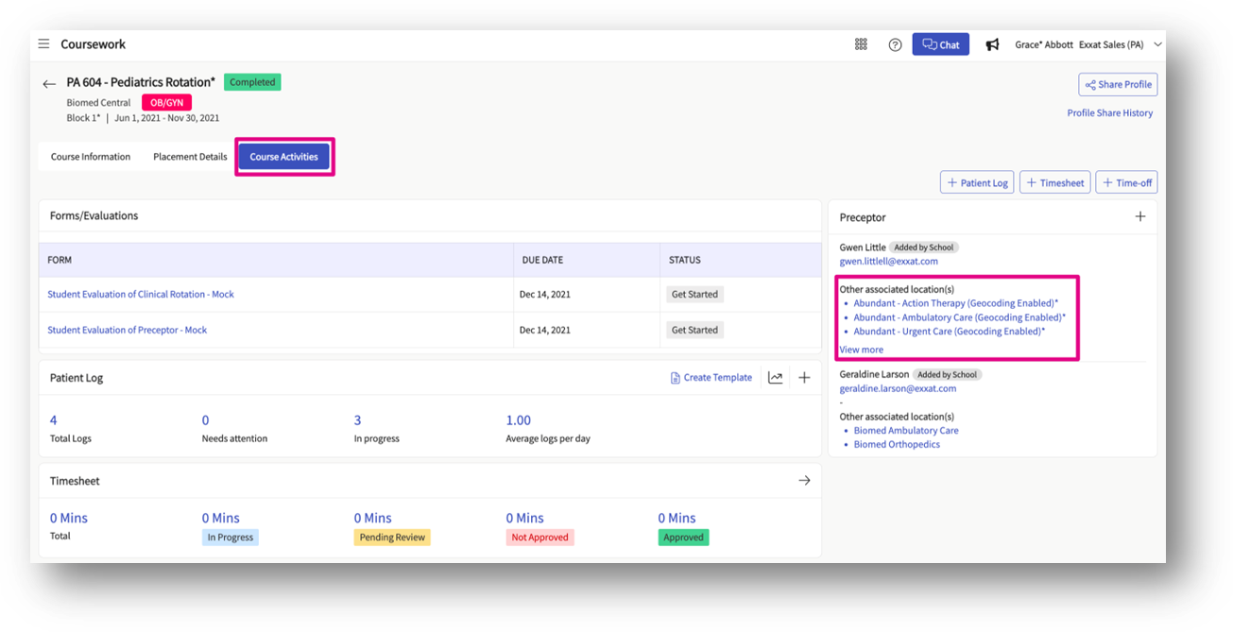
4. Click on the associated location name to check the list of other locations as well as information like Address, Location requirement upload, Reference documents, Notes, etc.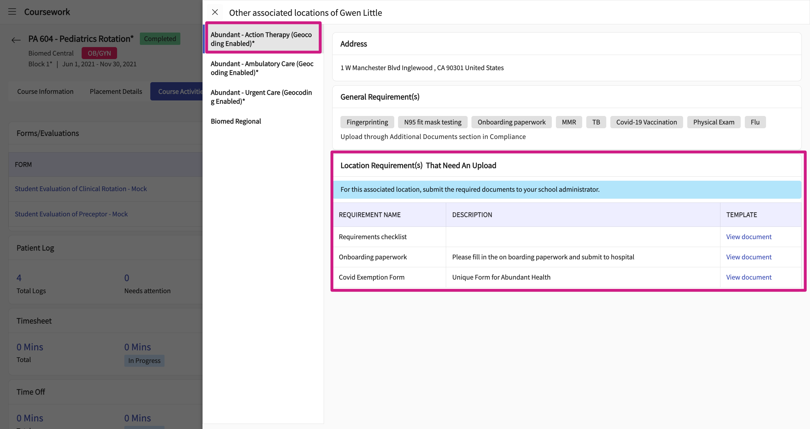

**Note:** Please note that students do not have the option to upload location requirements under this screen. Students need to submit location requirements directly to the school program's administrators/faculty; however, any document templates will reflect to the student for download when added by the school.