Cumulative Report

Curriculum Mapping

When you would like to view mappings of your entire curriculum with overall standards mapped so far at either course or measure level, then you can generate our cumulative report which is in excel form.

1. Click on the "Curriculum mapping” from your dashboard and go to the “**Mapping Reports**” page appearing on top right corner.



1. This takes you to the Mapping summary dashboard. As you scroll further below, you will find a **Cumulative report tab** on the right hand side under the other course based reports section.

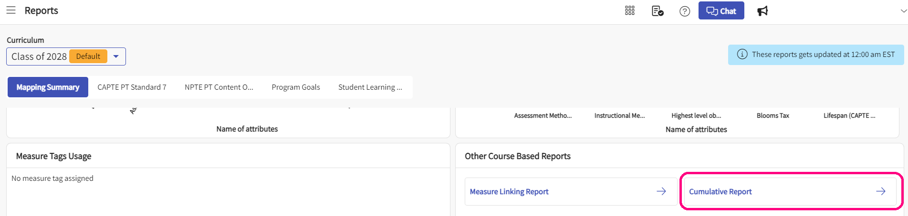

1. Once you click on **Cumulative Report** , you will be asked to pick the choices for your report.
   1. **Select courses to be included in this report:** This will allow you to pick the courses for which you need the report. You can pick as many as required since it is a multi-select option. This option is mandatory, only then you can download the report.
   2. **Course attributes:** If you check off this option, the report will include all the course level attributes that you have added in the system for respective courses. If you haven't added any attributes at this level, the column will be empty.
   3. **Course Measure attributes:** If you check off this option, the report will include all the course measure level attributes that you have added in the system for respective course measures. If you haven't added any attributes at this level, the column will be empty.
   4. **Mapping attributes:** If you check off this option, the report will include all the Mapping level attributes that you have added in the system for respective course mappings. If you haven't added any attributes at this level, the column will be empty.

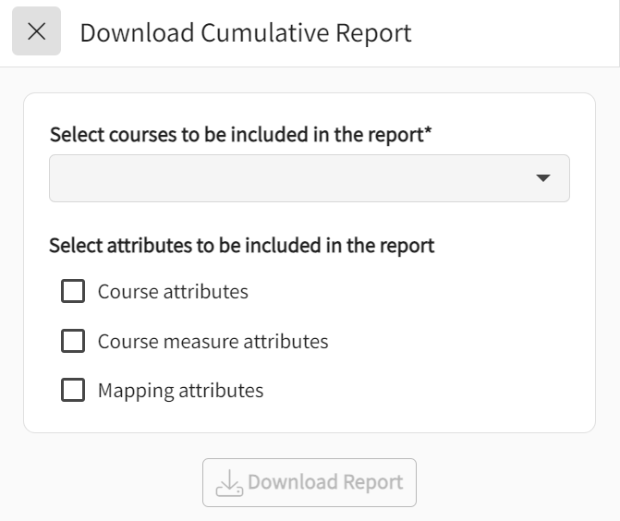

1. Click on **Download report** after picking the courses and attributes option. An excel will be generated with all the information.

