Using Placement Assist

STEPS V4

Placement assist is an Auto-placement report tool that matches your students to slots. This feature now supports placing students who have completed the following wishlist:- slot based wishlist, location based wishlist, Slot and location based wishlist, setting based wishlist, Location Area based wishlist, and randomized placements without a wishlist.

Placement Assist works even without a wishlist, you may still use advanced options to influence the output, even when you don't have a wishlist

You can run as many placement assist runs as you’d like, or make manual changes. Once you’re happy with your placements, you will make the placements in the system.

This feature is now available for all the programs.

Select Placements from your left-hand menu or dashboard.  
  


1. Select your desired course or placement group.

* You can also select a placement group to manage multiple courses at a time.

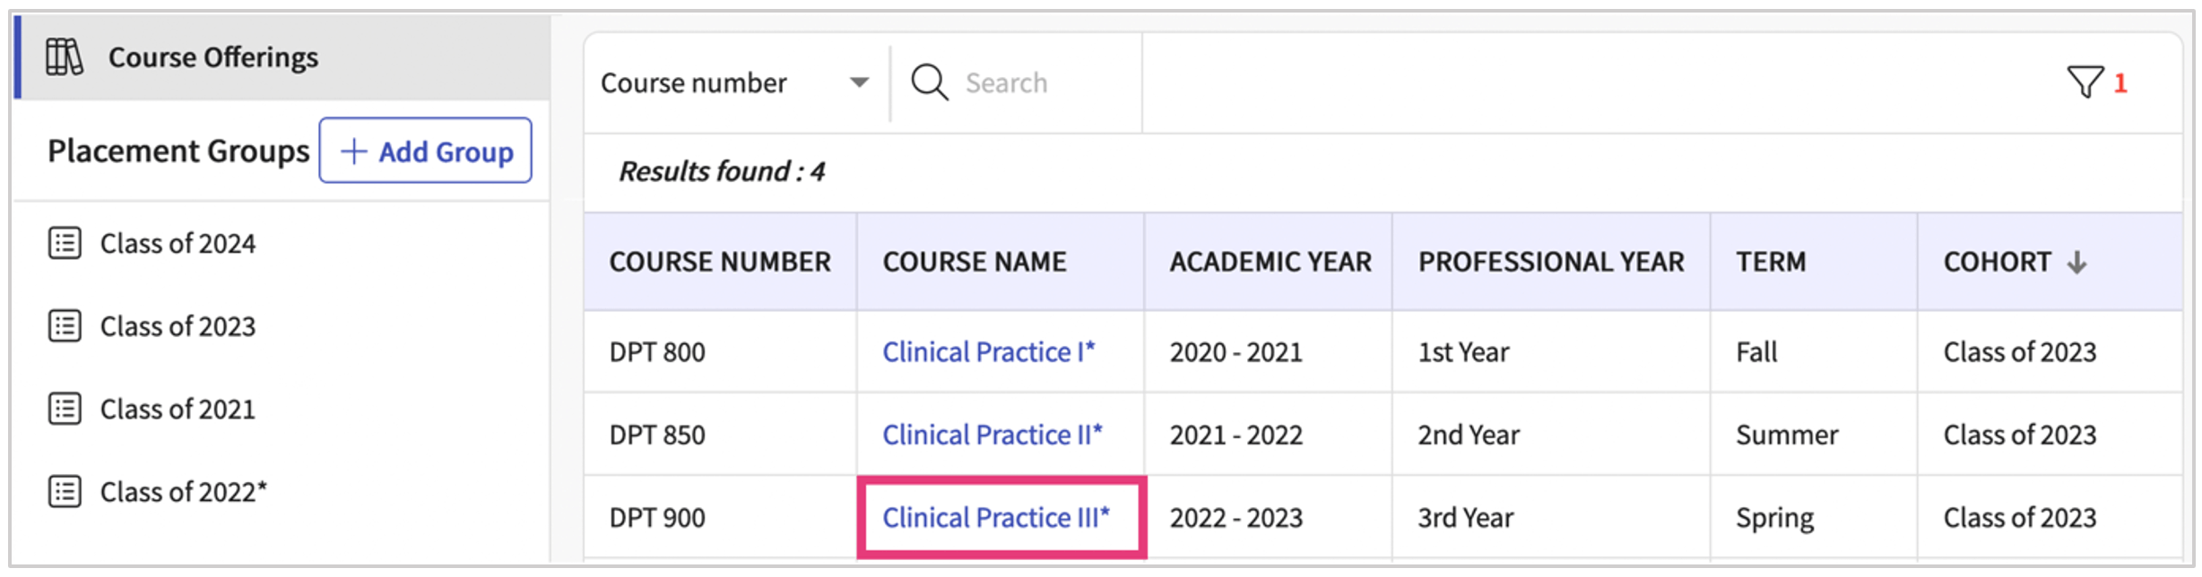

1. If you selected a placement group, click Placements for Group.   
     
   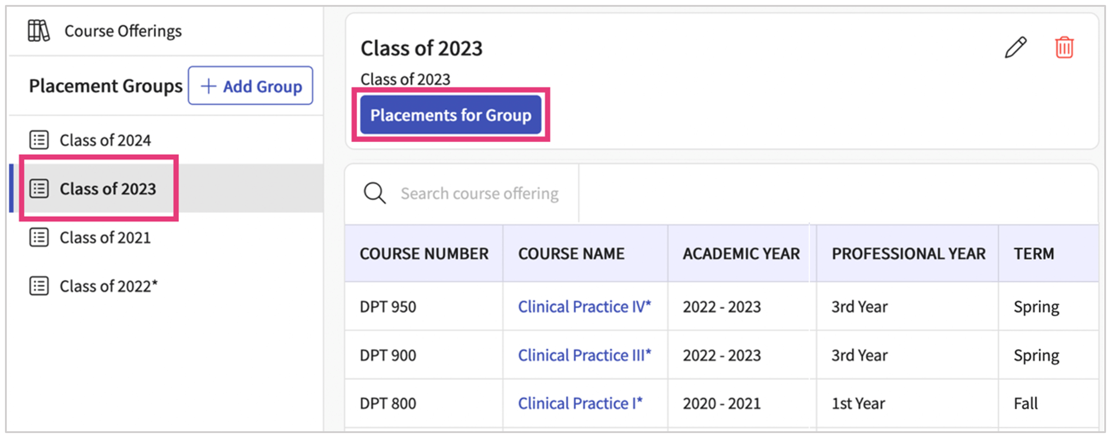
2. On the Placements page, click Placement Assist.  
     
   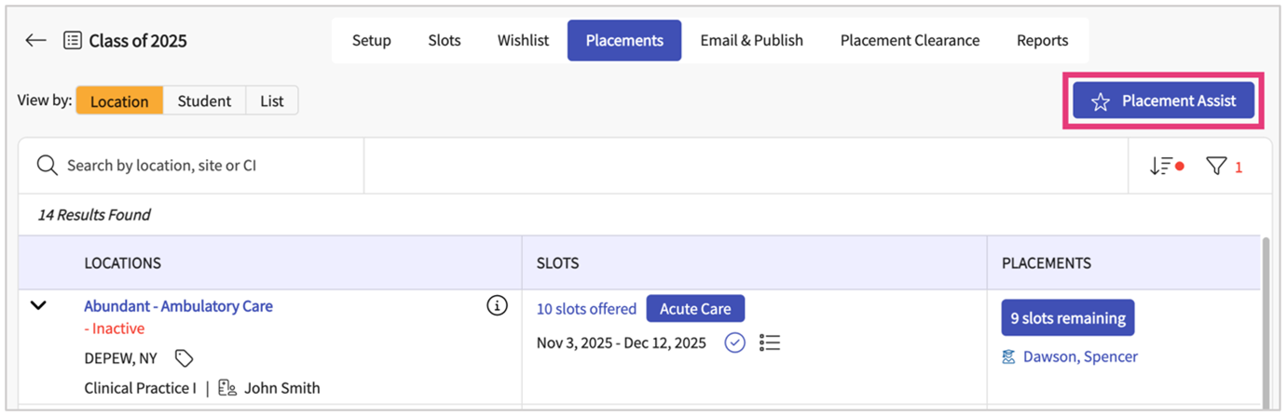
3. The system will take you to the Setup page. Select the rotations you would like to include in your placement assist.
   * 1. If a rotation does not have a wishlist, you can run a placement assist on it anyway! Students will be randomly placed into available slots.

Rotation with a wishlist

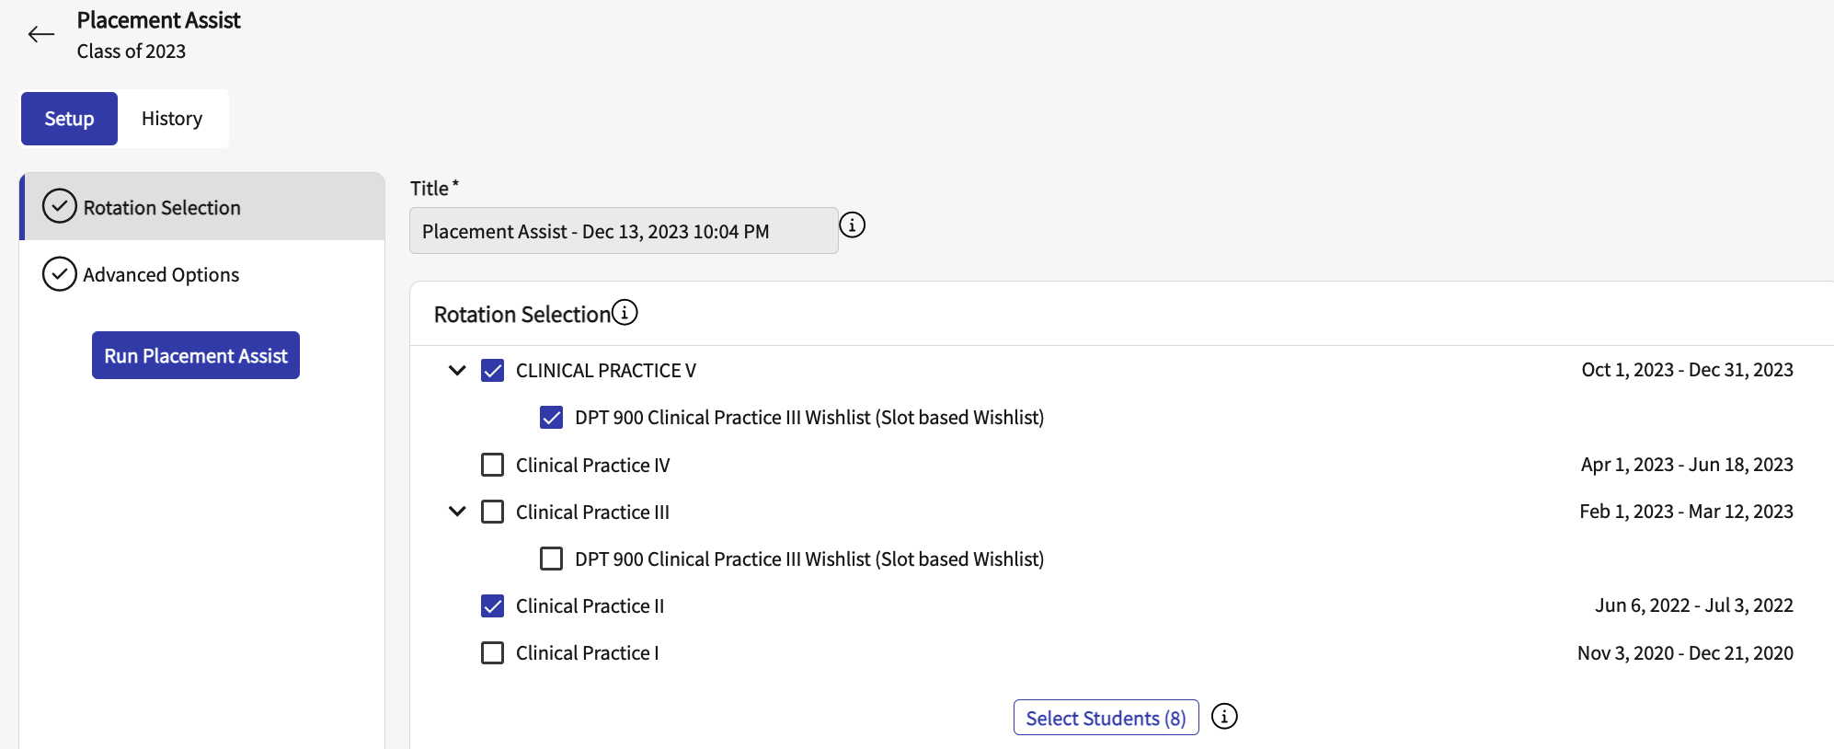

Rotation without a wishlist

For PA programs:-

It is recommended to run the placement assist on a whishlist location based, slot based or both, however, select the setting available on the wishlist for the students to rank the slots/location for the same setting as the course. For Example:- If you are setting up a wishlist for Family Medicine course select only Family medicine as a setting on the Wishlist set-up.

1. Select all the Rotations and Wishlist for all the courses by clicking the check box.

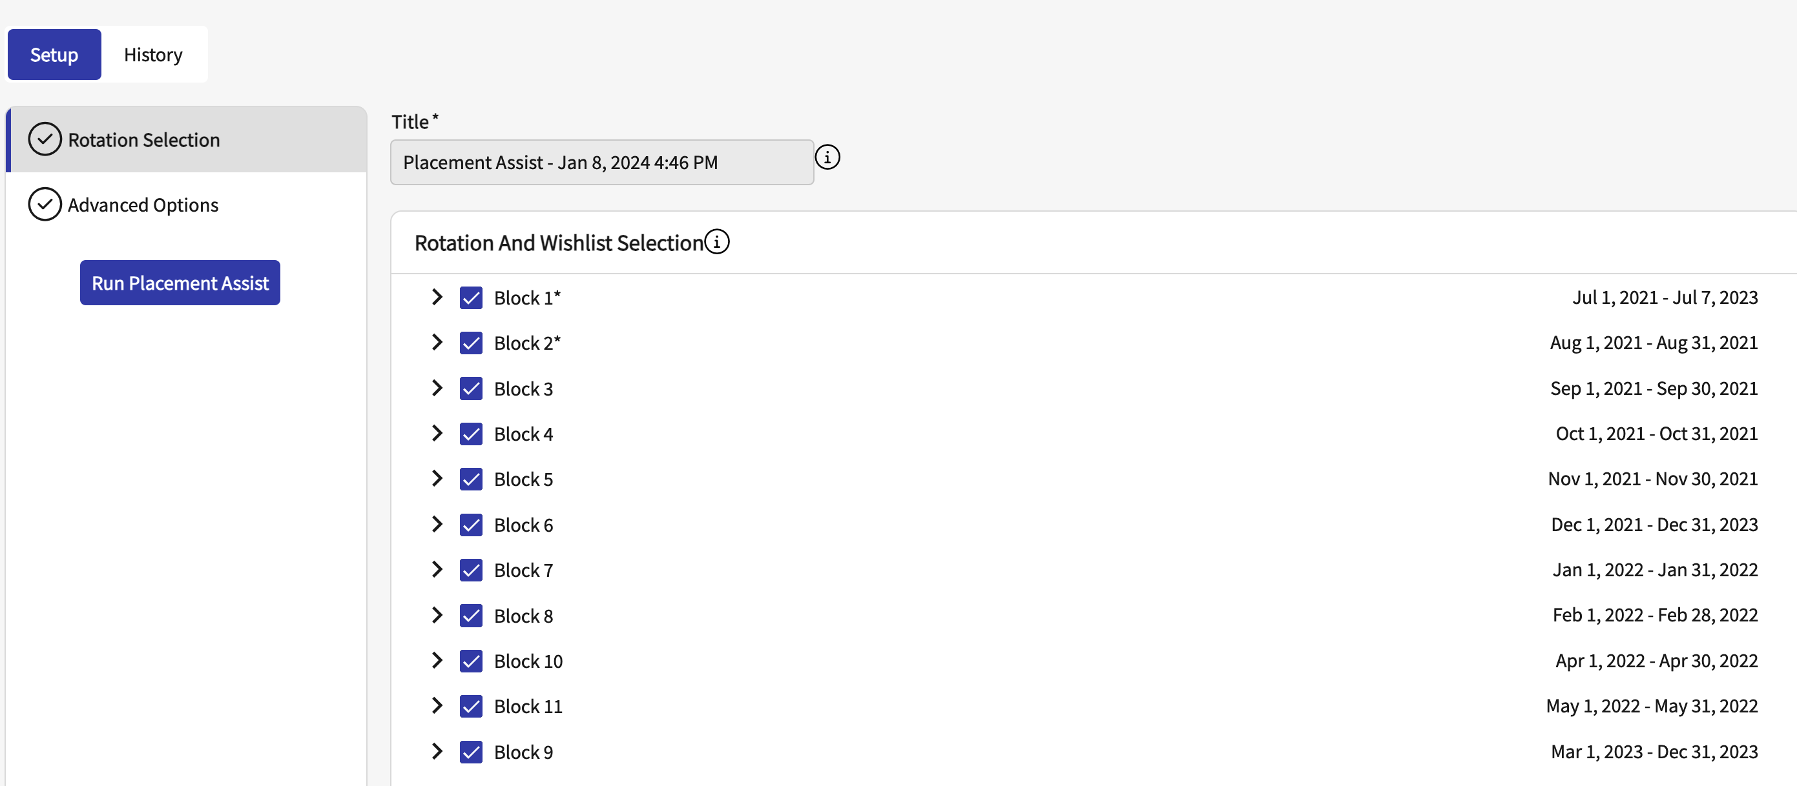

Rotation with a wishlist for each course

* 1. Here each course has a wishlist with the course setting

1. All students registered for the course will be included in your run. If you’d like to exclude students, click on Select Students (#).  
     
   A screenshot of a computer

   Description automatically generated
2. A drawer will open. Deselect any students and click Update.  
     
   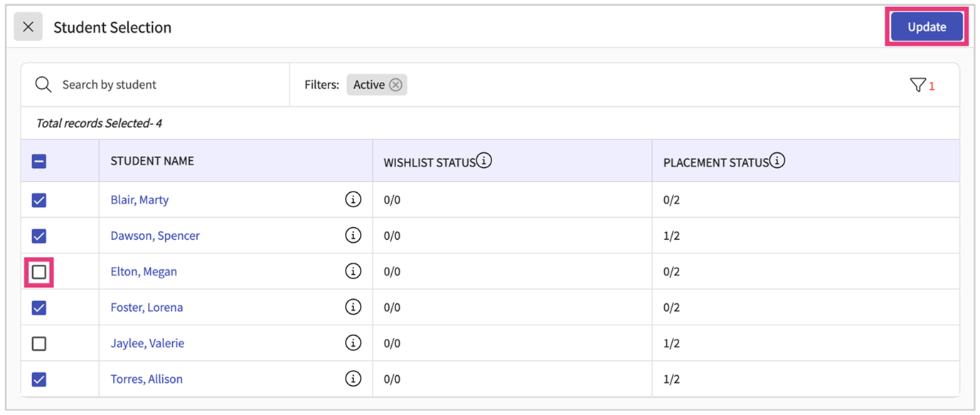
3. Advanced Option:- You’ll then decide whether you’d like to use any advanced options.

* + 1. **Include Placed Students and Used Slots:-** allows you to include any placed students and used slots in your run. This will not unplace your student but will simply allow you to view how including them in the mix will affect all other placements.
    2. **Customization based on Slot Type:**- Enable this option to exclude specific slot types from consideration. Assign custom weightages to prioritize certain slot types, higher the number higher the weightage. Check the box to include the type of slot in the run.

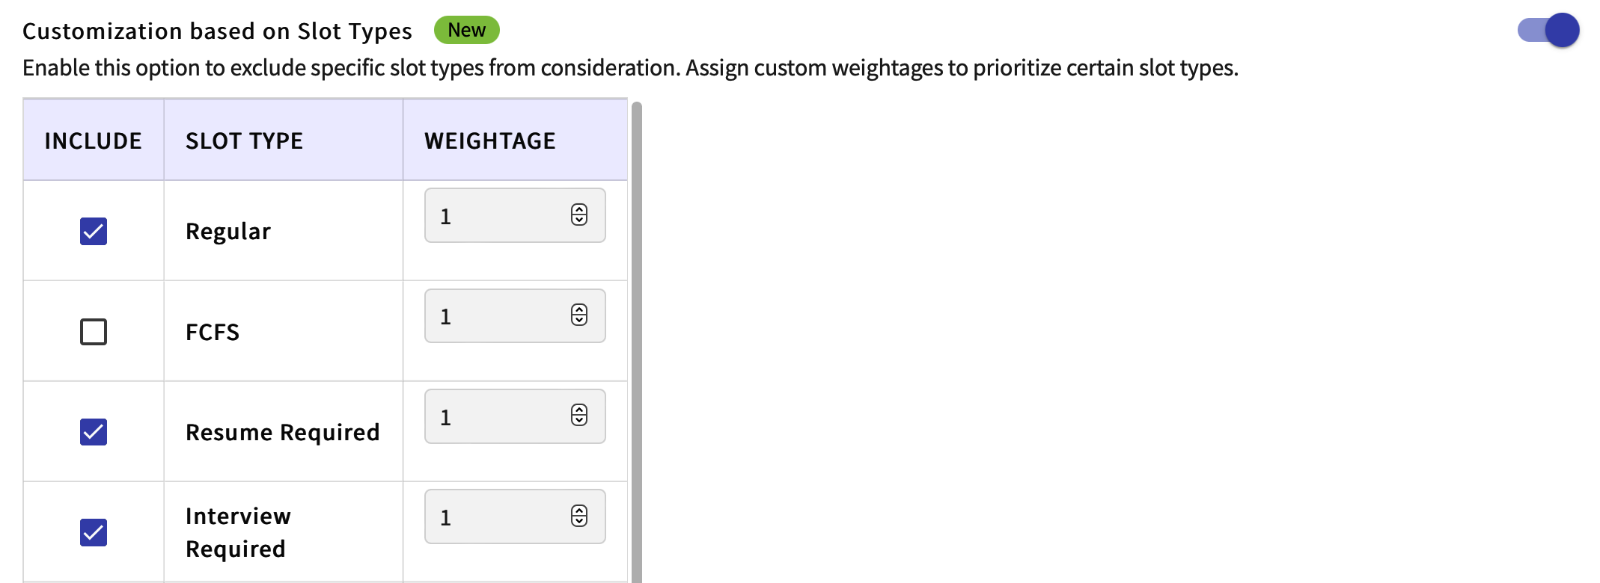

c. **Customization based on Slot Settings:-** Enable this option to exclude specific settings from consideration. Assign custom weightages to prioritize certain settings, higher the number higher the weightage.

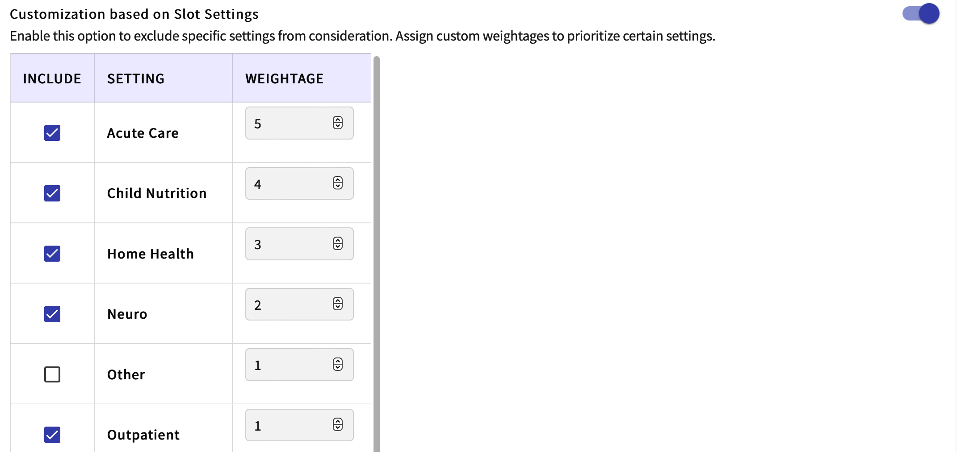

d. **Customization based on Slot Status:-** Enable this option to exclude specific slot statuses from consideration. Assign custom weightages to prioritize certain slot statuses.

1. Once you’ve made your selections, click Run Placement Assist.  
     
   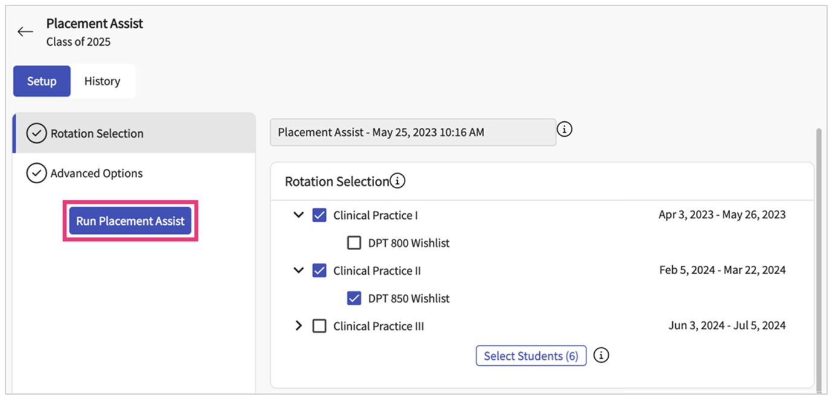
2. You’ll be taken to the History tab where your run will show as Pending. Click the refresh arrow. The grid will update and show you a Completed status. Click on the Download icon.  
     
   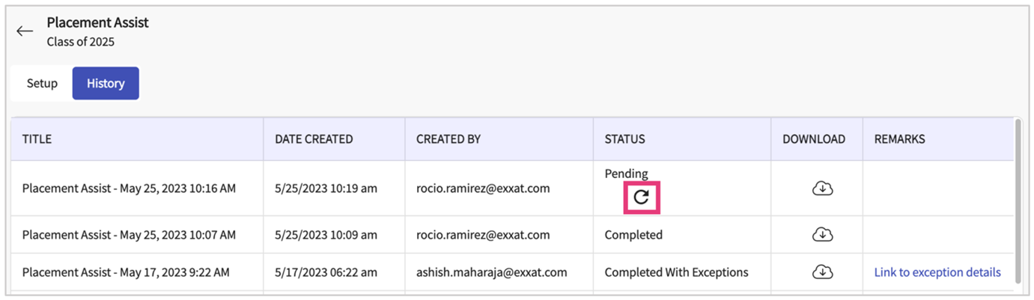
3. Placement assist report for a rotation with slot based wishlist:- The system will download an excel file for you to review which contains 3 tabs:
   1. **Summary:-** On the Summary tab, view a quick overview of the number of students who were included, whether they received something on their wishlist, if they were successfully placed, and more.

* 1. **Placements:-** On the Placements tab, you will see detailed information for each student. The first few rows will give you details about what site a student got matched with, the setting, Clinical instructor, Slot type Supervision and the demand (meaning how many students also selected that site and added it to their wishlist).

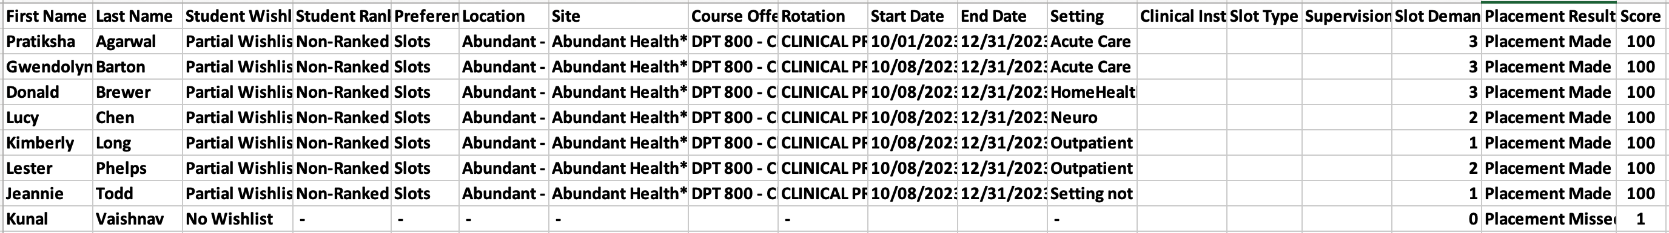

* 1. Supply Demand:- On the Supply demand tab, you can easily review which sites are most in-demand vs what students are requesting.

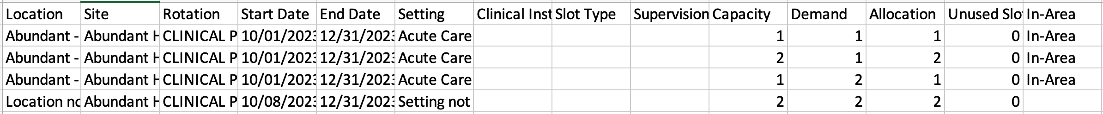

1. The matches made by Placement Assist are a good starting point to give you insight as to where to place your student. This is not something set in stone, and you can decide to ignore any matches made and place a student elsewhere.