View Site, Location, and Personnel Reports

Prism

As you enter data in the system, you’ll need to analyze the data! Use our handy reports to find what you are looking for.

1. Select Sites from your dashboard or left menu.

1. Select Reports from the ribbon at the top of the page.

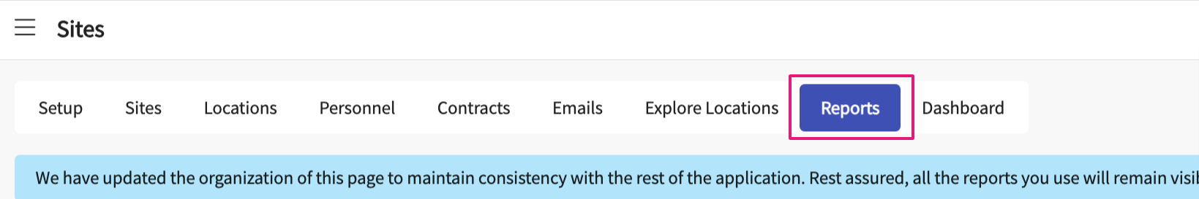

1. The report list will load. On your left panel, you will have reports organized by entity – Site, Location and Personnel.

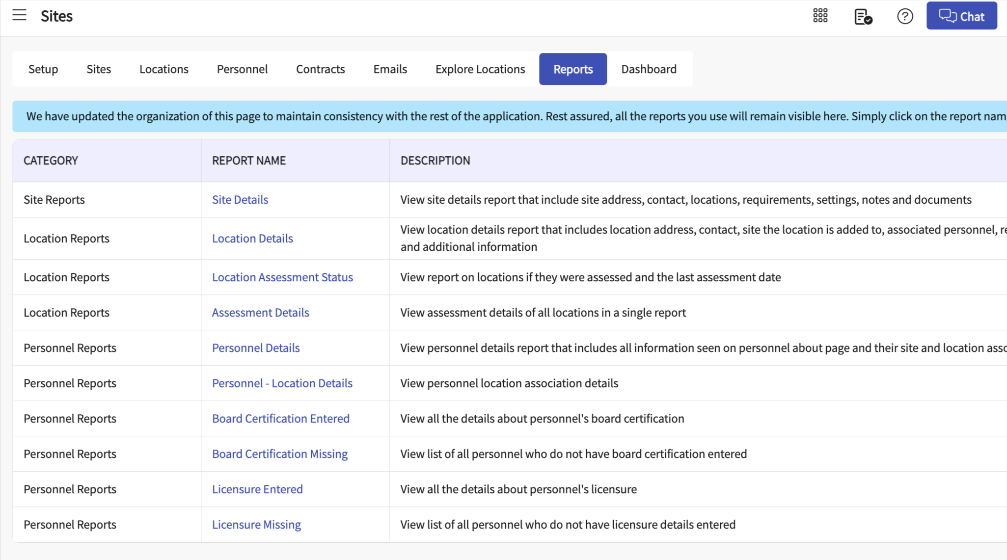

1. Many of these reports will include similar features to help you sort through the data:
   1. Export option to excel
   2. Ability to edit columns shown on the report, temporarily remove or rearrange the order.
   3. Filter option to limit records shown based on different fields like cohort, group, and so on.   
      A black and white image of a wrench

      Description automatically generated with low confidence
   4. The search bar allows you would do a search on any data available on the report. Simply enter the word you want to search for in search box  
      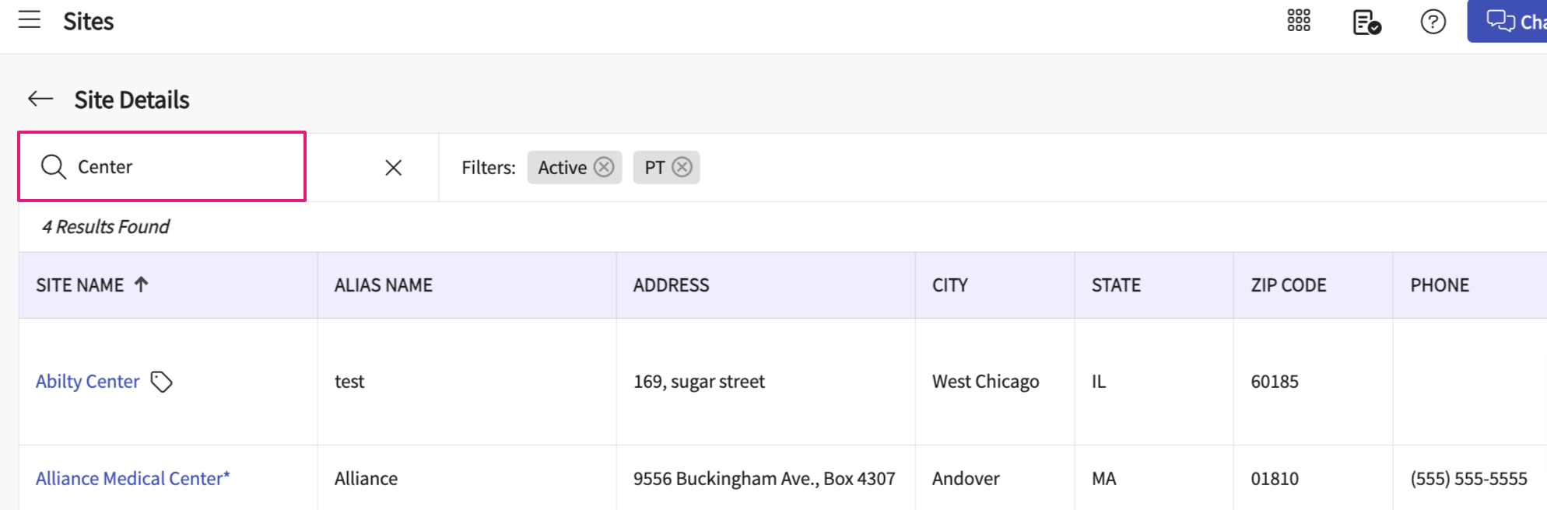
2. Reports available for Site:
   1. Site Details
3. Reports available for Location:
   1. Location Details
   2. Location Assessment Status
   3. Assessment Details
4. Reports available for Personnel:
   1. Personnel Details
   2. Personnel – Location Details
   3. Board Certification Entered
   4. Board Certification Missing
   5. Licensure Entered
   6. Licensure Missing