Adding Profile Attestation

Your school may need sign off on statements on your profile or at the beginning of theplacement**.**   
Attestation section allows student to acknowledge / provide electronic signature on this attestation.

**Steps:**

1. Login to your account.
2. Attestations appears at the top of the dashboard screen. Students can check the content of the attestation, due date & option to click on **I Agree** button to acknowledge the attestations.  
     
   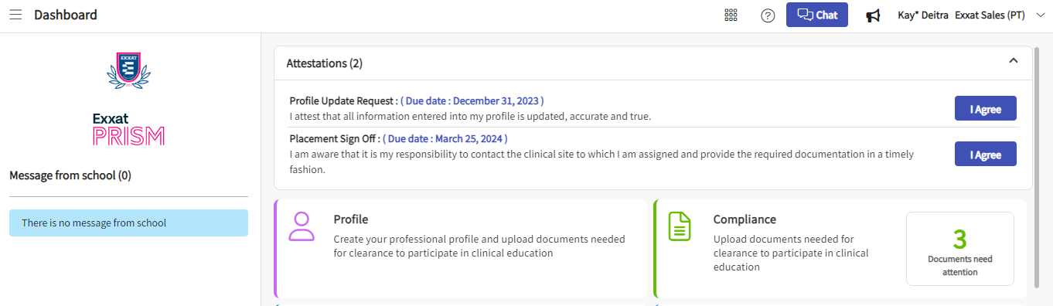
3. Once you agree to an attestation, it will disappear from dashboard screen. You can do the audit of the same within the profile tile under Agreed Attestations section.

Select Profile from your dashboard or left menu.

1. Click on Academics section.   
     
   A screenshot of a computer

   Description automatically generated
2. Here you can find the list of all Agreed Attestations, date & time stamp when it was acknowledged.

