Moving a Location from one Site to another

STEPS V4

Within the system, you will have Sites (group or entity with which a contractual relationship is established) and Locations (a physical location where patient care takes place).

To move a Location from one Site to another due to any reason such as a merger or takeover, please follow the below steps.

1. Select Sites from your left-menu or dashboard.  
   
2. Find and Select the Location you’d like to move.  
   **Pro-tip: use search box and filters to find what you’re looking for!  
   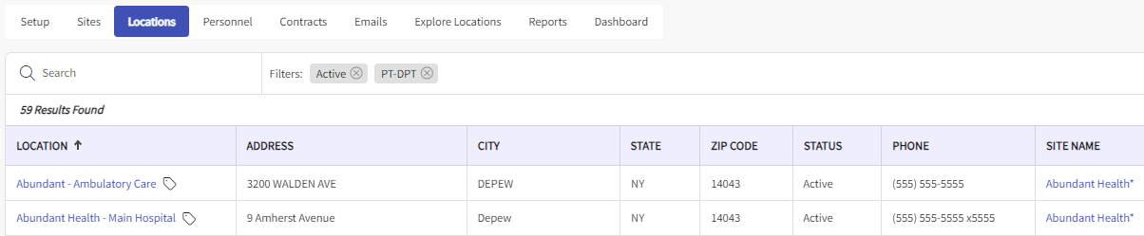
3. On the ribbon at the top of the page, Click on Move Location.  
   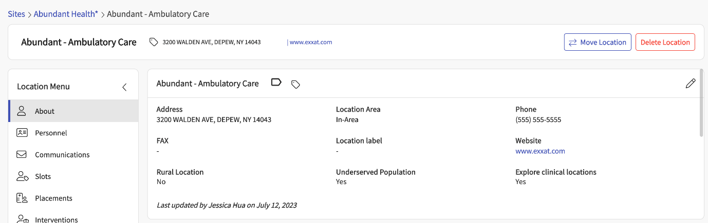
4. The page will load all existing Sites > Then Select / Search the Site from the option provided. 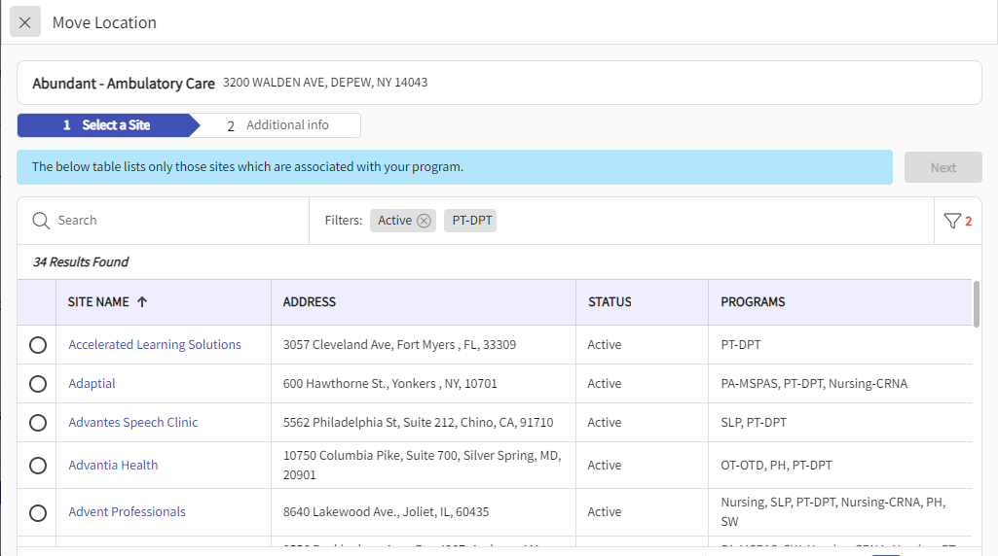
5. Post Selecting the Site the Next Button will be Highlighted:  
   A screenshot of a computer

   Description automatically generated

**Please note that Attributes inherited from Site such as Settings, Categories, Requirements, Requirement uploads, Notes, Documents and Contracts **will not be moved.**

1. Once you confirm the details next step is to click on Move Location.A screenshot of a computer

   Description automatically generated
2. Please Click on Yes to Confirm the movement.  
   A screenshot of a computer

   Description automatically generated
3. Post confirmation of the movement the system will pop-up the below Information. Thus, confirming the Location Movement.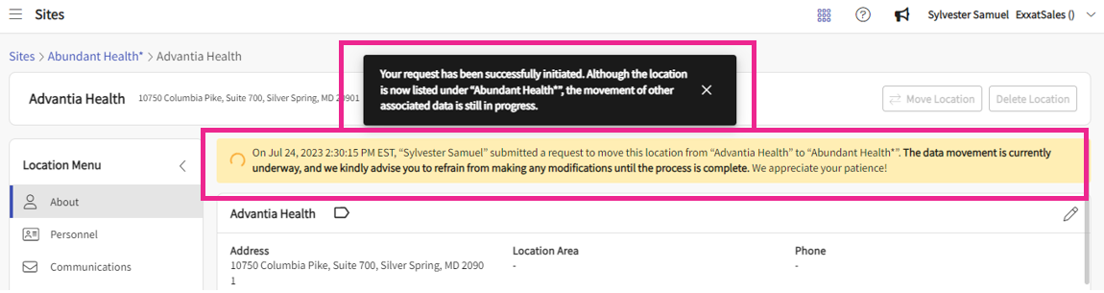
4. Once the task is completed the system will display below confirmation and this completes the location movement process.A screenshot of a computer

   Description automatically generated
5. You can see the audit log/history logs of from which site this location was moved to this site along with who and timestamp of when it was moved
6. Select the Site name you want to see audit log of
7. Select the Locations tab and Select "Location Movement History" button  
   A screenshot of a computer

   Description automatically generated
8. See the details on right hand side

