Mapping Tags Report

Curriculum Mapping

If you need to generate reports to review tags added at mapping level within a curriculum, then you can find this under Mapping tags.

1. Click on the "Curriculum mapping” from your dashboard and go to the “Mapping Reports” page appearing on top right corner.



1. This takes you to the Mapping summary dashboard. On top left-hand side, you will find a drop-down menu which will allow you to change the “Curriculum/cohort” for which you wish to see the reports for. This is where you can select the standard also for which you need to generate reports for.

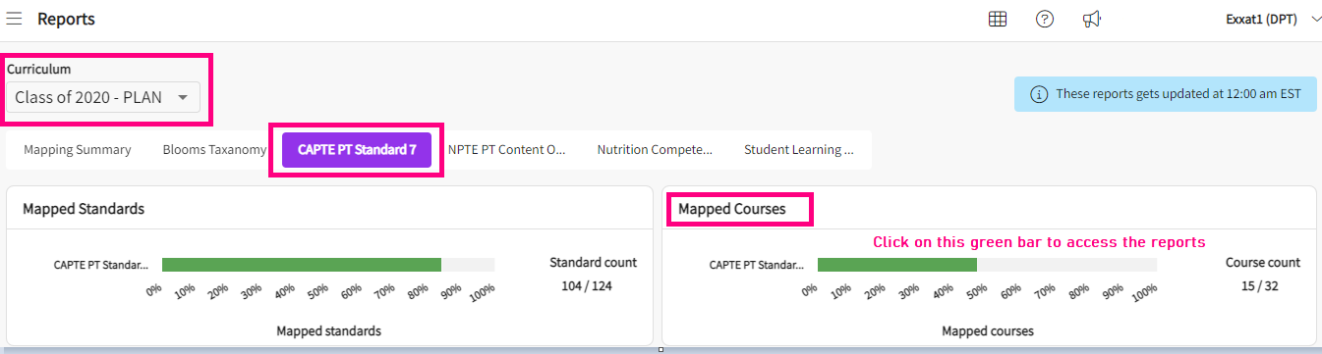

1. Once you pick the standard, you will see multiple tiles namely, Mapped Standards, Mapped courses, Mapping attributes and lastly the Mapping tags.

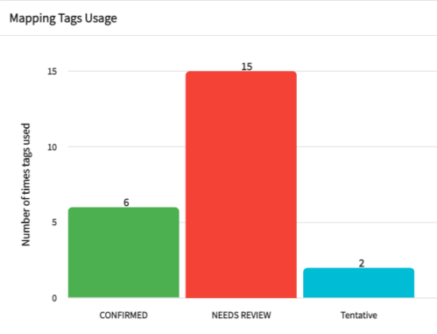

1. Here you will find all the tags utilized across curriculum and each one of those bars are clickable. When you click on the bar, it takes you to the report screen for tags as shown below.

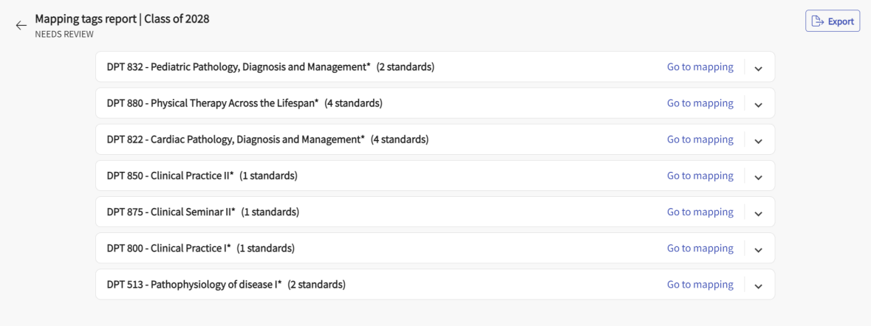

1. On the top right hand side, you have the option to export the report in word file. You can download the report and go through the information.
2. If you wish to setup the mapping tags, this article talks about how to add them at mapping level: <https://exxat.zendesk.com/hc/en-us/articles/20233261427601-Adding-Editing-Deleting-Mappings-Course-For-Curriculum-Mapping->