Reports - Mapping Summary

Curriculum Mapping

Mapping summary dashboard gives you an overview of your entire curriculum showing you all the mapped standards, courses, attributes and tags.

# View Mapping Summary Dashboard:

1. Click on the "Curriculum mapping” from your dashboard and
2. Select “Mapping Reports” page appearing on top right corner.

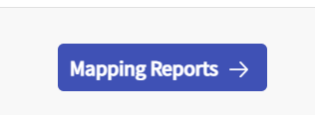

1. This takes you to the Mapping summary dashboard. On top left hand side you will find a drop down menu which will allow you to change the “Curriculum/cohort” for which you wish to see the reports for.

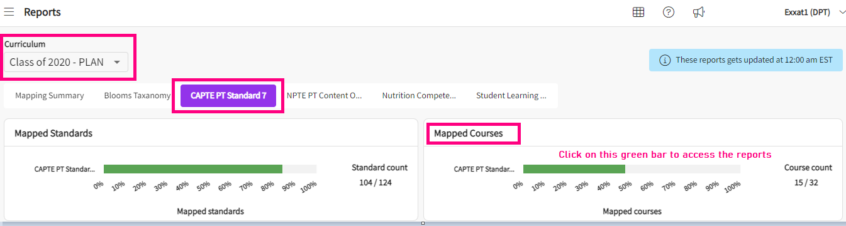

1. Once you have selected the curriculum/cohort, you will be able to view multiple tiles related to that curriculum/cohort as follows:
   1. **Mapped standards tile**
   2. **Mapped courses tile**
   3. **Course attributes usage tile**
   4. **Measure attributes usage tile**
   5. **Measure tags usage tile**
   6. **Other course based reports tile**

**MAPPED STANDARDS TILE:**

*This tile represents all the standards that have been activated for the cycle you have selected and progress of each of those standard mappings. It gives you the total number of standards mapped / total number of standards present under standard counts for each standard. The overall progression of every standard mapped is shown in terms of percentage as well at the bottom of the bar. You can hover over the green bar to see the exact percentage of mapped standards.*

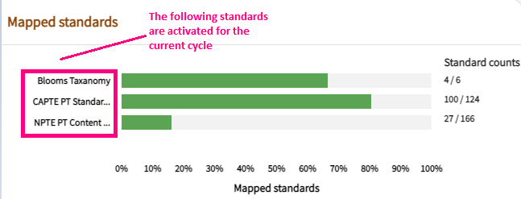

**MAPPED COURSES TILE:**

*This tile represents all the standards that have been activated for the cycle you have selected and how many courses have been mapped to that particular standard. It gives you count of total number of courses mapped / total number of courses present under the courses counts for each standard. You can also hover over each of the green bar for every standard to see how much in terms of percentage the courses have been mapped to that standard.*

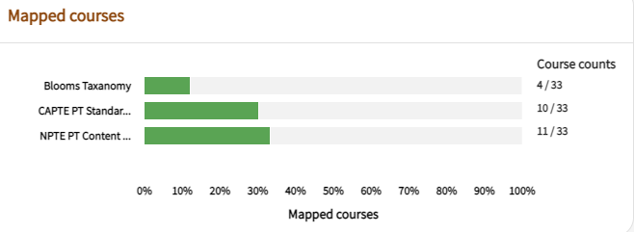

**COURSES ATTRIBUTES USAGE TILE:**

*This tile represents the attributes category assigned at course level and number of times attribute category has been used. This chart is clickable. You can click on any of the attribute category, and it will take you to the detailed screen showing you the attributes within that attribute category and providing you a course attribute report.*

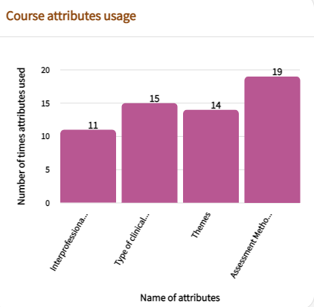

1. If you click on any of the attribute categories from the chart as shown above*.* You will be directed to the screen showing you further details of that attribute category. It shows you the sub child / attributes of that attribute category and number of times the attribute has been used.

1. As you scroll down on the screen you will find a grid like report showing you the course name vertically and the attributes horizontally. You will find checkmarks showing up wherever the attribute has been assigned to a particular course.

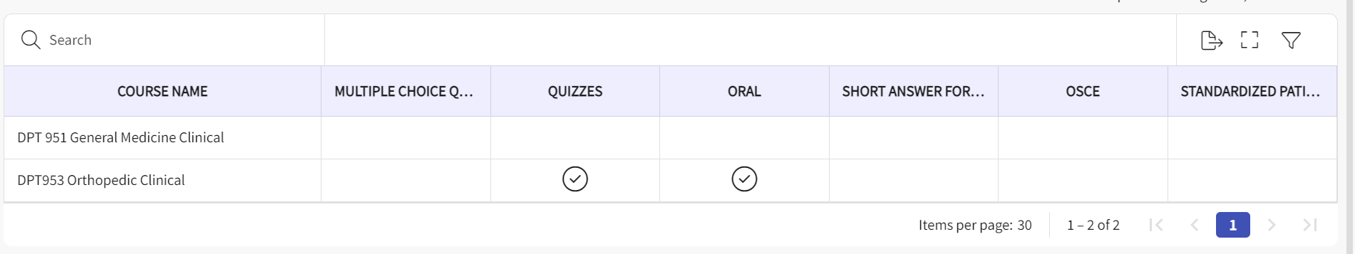

1. On this page you will find the following options:
   1. **Search Bar :** This allows you to search a particular course. It has a drop down next to it from where you can select the course code/ course name and then type the text on search bar.
   2. **Export to Excel Icon :** By clicking on export to excel, it downloads the entire report into an excel format.
   3. **Full Screen Symbol :** Next to “export to excel”, you will notice a square shaped symbol. This allows you to switch to full screen mode.
   4. **Filters Symbol :** This attribute filter allows you to select particular attributes from that entire list of attributes from the drop down menu for which you wish to generate the report. Click on apply once you have selected the attributes and the report will be generated accordingly.

**MEASURES ATTRIBUTES USAGE TILE:**

*This tile represents the attributes category assigned at measure level and number of times attribute category has been used. This chart is clickable. You can click on any of the attribute category, and it will take you to the detailed screen showing you the attributes within that attribute category and providing you a measure attribute report.*

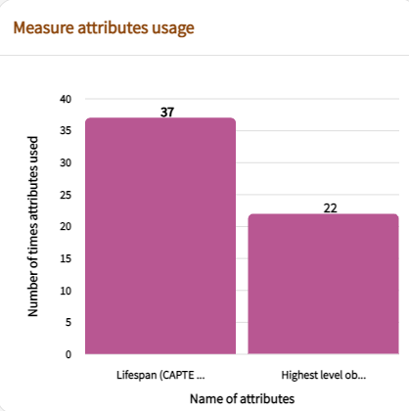

1. If you click on any of the attribute categories from the chart as shown above*.* You will be directed to the screen showing you further details of that attribute category. It shows you the sub child / attributes of that attribute category and number of times the attribute has been used.

1. As you scroll down on the screen you will find a grid like report showing you the course name vertically and course measures under every course name and the attributes horizontally. You will find checkmarks showing up wherever the attribute has been assigned to a particular course measure.

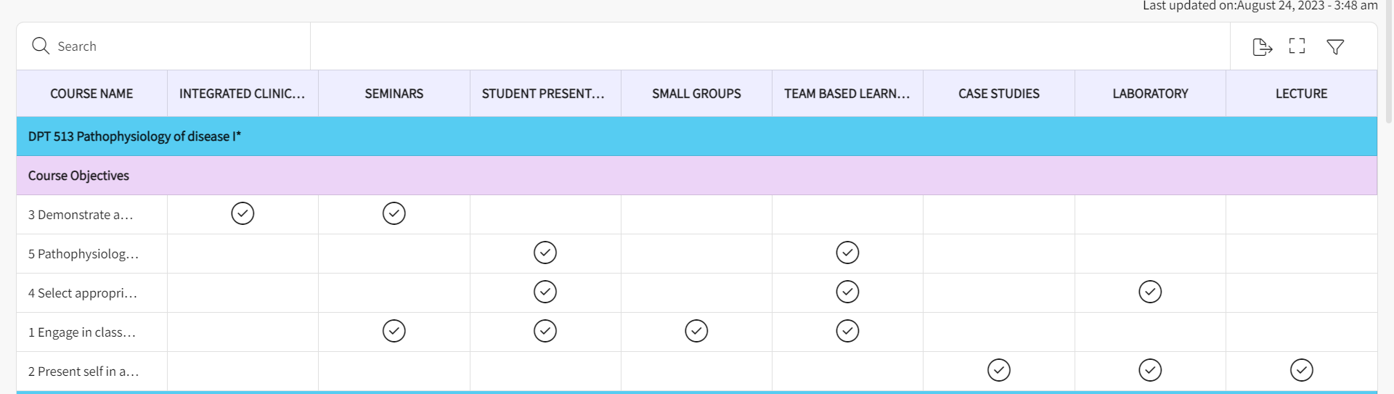

1. On this page you will find the following options :
   1. **Search Bar:** This allows you to search a particular course. It has a drop down next to it from where you can select the course code/ course name and then type the text on search bar.
   2. **Export to Excel Icon:** By clicking on export to excel, it downloads the entire report into an excel format.
   3. **Full Screen Symbol:** Next to “export to excel”, you will notice a square shaped symbol. This allows you to switch to full screen mode.
   4. **Filters Symbol:** This attribute filter allows you to select particular attributes from that entire list of attributes from the drop down menu for which you wish to generate the report. Click on apply once you have selected the attributes and the report will be generated accordingly.

**MEASURES TAG USAGE TILE:**

*This tile represents the tags assigned at course measure level and number of times tags has been used. This chart is clickable. You can click on any of the tags and it will take you to the detailed screen providing you a measure tags report.*

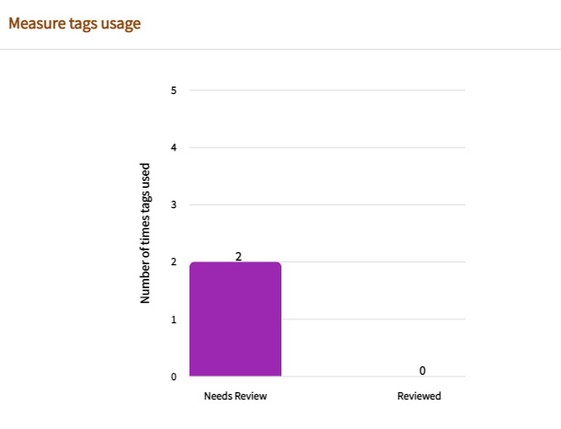

1. If you click on any of the tags from the chart as shown above*.* You will be directed to the screen showing you the list of course/s and the list of measures that has been tagged with using that tag you selected.

1. On this page you will find the following options :
   1. You can click on the caret symbol to expand/collapse a particular course. When you expand it, it shows you list of objectives( measures ) tagged.
   2. On this screen, next to each course, you will find the “go to measures” text. This is clickable, it allows you to go back to the measures tagged and edit or delete it as required.
   3. You can export this entire report into word format by using “export to word” on top right hand side.