Cloning Curriculum Grid

Once you have created a curriculum grid, you can copy/clone it into another grid with exactly same details and make minor tweaks to the newly created grid.

1. From your left-menu, select Curriculum Mapping.



1. On this page, you will find list of all curriculum on left hand side and “Clone curriculum” option for each on right hand side.

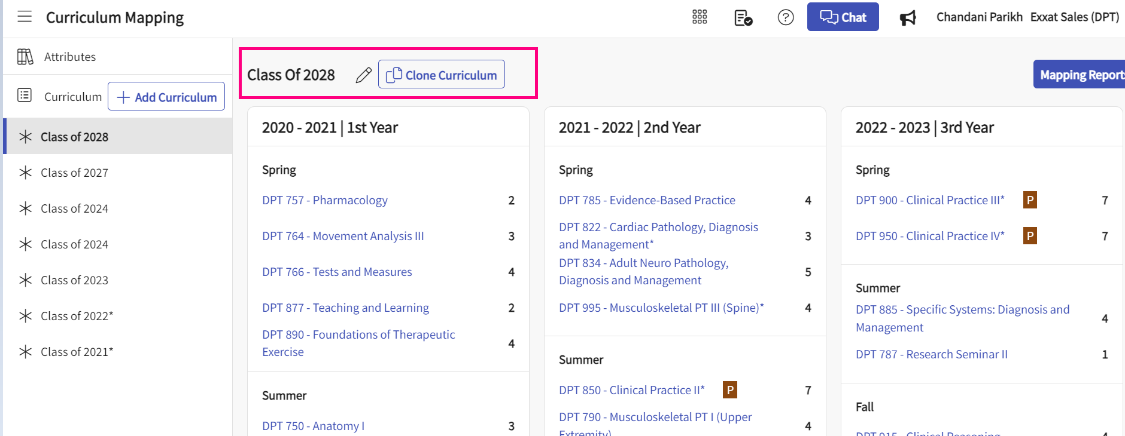

1. Click on the “Clone curriculum button”.
2. A drawer will open with three steps:
   1. Basic Details
   2. Course Offerings
   3. Course Setup
3. Basic Details: This is where you can enter basic information. Click Next when done.
   1. **New Curriculum name**: name for your curriculum sequence that you are creating.
   2. **Description**: any related information for this curriculum.
   3. **Assign Cohort**: This will only show up if you are a cohort based/lockstep setup client otherwise you will not see this on your system. In the drop down, you will have list of all cohorts. If you do not see your cohort here, you can create a new cohort from Students > cohort page and select it in this drop down. This option of Assign cohort will not show up for schools that have a non lockstep setup of their tenant.

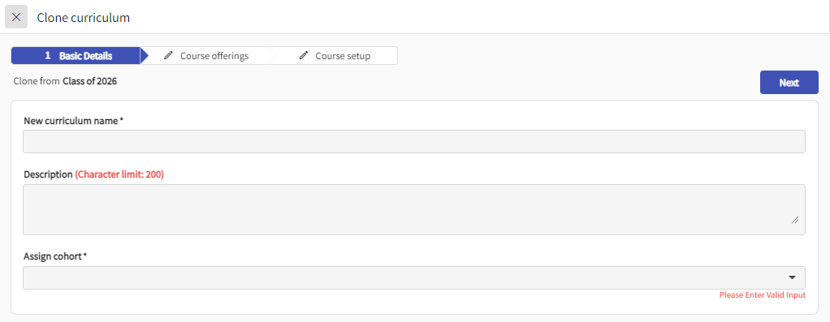

1. Course Offerings: on this step you will select the courses you would like to include in your curriculum.
   1. You will have the option to edit the Academic year as well on top for each year.
   2. Select / Deselect the courses that you would like to add as part of your curriculum.
   3. Click Next when done.

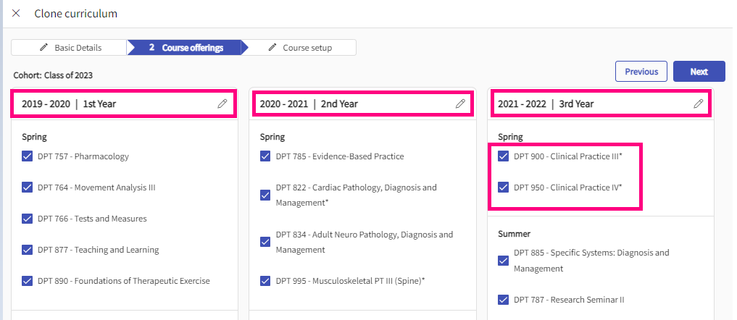

1. Course Setup: This is where you decide what information from previous curriculum you would like to bring over to the new curriculum such as the details, objectives, mappings etc.

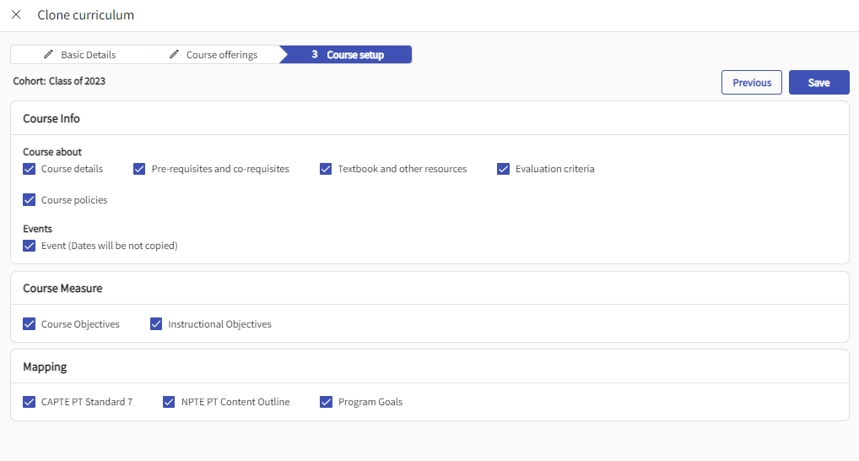

1. Once you have select the information that needs to be cloned. Click on Save and it will take about 30 to 45 minutes for the process to be completed depending on the amount of data in the system. While it continues to save, you can work on other pages of the system and refresh it after 60 minutes to check if it has been completed or not.