Assigning Attributes to a Course Measure

Curriculum Mapping

Attributes are a great tool to track important aspects of your curriculum and enable the generation of filtered reports based on specific topics, teaching methodology, assessment types, etc. You can assign attributes to a course measure if you would like to track how an objective is being assessed across the curriculum within a course etc.

Please note that before you can assign attributes to any of the course measures, you’ll need to complete the following steps:

1. Create an attribute category.
   1. To learn more, view our help resource here: [click here](https://exxat.zendesk.com/hc/en-us/articles/20029195107857-Adding-Editing-Deleting-Attributes-For-Curriculum-Mapping-)
2. Assign it to a course measure level
   1. Assign it to a course measure level on the Curriculum grid >> Mapping setup >> Select course measures.

To learn more, view our help resource here: [click here.](https://exxat.zendesk.com/hc/en-us/articles/20481464485905-Adding-Curriculum-Grid-in-Curriculum-Mapping-)

1. To assign attributes to any course measure, go to curriculum mapping and then open the course for which you need to assign the attributes:

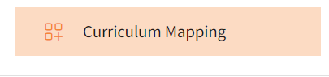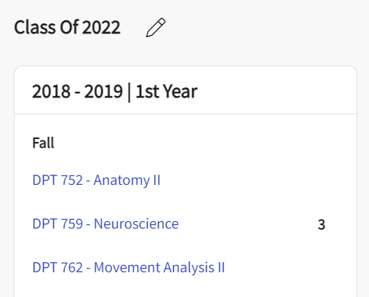

1. You’ll be redirected to the About section for the course you have selected. There are two ways through which attributes can be assigned to measures.

**Method A:**

* 1. Click on **Measures** from the left-hand menu on this page.

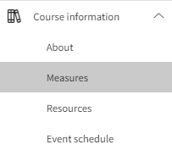

* 1. Expand the category of course measures that you would like to assign an attribute to and click on the pencil icon for the course measure for which you need to assign an attribute.

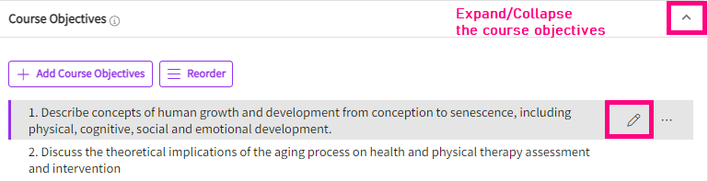

* 1. A drawer will open, and you will be able to see all the attributes drop down that have been activated for this particular cours measure category under the description text box. Click on the drop down and select the attributes. This is a multi-select section, so feel free to choose as many items as needed!
  2. To remove any selected attributes from a course measure, unselect them from the same list. The attributes will be deleted only for that particular course measure.
  3. Click Save when done.

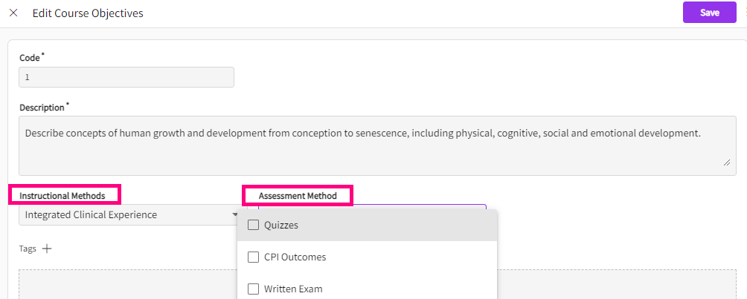

**Method B:**

* 1. On the course page, click on “Go to mapping”

* 1. On the mapping page, you will find all the measures that have been activated for mapping, click on the measure category to expand it and click each individual one to associate attributes to it.

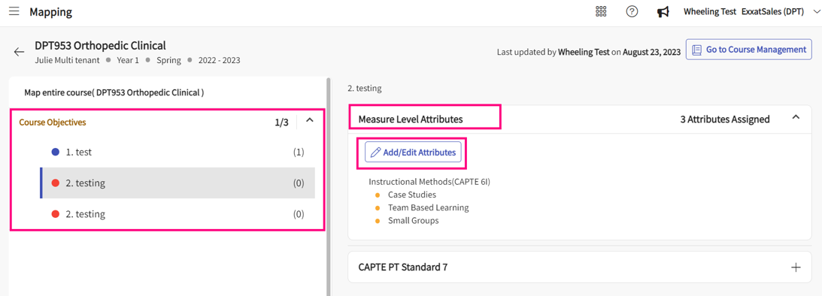

* 1. You will find the measure level attributes showing up with the “Add/edit attributes” button. Click on it to assign the attributes.
  2. Click on save once done.