Assigning Attributes to a Course

for Curriculum Mapping

Attributes are a great tool to track important aspects of your curriculum and enable the generation of filtered reports based on specific topics, teaching methodology, assessment types, etc. You can assign attributes to a course if you would like to track things like – whether a course meets a particular assessment method, or how the course Is being taught.

Please note that before you can assign attributes to a single course, you’ll need to complete the following steps:

1. Create an attribute category.
   1. To learn more, view our help resource here: [click here](https://exxat.zendesk.com/hc/en-us/articles/20029195107857-Adding-Editing-Deleting-Attributes-For-Curriculum-Mapping-)
2. Assign it to a course level
   1. Assign it to a course level on the “Curriculum grid” >> “Mapping setup” >> “Select attributes for courses”
   2. To learn more, view our help resource here: [click here.](https://exxat.zendesk.com/hc/en-us/articles/20481464485905-Adding-Curriculum-Grid-in-Curriculum-Mapping-)
3. You can assign attributes to any course, Go to **Curriculum mapping**>> Select the **Course** for which you need to assign the attributes.

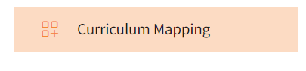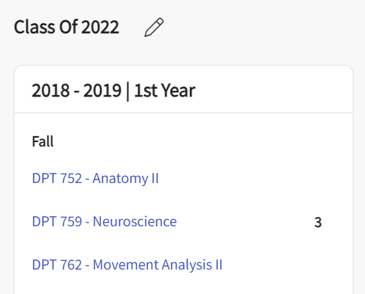

1. You’ll be redirected to the **About** section for the course you have selected. There are two ways through which attributes can be assigned to a course as described below:

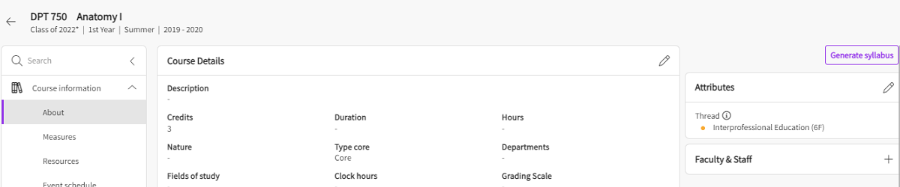

**Method A:**

1. Click on the pencil icon within the Attributes section on the right-hand side.



1. A drawer will open, and you will be able to select the attributes from the dropdown list under the Assessment Method section. This is a multi-select section, so feel free to choose as many items as needed!
   1. To remove any selected attributes from a course, **unselect** them from the same list. The attributes will be deleted only for that particular course.
   2. Click **Save** when done.

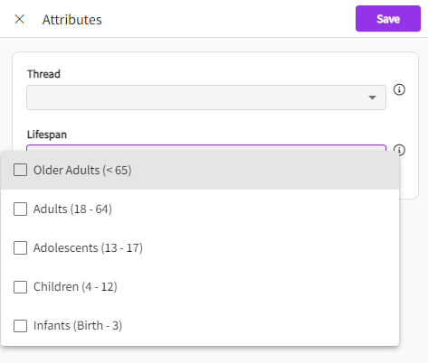

**Method B:**

* 1. On the course page, click on “**Go to mapping**”

* 1. On the mapping page, you will find the “Map entire course” text where if you click, the attributes that have been activated for the course level.

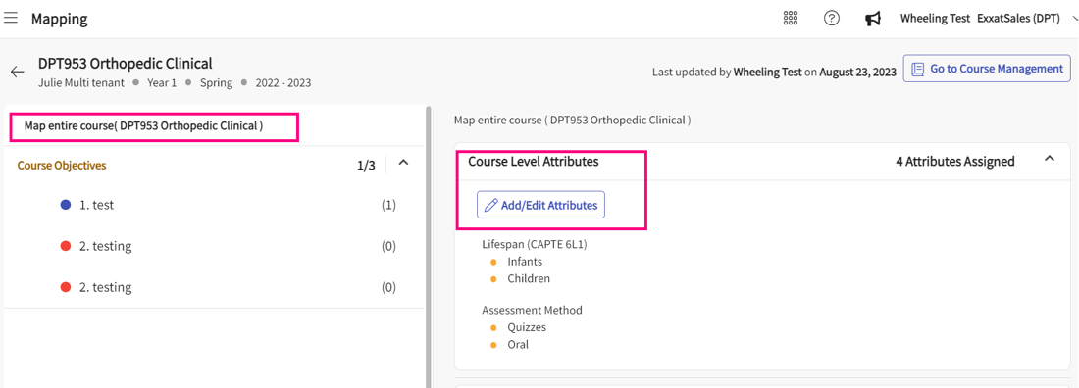

* 1. You will find the course-level attributes showing up with the “**Add/edit Attributes**” button. Click on it to assign the attributes.
  2. Click on **Save** once done.