Managing Accreditation Standards

Curriculum Mapping

This document is a step-by-step guide to activate, edit or inactivate the accreditation standards in Curriculum mapping.

* Activating Standards
* Deactivating Standards
* Adding or Editing Standards
* Deleting Standards

1. On your left-menu, select Program Details.

1. The following page will appear. On the left panel, click on Standards.

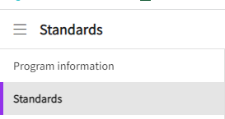

1. This will take you to standards screen where you can activate, edit, and delete accreditation standard details.

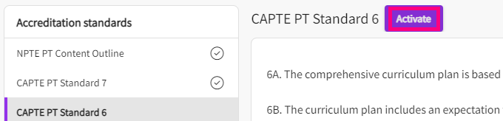

**Activating Standards**

1. On this page you will find all the pre-populated accreditation standards for your program based on your domain.
2. Select the Standard you wish to activate from the left panel. On the right-hand side of the page, click on Activate.
   1. The standard will activate and you will find a checkmark next to that standard.

**Deactivating Standards**

1. Select the standard you would like to deactivate from the left panel. On the right-hand side of the page, click on the edit pencil.

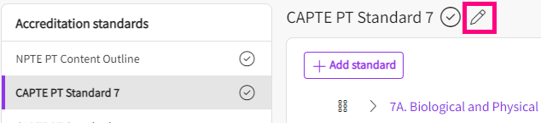

1. A drawer will open on the right-hand side showing the following options:
   1. Use the toggle button to turn it into a gray color and click Save.
   2. On this drawer, you can also edit the standard name in the textbox provided.
   3. *Please note, If the standard has been mapped to a course/ course measure then by deactivating the standard that will also delete the mappings associated to it.*

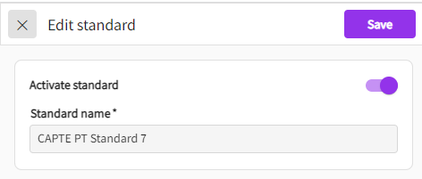

**Adding or Editing Standards**

1. You can add a sub-standard to any of the prepopulated accreditation standard.
   1. Click on standard for which you need to add a new standard category or a substandard.

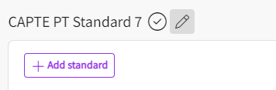

* 1. On the right-hand side, click on +Add <<Standard Name>>. A drawer will open with the following options:
     1. **Standard code**: You can put any code here related to standard i.e 1, 1.a, A, 7D etc. This is the code for that standard which will also show up in the reports when you map it with a course or course objective.
     2. **Standard description**: This is where you add the actual description of the standard.
     3. **Annotations**: This is where you can add notes or explanation of that specific standard.
     4. **Save**: Click Save once done.
  2. You can also add a sub-standard to a standard category. Hover over a standard category for which you wish to add a sub-standard, and click on the + icon. You will then fill in the fields to add a sub-standard.

* 1. To re-arrange the order of standards, click on the 6-circle grid next to each standard and drag it to the desired place. Click Save on the top right-hand side of the page to save the changes you’ve made.

**Deleting Standards**

1. To delete a standard from the accreditation standards, click on the standard you want to delete. For example, for CAPTE PT, if you need to delete “7C: Clinical sciences”. A drawer will open.
   1. Click on the vertical ellipsis next to the save button and you will find the delete option. Once you click on delete, you will get a validation message asking you to confirm you’d like to delete the standard. As soon as you confirm, the standard will be deleted.

