Adding, Editing & Deleting Linking in Courses

Curriculum Mapping

Linking is the feature that allows you to make a connection between your course measures. If you have a course objective and an instructional/lecture objective and you need to like your course objectives to a lecture objective, then you can utilize this feature.

* How to link course measures
* Editing and deleting the link between different course measures

# Linking Course Measures:

1. From your dashboard go to Curriculum Mapping.



1. On the ribbon at the left, select **Course** from Curriculum Grid.

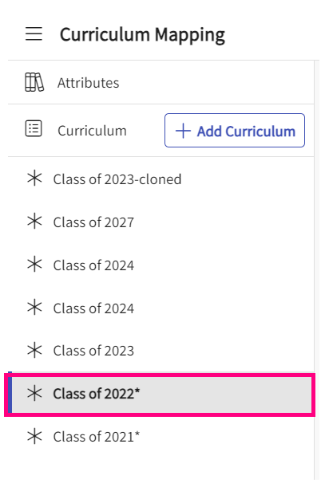

1. You will see list of all the curriculum grids created so far and then you can click on the grid and select the course for which you want to add linking.

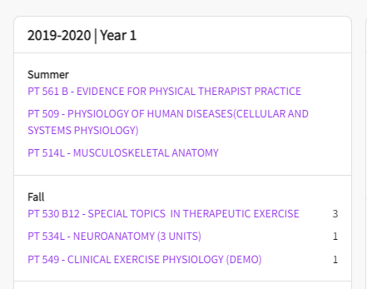

1. When inside of a course, click on the measures tab from the left-hand menu.

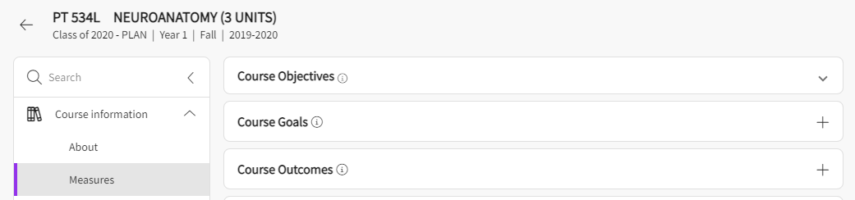

1. For linking to work, you will need to have the different measures added on this measures page already. You can add them if they have not been added yet. Once the measures are ready, you will see the cards for different categories. Let’s say you need to make a link between your course objectives and lecture objectives. Click on the course objective to make a link and you will find a chain symbol appearing on the right-hand side as shown below.

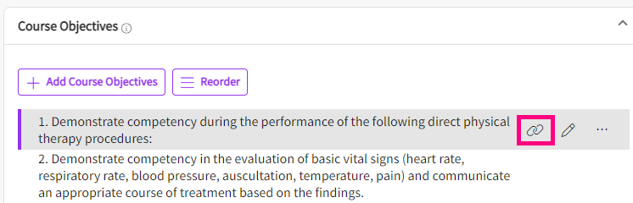

1. Click on this symbol and it will start showing you list of all different measures that is added in the system for this course and it is a multi-select option. You can select the lecture objectives that needs to be linked to the course objective you selected.

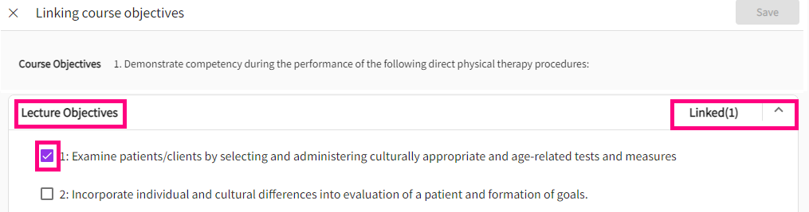

1. Click on save once done.
2. Now your course objective is linked to a lecture objective, and this will start showing up on the reports as well.

# Editing/Deleting Linking in Course Measures:

1. To edit or delete an existing link, you can click on the objective and the chain symbol as you did while adding the link. Now you can deselect the links that were added and click on save once done.

