Mapped Courses Report

Curriculum Mapping

If you need to generate reports for each course within a curriculum, then Mapped courses is the correct page to help you with that.

1. Click on the "Curriculum mapping” from your dashboard and go to the “Mapping Reports” page appearing on top right corner.

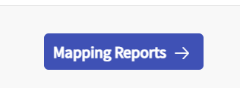

1. This takes you to the Mapping summary dashboard. On top left-hand side, you will find a drop-down menu which will allow you to change the “Curriculum/cohort” for which you wish to see the reports for. This is where you can select the standard also for which you need to generate reports for.

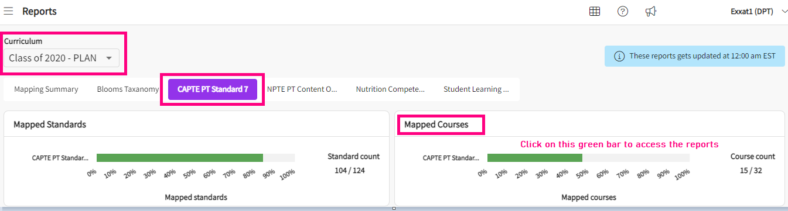

1. On the Mapped courses tile, you will be able to view standard that have been activated for the cycle you selected, and it will give you the count of total standards mapped vs. total standard present in the system. You can hover over the bar to view the percentage of mapped standards. This bar is also clickable.
2. When you click on the bar, it takes you to the report screen for mapped courses as shown below

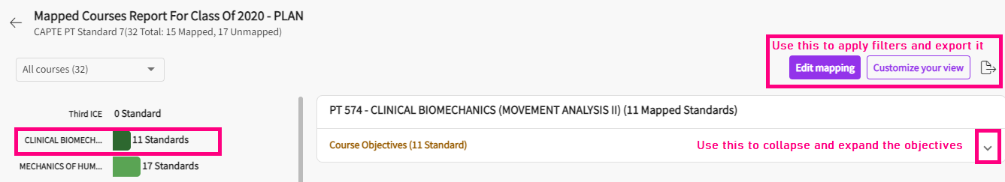

1. On the top left-hand side, you have the drop-down menu to switch between “all courses” and “unmapped courses”. Depending on your choice here, it will generate the report.

1. The list of all courses showing up on the left-hand side are clickable.
   1. In the screenshot below, I have selected the “SPECIAL TOPICS IN THERAPEUTIC EXERCISE” course by clicking on it from the left-hand side. It gives you the details on the right-hand side with the entire course code and course name. It shows the measure category (I.e., course objectives) and total standards mapped to it. On top right hand side you will find the option of “Edit mapping”. Upon clicking on the edit mapping, it directs you to the mapping screen of that course where you can delete/update the mappings.

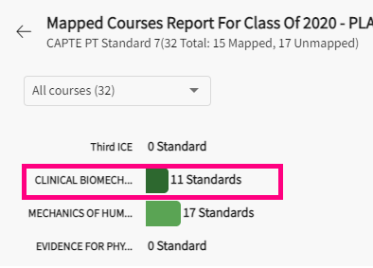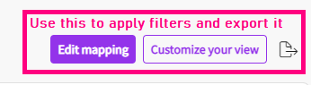

* 1. Click on the dropdown arrow to view the mappings done for each course measure for a selected course:

1. If you want to include additional information for your report, you can use the “Customize your view” button on the top right-hand side. It will have the following options:
   1. **Mapping details**: This option lets you pick the details you want to include for the report. It has the following sub options to pick:
      1. **Course attribute**: It allows you to include attributes that have been assigned at the course level if any.
      2. **Course measure category**: It allows you to pick if you wish to include all your course measures or just specific categories into the report.
   2. **Course measure attribute**: It allows you to include attributes that have been assigned at the course measure level if any.
   3. **Measure tags**: You can select this if you want to include the measure level tags in the report.
   4. **Measure attachments**: You can select this if you want to include any measure attachments in the report.
   5. **Linking**: You can select this option if you want to also include the linking in the reports.
   6. **Mapping attribute**: You can select this if you want to include the mapping level attributes in the report.
   7. **Mapping tags**: You can select this if you want to include the mapping level tags in the report.
   8. **Mapping attachments**: You can select this if you want to include any mapping attachments in the report.
   9. **Notes**: You can choose whether to include any notes for mapping in the reports or not.
   10. **Do you want to apply selected options for all the courses?**: Here you can select between “yes” or “no” to decide whether all the above selection should be applicable to rest of the courses or not.
   11. **Mapped standards**: This will only list out all the standards mapped to the courses without showing the course measures/objectives.
   12. **Unmapped measures:** This will list out all the unmapped measures for all the courses.
   13. **Save**: Once you have customized all the options/selections, click on save to generate the report.

1. The system will then run the report showing you the mapping details/mapped standard or unmapped measures based on your selections.
2. Click on Export symbol to download the report.

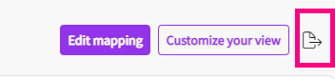

1. A drawer will open, and you’ll select the format of your report.
   1. **Selected course**: This option lets you download the report only for the course that you have selected.
   2. **All courses**: This option lets you download the report for all courses.
   3. **Word**: This option lets you download the report in word format.
   4. **Excel**: This option lets you download the report in excel format.

