Mapped Standards Report

Curriculum Mapping

If you need to generate reports for each standard mapped to different courses and course measures within a curriculum, then Mapped standards is the correct page to help you with that.

# View Mapped Standards Report:

1. Click on the "Curriculum mapping” from your dashboard and go to the “Mapping Reports” page appearing on top right corner.

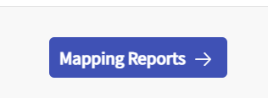

1. This takes you to the Mapping summary dashboard. On top left hand side you will find a drop down menu which will allow you to change the “Curriculum/cohort” for which you wish to see the reports for. This is where you can select the standard also for which you need to generate reports for.

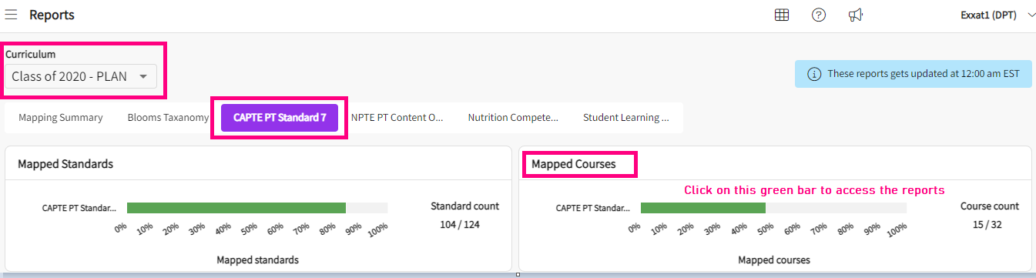

1. On the Mapped standards tile, you will be able to view all standards that have been activated for the cycle you selected, and it will give you the count of total standards mapped vs. total standard present in the system. You can hover over the bar to view the percentage of mapped standards. This bar is also clickable.
2. When you click on the bar, it takes you to the report screen for mapped standards as shown below.

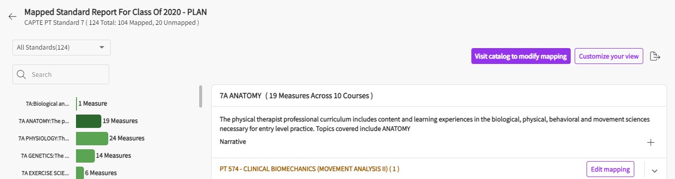

1. On the top left-hand side, you have the drop-down menu to switch between “all standards” and “unmapped standards”. Depending on your choice here, it will generate the report.

1. There is also a search bar on the left hand side, that allows you to type in the keywords and search for specific standards on this page.

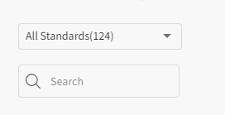

1. The list of all standards showing up on the left-hand side are clickable.
   1. In the screenshot below, I have selected the “7A Anatomy” standard by clicking on it from the left-hand side. It gives you the details on the right-hand side with the description of the standard. It shows name of courses mapped to that standard. Next to each mapped standard you will find the option of “Edit mapping”. Upon clicking on the edit mapping, it directs you to the mapping screen of that course where you can delete/update the mappings.

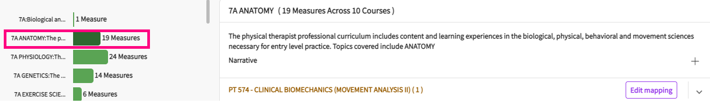

1. On the right-hand side of the screen where the standard description is provided, you will also find the “**Visit catalog to modify mapping”** button. This button directs to the curriculum grid of mapping screen where you will be able to pick any course to modify its mappings.
2. To view the mappings done for each course/course measure for a selected standard, you can use the dropdown arrow present next to each course name as shown in below screenshot:

1. You can also add narratives to a standard by clicking on the “+” icon shown under standard descriptions. It opens a drawer on right hand side where you can add the narratives.

1. If you want to include additional information for your report, you can use the “Customize your view” button on the top right-hand side. It has the following options present:
   1. **Narratives:** You can choose to include narratives as part of report or not.
   2. **Mapped courses and measures:** You can choose if you wish to see the mapped courses and measures or not.
   3. **Mapped courses list:** You can choose if you wish to include only the mapped courses list without any measures.
   4. **Course attributes :** You can select this if you want to include any course level attributes on your report.
   5. **Course measure attributes :** You can select this if you want to include any course measure level attributes on your report.
   6. **Mapping attributes:** You can select this if you want to include the mapping level attributes in the report.
   7. **Mapping tags:** You can select this if you want to include the mapping level tags in the report.
   8. **Mapping attachments:** You can select this if you want to include any mapping attachments in the report.
   9. **Linking:** You can select this option if you want to also include the linking in the reports.
   10. **Notes:** You can choose whether to include any notes for mapping in the reports or not.
   11. **Do you want to apply this selection for all standards?:** Here you can select between “yes” or “no” to decide whether all the above selection should be applicable to rest of the standards or not.
   12. **Save:** Once you have customized all the options/selections, click on save to generate the report.

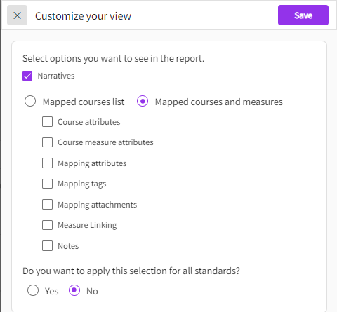

1. Once you click on save after selecting the filters for customize your view, you will notice the mapping attributes, tags etc. showing up on your screen for each mapping if any were assigned.

1. Click on Export symbol to download the report.

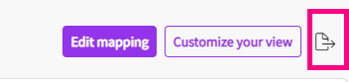

1. A drawer will open, and you’ll select the format of your report.
   1. **Selected standard**: This option lets you download the report only for the standard that you have selected.
   2. **All standards (parent and child)**: This option lets you download the report for all standards including the parent and the child for the current standard that you have selected. For example, if you have selected the “CAPTE” standard then it will include all the parent and child standards of CAPTE in the report you download.
   3. **Word**: This option lets you download the report in word format.
   4. **Excel**: This option lets you download the report in excel format.

