Measure Linking Report

Curriculum Mapping

Measure linking report generates data into word format and provides you list of all the course measures that are linked within the courses in the curriculum.

1. Click on the "Curriculum mapping” from your dashboard and go to the “Mapping Reports” page appearing on top right corner.

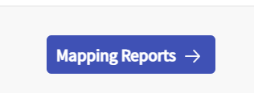

1. This takes you to the Mapping summary dashboard. On this page, you will find a tile with “Other course based reports”. Select “measure linking report”.

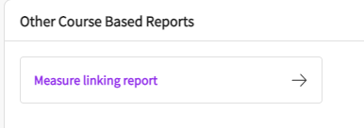

1. This will give you list of all the courses that has measures linked in the system and you will be able to expand each course to view the details.
   1. Click on “go to measures” to go to the course directly and change the linking if needed to.
   2. You can use the dropdown arrow to expand and view the measures linking report.
   3. You can use “Export to word” to download the report.



 