Reports - Mapping Attributes

Curriculum Mapping

Mapping attributes report is a report that helps you view the progression of your curriculum.

This is a special mapping report that allows the program to showcase progression of student learning as they go through the curriculum from matriculation to graduation. The program may choose to define the learning areas (knowledge, skills, attitudes) at different Bloom’s levels (novice, intermediate, advanced). The labels for ‘areas of learning’ and the ‘levels’ are customizable and defined by the user.

1. Click on the "Curriculum mapping” from your dashboard and go to the “Mapping Reports” page appearing on top right corner.

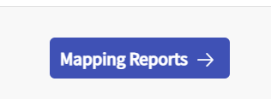

1. This takes you to the Mapping summary dashboard. On top left hand side you will find a drop down menu which will allow you to change the “Curriculum/cohort” for which you wish to see the reports for.

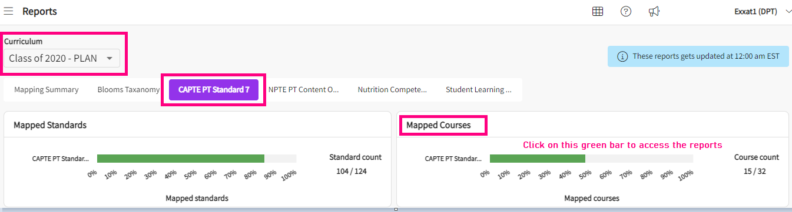

1. To view the mapping attribute report, you can select the standard from horizontal menu where the mapping attributes have been assigned/activated.

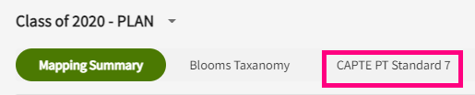

1. Once you select the correct standard from horizontal menu, you will be able to see a tile labelled as “Mapping attributes usage” and a header “Get customized excel report”. Click on “Get customized excel report”.

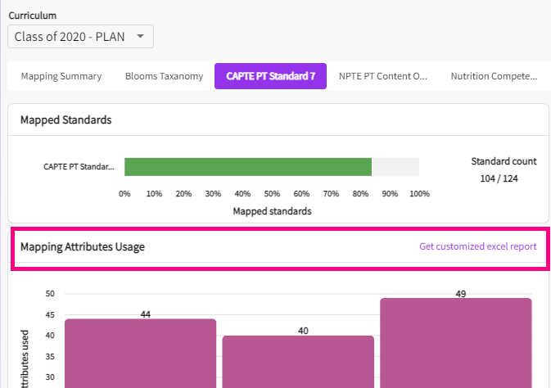

1. Once you click on “Get customized excel report” , you will be able to see two places to select “Standards” and “Courses” as shown below in the screenshot. Click on “+” icon for each and select specific/all standards and courses for which you wish to view the report and click save.

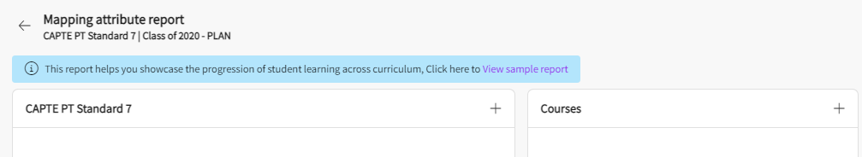

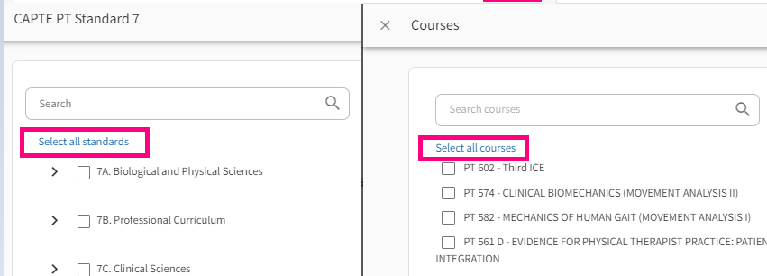

1. Now, from the right-hand side, select the attributes that you wish to include in your report.

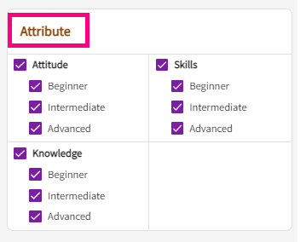

1. Lastly, on the right-hand side, under attributes, you will find “Select your view” option. Select the appropriate view as per the report you wish to download.

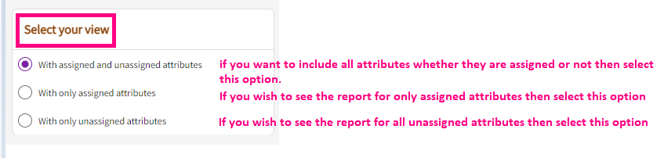

1. Once you have made all the above selections, you will find “Export to excel” on top right hand side. Click on it to download the report.

