Editing & Deleting Curriculum Grid

Curriculum Mapping

You may need to modify or delete curriculums. If you add a new course to the system from the course catalog page and after creating the course offering, you will have to use the edit functionality to add the new course in the grid created.

1. From the dashboard, select **Curriculum Mapping**.



1. You will see the pencil icon is given next to the name of curriculum. To edit the curriculum, click on the pencil icon.

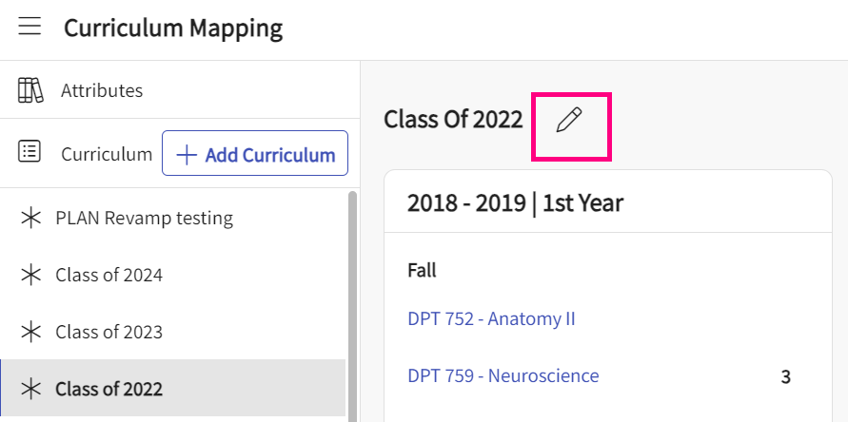

1. A drawer will appear showing you 4 steps: You can refer to [“Add curriculum”](Adding Curriculum PLAN V4.1.docx) for details below sections.
   1. Details
   2. Course offerings
   3. Mapping Setup
   4. Curriculum Grid
2. Make any necessary changes, click Save when done.
3. To delete a curriculum, please contact SUPPORT (v4support@exxat.com). School users do not have the ability to delete a curriculum.