Adding & Deleting Resources in courses

Curriculum Mapping

The system allows you to house as many documents as you would like to for a particular course.

1. On the curriculum mapping page, select Curriculum Grid from the left ribbon.

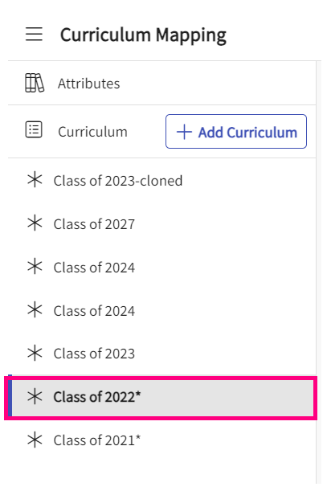

1. You will see a list of all the curriculum grids created so far and then you can click on the grid and select the course for which you want to add/delete resources.

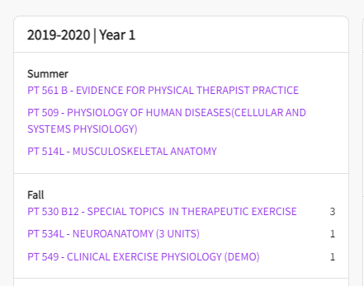

1. When you are inside of a course, on the left-hand menu under course information, you will find “Resources” tab.

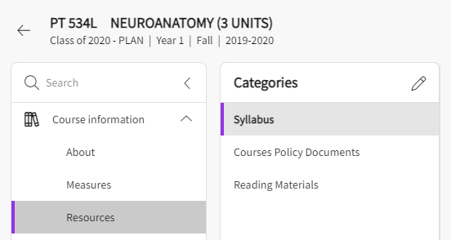

1. On the resources page, you will find three categories by default: “Syllabus”, “Course policy documents” and “reading materials”. On the right-hand side, you will find the “Add resource” Button. Click on any category and add a resource to it:

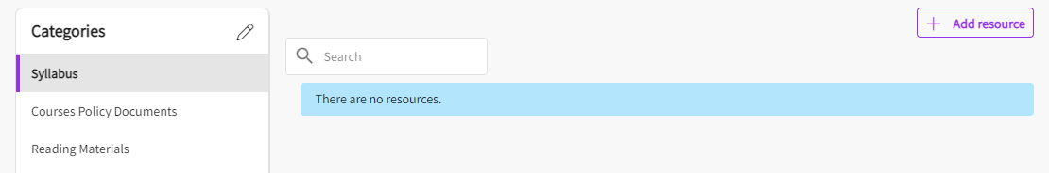

* + 1. **Syllabus:** This displays the syllabi document that may have been added already. If not added, you will find the button “Add resource” and a drawer will show up on the right-hand side where you can add in the details for the type of syllabus you are uploading and click on save once done.
    2. **Course policy documents:** as similar to syllabi, this will show documents that may have been added on the “about” page under “Course policy” card while adding a policy. You can use “Add resource” button to add a document.
    3. **Reading materials:** This will also show documents that may been added while adding the textbooks and resources on the “bout” page under “textbooks” card. You can use “Add Resource” button to add a document.

1. You can also create your own categories and add resources to it. If you click on pencil icon next to categories, a drawer on right-hand side will pop up to allow you to update existing categories and add a new category.

**Download/Delete A Resource:**

 Once you have added the documents, you will be able to perform actions on that document such as “Delete” or “Download” it. You can use the pencil icon to update the resource information.

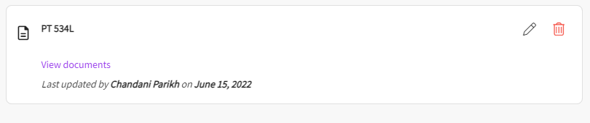

1. **Delete:** To delete a document, click on the trash icon for that resource.
2. **Download:** To download a document, click on the view documents link appearing under the resource and you will find the download button on that page.

