Retrieving information to curate your AAR Report
Prism
Exxat can help you gather your data for the Annual Accreditation Report (AAR Report). In this section, we will provide you with steps and instructions to pull relevant data from different sections for AAR reporting.

Tip: Since different schools like to curate their list of clinical sites differently for reporting purposes, we have provided filters for sites/locations with contracts. Go to the 'Contracts' tab to see the contracts and the associated sites. Then, you can further filter the contract status to get the correct contracts. If you are looking to get the contracts associated with the locations, there is a column that can tell you how many locations are associated with the contract, and when you export the data to an Excel, you can see the location names and get the count of contracts related to the locations. Schools can use this information to curate their list for reporting.

Getting data for your AAR Report

Clinical Education Information
Section 1: Number of clinical education sites with which the program had a clinical education agreement.
- Go to Sites from the left hamburger menu.

- Go to the sites or locations tab and get the count listed at the top of the table.
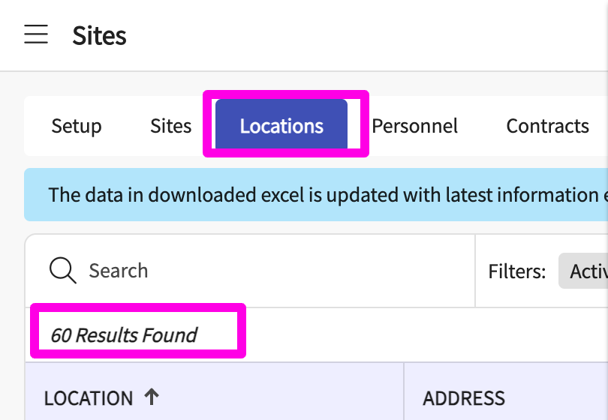

- For further curating your list for reporting, go to the contracts tab and use filters for site status and contract status.
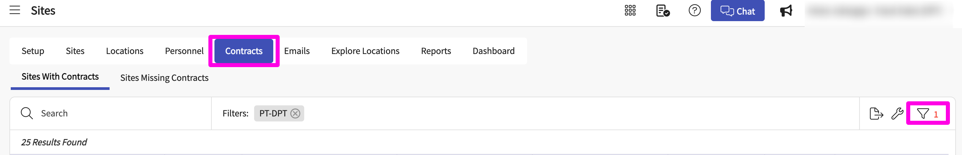

- Select the desired options from the “Site Status” and Status i.e., contract Status.
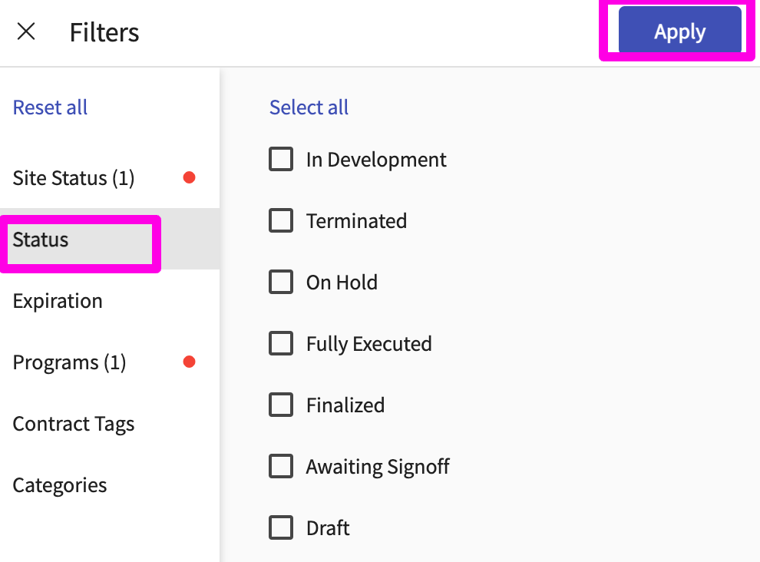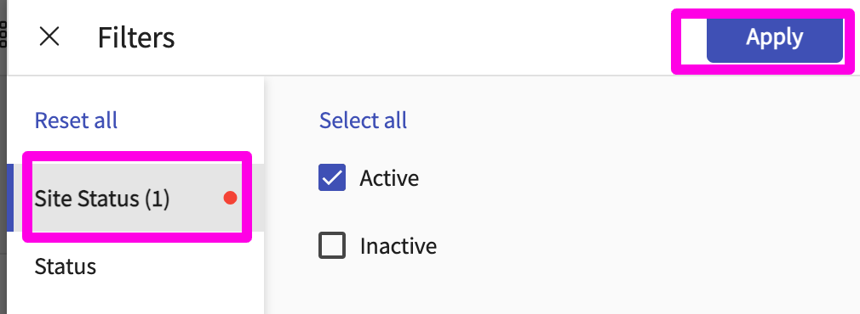
- Click on the Export icon available on the right-hand corner of the search bar. Get the number of sites and locations from the downloaded Excel report.


Pro Tip for next three sections (1.2, 1.3, and 1.4): Create a Learning Activity Group with the course offerings for the cohort or academic year that you are reporting on.
Section 1.2: Of the clinical instructors who worked with your students during the last academic year, what percentage (%) were Credentialed Clinical Instructors?

Steps:
- Go to the Learning Activity section from the left hamburger menu.

- Ensure that you have the right Learning Activity group.
Make sure we have selected a cohort with the required courses.
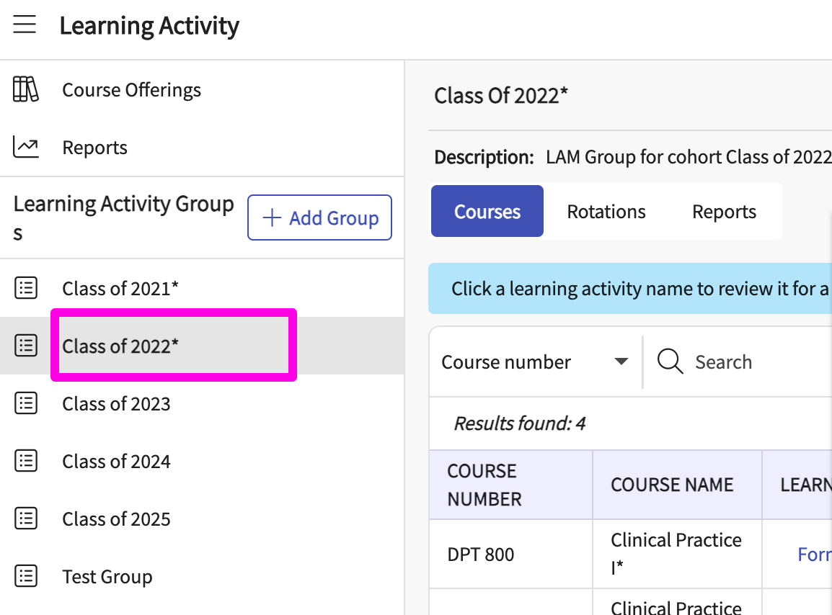

- Go to the Reports section and click on Total Qualifications of CIs (Standard 4O) report.
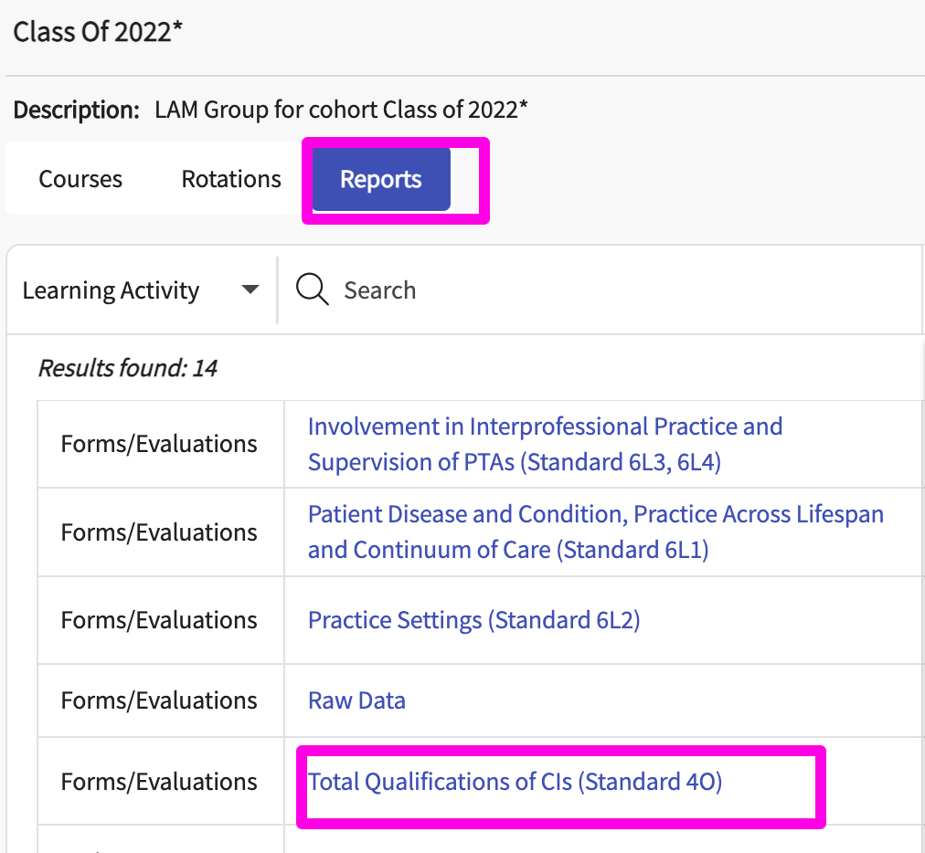

- Select the appropriate Learning Activity group and relevant group and rotations and click on ‘Download Report’ to get the data.
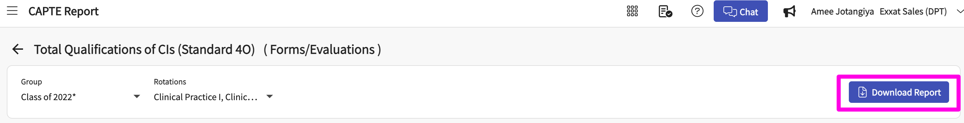

Section 1.3: Of the clinical instructors who worked with your students during the last academic year, what percent (%) held some type of certification of advanced clinical skill (e.g., ABPTS, FAAOMPT, other; but not first aid/CPR)?

Steps:
- Go to the Learning Activity section from the left hamburger menu.

- Ensure you have the required Learning Activity Group (based on courses from one or more cohorts)

- Go to the Reports section and click on the Total Qualifications of CIs (Standard 4O) report.
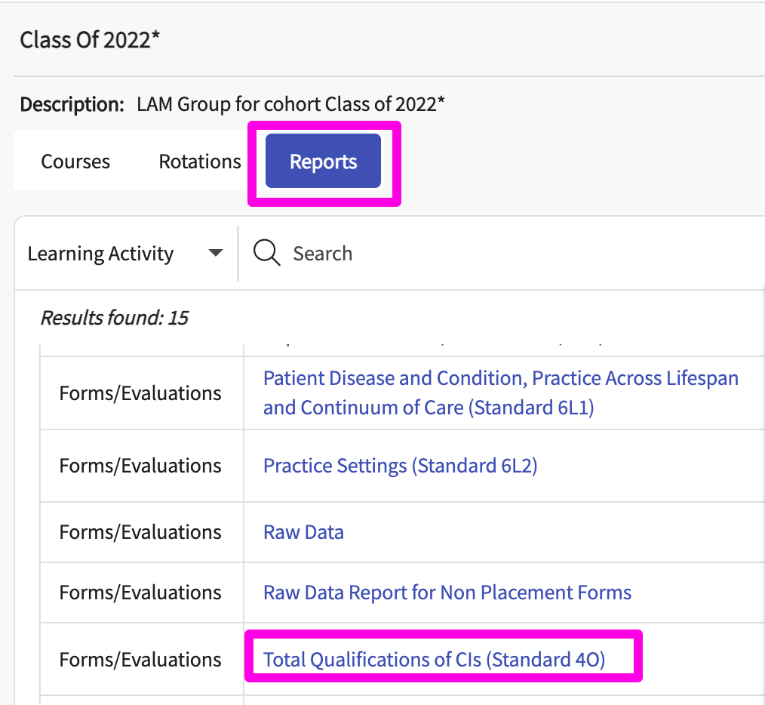

- Select the appropriate LA group and relevant group and rotations and click on ‘Download Report’ to get the data.

Section 1.4: Have any students had a clinical instructor who has had less than one year of clinical experience regardless of part-time or full-time assignment?
Steps:
- Go to the Learning Activity section from the left hamburger menu.
- Ensure you have the required LA group (based on courses from one or more cohorts)

- Go to the Reports section and click on Total Qualifications of CIs (Standard 4O) report

- Select the appropriate LA group and relevant courses and click on ‘Download Report’ to get the data.

Applicant Admission Information
Section 2: Average age of students who enrolled in the professional phase of the program.
Steps:
- Go to the Students section from the left hamburger menu.
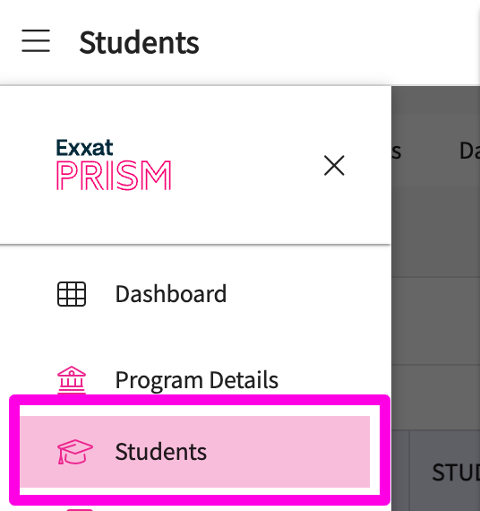
- Go to the dashboard tab, go to the demographic section on the report, and select the cohort to get the data.
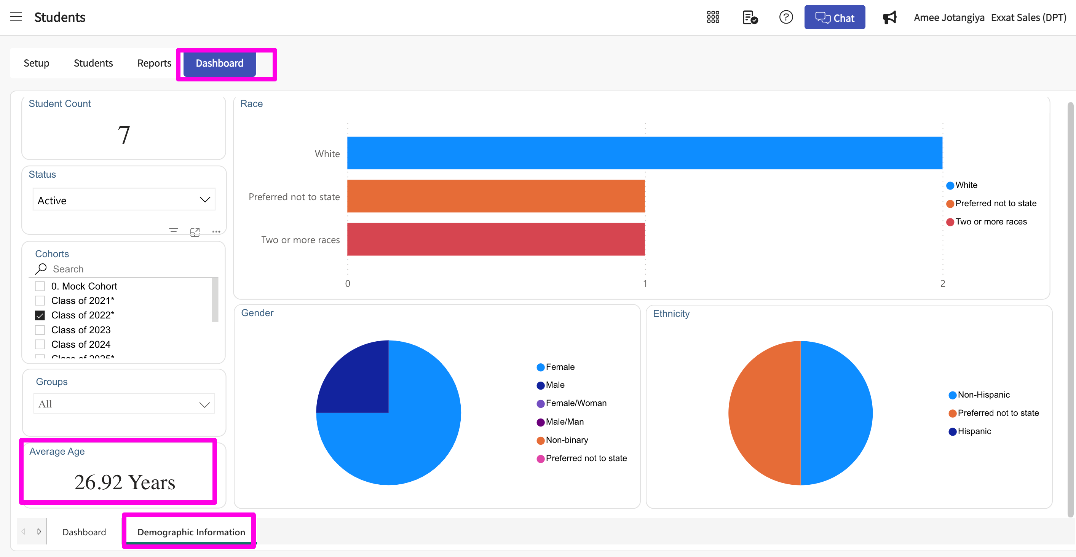

Enrollment Information
Section 3: Enrollment this calendar year for each class of students IN THE PROFESSIONAL PHASE of the program. Note that there is now a third gender choice for those who do not identify with an existing option or choose not to answer:
Steps:
- Go to the Students section from the left hamburger menu
- Go to the dashboard tab, go to the demographic section on the report, and select the cohort to get the data.

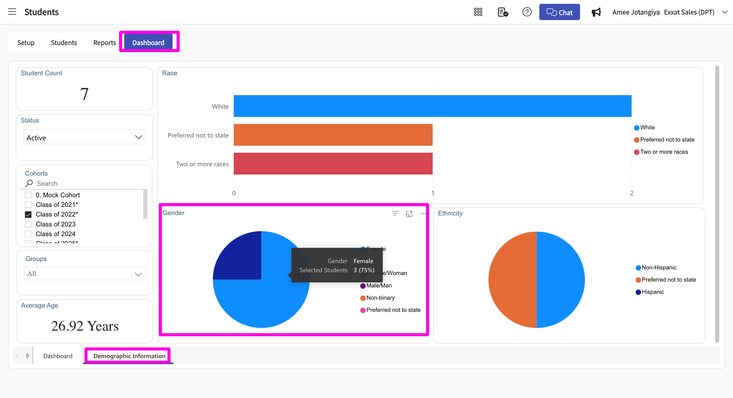

Section 4.1: Total number of students enrolled IN THE PROFESSIONAL PHASE OF THE PROGRAM who are of the following race or ethnic origin:
Steps:
- Go to the Students section from the left hamburger menu.
- Go to the dashboard, go to the demographic section on the report, and Select the graduating cohort to get the data.
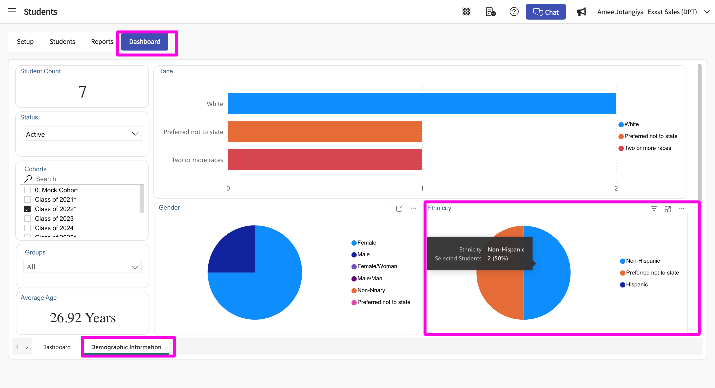

Section 4.2: Number of students who graduated or are expected to graduate this calendar year who are of the following race or ethnic origin.

Steps:
- Go to the Students section from the left hamburger menu.
- Go to the dashboard, go to the demographic section on the report, and select the graduating cohort to get the data.
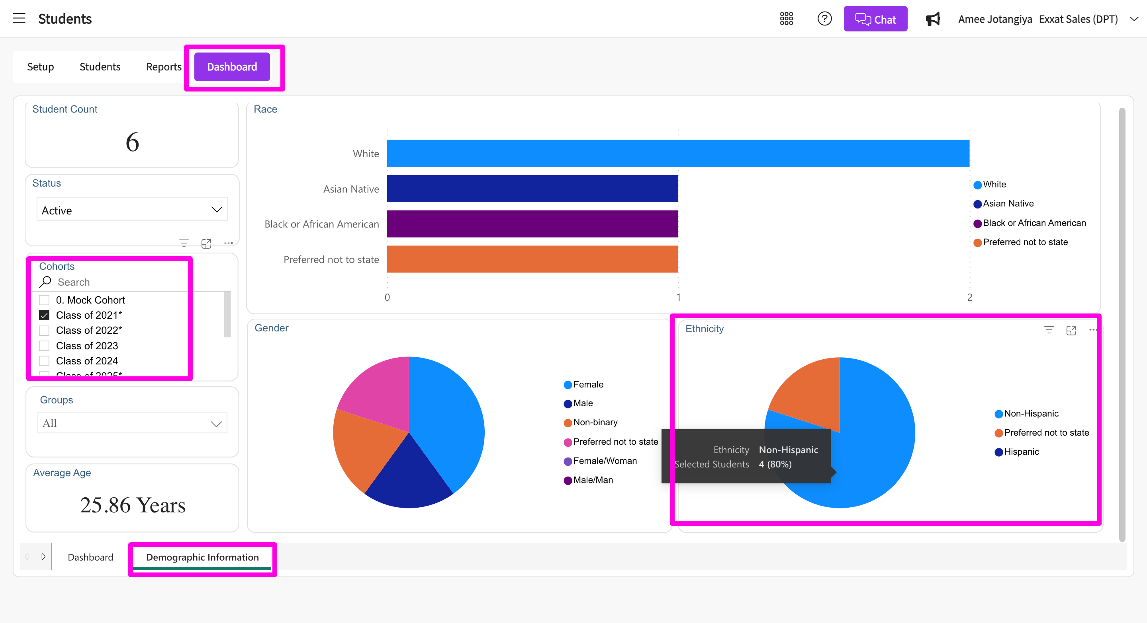

Pro-tip: You can mark off student academic status as ‘decelerated’ under student profile to track them in the system. Moreover, you can also change the cohort of such students in the system to get the most up-to-date numbers on this.

