Student Mobile Application

**Welcome to the "Exxat Student" Application (APP) Help Guide: Stay Connected, Stay Supported**

"Exxat Student" is your dedicated companion designed to assist you while you are on the move. This user-friendly mobile application offers a world of convenience, ensuring that you can access the support you need, right from the palm of your hand.

List of things you can achieve via the Student Mobile App

*You can click on any hyperlink below to go to a particular section.*

Table of Contents

How to get the app: 1

How to Login to app 2

How to Enable Biometrics Login Feature: 4

How to view Announcements: 6

How to complete Attestations: 7

How to view your profile 8

How to add and complete evaluations 9

How to add Patient Logs? 13

How to add Timesheet 16

How to Edit Saved Timesheet 20

How to add Time off 21

How to add Support Ticket 23

# How to get the app:

In this section, you will learn how to download the App

**For Android Users:**

1. Go to the Google Play App (Play Store) on your Phone/Tablet.
2. Search for the app named **Exxat Student** app
3. Click on Install

**For iOS Users:**

1. Go to App Store on your iPhone/iPad
2. Search for the app named **Exxat Student** app
3. Click on **Get App**

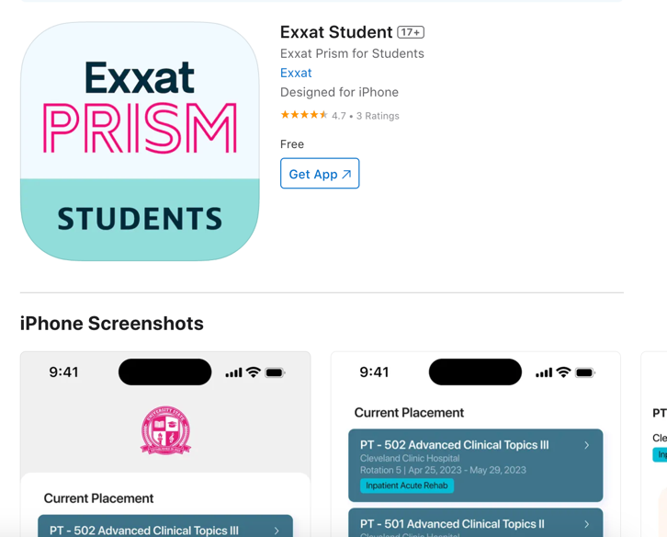

# How to Login to app

**In this section, you will learn about how to Login into the App**

***Steps:***

1. *Open the App* “Exxat Student”
2. Enter the same username you use to log in to Exxat Prism

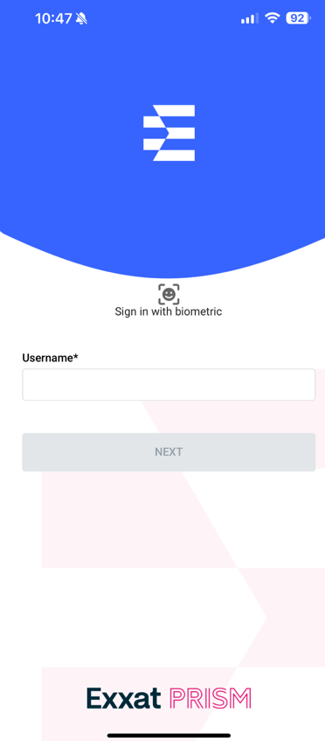

1. Enter your **Password** and click on “Login”  
   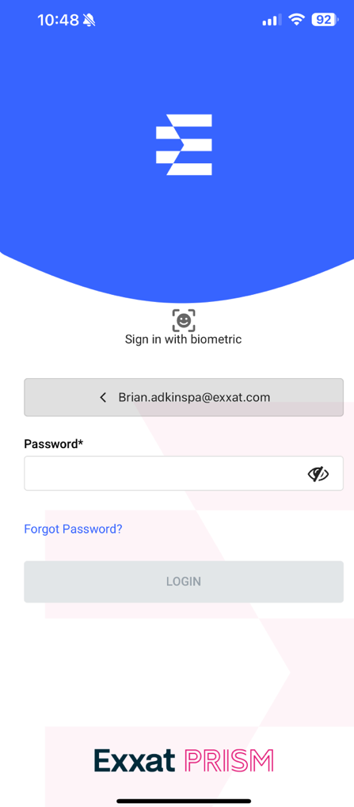

# How to Enable Biometrics Login Feature:

**In this section, we will talk about the steps you perform to enable login using the biometrics feature on your phone**

**Steps:**

1. **Login** into the App
2. Go to **More**
3. Go to **Settings**A white background with black dots

   Description automatically generated
4. **Turn on** the bit “Enable Face ID” or “Enable Fingerprint” (This would depend on if your mobile device is having feature to enable login using face id or fingerprint)

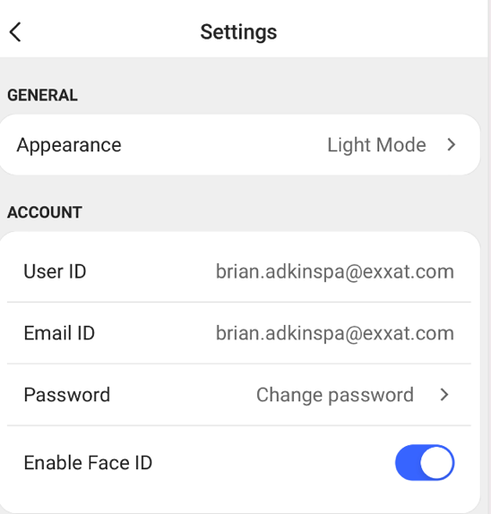

1. Having enabled this, when you login into the account next time your login screen will look like the below image, select/tap on the **smiley face picture frame icon** to sign in.

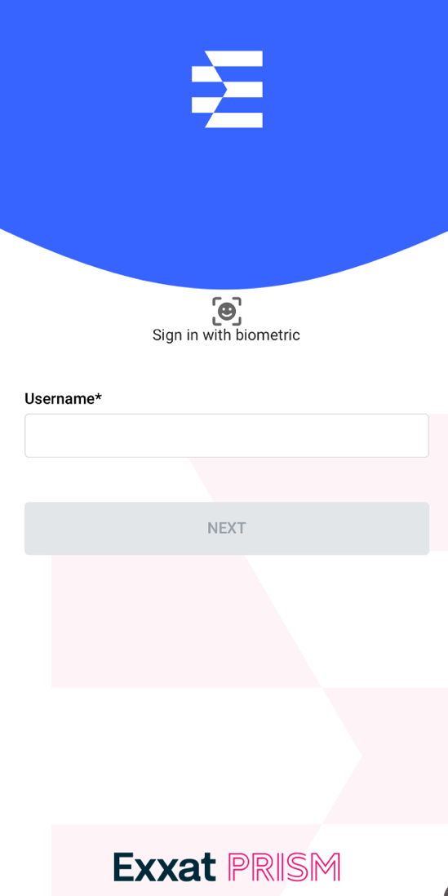

# How to view Announcements:

In this section, we will see how you can view announcements added by your school

Steps:

1. Go to the **Home** Page
2. On the home page under the **Announcements** section, you will see all the announcements added by your school.

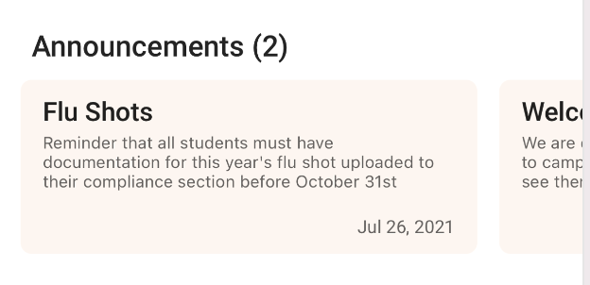

1. Click/Tap on any **announcement card** you would like to view the details of

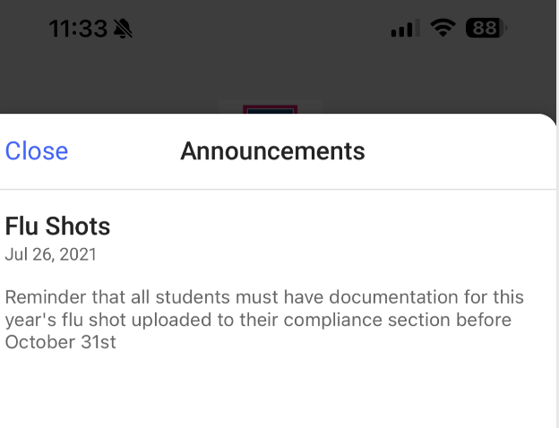

# How to complete Attestations:

In this section, you will learn about how you add Attestations

Steps:

1. Go to the **Home** page
2. On the home page under the **Attestations** section   
   Screens screenshot of a medical application

   Description automatically generated
3. Click on the **Agree** button
4. Select/Tap the **Confirm** button to add an attestation.

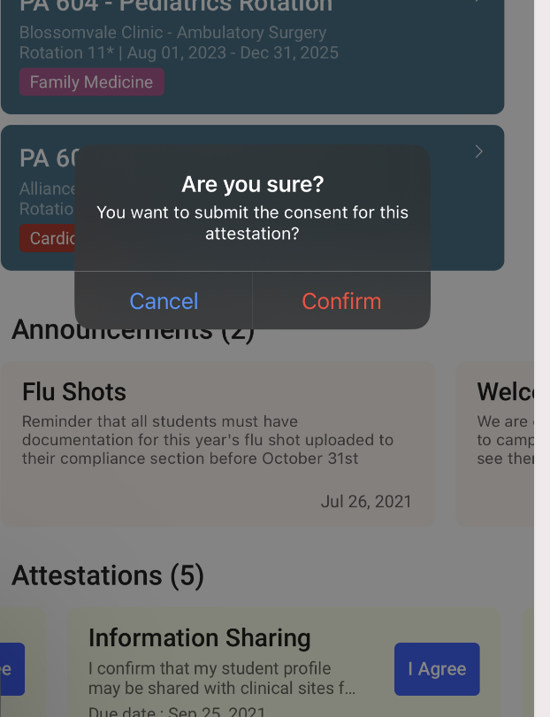

# How to view your profile

In this section, we will see how you can view your profile

**Steps**:

1. Go to **More**
2. Select/Tap the option **Profile**  
   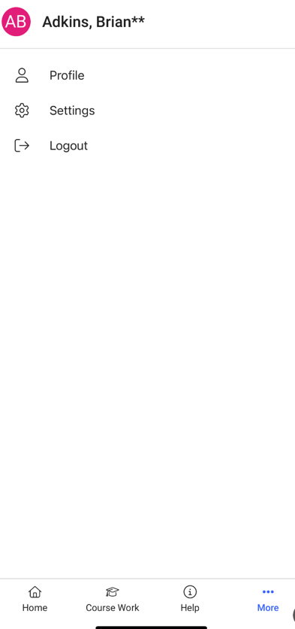
3. Select/Tap any **profile section name** you want to view more details on  
   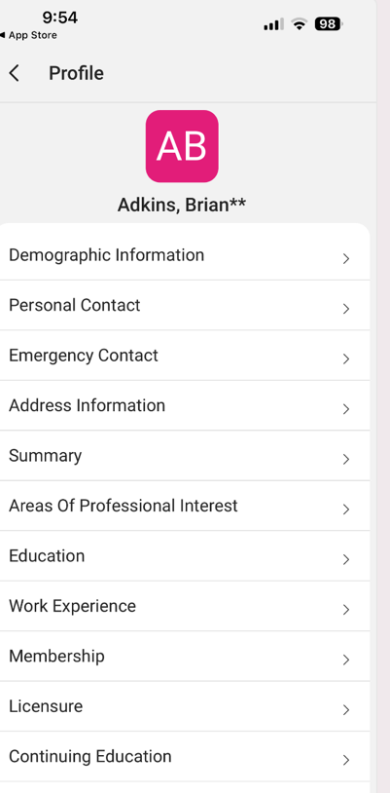

# How to complete evaluations

In this section, we will talk about completing evaluations for all the current placements assigned to you.

1. Go to **Coursework**
2. Select/Tap the desired **current placement** you want to complete Evaluations   
   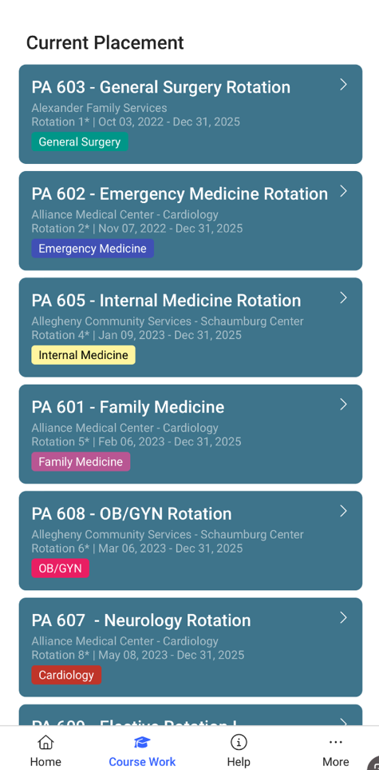
3. Select/Tap the **Evaluation** (you can see all the forms assigned to you)  
   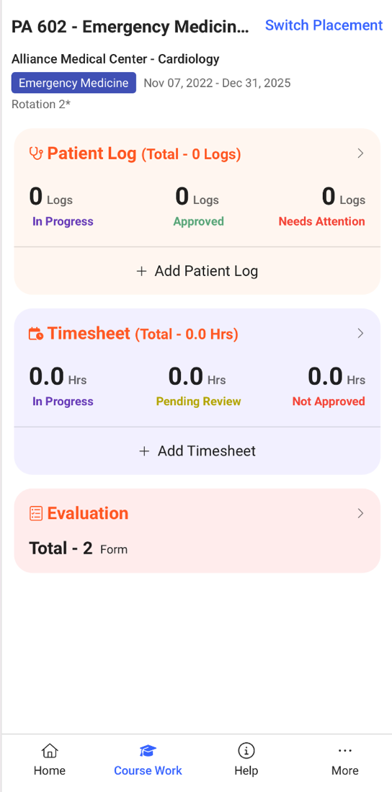
4. Select/Tap the Evaluation Name  
   A screenshot of a cell phone

   Description automatically generated

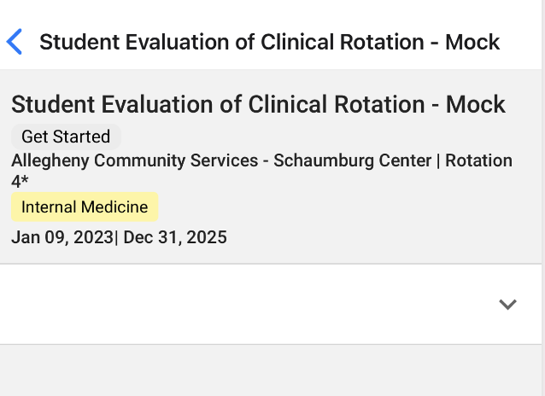

1. Select/Tap the down arrow to enter the ratings and comments  
   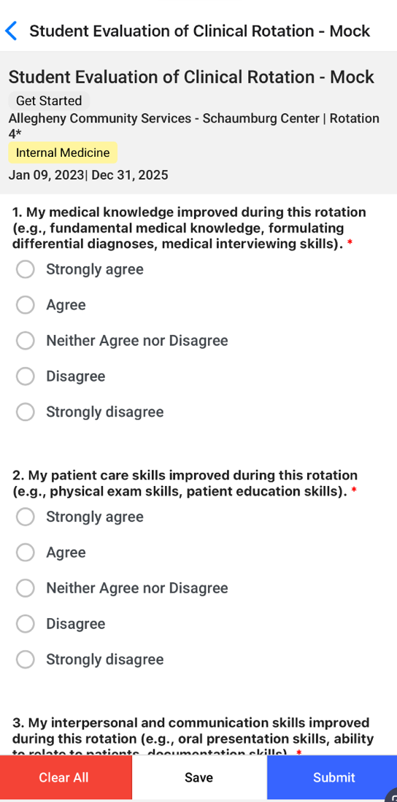
2. You can either **save** – will allow you to save your added ratings and comments and come back to it later time
3. You can either **Submit** - it this will mark the evaluation completed by you
4. You can either use **Clear All –** this will allow you to clear all the responses for the evaluations

# How to add Patient Logs?

**In this section, we will talk about completing Patient Log for all the current placement you need to complete Patient Logs**

***Steps:***

1. Go to Coursework
2. Select/Tap the current placement you want to add Patient Log  
   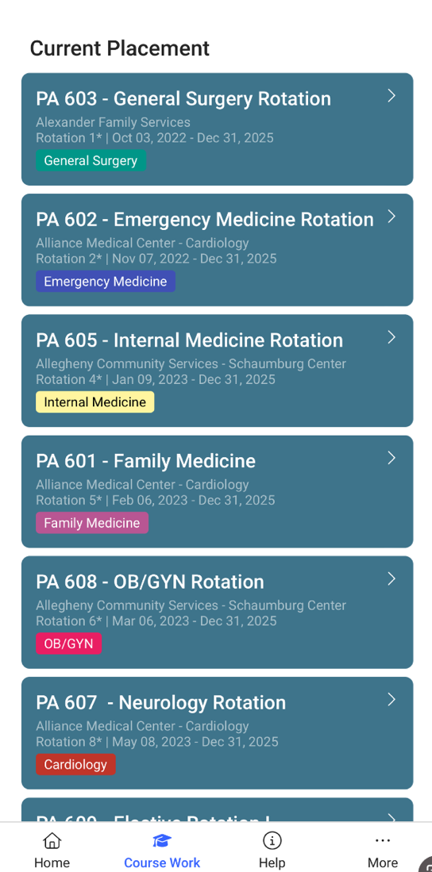
3. Select/Tap the Patient Log card or select **+ Add Patient Log** button  
   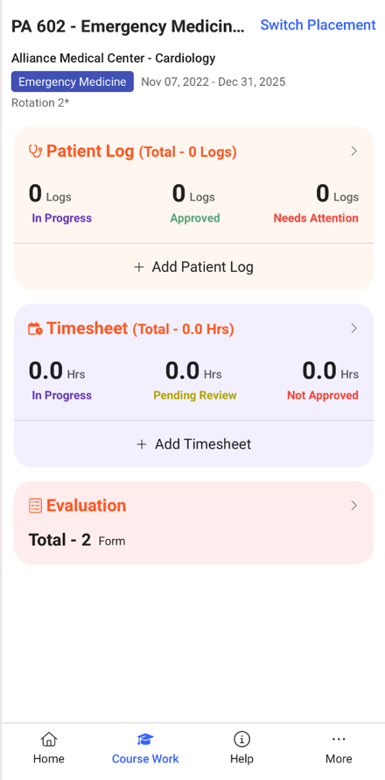
4. Click/Tap the down arrow to add further information in each section  
   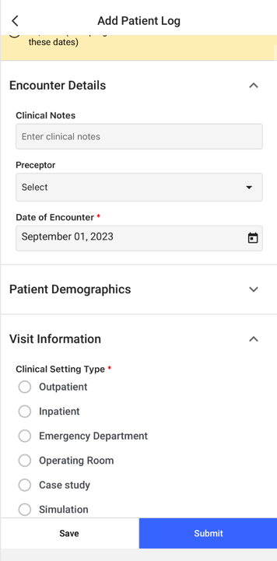
5. You can **Save** button to save your work and come back later to complete it.
6. You can **Submit** button to submit the patient log.

# How to add Timesheet

**In this section, we will talk about how to add Timesheet for your placements.**

***Steps:***

1. Go to Coursework
2. Select/Tap the current placement you want to add Timesheet   
   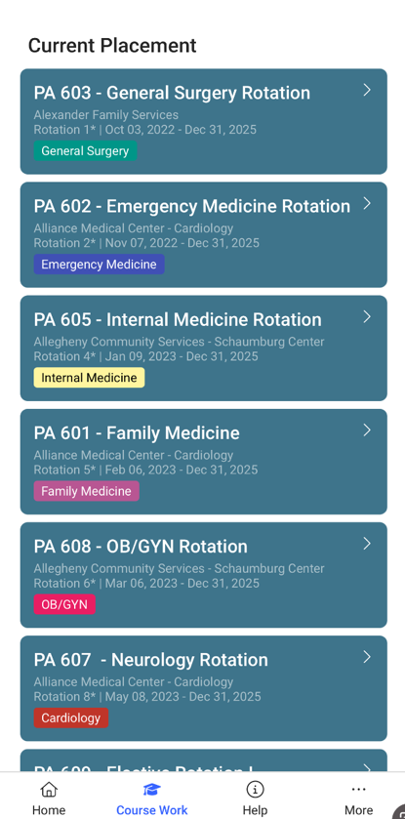
3. Select/Tap the Timesheet card or select + Add Timesheet button to add a timesheet  
   
4. When you are in the Calendar view to add a timesheet click on the plus icon at the right-hand side bottom of the screen  
   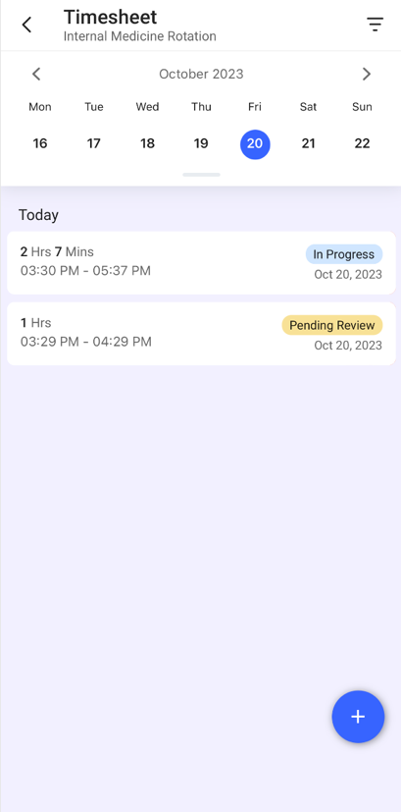
5. You can then enter the date, start time, end time, any break time you took (in minutes), the number of patients you saw, and any notes you’d like to share.  
   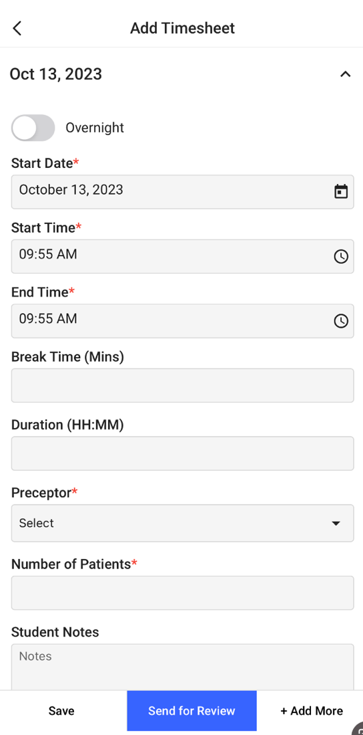
6. You can tap on **Add** button on right hand of your bottom screen to add timesheet
7. Select **Save** button to save your work
8. Select **Send** of Review button to send it to review
9. Select **+ Add More** button to add multiple entries for the timesheet, use the down arrow to expand and fill out the details.

# How to Edit Saved Timesheets

**In this section, we will talk about how to edit Timesheets for your placements.**

***Steps:***

1. Go to Coursework
2. Select/Tap the placement for which you want to edit the timesheet
3. Go to Timesheet and click the forward arrow to open
4. Select the timesheet marked as “In Progress”  
   A screenshot of a phone

   Description automatically generated
5. Fill out rest of the details and send them for Review

# How to add Time off

**In this section, we will talk about how to add Time off during your placement**

***Steps:***

1. Go to Coursework
2. Select the current placement you want to add Time-off   
   A screenshot of a medical application

   Description automatically generated
3. Select the Time off forward arrow or Select + Add Time off

1. Add all the details like From and to date, Reason for Time-off, plans you make up for your missed time, Notify Preceptor, any files, and **send for review**  
   A screenshot of a phone

   Description automatically generated

# How to add Support Tickets

**In this section we learn on how to add support tickets for any issues and concerns on the App**

***Steps:***

1. Click on the Help
2. Select + icon on bottom right comer to add a ticket
3. Add your concerns and **submit**.  
   A screenshot of a upload file

   Description automatically generated
4. Track the status of your open tickets under this **Help** Section.