Tenant level app for Compliance View

Prism

University administrators now have the ability to review Compliance across all programs within the Tenant Application via the Compliance Management section.

1. Click on University Administrator from the top left corner of your screen.

1. Select Compliance Management from the middle box.



1. You will see two tabs at the top left of your screen. In the ‘Student’ tab, the system will load all students, the program & the respective cohort they belong to along with the current status for all compliance items of those individual students. You can also click on the funnel icon to filter the status.

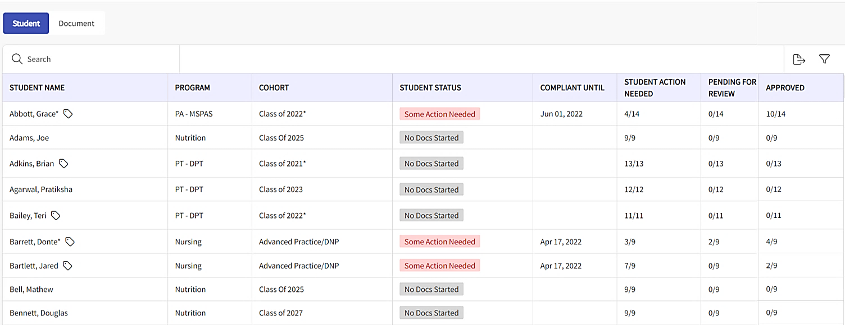

1. Click on the “Student Status” filter, choose the required filter option and click on apply.

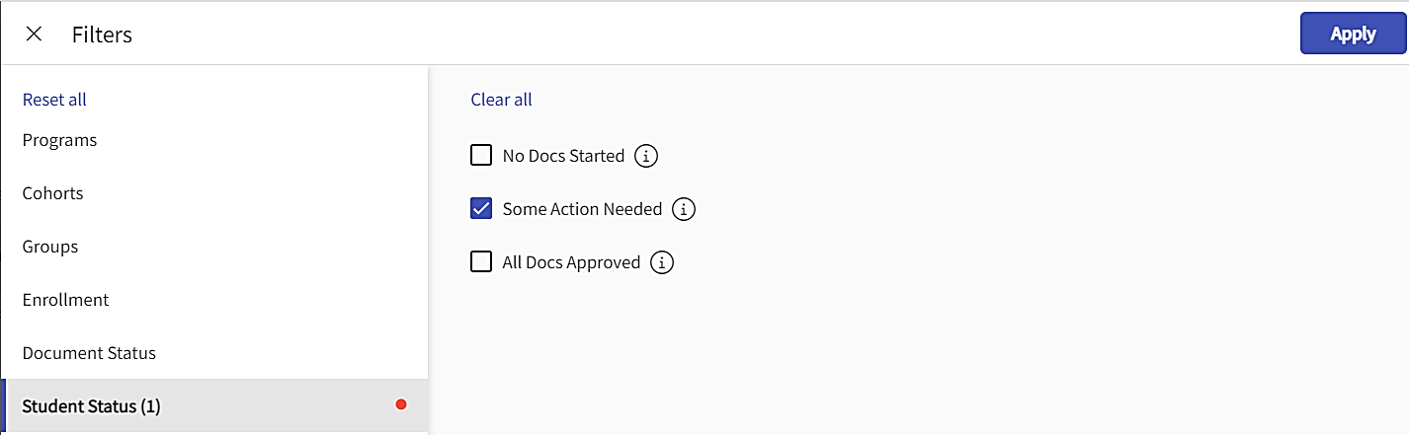

1. On the “Student Status” column beside each student name, click on the status.

1. A drawer will open to view the consolidated detailed status of all the documents for that individual student.

1. Review detailed information for that student. You can update the document status, select the reason from the drop down and provide comments (if needed). Once done, click Update Status.

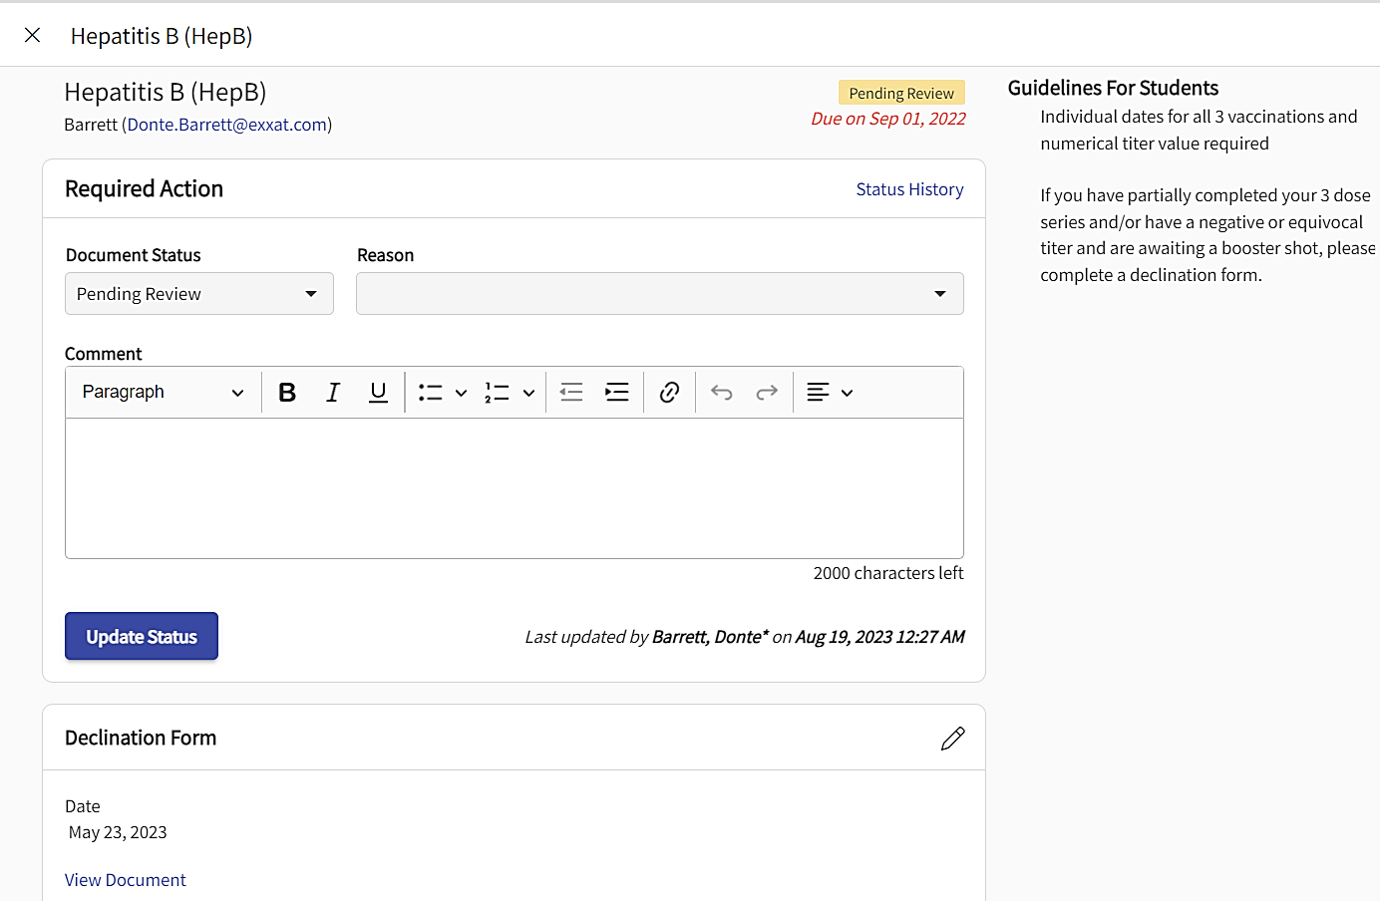

View any uploaded documents

Edit compliance item details

1. The status will change, and the requirement will update. Close the drawer to review other compliance items or go back to the main page.

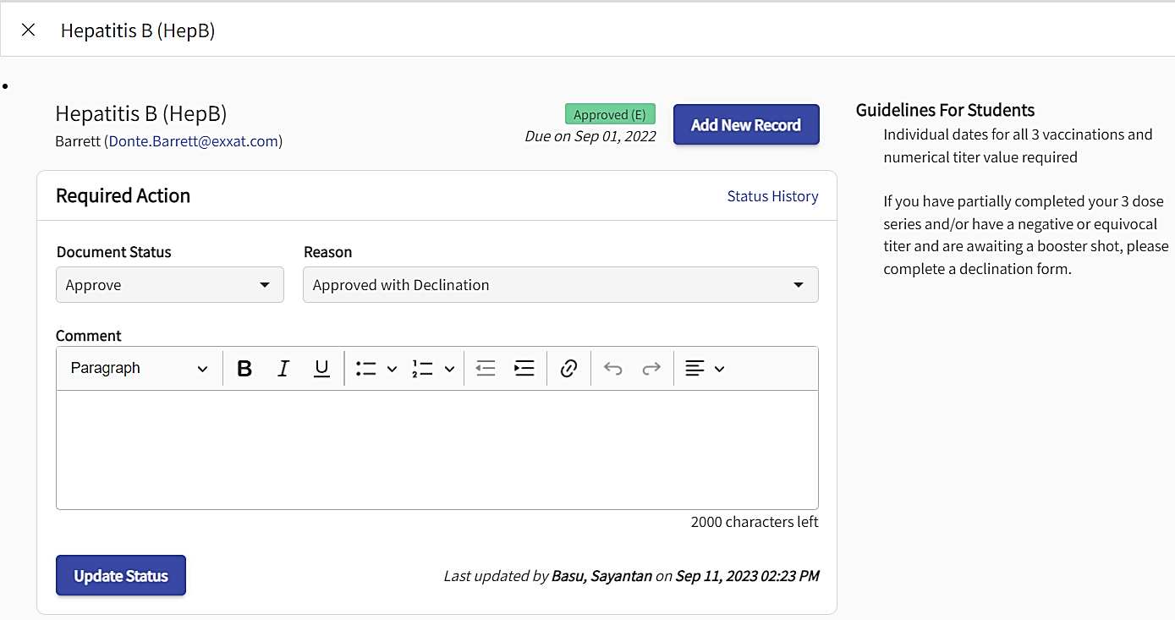

1. On the main page, when you click on the ‘Document’ tab, the system will load the students name, the program & cohort they belong to along with the current individual document status of the students. You can scroll down and check the status, or you can click on the funnel icon to filter the status. Uncheck the filter of “Some Action Needed” as shown in the screenshot before clicking on the funnel icon.

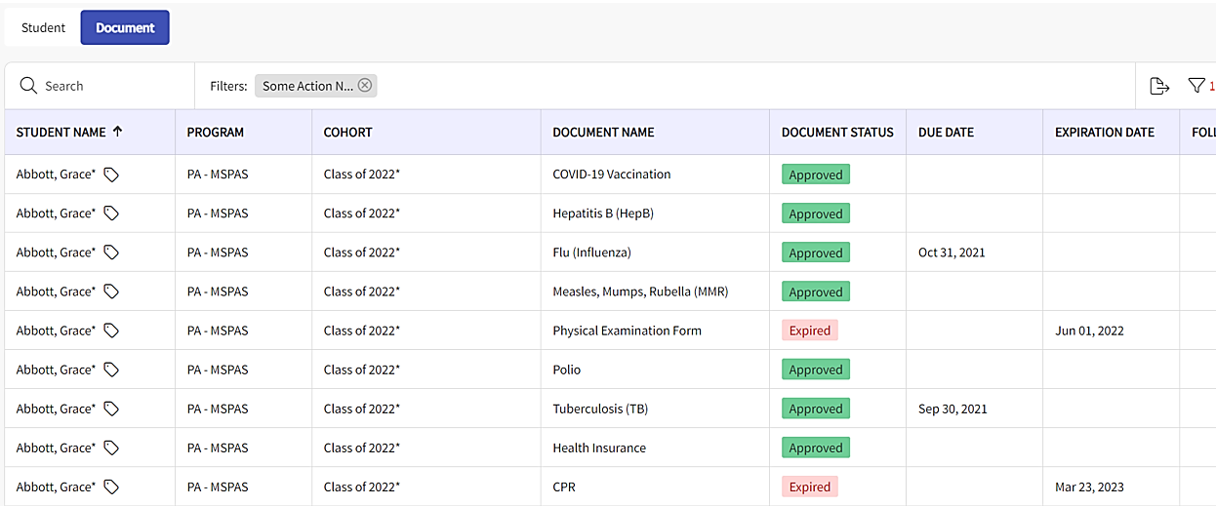

1. Click on the “Document Status” filter, choose the required filter option and click on apply.

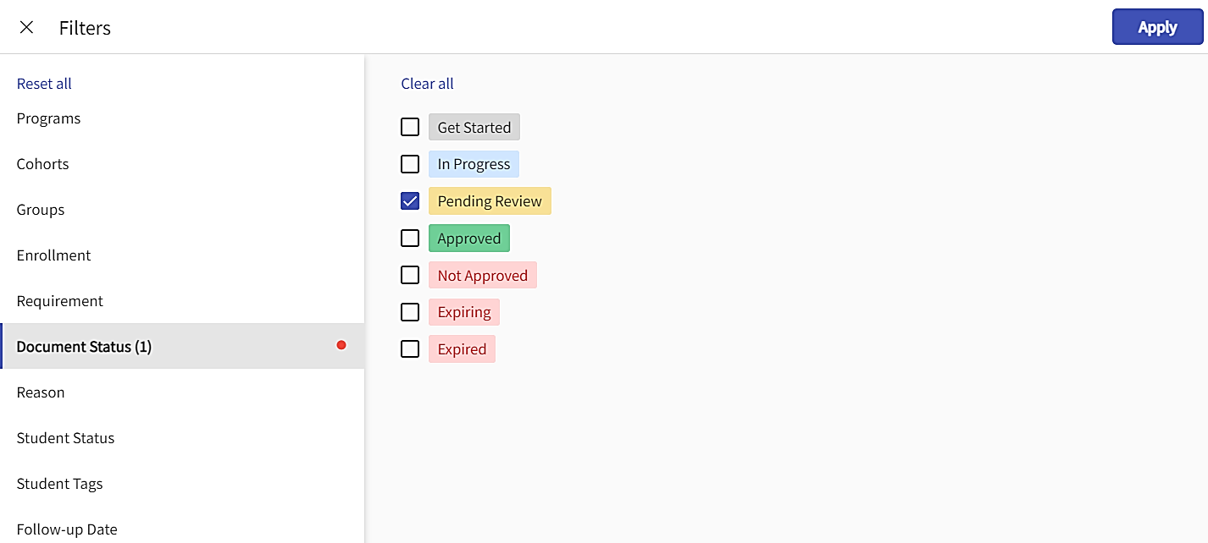

1. On the “Document Status” column beside each student name, click on the status.

1. Review detailed information for that student. You can update the document status, select the reason from the drop down and provide comments (if needed). Once done, click Update Status.

View any uploaded documents

Edit compliance item details

1. The status will change, and the requirement will update. Close the drawer to review other compliance items.

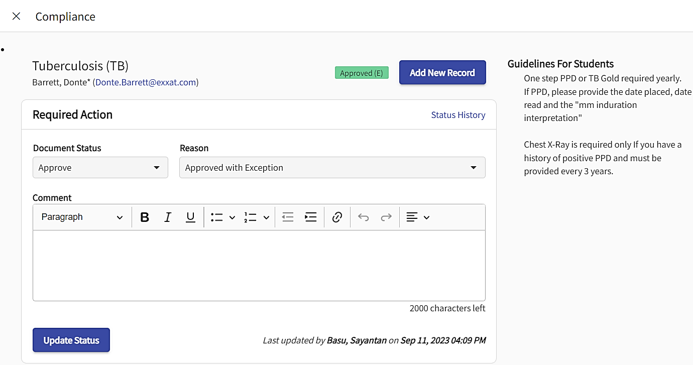

1. You can also export the information listed on the grid in both the tabs.

1. The report will include the overall status of each compliance item, along with any dates entered for easy reviewing.

