Creating a Wishlist

Prism

A Wishlist allows you to collect student preferences on where the student would like to get placed for a specific Course.

This document will cover the following Wishlist types:

* Slot
* Location
* Setting
* Location Area
* Questionnaire

1. Select Placements from your left-menu.

1. Select the Course to set-up a Wishlist by clicking on the course name. You can use the filter option to quickly find the course that you are looking for.

1. If you’d like to manage placements for multiple courses, select your placement group and then click on Placements for Group.

1. Choose the Wishlist tab from the banner that appears on the top of the page.

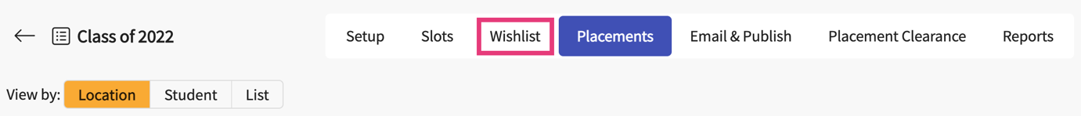

1. The system will display all previously created Wishlists for the selected course list. Click on + Create Wishlist to set-up a new Wishlist.

1. You will now be taken to a new page to set you configure the Wishlist. On step 1, you will provide the following information:
   1. **Wishlist name**: This name will appear throughout the system where the Wishlist information shows up. You and your students will see this Wishlist name.
   2. **View only date**: This is the date on which the students can view the Wishlist, but yet cannot begin filling them. You can set this before the open date to allow students to begin their research!
   3. **Open date**: The earliest date from which students can start filling their preferences and submit them
   4. **Close date**: The last date by which students can submit and modify their Wishlist.
   5. **Set up**: decide which Wishlist you would like to utilize.
      1. Slot wishlist: Students can provide their preferences over the slots available from different locations
      2. Location wishlist: students can provide their preferences over the locations available in your database
      3. My Request: students complete a form (that your program customizes) to request a placement at a Location. This can be used at times when you would want your students to find the placement location by themselves.
      4. Setting: Students can provide their preferences over the available settings
      5. Location Area: Students can provide their preferences over the available location areas. Location areas can be defined by the program. For eg: In Area, Out of Area or Regional areas
      6. Questionnaire: Students can fill in a questionnaire to indicate their qualitative preferences.

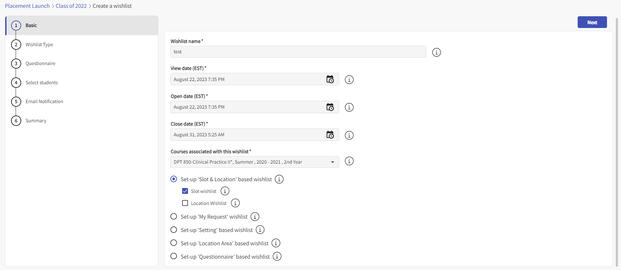

1. On step 2, you will set your preferences on the type of information you’d like to show your students. The options you see will depend on the type of Wishlist you selected on step 1.
2. **Step 2 for Slot based wishlist**: all settings and states will be included by default, but you can choose to exclude any items if needed. Click on the pencil icon to edit either list.
3. You can also choose slot based on Location tag, Location area and location categories.

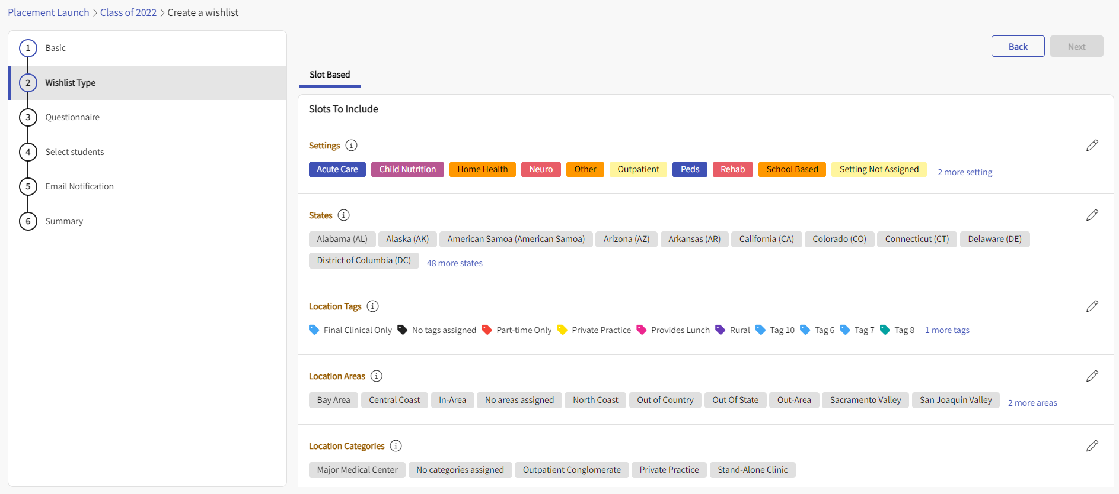

1. There are additional bits that you can select as part of the Slot Based Wishlist that shows up under the Additional Information section shown below.
   1. Choose if you’d like to show students how many slots you have available, along with the status and clinician details for each location.
   2. Choose if you’d like to show the status of slots that are available to the students.
   3. Choose if you’d like to show the rotation name to the students.
   4. Choose if you’d like to show the Slots Clinical Instructor name to the students.
   5. Decide if students should be able to upload any documents along with their Wishlist.
   6. Confirmed, Regular slots are included by default, but if you have any tentative, or other slot types you’d like to include, check them off with the open checkbox.
   7. Set a minimum number of how many entries your student must include before they can submit. You can also set a maximum and guidelines for them 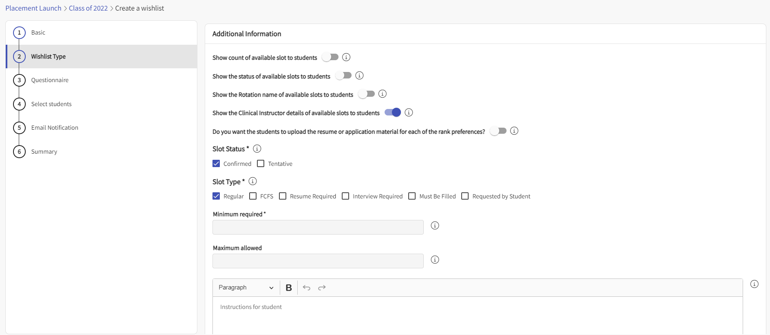
2. **Step 2 for Location based Wishlist**: all states will be included by default, but you can choose to exclude any if needed. Click on the pencil icon to edit the list.
3. For locations to include, you have a few options. You can choose to include all locations, locations that have not offered slots for the given rotation, or locations that have offered slots for the given rotation. Once you make your selection, you can decide which settings to include. All settings will be included by default.
4. Set a minimum number of how many entries your student must include before they can submit. You can also set a maximum and add guidelines for them to follow.

1. **Step 2 for Setting based Wishlist**: all settings will be included by default. You can choose to exclude any if needed. Click on the pencil icon to edit the list.
   1. If you’d like to add new settings, please go to Program Details > Edit Program Clinical Settings.
2. Set a minimum number of how many entries your student must include before they can submit. You can also set a maximum and guidelines for them to follow.

1. **Step 2 for Location Area based Wishlist**: all location areas will be included by default. You can choose to exclude any if needed. Click on the pencil icon to edit the list.
   1. If you’d like to add new location areas, please go to Sites > Setup > Sites Organization > Edit Location Area
2. Set a minimum number of how many entries your student must include before they can submit. You can also set a maximum and guidelines for them to follow.A screenshot of a computer

   Description automatically generated with medium confidence
3. **Step 2 for Questionnaire based Wishlist**: You are able to put instructions for the students and you can set up the questionnaire for the students to answer.

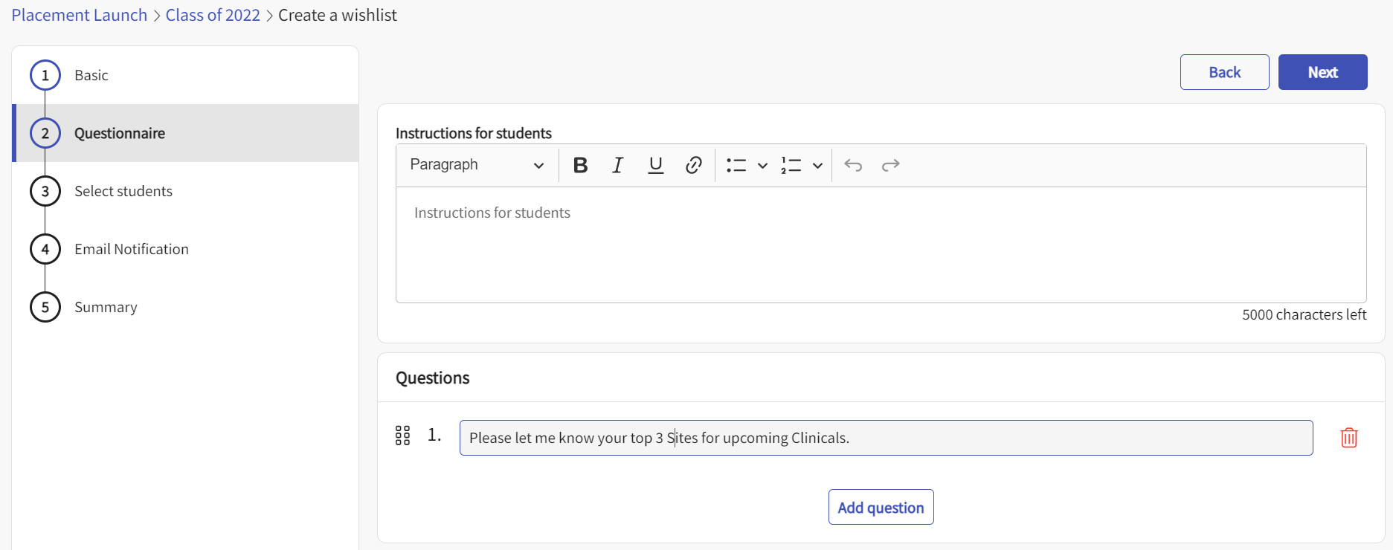

1. Step 2 for My Request Wishlist: This is a special type of Wishlist. You need to work with our configuration team to customize the list of questions that need to show up on this request form. Please raise a support ticket or work with your AM to configure the My Request form.
   1. Once the form is configured, the form name shows up on the Select Form dropdown. Please pick the form name
   2. Select the rotation for which you need to activate the My Request form
   3. Set the Minimum number of times this request form can be filled by the student
   4. Set the maximum number of times this request form can be filled by the student
   5. Add instructions for the student.

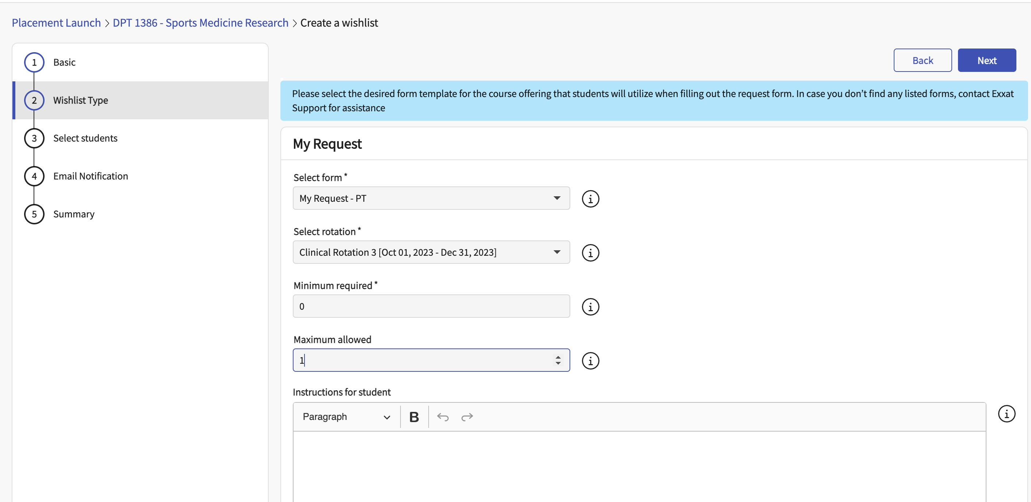

1. **Step 3 for all the Wishlists:** This will allow you to create a list of questions for your students to answer. This does not show up for the Questionnaire based Wishlist. If you’d like to add questions, select Yes.

1. Type in each question and rearrange the order using the order by icon that appears on the left. Once done, click Next.
   1. Use the trash bin to delete any unwanted questions.

1. **Step 4 for all the Wishlists – This** step will show the list of students who are registered for the selected course. They will all be included by default. Make any necessary changes using the open checkboxes.
   1. If you foresee changes in the course registration list post the creation of the wishlist, check off the statement – Automatically update student selection when course registration is updated. By selecting this option, whenever the course registration list is updated, the wishlist registration list will be automatically updated.

1. **Step 5 for all the Wishlists** :This step will allow you to set email notifications.
   1. Decide if you want students to be notified when the Wishlist opens, 24 hours before closure, and once it closes.
   2. This step will have further options if it is a My Request Type of Wishlist. You will have the ability to notify the school and the student whenever a status change happens or whenever a comment is added.

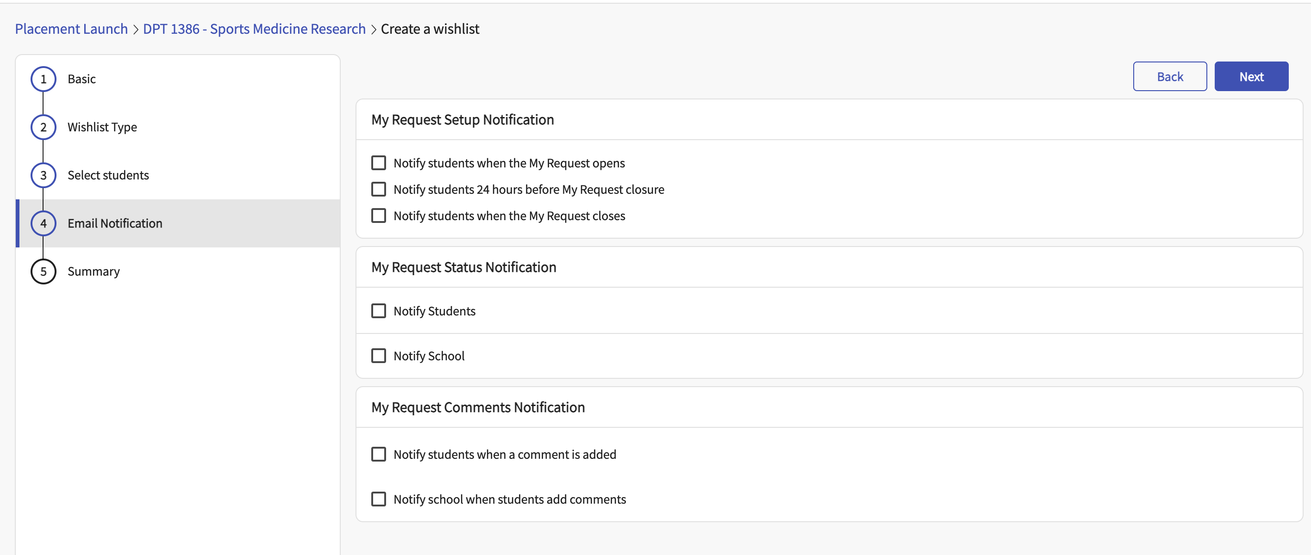

1. **Step 6 for all the Wishlists :** This step will show you a summary of all your selections. Review it carefully. If changes are needed, click Back to make modifications. If everything is good to go, click Save.

1. Your Wishlist will now be saved and will appear within the Wishlist tab. To view the Wishlist from your student’s point of view, click Preview.

1. A drawer will open, allowing you to preview the Wishlist.

