Student

User Guide

*Last updated on July 6, 2023*

Table of Contents

Logging in and Dashboard 3

Profile 4

Academics 4

Profile 4

Share Profile 5

Compliance 6

Clinical Coursework 7

Course registration 7

Submitting preferences for a placement 7

Pre-Placement 8

During Placement 9

Learning Activities 11

Explore Clinical Locations 11

Published Slots 12

Getting Help 12

# Logging in and Dashboard

Before you can access Exxat Prism, your program must add you to the system and send you an invitation!

There are two types of accounts:

* General
* Single Sign On

With a general account, you will be sent an invitation which will provide you with a link to set up your password and access your account. The link will remain active for 60 days, so make sure to set up your account within that timeframe!

If you program has Single Sign On (SSO) enabled, your program will inform you once your account is active, and you will use your school credentials to access your account.

Your dashboard is comprised of 8 tiles. Some tiles will show you a number to indicate anything that needs your attention. Your program may post announcements. Announcements will be listed on the left panel of your dashboard.

***Resources:***

[Accessing & Navigating Exxat Prism](https://exxat.zendesk.com/hc/en-us/articles/16783857841937-Accessing-Navigating-Exxat-Prism-)

# Profile

Clicking the “Profile” tile on your dashboard, or landing screen, will take you to the section of the system that contains your individual demographics and information which is broken up into 2 major sections denoted by tabs across the top:

## Academics

The academic information section is edited by your faculty and available as “read only” for you.

It contains data unique to your participation and progress within in the program.

## Profile

The profile section contains the information that you fill out about yourself. Throughout this section you will see edit pencils; clicking these allows you to make changes or additions to the information contained in each section. You will also see add icons (+). Clicking these allows you add information to a section that is currently empty.

The information entered into the profile section will be shared with the site at which you will be completing your clinical experience so please keep your audience in mind when writing entries.

You will also enter personal contact information and emergency contacts within this section.

## Share Profile

You may be asked to send your profile to Site Contacts prior to starting a placement. The Share Profile option will be available within both tabs (Academics and Profile)

When sharing your profile, you will be provided with options to include your “Required Documents” (the documents you have uploaded into the Compliance section, more on that below) and your contact information. You will also be given the opportunity to enter any notes that should accompany your message. Please make your selection carefully before sending. The recipient of this information will receive an e-mail similar to the below with the pink fields filled with your unique information:

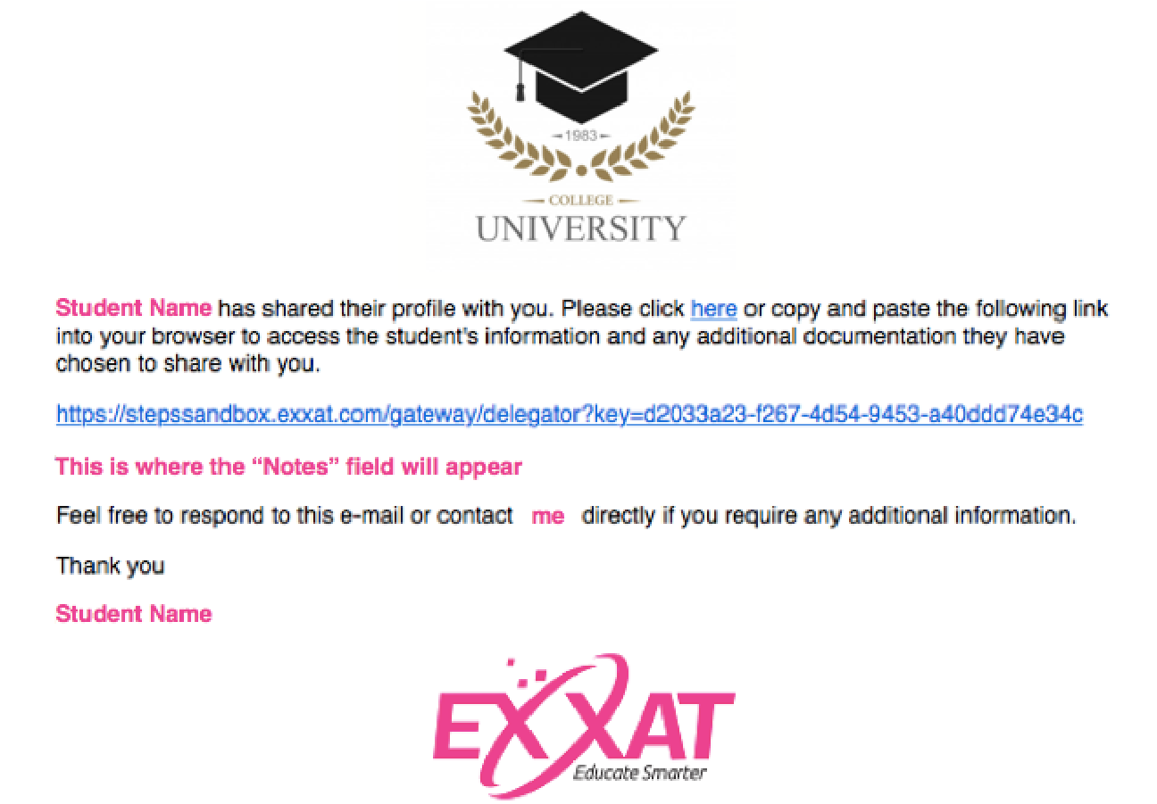

The link contained in the message will take them directly to the information contained in your “Profile” section along with your “Contact” and/or “Compliance sections based on the options you selected. No login information is needed to access the link. Please note this link will expire after 60 days.

***Resources:***

[Completing Your Student Profile](https://exxat.zendesk.com/hc/en-us/articles/15364760094097-Completing-Your-Student-Profile)

[Sending Profile to Sites](https://exxat.zendesk.com/hc/en-us/articles/15364820657297-Sending-Profile-to-Sites)

# Compliance

The compliance section allows you to upload the documents required by your school. You will see a list of these documents on the left (if you are viewing this section on a smaller screen, you may need to click the “hamburger menu” icon to view the list.)

Each document will appear in this list with a status indicator letting you know if nothing is yet on file for you (Get Started), your document is awaiting review from your faculty (Pending Review), the document has been reviewed and it meets expectations (Approved) or if the document has been reviewed and falls short of expectations (Not Approved).

Be sure to read the Guidelines for Students section on the left to learn what type of documentation your program requires. icon.

Documents that will be shared along with your profile link if you choose the option to “include the required documents in the profile link” will be clearly marked with a blue banner:



***Resources:***

[Uploading Compliance Documents](https://exxat.zendesk.com/hc/en-us/articles/15365612513681-Uploading-Compliance-Documents)

# Clinical Coursework

This section is your Go-To while you prepare for a placement. It will include everything from course specific resources, wishlists which will collect your preference for a placement, and where all in activities completed during your placement that your program collects through Exxat will be completed.

The amount of information shared with you will vary at different points in time:

## Course registration

Your program will register you for any courses you need to be associated with. Once you are registered, you will have access to any course details and resources your program has shared with you.

## Submitting preferences for a placement

Sometime before your placement begins, your program may request you to provide your preferences on your placement via a wishlist.

There are many types of wishlists available:

* **Slot Based**: pick and choose from placement offers provided by Locations.
* **Location Based**: pick and choose from Locations your program has a contract agreement established with
* **Slot and Location Based**: pick and choose from both Locations who have offered placement offers and any remaining Locations that have a contract agreement with your program
* **Setting Based**: Select and rank settings available chosen by your program
* **Area Based**: select and rank geographical areas chosen by your program
* **My Request**: complete a form where you provide the full details of a Location you would like to be placed for.

***Resources:***

[Completing a Location Based Wishlist](https://exxat.zendesk.com/hc/en-us/articles/15364964921489-Completing-a-Location-Wishlist)

[Completing a Slot Based Wishlist](https://exxat.zendesk.com/hc/en-us/articles/15365454950673-Completing-a-Slot-Wishlist)

[Requesting Placement via My Request](https://exxat.zendesk.com/hc/en-us/articles/15365551818385-Requesting-Placement-via-My-Request)

[Completing a Slot & Location Wishlist](https://exxat.zendesk.com/hc/en-us/articles/15365447008017-Completing-a-Slot-Location-Wishlist)

[Completing a Setting Based Wishlist](https://exxat.zendesk.com/hc/en-us/articles/15365405402257-Completing-a-Setting-Wishlist)

[Completing a Location Area Based Wishlist](https://exxat.zendesk.com/hc/en-us/articles/15364882429457-Completing-a-Location-Area-Wishlist)

## Pre-Placement

Once you have successfully been matched with a Location, your school will publish placement information for you to prepare prior to the placement starting.

You will continue to have access to any course details, resources and wishlists you have completed, but you will now also have access to:

* **Attestations** you program is requesting you to review and sign off on
* **Location details**: Address, contacts, documents, and any additional requirements you must provide prior to starting the placement
* **Placement Faculty details**: Faculty who are assigned to your placement (if any)
* **To Do List**: this is your list of assignments you will complete during your placement. Your program will decide when to publish these for you to view, so they may not be available right away.

***Resources:***

[Coursework Overview](https://exxat.zendesk.com/hc/en-us/articles/15365766887697-Coursework-Overview)

[Uploading & Sharing Location Specific Requirements](https://exxat.zendesk.com/hc/en-us/articles/15365935345041-Uploading-Sharing-Location-Specific-Requirements)

## During Placement

Once your placement begins, you will want to keep an eye on your To Do List!

Your program may request you to complete any of the following:

### Provide Clinician information

Your program may assign any clinicians who will be supervising you during your placement. If this is the case, their information will be displayed on your To Do List. If not, your program may request you to provide their name, email and phone number.

They may also request that you provide % of supervision. Please connect with your program on guidelines to follow.

### Upload Assignments

This type of learning activity will require you to upload a file. Please review any instructions and templates prior to submitting your assignment.

### Complete specific Forms/Evaluations

This learning activity will require you to complete a form. Some examples are self-evaluations, evaluations of the Site which you are placed, evaluations of the Clinician who is supervising you, and more.

When completing these forms/evaluations, please note you may have to send your form to your clinician for review.

### Complete Patient Logs

When entering patient logs, make sure you are logging them within your placement dates. Your program may set a defined window where a log must be created within a specific number of days. For example, your program may only allow you to enter logs within 5 days of the patient encounter. This means you will not be able to enter a log if the date is past longer than 5 days.

You can edit all patient logs (except the date of encounter field) while they are In Progress or a Submitted status. Once your patient log has been approved, you cannot make further edits.

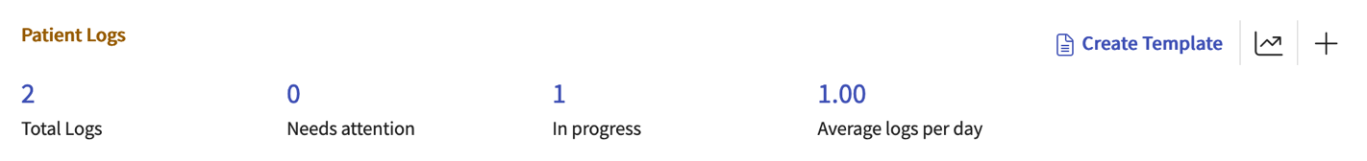

### Complete Timesheets

When completing timesheets, make sure you are entering times within your placement dates. Your program may also set a defined window for entering and editing past timesheets. For example, your program may only allow you to edit timesheets within the past 5 days prior to being approved. This means you will not be able to edit or enter anything that is past longer than 5 days.

Your program may allow you to submit timesheets for future dates. If so, you will be able to enter your timesheet and save your progress, but you will not be able to submit until the day of.

You can edit all fields within a timesheet and delete entries until it is approved. Once approved, you cannot make further edits or delete an entry. Patient logs cannot be deleted once they are submitted.

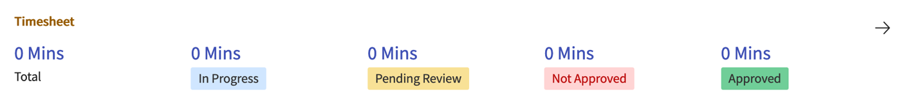

### Request Time Off

Life happens, and during your placement, you may need to miss time in clinic! For this reason, your program may allow you to submit time off requests.

They may request that you categorize your time off request and provide proper documentation.

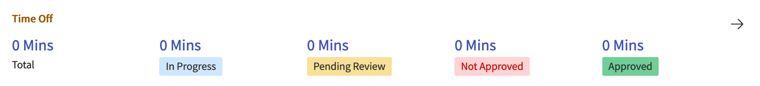

***Resources:***

[Providing Instructor Information](https://exxat.zendesk.com/hc/en-us/articles/15365909446161-Providing-Instructor-Information)

[Adding Patient Logs](https://exxat.zendesk.com/hc/en-us/articles/15365707728273-Adding-Patient-Logs)

[Completing Timesheets](https://exxat.zendesk.com/hc/en-us/articles/15365828149009-Completing-Timesheets)

[Completing Forms/Evaluations](https://exxat.zendesk.com/hc/en-us/articles/15365867172241-Completing-Forms-Evaluations)

[Requesting / Logging Time Off](https://exxat.zendesk.com/hc/en-us/articles/15365914191889-Requesting-Logging-Time-Off)

# Learning Activities

While the Clinical Coursework section assists you with focusing on a specific placement, the Learning Activities give you a focused view on individual learning activities (Forms/Evaluations, Patient Log, Timesheets, Time Off) and gives you the option to run reports!

***Resources:***

[Clinical Coursework vs Learning Activities](https://exxat.zendesk.com/hc/en-us/articles/15365756225553-Clinical-Coursework-vs-Learning-Activities)

[Learning Activities Overview](https://exxat.zendesk.com/hc/en-us/articles/15365854574865-Learning-Activities-Overview)

[Viewing Timesheet Report](https://exxat.zendesk.com/hc/en-us/articles/15365956456977-Viewing-Timesheet-Report)

# Explore Clinical Locations

When you have an upcoming wishlist, you can prepare in advance by doing research on Locations available to you via the Explore Clinical Locations page!

This is an interactive map that allows you to search for a specific Location, or using filters, and see where they are on a map.

***Resources:***

[Researching Sites](https://exxat.zendesk.com/hc/en-us/articles/15364658728337-Researching-Sites)

# Published Slots

Your program may receive slot availability for an upcoming placement that is time sensitive and requires your program to provide student information to reserve the slot.

If your program utilizes this feature, you will have a Published Slots section for you to express interest in a slot.

***Resources:***

[Expressing Interest in Published Slots](https://exxat.zendesk.com/hc/en-us/articles/15365511235473-Expressing-Interest-in-Published-Slots)

# Getting Help

Your program, along with Exxat want to ensure you have the resources you need to be successful.

Your program may provide you with general resources and school contact information for you to quickly find information you need or know who to contact.

If you face any technical issues with Exxat, we are only an email away! You can easily contact [v4support@exxat.com](mailto:v4support@exxat.com) via email or submit a ticket through the system.

You can access our [Help Center](https://exxat.zendesk.com/hc/en-us) for written guides that take you step-by-step on completing activities in the system.

If you prefer to watch videos instead, visit our [YouTube Channel](https://www.youtube.com/@Exxat), Exxat. We have a curated [playlist](https://youtube.com/playlist?list=PL5ycGncYZ0K4e9JvWkir9Fn_7Gu9c-v2l) for everything you might need assistance with!

***Resources:***

[Resources Available for Students](https://exxat.zendesk.com/hc/en-us/articles/15364695804945-Resources-Available)

[Help Center](https://exxat.zendesk.com/hc/en-us)

[YouTube Channel](https://www.youtube.com/@Exxat)

[Student Orientation Playlist](https://youtube.com/playlist?list=PL5ycGncYZ0K4e9JvWkir9Fn_7Gu9c-v2l)