Faculty

User Guide

*Last updated on June 19, 2023*

Table of Contents

Logging in and Dashboard 3

Profile 5

Courses 6

Advisees 7

Student Placements 9

Mapping and Reports 10

Getting Help 11

# Logging in and Dashboard

Before you can access Exxat Prism, your program must add you to the system and send you an invitation!

There are two types of accounts:

* General
* Single Sign On

With a general account, you will be sent an invitation which will provide you with a link to set up your password and access your account.

If you program has Single Sign On (SSO) enabled, your program will inform you once your account is active, and you will use your school credentials to access your account.

Your dashboard is comprised of 9 tiles. Some tiles will show you a number to indicate anything that needs your attention. Your program may post announcements. Announcements will be listed on the left panel of your dashboard.

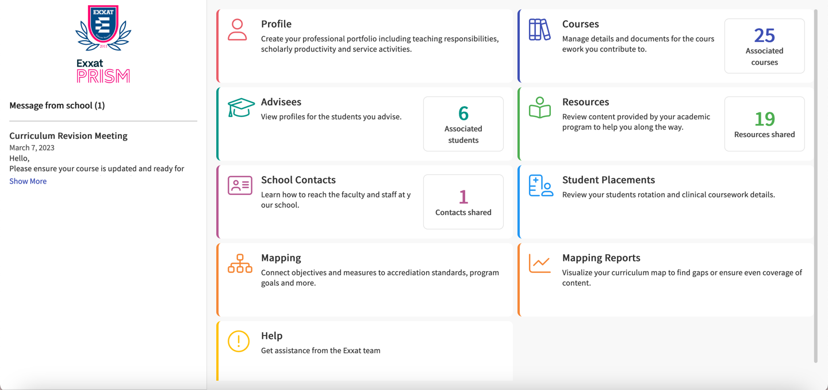

The tiles available to you may differ from the screenshot, depending on the sections your program has configured for your access.

There are three levels of data access you may have, that will be determined by your associations:

***Resources:***

[Logging into Exxat](https://exxat.zendesk.com/hc/en-us/articles/15346516614161-Logging-Into-Exxat-for-Faculty)

[Logging into Exxat for Faculty via SSO](https://exxat.zendesk.com/hc/en-us/articles/16297222025745-Logging-into-Exxat-via-SSO-)

[Navigating Exxat for Faculty](https://exxat.zendesk.com/hc/en-us/articles/15346575095313-Navigating-Exxat)

# Profile

The profile section allows you to build your professional portfolio with individual sections for your demographics, teaching and service responsibilities and scholarly activity accessible from the left.

***Resources:***

[Completing Profile](https://exxat.zendesk.com/hc/en-us/articles/15348724546833-Completing-Profile)

[Generate CV](https://exxat.zendesk.com/hc/en-us/articles/15348765031441-Generate-CV)

[Sharing Contact Information](https://exxat.zendesk.com/hc/en-us/articles/15348790594065-Sharing-Contact-information)

# Courses

Your program’s system administrator will associate you to courses you manage. You’ll be able to update course details, measures, attributes, add resources for students and sites to access, along with activating learning activities for courses which require a placement.

*If a course that you manage is not listed within this section, contact your system administrator.*

The Curriculum Grid will show you grids which provide an overview of the academic trajectory or progression for a group of students enrolled in your program. You will see all courses, and if you are not assigned to them, they will be in view-mode only and will not allow any edits.

***Resources:***

[Courses Overview](https://exxat.zendesk.com/hc/en-us/articles/15363701328401-Courses-Overview)

[Managing Courses](https://exxat.zendesk.com/hc/en-us/articles/15363881182225-Managing-Courses)

[Assigning Attributes to a Course](https://exxat.zendesk.com/hc/en-us/articles/15363694067985-Assigning-Attributes-to-a-Course)

[Managing Course Measures](https://exxat.zendesk.com/hc/en-us/articles/15363821445137-Managing-Course-Measures)

[Adding Course Resources](https://exxat.zendesk.com/hc/en-us/articles/15363608420625-Adding-Course-Resources)

[Managing Course Events](https://exxat.zendesk.com/hc/en-us/articles/15363726071953-Managing-Course-Events)

Learning Activities:

[Activating Assignments](https://exxat.zendesk.com/hc/en-us/articles/15349424296465-Activating-Assignments)

[Activating Forms/Evaluations](https://exxat.zendesk.com/hc/en-us/articles/15363302843409-Activating-Forms-Evaluations)

[Activating Patient Logs](https://exxat.zendesk.com/hc/en-us/articles/15363399456529-Activating-Patient-Logs)

[Activating Timesheets](https://exxat.zendesk.com/hc/en-us/articles/15363500301329-Activating-Timesheets)

[Activating Time Off](https://exxat.zendesk.com/hc/en-us/articles/15363464069905-Activating-Time-Off)

[Reviewing Assignments by Course](https://exxat.zendesk.com/hc/en-us/articles/15363986492945-Reviewing-Assignments-by-Course)

[Reviewing Forms/Evaluations by Course](https://exxat.zendesk.com/hc/en-us/articles/15364029143185-Reviewing-Forms-Evaluations-by-Course)

[Reviewing Patient logs by Course](https://exxat.zendesk.com/hc/en-us/articles/15364135697681-Reviewing-Patient-Logs-by-Course)

[Reviewing Timesheets by Course](https://exxat.zendesk.com/hc/en-us/articles/15364236556049-Reviewing-Timesheets-by-Course)

[Reviewing Time Off by Course](https://exxat.zendesk.com/hc/en-us/articles/15364178383505-Reviewing-Time-Off-by-Course)

[Viewing Learning Activity Reports](https://exxat.zendesk.com/hc/en-us/articles/15362237141649-Viewing-Learning-Activity-Reports)

# Advisees

Within the system, you can view and manage students that you work with. Whether it’s viewing or sharing their profile, viewing the overall status of their compliance items, adding communications, interventions, or reviewing their placement and learning activities, this section can do it all!

*If a student that you manage is not listed within this section, contact your system administrator.*

***Resources:***

[Viewing Advisees Profiles](https://exxat.zendesk.com/hc/en-us/articles/14995866952977-Viewing-Advisees-Profiles)

[Tagging Students](https://exxat.zendesk.com/hc/en-us/articles/14995863235729-Tagging-Students)

[Adding Student Communications](https://exxat.zendesk.com/hc/en-us/articles/14995670171025-Adding-Student-Communications)

[Adding Student Interventions](https://exxat.zendesk.com/hc/en-us/articles/14977920436753-Adding-Student-Interventions)

[Reviewing Student Clinical Coursework](https://exxat.zendesk.com/hc/en-us/articles/14995771937425-Reviewing-Student-Clinical-Coursework)

[Reviewing Student Learning Activities](https://exxat.zendesk.com/hc/en-us/articles/14995830989329-Reviewing-Student-Learning-Activities)

# Student Placements

Students Placements will allow you to view and manage the placement related information and activities for all the students for whom you have been assigned as a Faculty of Record by the system administrator.

*If a course or student that you manage is not listed within this section, contact your system administrator.*

***Resources:***

[Reviewing Student Placements](https://exxat.zendesk.com/hc/en-us/articles/15349128845969-Reviewing-Student-Placements)

[Adding Placement Communications](https://exxat.zendesk.com/hc/en-us/articles/15348868682001-Adding-Placement-Communications)

[Adding Placement Interventions](https://exxat.zendesk.com/hc/en-us/articles/15348909904401-Adding-Placement-Interventions)

# Mapping and Reports

Your program may create curriculum grids to easily track the academic trajectory or progression for a group of students enrolled in your program. If so, you will connect objectives and measures to accreditation standards, program goals, and more. With the assistance of reports, you can also find gaps and ensure even coverage of content.

***Resources:***

Coming soon!

# Getting Help

Your program, along with Exxat want to ensure you have the resources you need to be successful.

Your program may provide you with general resources and school contact information for you to quickly find information you need or know who to contact.

If you face any technical issues with Exxat, we are only an email away! You can easily contact [v4support@exxat.com](mailto:v4support@exxat.com) via email or submit a ticket through the system.

You can access our [Help Center](https://exxat.zendesk.com/hc/en-us) for written guides that take you step-by-step on completing activities in the system.

If you prefer to watch videos instead, visit our [YouTube Channel](https://www.youtube.com/@Exxat), Exxat. We have a curated [playlist](https://youtube.com/playlist?list=PL5ycGncYZ0K5gUdmC8da6m3qqwX8WpS8G) for everything you might need assistance with!

***Resources:***

[Help Center](https://exxat.zendesk.com/hc/en-us)

[YouTube Channel](https://www.youtube.com/@Exxat)