Managing Course Activities – Timesheets
Prism
For a student to complete the timesheet learning activity, it must be configured for a course first. Once it is configured, the students who are placed at the respective courses will be able to fill in the timesheets.
- Select Courses from your dashboard or left menu.



- Select the course you’d like to manage.
  - Use the search or filter options to quickly find what you’re looking for.

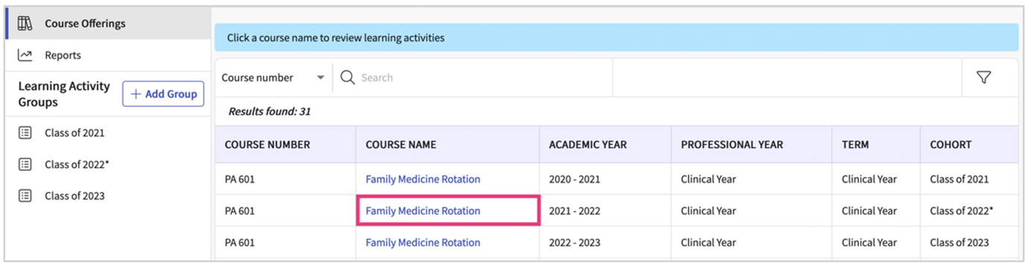

- Expand the Learning Activities option on the left panel and select Setup.

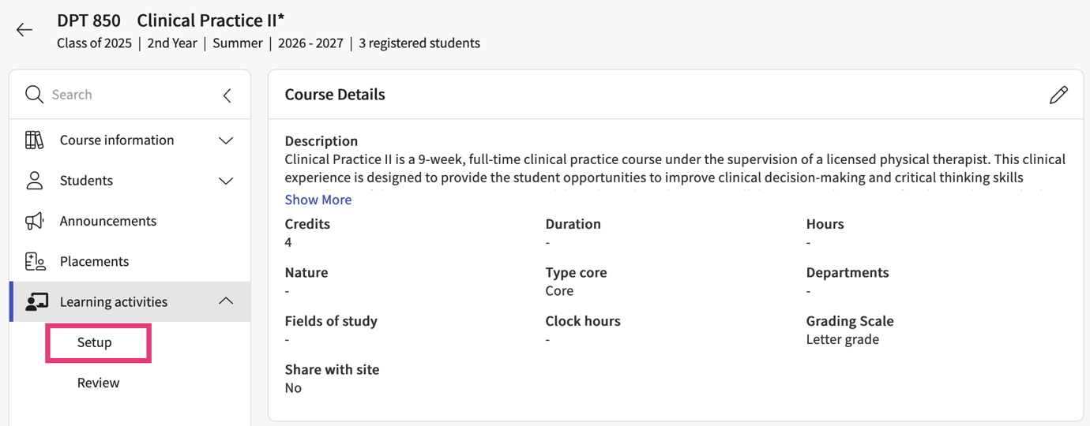

- Another pathway you can take is by going to Learning Activities from your dashboard or left menu.



- Find and the course you’d like to manage and click Setup from the action column.

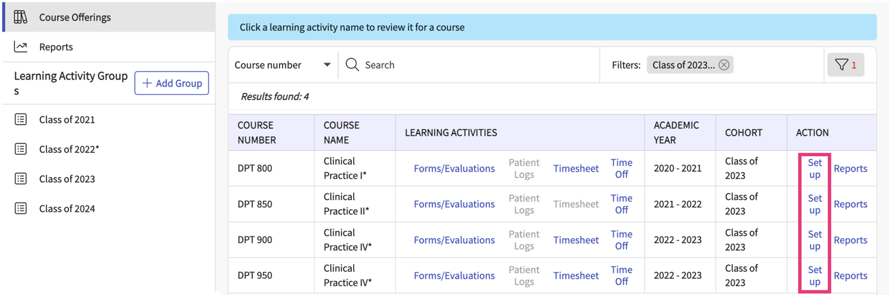

- The system will load all learning activities and will indicate any that are activated. Click on the pencil icon for Timesheets.

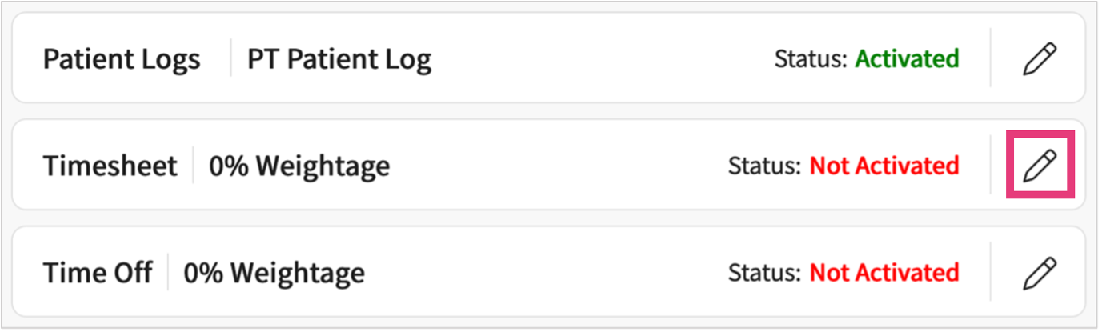

- A drawer will open. Make sure to active the timesheet. You will then set your preferences on items available.

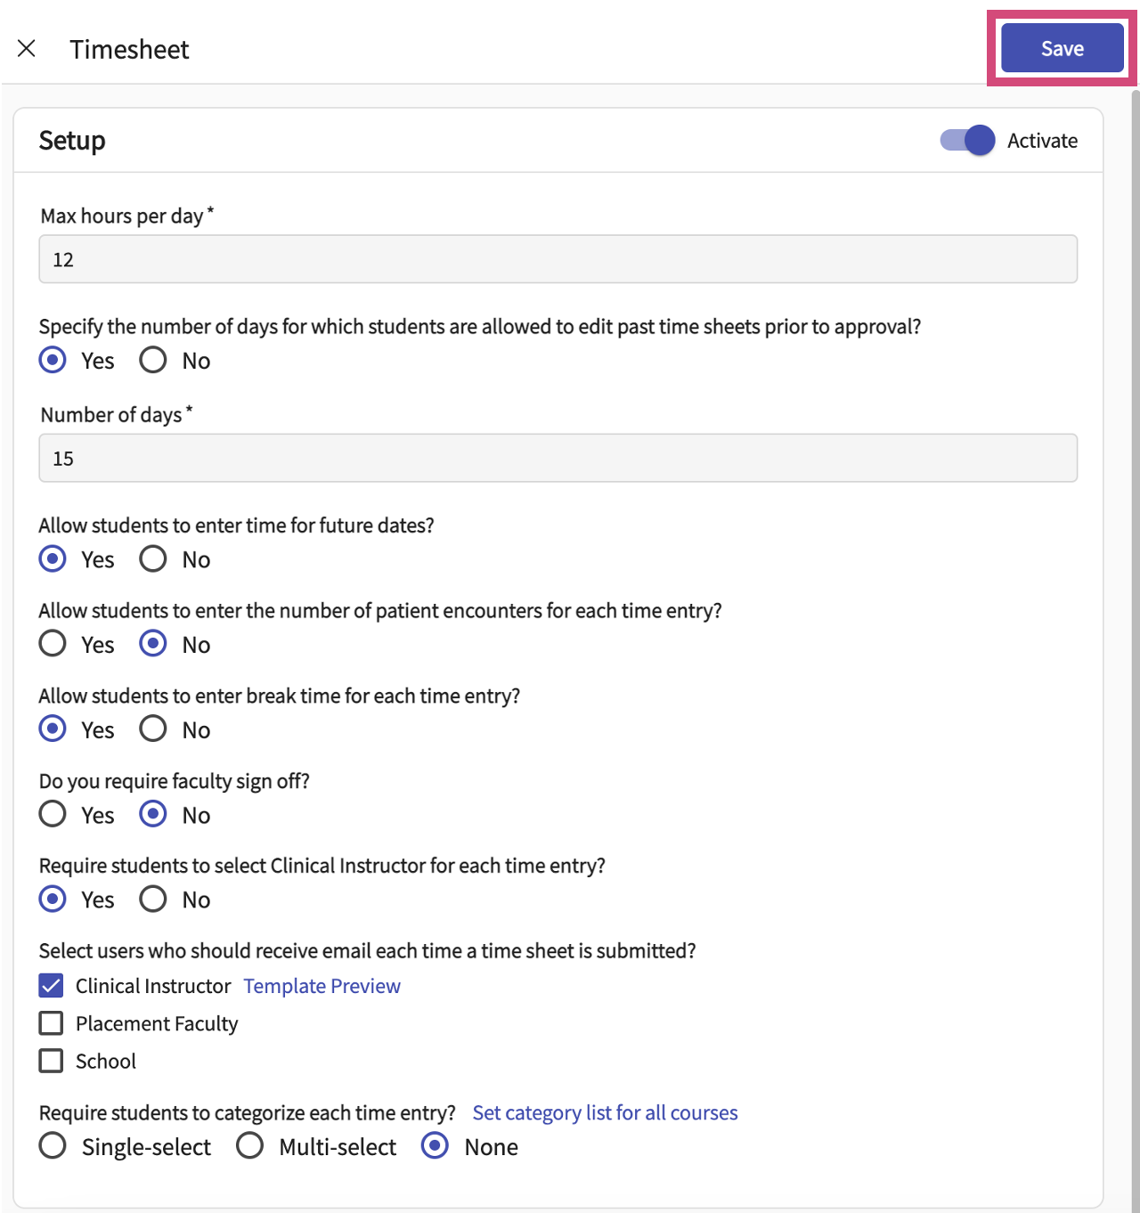

- Once you click on save, you will see the status for the timesheet as Activated.

