Managing Course Information
Prism
As you build your courses within Prism, you may want to add valuable details which you can share with students, and also use to generate a syllabus.

- Select Courses from your dashboard or left menu.



- Select the Course you’d like to manage.

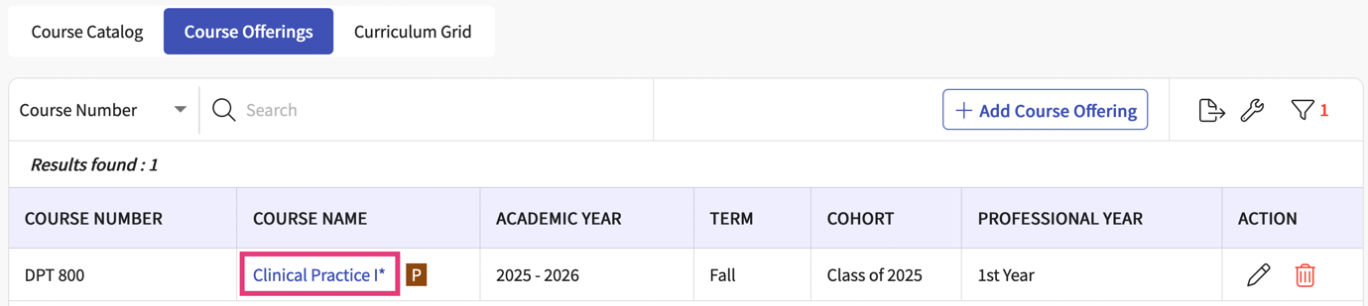

- You’ll be taken to the Course’s About page. The About page will have several sections available for you to manage.

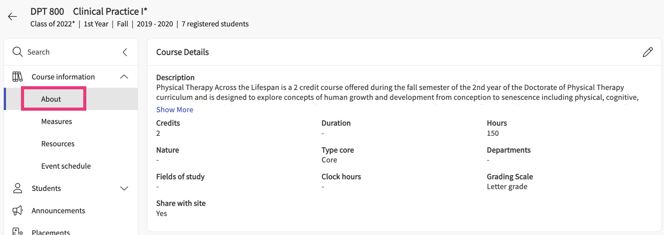

- Course Details: add a course description, credit and hour information along with other details and decide if this information should be shared with sites within the Site Resources page.

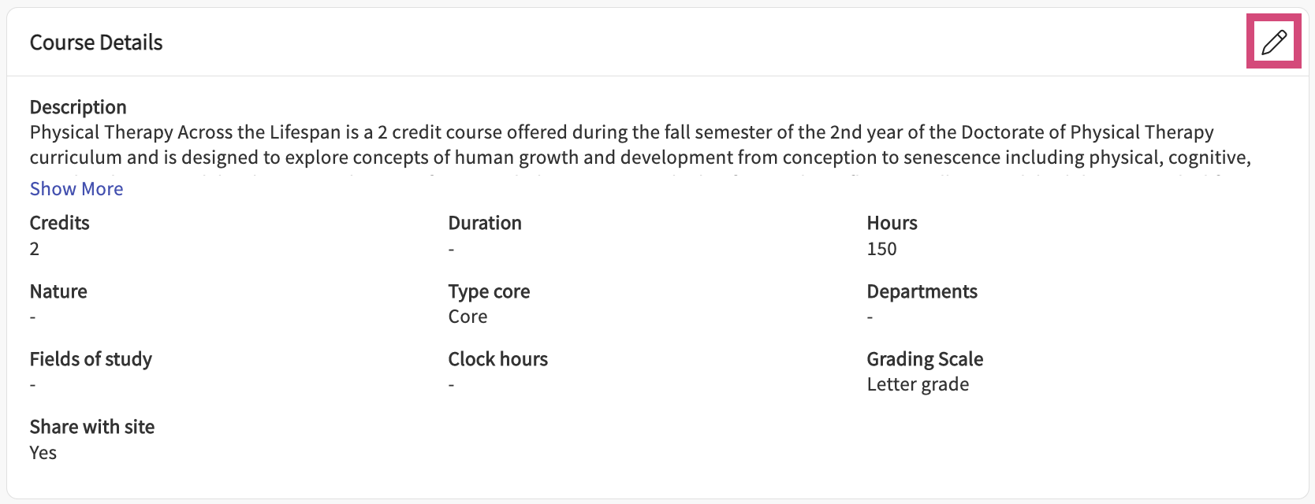

- Attributes: if your program uses curriculum mapping, attributes are a great tool to track important aspects of your curriculum and enable generation of filtered reports based on specific topics, teaching methodology, assessment types, and more.
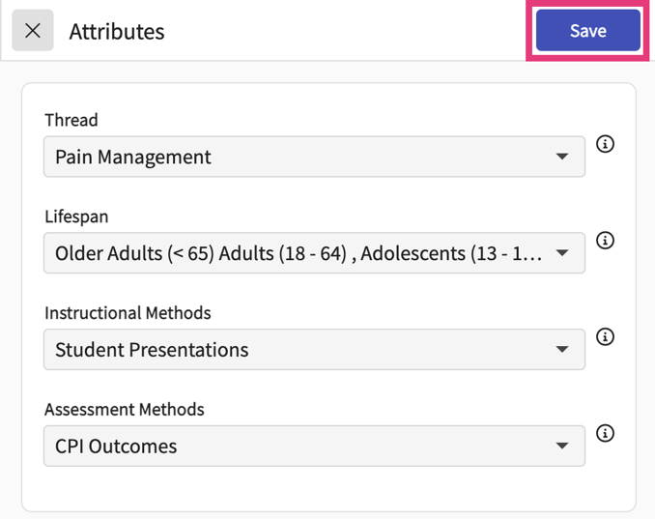
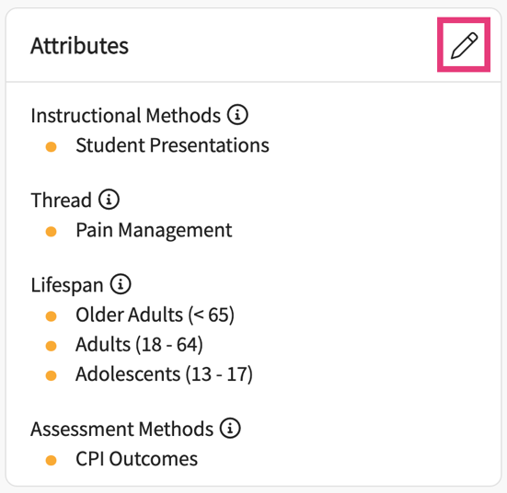

- Faculty & Staff: if any of your faculty members help with managing courses, you’ll first have to give them access to the course before they can see it on their portal.
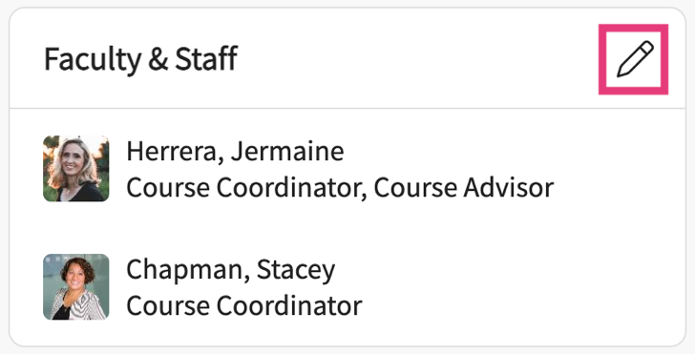
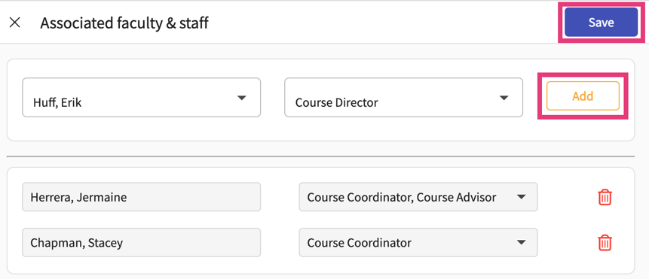

- Provide any details on any pre-requisites and co-requisites.

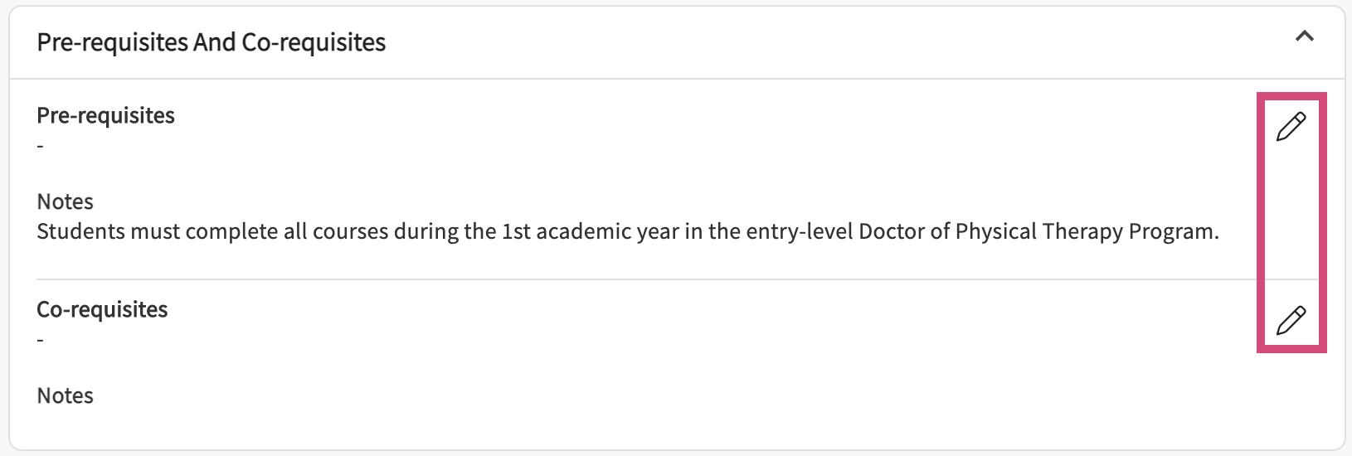

- Add details on textbooks and other resources your students may need.

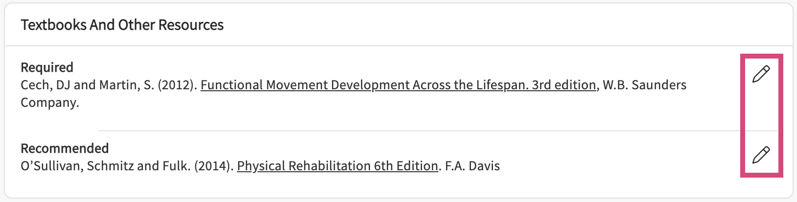

- Add information as to the evaluation criteria that will be used for this course.

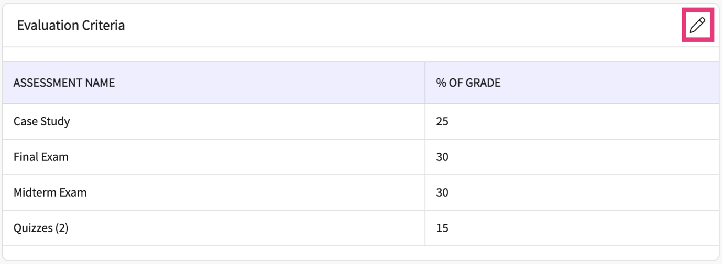

- Add course policies using the + icon. Edit any existing policies using the pencil icon.

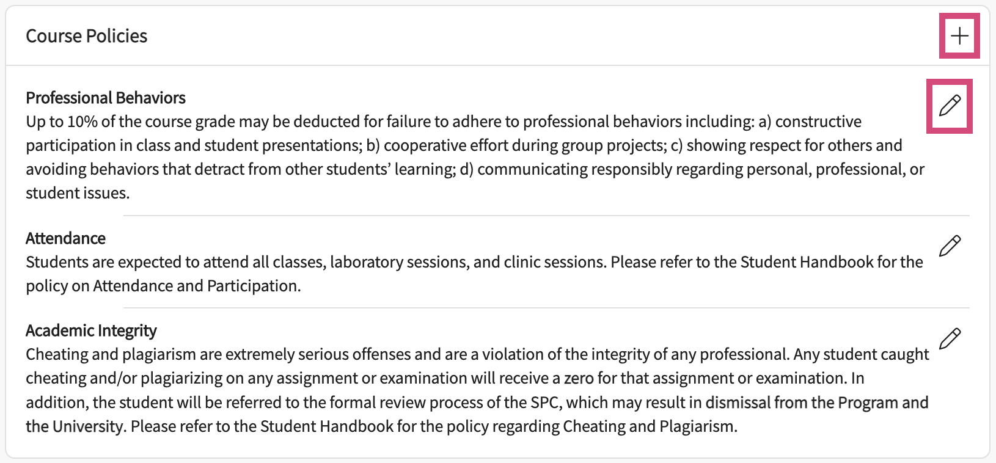

- The grading scale at the end of the page will be view-only. Please head over to the Program Details section to make any necessary changes.

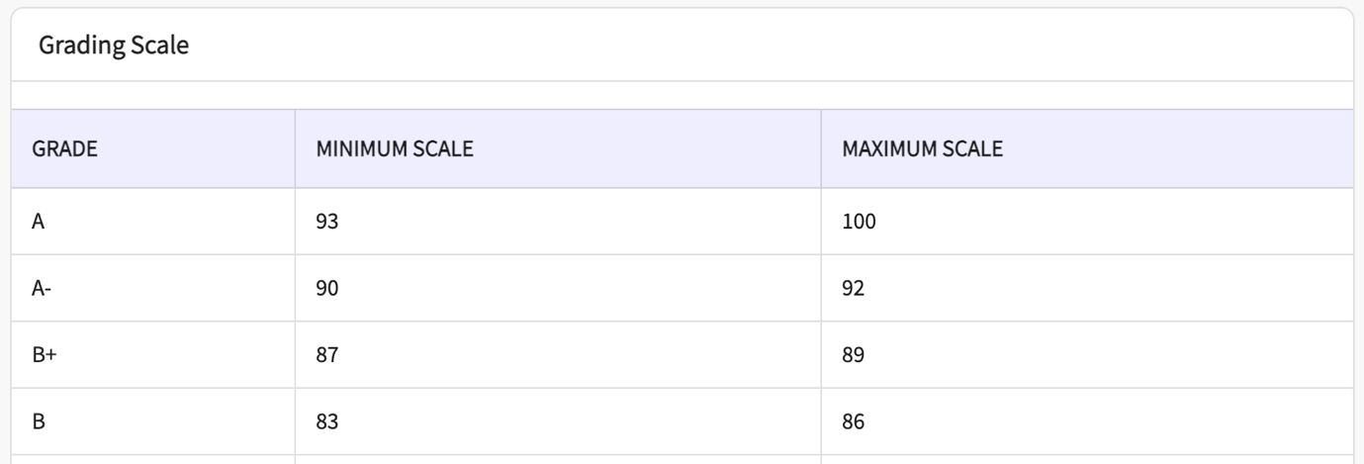

- Once you have added all necessary information, you can download a word file of your course profile. Click Generate Syllabus at the top of the page.

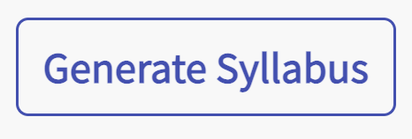

- A drawer will open, and you can select the different sections you’d like to include in your file. Once ready, click Download.

