Managing Attributes at Mapping Level

Prism

Attributes will help you keep track of your curriculum. They help you identify how a course is being taught across curriculum, and it helps when you are mapping an objective to a standard and you need to show how the objective is being met with a particular standard (for example: instructional methods, assessments outcomes, learning levels, etc.).

* Adding Attributes
* Editing Attributes
* Deleting Attributes

1. Select Courses from your dashboard or left menu.

1. Select Setup from the ribbon at the top of the page.

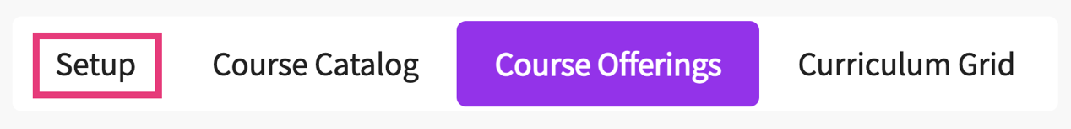

1. Click on Attributes from the left panel.

**Adding Attributes**

1. Once you click on Attributes, you’ll see a page similar to the image below. It will contain two sections:
   1. **Course, course measures and even attributes**: use this section if you want to create list of attributes to be assigned at course level, course measure level and event level. The list that is created at this section will be visible on the mapping set up page where you can activate the attributes you need to use.

* 1. **Mapping attributes**: use this section if you want to create list of attributes that needs to be assigned during mapping. For example, while you’re mapping your course measures to a standard and you need to track another aspect at this level (for example, learning levels etc.).

1. Click on the + icon to add a new attribute category. A drawer will open with the following fields:
   1. **Activate**: ensure this is on in order to manage within the curriculum. If is not active, it will not appear within the curriculum or within courses.
   2. **Add category**: name of your attribute.
   3. Checkboxes
      1. **Courses**: check off if this attribute is assigned at the course level. By course level, it means the course code and course name only. If you assign an attribute at the course level, it generates a report showing you what course is using what type of attribute.
      2. **Course measures**: check off if this attribute is assigned at the measure level. This will generate a report showing what measure (objective, outcomes or goals) the attribute is meeting.
      3. **Events**: check off if you’d like to track how a particular even is meeting an attribute.
      4. *We recommend you to avoid selecting all the check boxes for a single attribute, as it will create redundant data for you in the system. We suggest you use an attribute for a single level, either course level, course measure level or event level.*
   4. Click Save when done.

1. Once you have added an attribute, you can begin to add subcategories within that attribute. To do that, click on the ellipsis next to the attribute and click +Add Child.

1. A drawer will open. Enter in the name of the child attribute and click Save when done.

**Editing Attributes**

1. To edit an attribute, click on the pencil icon. A drawer will open where you can make any desired changes. Click Save when done.

**Deleting Attributes**

1. To delete an attribute, click on the ellipsis and select Delete.

1. You will get a validation message asking you to confirm you want to delete an attribute.
   1. Please note, an attribute cannot be deleted if it is associated with a course. Reach out to [v4support@exxat.com](mailto:v4support@exxat.com) for assistance.