Understanding Course vs. Rotation
Prism
One of the major foundational shifts in the new version is that it will be built around courses. This allows the system to be organized around a course number, term and academic year, mirroring the organization utilized by academic programs.

Course
A “course” is what a student will enroll in. It is a stand-alone element that can be used time after time. Courses are basically the foundation of any academic program. You only have to create a course once. Just as the registrar’s office at your academic institution recognizes a course, such as PA 601, and allows students to register for it at any time the department offers it, Exxat STEPS allows the same.

Like a syllabus, each course will have specific learning activities that students complete during that course such as specific evaluations and assignments. Each time a student participates in this course, these activities will be presented to the student for completion.

In PT/OT/Nursing, Courses define Timeframe, often done in any Setting. However, in PA program, courses define Setting often done at any time of the clinical year.

Finding a Course:

- Select Courses from your left-menu or dashboard

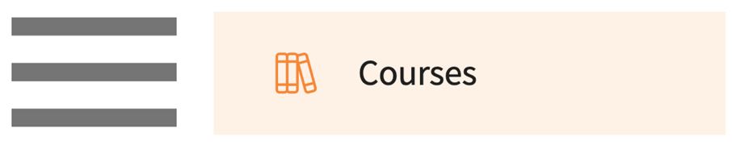

- The page will display all existing courses.

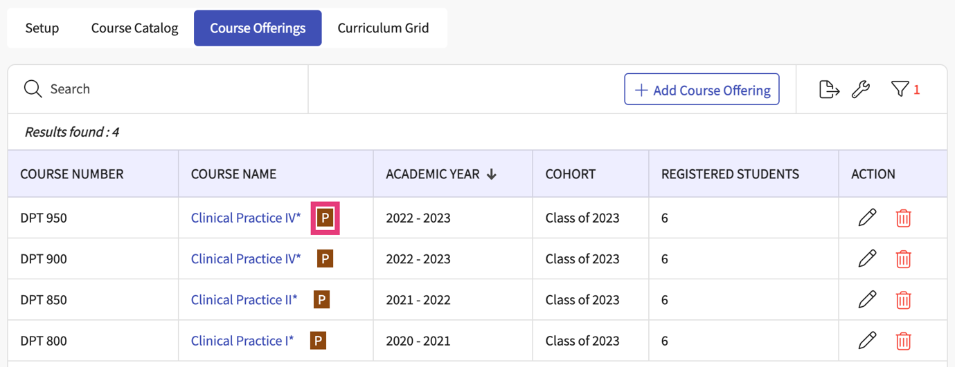
Indicates if course requires placements

Rotation
Rotations are the time period during which students participate in a course or courses, and this is where students can complete specific learning activities.

A rotation may be a time in which all students from a cohort complete the same course (such as in PT or OT) or a time in which students from a cohort complete one of many courses offered (such as in PA). When setting up a rotation timeframe, you will select which course(s) students may complete during that timeframe.

If multiple courses have been selected for a rotation, you will be given the opportunity to identify the specific course a student is completing when placing a student in a slot.

Finding a Rotation:

- Select Placements from the left menu or dashboard.



- Select the course you’d like to manage.

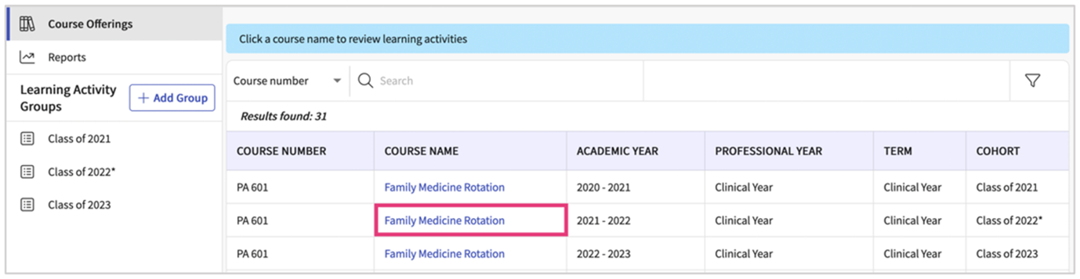

- Within the Setup tab, you will see all your rotations.

