Accessing the Slot Request for Site
Prism
Your school partner uses Exxat Prism to manage clinical education. You’ll be able to easily access a slot request on our cloud-based system without a login to provide your school partner with slots. We hope you’ll find Prism improves efficiency and promotes clear communication in this endeavour.

- Your school partner will send their slot request email right to your inbox from notifications@exxat.com. A sample email has been provided below. Your school partner may have customized their email and included attachments so you may see some variation than what is shown here.
  - Click on the link to get started!

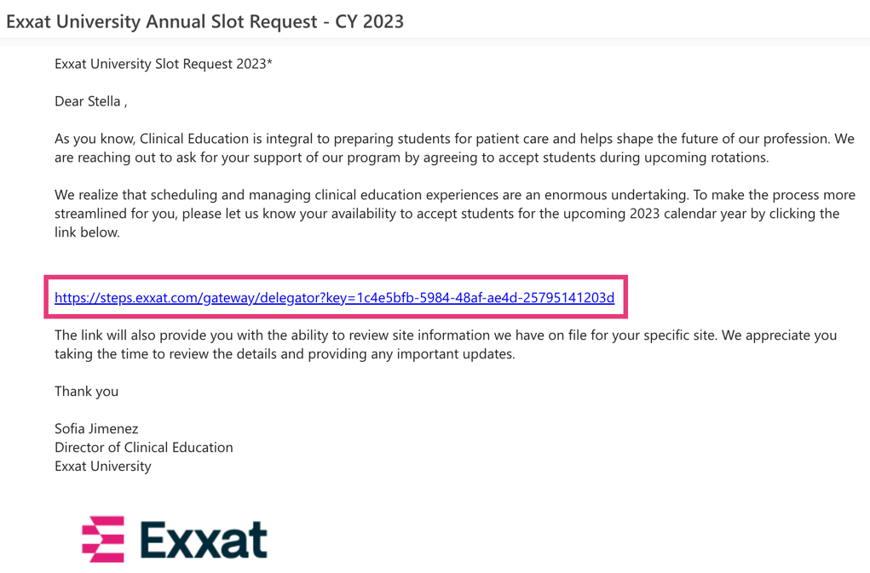

- You will be redirected to a page which looks like the image below. The first page will include a personalized message from the program and any resources they’d like to share. Click Start to begin.

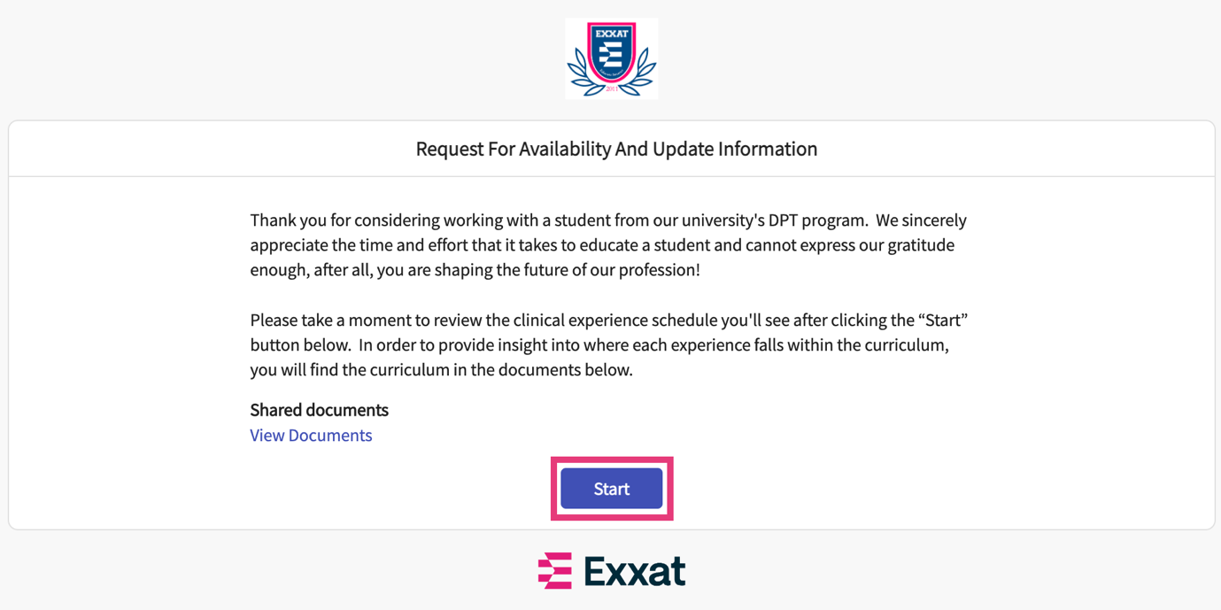
View any attachments

- On step 1, you will see all the locations you are associated with and will have the option to add availability information.
- On the right side of the page, you can easily view the different rotations the program has scheduled. Hover over the icon to view any notes the program has shared with you.

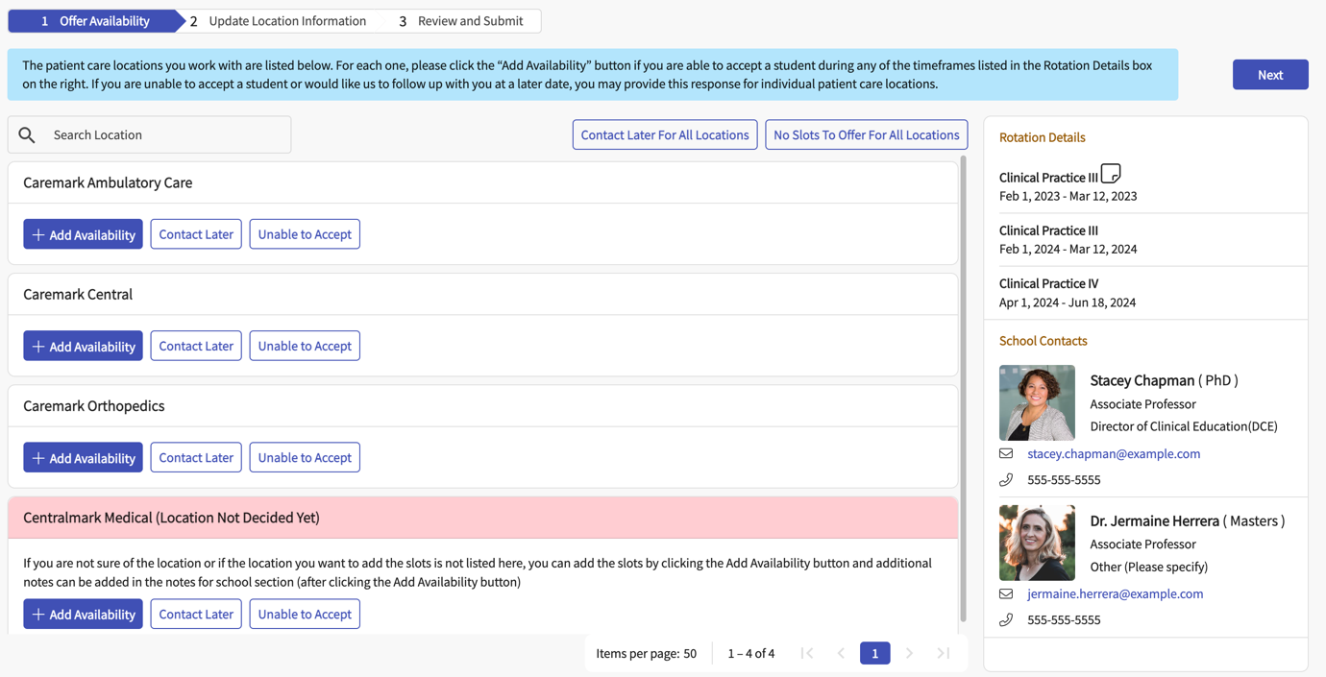

- To add slots, click + Add Availability for the desired location.

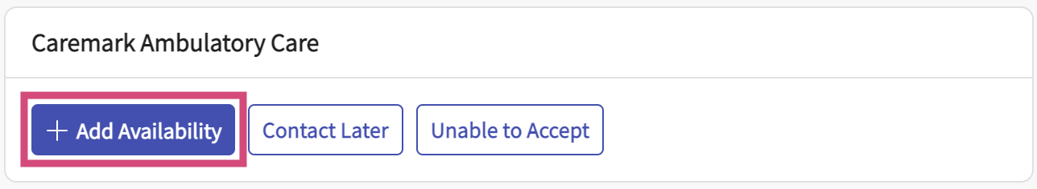

- The program may provide you with the option to add slots without assigning a location. If that feature is available, click + Add Availability for the card at the bottom of the page with includes the text (Location Not Decided Yet)

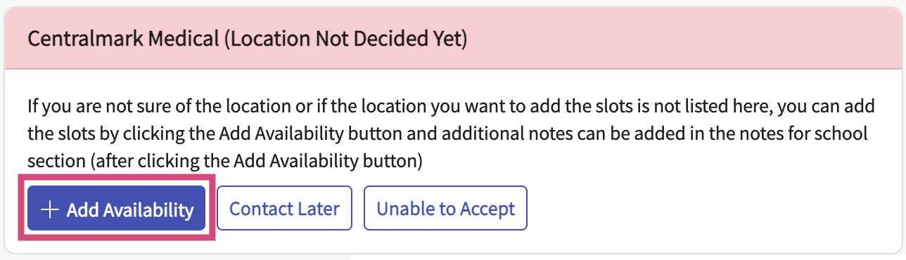

- A drawer will open. Provide all necessary information regarding the slot. At the bottom of the drawer, you will see all the rotations the program included in their request. You can make changes to the start and end date, along with how many offers you can provide. Once done, click Save.
  - Please note Number of Students is a mandatory field.

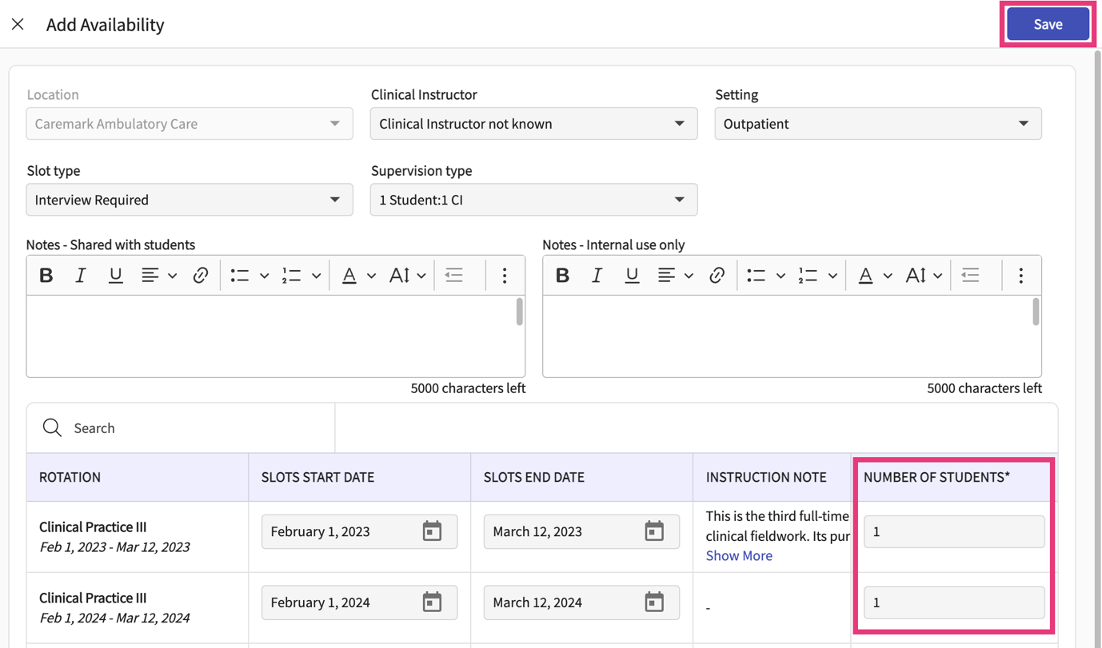

- Your slot will be added.
  - To add more availability, click on the + icon.
  - To edit or delete offered slots, click the pencil icon.

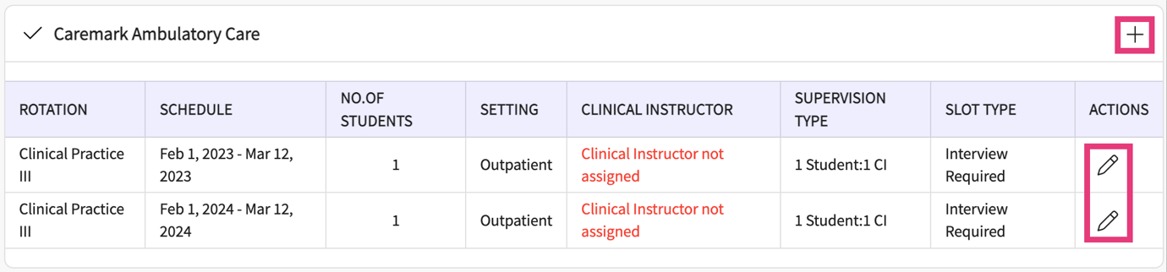

- If you cannot offer slots at this time for a specific location but would like to be contacted at a later time, click Contact Later for the respective location.

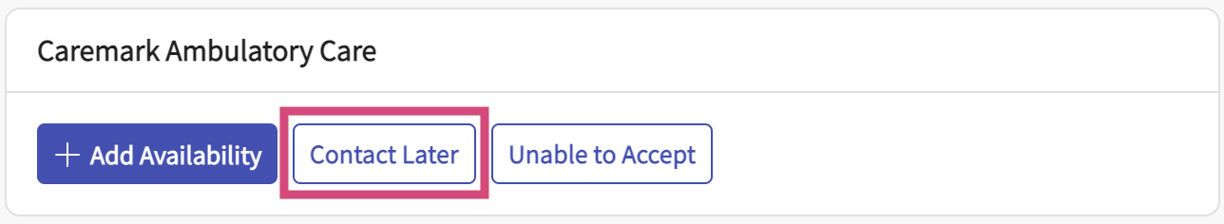

- If you cannot offer slots for any location but would like to be contacted at a later time, click Contact Later for All Locations.

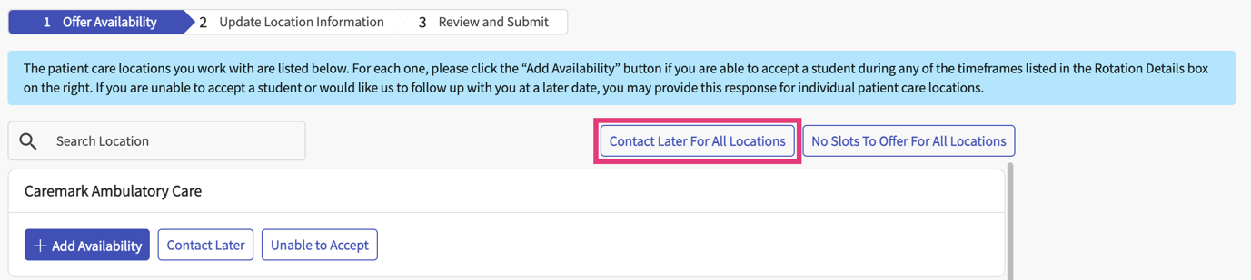

- A pop-up will appear. Click on the calendar icon to enter a date. Once done, click Submit.

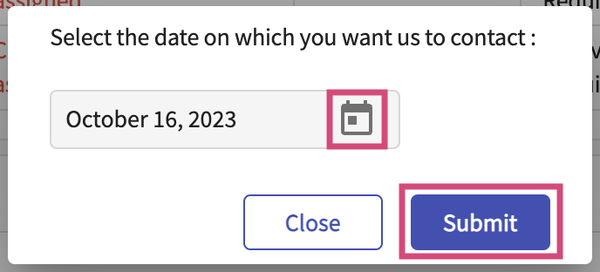

- The contact date will be listed. If you’d like to make changes, click change the response.

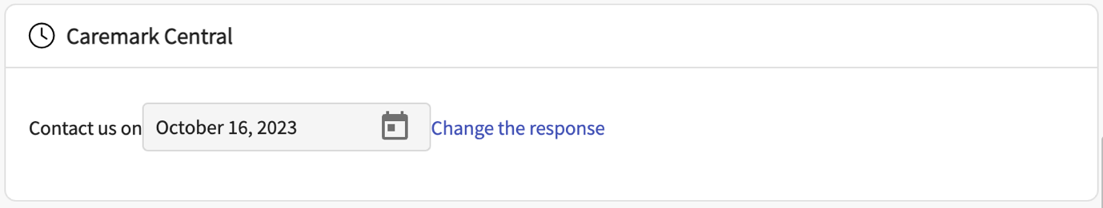

- If you have no slots to offer for a specific location, click Unable to accept for the respective location.

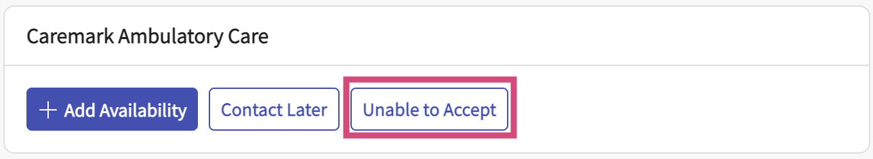

- If you have no slots to offer for any location, click No Slots to Offer for All Locations.

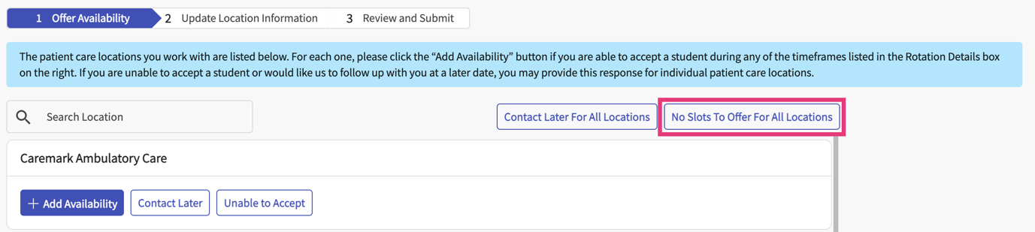

- The page will update. If you’d like to make changes, click change the response.

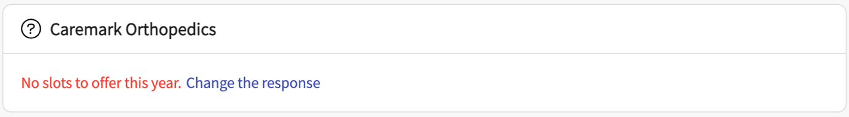

- Once done adding slot availability, click Next at the top of the page.

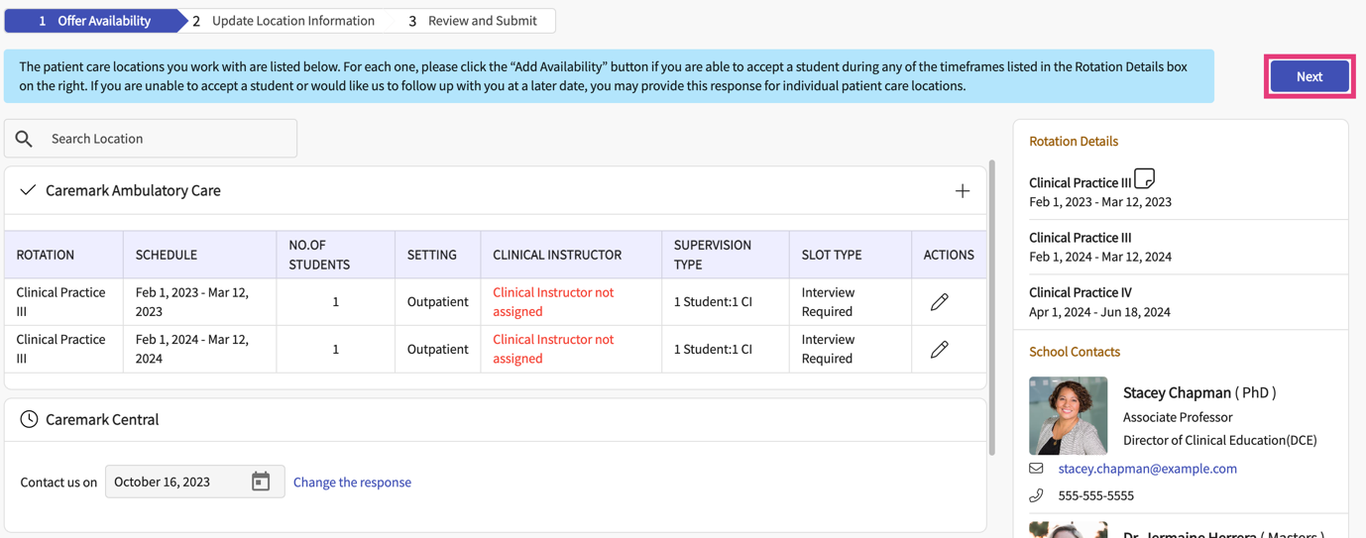

- The program may have included an option for you to provide updated location information. If so, this will appear on step 2.
- The left pane will list out each location you are associated with.
- The middle pane will show you the information the program has on file for the selected location. Review the information and indicate any updates on the notepad on the far right of the page.

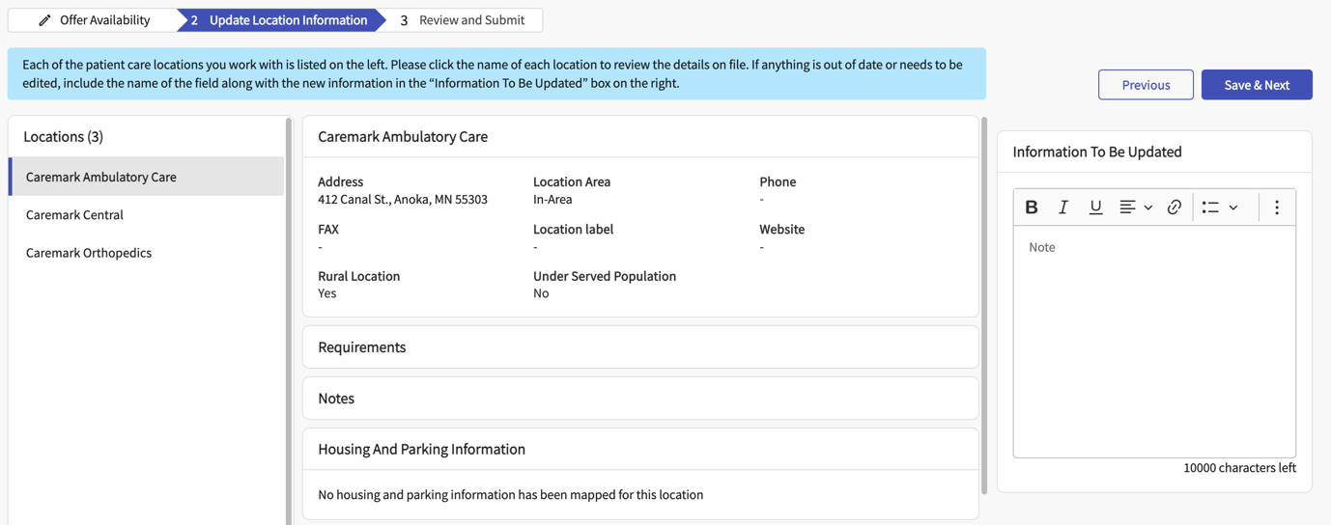
Switch between locations here

- Once done making updates for any desired locations, click Save & Next.

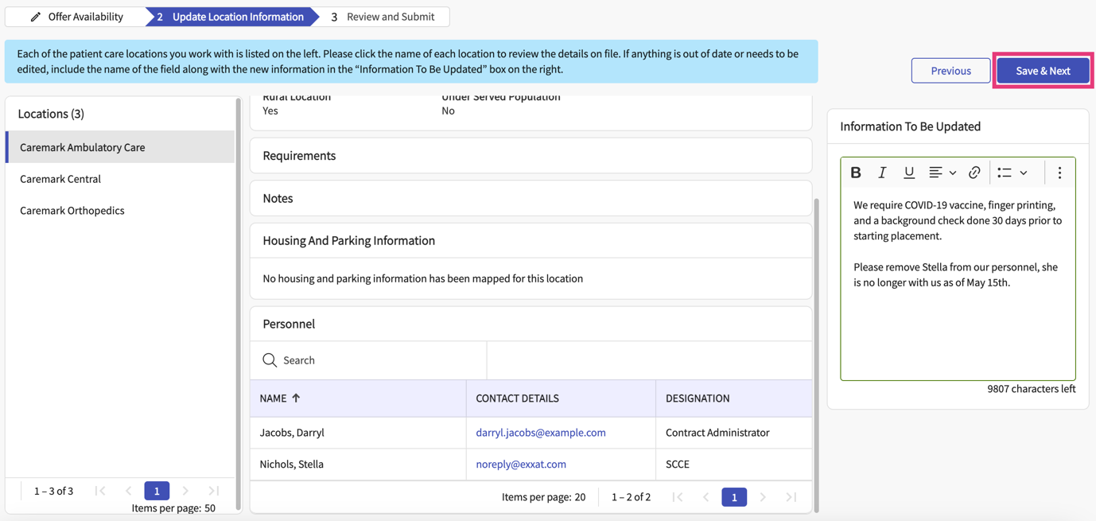

- On the last step, you will view a summary of your responses.
  - To go back and make changes, click Previous.
  - To submit your preferences, click Submit.
  - Once you submit, you may receive a confirmation email with a summary of your responses.

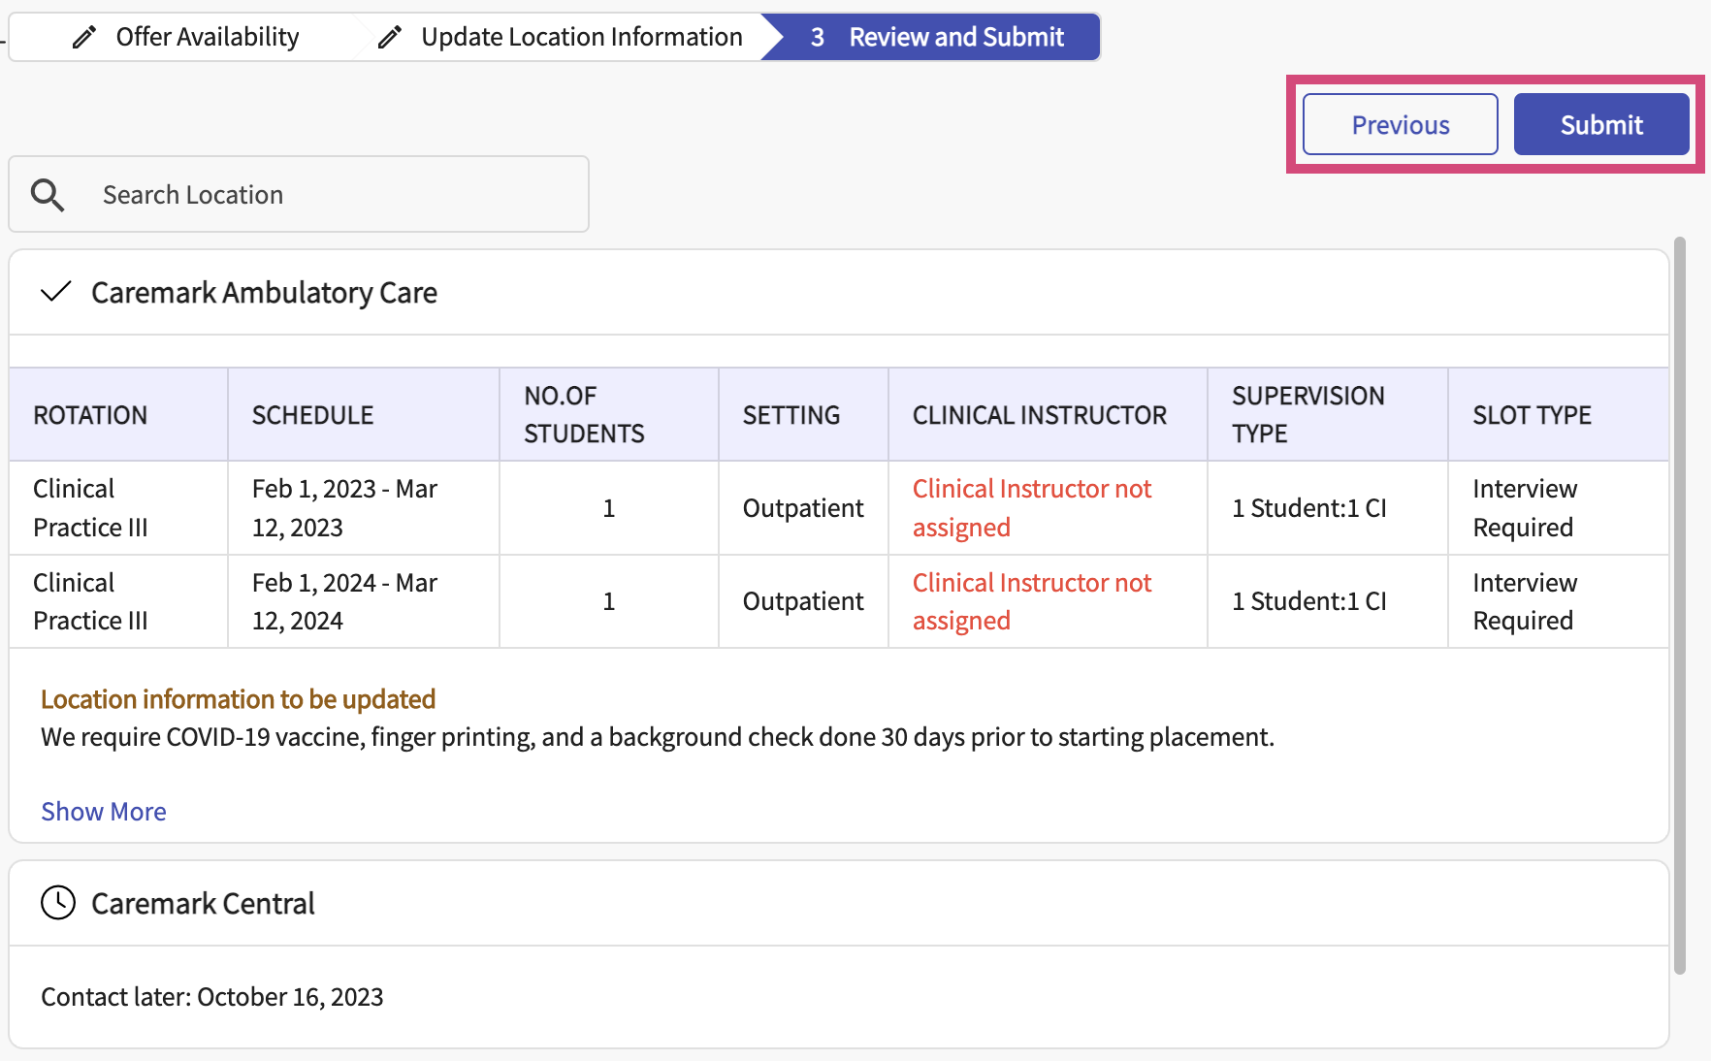

- Once you click submit, a pop-up will appear asking you to confirm submission. Click Ok.

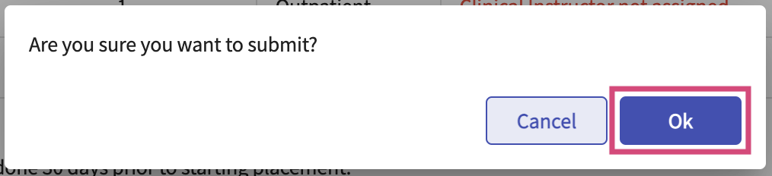

- The page will reload and will show a submitted status. You can always go back and view your responses and make changes if needed.

